EMIS — Architecture and Diagrams
Project: Design and Development of a Privacy-Aware QR/NFC-Based Emergency Medical Information System

1. Purpose and scope
EMIS is a proposed system for giving emergency responders rapid access to a limited, owner-approved medical summary through a QR code or NFC-enabled card. The owner is expected to manage the underlying information through authenticated access. Medical data is self-reported and must not be represented as clinically verified unless a future verification process is implemented.
Current state: A Next.js frontend prototype and UI/UX design materials exist. Spring Boot API, persistent storage, authentication/authorization, and working QR/NFC workflows remain planned or in progress; their operation is not claimed here.

2. System Context Diagram
The system boundary separates EMIS from the people and external services interacting with it. A scanner uses a phone's native QR/NFC capability to open a URL; the browser then accesses the proposed EMIS web application. Emergency calls are initiated through the phone's dialer, not handled by an EMIS emergency-dispatch integration.
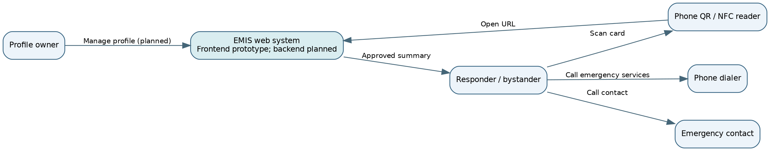

Context assumptions
- The QR code and NFC tag are intended to reference a profile URL rather than store detailed medical records directly.
- A public emergency view should reveal only an explicitly defined minimum dataset.
- Access to editing and private fields should require owner authentication once implemented.
- Internet access may be necessary for a hosted profile; offline availability is not assumed.

3. Use Case Diagram
The diagram below expresses planned interactions and is not evidence that each use case is implemented. Mermaid flowchart notation is used to show actors and use cases in an editable GitHub-compatible format.
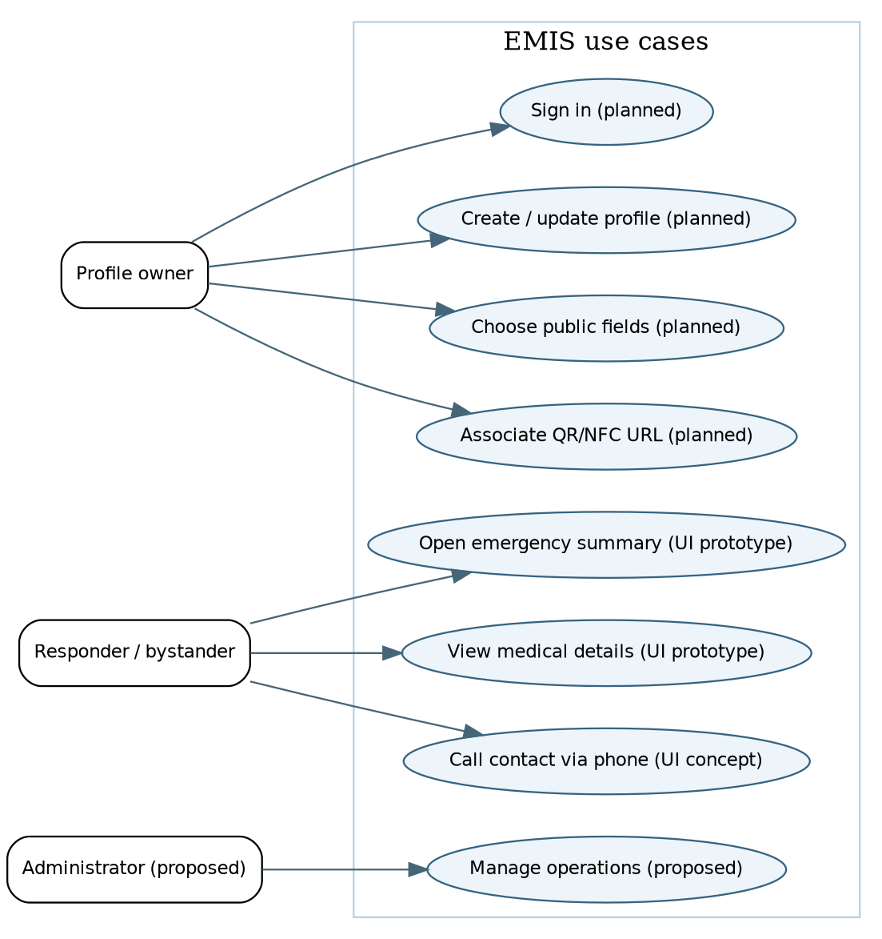

Core use case: Open emergency summary
- A responder finds the physical medical ID card.
- The responder scans the QR code or taps the NFC tag (future workflow).
- The device opens the associated profile URL.
- EMIS presents the approved emergency summary, such as allergies and emergency contacts.
- The responder may use the device to call emergency services or the listed contact.
Exceptions to design and test: invalid or revoked URL; unavailable network; missing data; incorrect/self-reported information; unauthorized request for private data.

4. Component Diagram:
Solid arrows describe the intended interactions. Components labeled planned have not been confirmed as operational in the current repository.
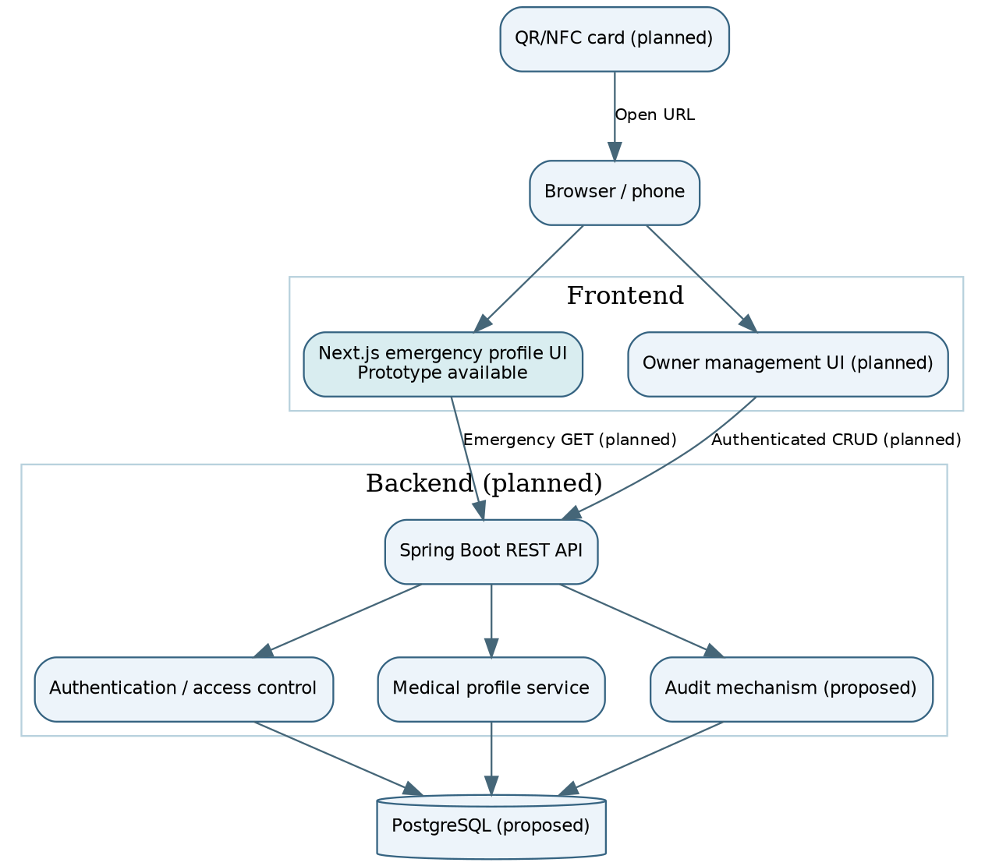

Proposed component responsibilities
Component | Responsibility | Status
Next.js emergency profile UI | Display sample emergency information and user interface | Prototype exists
QR/NFC card and link | Open the associated emergency profile URL | Planned
Spring Boot REST API | Handle profile requests and updates | Planned / development not verified
Authentication / authorization | Protect private data and profile editing | Planned
Medical profile service | Validate, retrieve, and update medical information | Planned
PostgreSQL | Persist profiles and access-related records | Proposed
Audit mechanism | Record appropriate access/change events without exposing unnecessary sensitive data | Proposed

5. Data flow and privacy boundaries
Emergency access (proposed): QR/NFC URL → browser → public emergency view → API → approved subset of profile data. No login is expected for the emergency subset, so its contents must be carefully minimized.
Owner update (proposed): owner authentication → owner management interface → API authorization → validated changes → database. The owner must not be able to edit another person's record.
Important design constraints:
- Do not place complete medical histories, passwords, or access tokens on a physical card.
- Use HTTPS for hosted pages and APIs.
- Limit public fields and avoid indexing or inadvertent exposure of sensitive profiles.
- Define revocation and lost-card replacement procedures before deployment.
- Provide clear warnings that medical data may be incomplete or self-reported.
- Evaluate applicable privacy and data-protection requirements before real patient deployment.

6. Requirements traceability (initial mapping)
Architecture element | Intended requirement area | Evidence / future verification
Public emergency view | Fast emergency access and limited disclosure | UI review; later API access tests
Owner management UI | Profile creation and updates | Future authenticated workflow tests
Access control | Confidentiality and authorization | Future negative authorization tests
QR/NFC URL | Emergency card navigation | Future device and invalid-link tests
Database | Persistence and data integrity | Future integration tests
Audit mechanism | Accountability | Future event and privacy tests
The exact requirement IDs should be aligned with the team's latest docs/requirements.md after review.

7. Key architecture decisions requiring validation
- Confirm whether the public emergency URL should use a revocable random identifier rather than an easily guessed sequential ID.
- Confirm the minimum public medical dataset with representative users and the supervisor.
- Decide the owner authentication mechanism and account recovery procedure.
- Select the final persistence schema and retention/deletion rules.
- Test usability, mobile compatibility, accessibility, and failure behavior under poor connectivity.
- Decide how NFC and QR links are provisioned and replaced if a card is lost.

8. Deliverables and limitations for the first pre-defense
Delivered by this document: editable source for three architecture diagrams; explanation of actors, components, interactions, data flows, privacy boundaries, and open design decisions.
Not claimed: deployed backend, connected database, operational QR/NFC card, clinically verified data, completed privacy compliance, or finished end-to-end tests.

