First Pre Defense Report
Diploma Project: Design and Development of a Privacy-Aware QR/NFC-Based Emergency Medical Information System
Team: Bekbolat Yergaliuly, Olzhas Omerzak Zhunisbekuly, Shugyla Akhit Zhasulankyzy
Supervisor: Yespenbetova Dana Altynbekqyzy
Repository: https://github.com/BekbolatSE2403/EMIS
YouTrack board (current status not verified)
Figma source designs (current frames not verified)
1. Project Proposal and Scope

1. Project Overview
The Emergency Medical Information System (EMIS) is a proposed web-based solution that enables a person to maintain essential emergency medical information and make an intentionally limited subset accessible through a QR code or NFC-enabled identification card. The concept is intended to help an emergency responder or bystander quickly locate user-provided information such as known allergies, relevant medical conditions, and emergency contacts when the card owner may be unable to communicate.
EMIS is not intended to diagnose illness, replace clinical records, verify medical facts, or substitute for professional emergency services. The initial interface is a prototype using demonstration data. QR/NFC access, backend persistence and production-grade access controls are planned work, not completed functionality. Clinical identity verification is outside the selected prototype scope.

2. Problem Statement
In an emergency, a person may be unable to explain important medical details. Information such as severe allergies or an emergency contact may be stored in different places, inaccessible to a nearby helper, or unavailable without unlocking the person's device. At the same time, exposing an entire medical history through a publicly scannable card would create privacy risks.
The engineering problem is to design a usable, reliable, and privacy-aware mechanism for sharing only selected emergency information through a QR/NFC entry point, while keeping sensitive profile management under the owner’s control. Section 2 presents a preliminary 31-submission survey summary; consent, eligibility, collection dates and final denominators must be verified before using the results as validated requirements evidence.

3. Target Users and Stakeholders
- Card owners: people who choose to store and selectively share their emergency information.
- Emergency helpers: bystanders or first responders who may scan a card to view a limited emergency profile. The design does not assume that all responders will rely on the system.
- Emergency contacts: individuals whom the card owner lists for contact in an emergency.
- Project stakeholders: the student development team, academic supervisor, and potential user representatives involved in requirements validation.

4. Aim and Objectives
Aim: Design and develop a prototype of a privacy-aware QR/NFC-based emergency medical information system that supports rapid access to a minimal emergency profile while providing a controlled process for managing the underlying information.
Objectives:
- Investigate user needs and identify the most useful and appropriate fields for an emergency profile.
- Review relevant academic work and compare existing medical ID and emergency-information solutions.
- Define functional and non-functional requirements with testable acceptance criteria.
- Compare and justify major technology choices for the frontend, backend, data storage, and component communication.
- Design system context, use case, and component diagrams, and document the data flow and trust boundaries.
- Develop accessible mobile and desktop interface prototypes for viewing an emergency profile.
- Implement, in later stages, secure profile management, a limited public emergency view, and QR/NFC-based profile access.
- Evaluate usability, correctness, access restrictions, and QR/NFC workflow behavior using defined test scenarios and metrics.

5.Project Scope

In Scope (Target Prototype)
- Responsive web interface for an emergency medical profile.
- Owner-facing profile creation and editing after authentication.
- Separation of private profile data from a minimal emergency view.
- Proposed QR-code and NFC-card linking to the emergency view.
- Storage and retrieval of selected profile fields through a backend API.
- Emergency contact display and links to general first-aid guidance, with appropriate medical disclaimers.
- Access-control, validation, logging, and security testing appropriate to a student prototype.
- Documentation, architecture diagrams, usability tests, and a demonstrable prototype.

2. Evidence of Relevance
The supplied survey summary reports that 93.5% of 31 submissions rated the proposed QR/NFC-based system as 4 or 5 on a five-point usefulness scale. These are reported descriptive results for all submissions; consent, eligibility, collection dates and final analysis denominators remain pending verification. The retained charts must not be presented as a filtered eligible sample or evidence of clinical effectiveness.
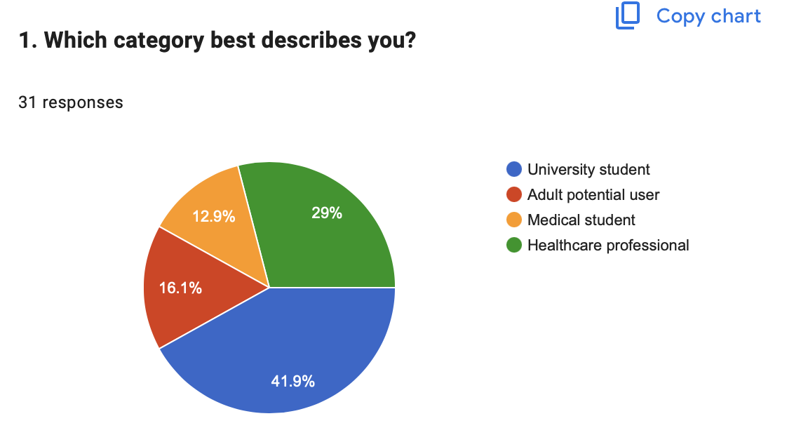
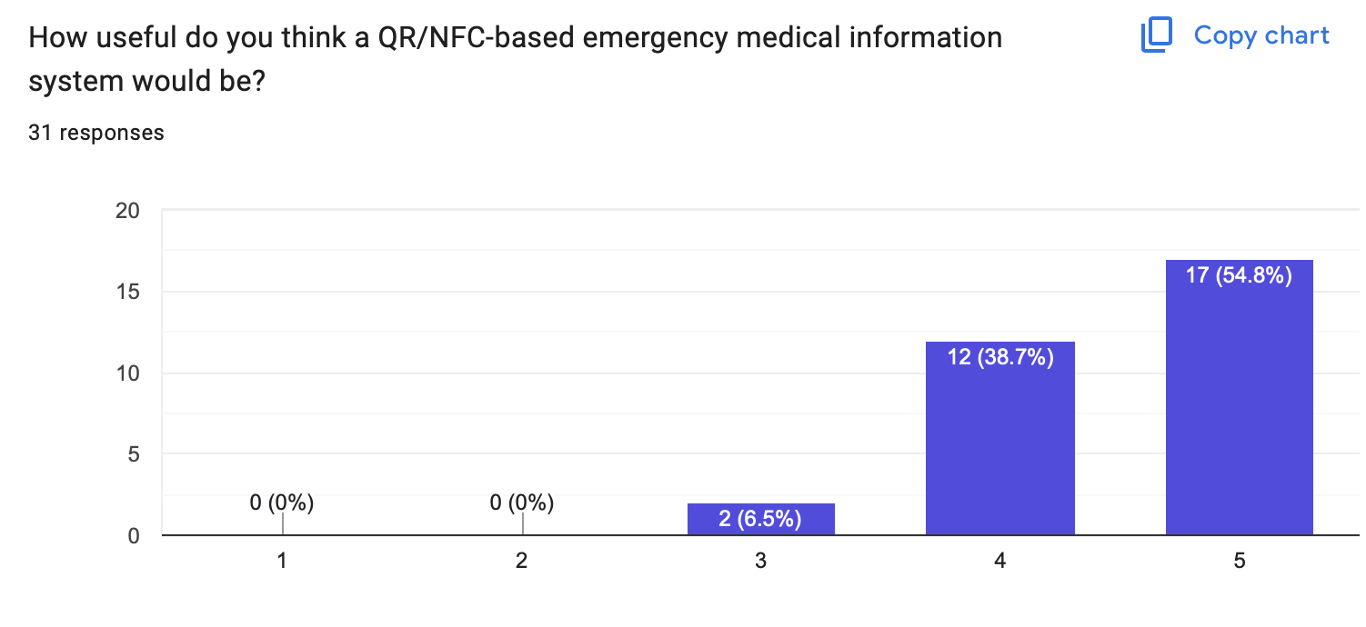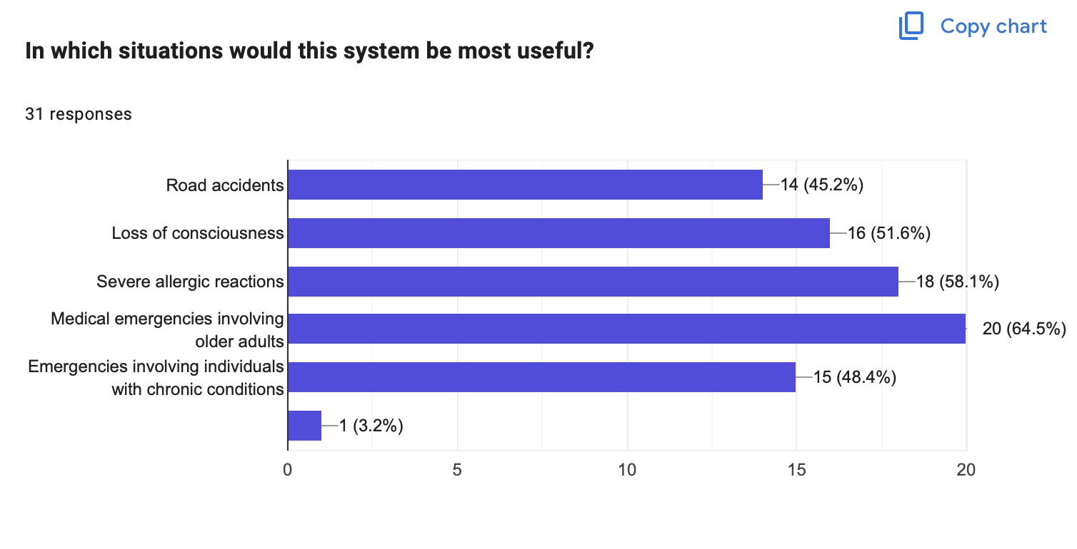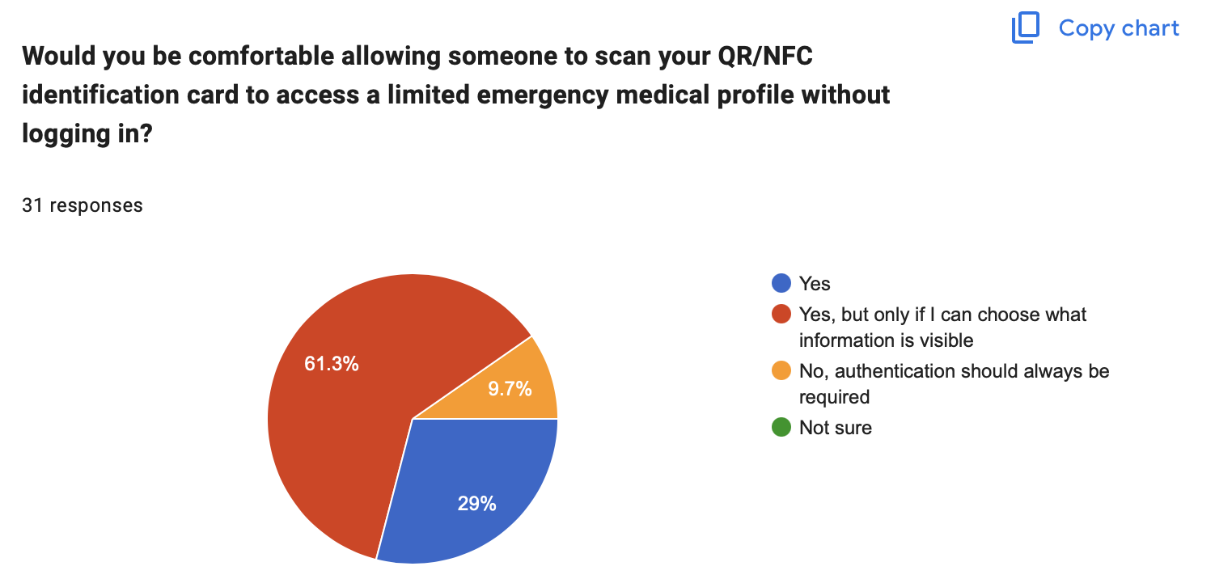
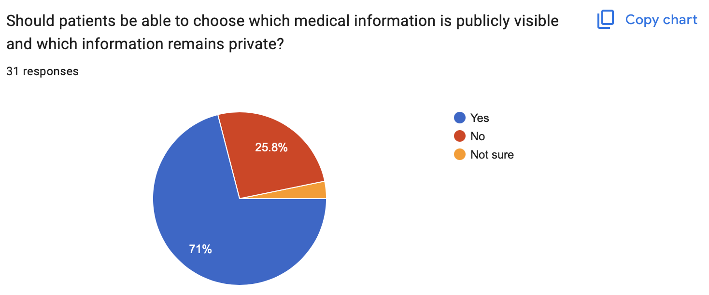
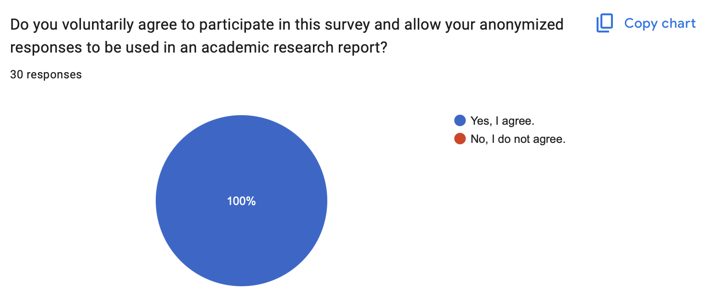
2.1. Purpose of Stakeholder Validation
To evaluate the relevance of the proposed Emergency Medical Information System (EMIS), the project team conducted an online stakeholder survey using Google Forms. The survey aimed to identify potential users' experiences with emergency medical information accessibility, assess the perceived usefulness of QR/NFC-based identification, and examine expectations regarding privacy, security, and system usability.
The findings were intended to inform the system's functional and non-functional requirements and support decisions concerning emergency information disclosure, access control, and reliability.
2.2. Research Methodology
The supplied survey summary records 31 submissions across four self-reported stakeholder categories: university students, adult potential users, medical students, and healthcare professionals. Original response-level records were not available for this revision, so these counts describe the reported submissions rather than a verified eligible analysis sample.
The questionnaire included multiple-choice questions, multiple-selection questions, five-point rating scales, and open-ended questions. The main topics were:
- Difficulties accessing medical information during emergencies.
- Perceived usefulness of QR/NFC emergency identification.
- Types of information considered important in emergencies.
- Privacy preferences and access-control expectations.
- Emergency scenarios and offline accessibility.
- Willingness to use the proposed system.
The preserved consent chart reports 30 answers, while the stakeholder charts report 31 submissions. The image alone cannot establish which response lacks a consent record or whether any submission must be excluded. Before final analysis, reconcile the counts against original records, verify age eligibility and collection dates, document exclusions under the approved procedure, and recalculate eligible-sample results.
The study represents preliminary stakeholder research using a non-probability sample. Consequently, its results are intended to support requirements analysis rather than provide statistically representative or clinically validated conclusions.
2.3. Participant Characteristics
The 31 survey responses were distributed across four stakeholder categories.
Participant category | Number | Percentage
University students | 13 | 41.9%
Adult potential users | 5 | 16.1%
Medical students | 4 | 12.9%
Healthcare professionals | 9 | 29.0%
Total | 31 | 100%
The inclusion of respondents from medical education and healthcare backgrounds provided additional perspectives on the proposed system's potential application in emergency situations.
2.4. Survey Results and Key Findings
2.4.1. Relevance of the Problem
Among the 31 respondents, 80.6% (25 participants) reported having experienced or witnessed an emergency in which important medical information was difficult to obtain.
Furthermore, 93.5% (29 participants) rated the potential usefulness of a QR/NFC-based emergency medical information system as either 4 or 5 on a five-point scale.
These findings indicate that the surveyed participants perceive emergency medical information accessibility as a relevant problem and consider the proposed solution potentially useful.
2.4.2. Essential Emergency Information
Respondents identified several categories of medical information that they considered important during emergencies.
Information category | Responses | Percentage
Blood type | 21 | 67.7%
Chronic medical conditions | 18 | 58.1%
Severe allergies | 17 | 54.8%
Current medications | 16 | 51.6%
Emergency contact information | 16 | 51.6%
Important medical warnings | 12 | 38.7%
The results indicate interest in accessing a concise emergency profile containing critical health-related information. However, the final selection of publicly visible medical fields requires further consideration of clinical relevance, information reliability, and patient privacy.
2.4.3. Privacy and Access Control
Privacy was an important consideration among respondents.
When asked whether a limited emergency profile should be accessible without authentication, 61.3% supported this approach only if patients could select which information was visible. An additional 29.0% supported access without login, while 9.7% preferred mandatory authentication.
Moreover, 71.0% agreed that patients should be able to determine which information is publicly accessible and which remains private.
These findings support the adoption of a patient-controlled disclosure model in which a minimal emergency profile can be accessed through QR/NFC identification while additional medical information remains protected.
2.4.4. Emergency Scenarios and Reliability
The most frequently selected scenarios were medical emergencies involving older adults (64.5%), severe allergic reactions (58.1%), and loss of consciousness (51.6%).
Regarding situations without internet connectivity, 54.8% preferred an option that would allow limited emergency information to be accessed directly from the identification card, subject to technical feasibility and patient approval.
These results highlight the importance of rapid information retrieval, mobile usability, and an appropriately designed offline-access strategy.
2.4.5. Potential Adoption
When asked about their willingness to use an emergency medical identification card with appropriate privacy controls, 67.7% selected the highest rating of 5, while 25.8% selected 4.
Overall, 93.5% expressed a positive intention to use the proposed system under these conditions.
This suggests favorable preliminary acceptance among respondents, although actual adoption would require further usability testing and evaluation of a functional prototype.
2.5. Implications for System Requirements
The stakeholder survey informed several proposed design requirements.
Finding | Proposed system requirement
High perceived usefulness of emergency information access | Provide rapid access to a concise emergency profile through QR/NFC identification
Strong preference for patient-controlled disclosure | Allow patients to select which approved fields are emergency-visible
Concerns associated with unrestricted access | Separate emergency-visible information from restricted medical records
Interest in information access without internet | Evaluate a privacy-conscious offline fallback mechanism
Importance of emergency scenarios involving vulnerable individuals | Prioritize readability, simple navigation, and mobile accessibility
Positive adoption intentions conditional on privacy | Include clear privacy settings and consent management
These requirements will guide subsequent architectural decisions, prototype refinement, and implementation planning.
2.6. Research Limitations
The reported sample comprises 31 submissions from a small, non-probability survey. Consent, eligibility, collection dates and exclusions have not been independently verified in this revision; results may change after that review and cannot be generalized to the wider population. Keep identifying records privately and publish only approved aggregate evidence.
Stakeholder categories were self-reported, and the survey did not independently verify participants' professional qualifications. The findings also represent perceptions and intended behavior rather than observed use of a functioning system.
Further evaluation will be required to assess clinical appropriateness, accessibility, security, and practical performance under emergency conditions.
2.7. Conclusion
The survey summary provides preliminary descriptive evidence of perceived relevance among the recorded submissions. Its use as stakeholder-validation evidence is conditional on verification of consent, eligibility and final analysis denominators. It does not establish clinical effectiveness or observed use of a working EMIS system.
The findings also demonstrate the importance of patient-controlled disclosure, reliable access to essential information, and privacy-aware emergency workflows.
These results provide a foundation for refining the system requirements and proceeding with security architecture design, prototype development, and usability evaluation.

3. Critical Literature Review

3.1. Literature Search and Selection
The review considers 15 supplied scientific publications; the team retained twelve and excluded three as less relevant to the intended EMIS workflow. This is a focused review of supplied publications, not a systematic search. Original Scopus search dates, query strings, result counts and screening records are not documented in the submitted materials, so search reproducibility and bibliographic verification remain limitations. No search date or verification activity has been invented for this revision.

3.2. Critical Analysis of Selected Publications
Study | Contribution | Limitation | Implication for EMIS
Biju et al. (2024) [1] | NFC medical card and companion application for accessing health information. | Directly comparable system; limited evidence in the supplied paper of large-scale emergency-responder evaluation. | Benchmark card/profile functionality; clarify how EMIS differentiates public and restricted information.
Raso et al. (2022) [2] | Two privacy-aware NFC/RFID healthcare architectures, including patient-defined access policies. | Focuses on sensor data and cloud sharing, not QR-based emergency identity cards. | Inform authorization, privacy separation and secure information sharing.
Manes et al. (2026) [3] | Observed QR-code use in an emergency department: 1,895 scans across six months. | QR links provided general administrative information, not personal emergency records. | Support feasibility of low-cost QR entry points; do not infer clinical effectiveness.
Bedriova et al. (2023) [4] | Designed and tested an NFC-supported oncology workflow with 100 patients across two clinics. | Oncology treatment workflow differs from unscheduled emergency access. | Guide NFC interaction design and practical usability evaluation.
Balasubramanian et al. (2022) [5] | Contactless NFC-enabled telehealth prototype with cloud-based data structuring and visualization. | Pandemic ward monitoring and NLP are beyond EMIS scope. | Support contactless retrieval and concise presentation of medical facts.
Çobanoğlu and Akalın (n.d.) [6] | Describes NFC use in telemedicine and patient monitoring scenarios. | Publication year and formal bibliographic venue require confirmation; primarily conceptual background. | Provide historical NFC healthcare context, not primary validation evidence.
Kuo et al. (2022) [7] | RFID-based hospital/public-setting identification and monitoring solution. | Concentrates on organizational monitoring and temperature checks. | Inform identification workflow and low-cost hardware considerations.
Shojaei et al. (2024) [8] | Systematic review of health-information security, access, storage and sharing. | Broad health information systems rather than emergency-card-specific evaluation. | Support access-control, secure storage and data-sharing requirements.
Tertulino et al. (2024) [9] | Mapping study of privacy requirements and gaps in electronic health records. | Institutional EHR emphasis rather than anonymous emergency profile retrieval. | Support privacy requirements and trade-offs with interoperability.
Mwogosi et al. (2026) [10] | TCCM review of privacy practices and barriers in EHR systems in developing countries. | Evidence reflects varied national and institutional contexts. | Justify privacy-by-design and attention to practical deployment constraints.
Khan et al. (2024) [11] | Review of passive and battery-free RFID medical technologies. | Many reviewed devices are sensors rather than simple NFC medical cards. | Support assessment of passive tags and hardware limitations.
Rehman et al. (2025) [12] | Wide-ranging review of healthcare IoT, architectures and security challenges. | Broad monitoring and connected-device scope; indirect relation to EMIS. | Provide wider security context without expanding EMIS into monitoring.

3.3. Critical Synthesis
Contactless identification and emergency access. MEDxSWIFT [1] offers the closest functional precedent for an NFC medical card, while Bedriova et al. [4] and Balasubramanian et al. [5] demonstrate NFC-assisted healthcare interactions in other clinical workflows. Kuo et al. [7] and Khan et al. [11] expand the hardware perspective to RFID identification and passive devices. Together, these studies support investigating contactless access, but none alone establishes that EMIS will reduce emergency response time or improve patient outcomes.
QR accessibility and user interaction. Manes et al. [3] report sustained use of QR-linked information in an emergency department. Their study concerns non-urgent information, so its results support the practicality of QR-based entry points rather than proving the suitability of QR-linked personal medical records. For EMIS, scan success, device compatibility, information readability and task-completion time require separate prototype testing.
Privacy and access control. Raso et al. [2] explicitly compare system-managed and patient-defined access policies, while Shojaei et al. [8], Tertulino et al. [9], and Mwogosi et al. [10] identify risks associated with unauthorized access, storage, sharing, and implementation governance. These studies support separating a deliberately limited emergency-visible summary from private medical information. A QR code or NFC tag is an access mechanism, not proof of authorization: sensitive data must not be exposed merely because someone can scan a physical card.
Scope boundaries. The broader IoT and telemedicine studies [5]–[7], [11], [12] offer relevant architecture and security lessons, but EMIS does not propose continuous physiological monitoring, diagnosis, or clinical decision-making. Their findings must therefore be transferred cautiously to a static or user-maintained emergency profile.

3.4. Research Gap
The selected literature addresses NFC medical cards, QR-based information access, healthcare identification, and privacy-preserving health information systems, but typically treats these topics separately or in different clinical settings. The gap motivating EMIS is therefore an integration and evaluation problem: how to design a practical QR/NFC-linked emergency profile that provides rapid access to a carefully limited public summary while restricting sensitive records and giving owners control over their information. MEDxSWIFT [1] demonstrates that the general NFC medical-card concept already exists; EMIS should be evaluated against such precedents rather than presented as the first system of its kind.

3.5. Implications for the Proposed EMIS Design
The literature informs five planned decisions: (1) use QR and NFC as alternative entry points to the same maintained profile [1], [3], [4]; (2) avoid storing sensitive medical histories directly on a freely readable tag [2], [8]; (3) separate public emergency facts from authenticated owner-managed records [2], [9], [10]; (4) keep emergency information concise and mobile-readable [3], [5]; and (5) evaluate scan reliability, time to locate essential facts, privacy leakage and access-control behavior using test scenarios rather than asserting unmeasured benefits [3], [4], [8]. These are design implications, not claims that the planned EMIS implementation has been clinically validated.

4. Existing Systems Comparison
Project: Design and Development of a Privacy-Aware QR/NFC-Based Emergency Medical Information System

1. Purpose
This document compares existing approaches for making essential medical information available during emergencies. The objective is to identify useful design patterns, limitations, and requirements for the proposed Emergency Medical Information System (EMIS).

2. Systems Selected
- Apple Medical ID (Health app): emergency medical information stored on an iPhone, with optional visibility from the lock screen. Official information: https://support.apple.com/guide/iphone/set-up-your-medical-id-iph08022b194/ios
- Android Emergency Information: emergency details and contacts that can be configured on supported Android devices; presentation varies by manufacturer and Android version. Official Android help: https://support.google.com/android/
- MedicAlert: medical identification jewelry linked to medical information and, in some offerings, an emergency-response service. Official website: https://www.medicalert.org/
- MyID: wearable medical identification products associated with a digital medical profile. Official website: https://getmyid.com/
These four systems represent two common models: phone-based emergency information and wearable identification linked to a profile or service.

3. Comparison Criteria
The same nine criteria are used for every system:
- Emergency access mechanism: how a responder finds the information.
- Dependence on the owner's phone: whether the owner's phone is needed at the scene.
- Physical identification option: whether an external item can direct responders to information.
- QR/NFC relevance: whether QR or NFC is central to the access model.
- Medical information scope: whether the system can present key facts such as allergies, conditions, or contacts.
- Information update workflow: how an owner updates their information.
- Privacy/access approach: what is publicly accessible and what needs protection.
- Connectivity dependence: whether the information can be accessed without network service.
- Main practical limitation: a significant constraint for emergency use.
Criterion | Apple Medical ID | Android Emergency Information | MedicAlert | MyID | Proposed EMIS
Emergency access | iPhone emergency/Medical ID interface, if enabled | Device emergency information interface, if supported and configured | Medical ID item and associated service/profile | Medical ID wearable and associated profile | Scan QR or tap NFC card to open limited emergency profile
Owner's phone required | Yes, for on-device access | Yes, for on-device access | Not necessarily | Not necessarily | No, if responder has a compatible device
Physical ID item | Not inherent to Medical ID | Not inherent to emergency information | Yes | Yes | Planned QR/NFC card
QR/NFC central | No | No | Not a universal requirement | Product-dependent; verify specific product | Planned dual QR/NFC entry
Key medical facts | Yes, if entered by owner | Yes, fields vary by device | Yes, depending on enrollment/service | Yes, depending on profile/product | Planned allergies, conditions, medications, contacts
Updates | Health app on owner's device | Device settings / safety app | Account/service workflow | Account/profile workflow | Planned authenticated owner dashboard
Privacy/access | Owner controls whether lock-screen information is shown | Device-specific controls | Service- and product-specific; verify | Service- and product-specific; verify | Planned minimum public data, restricted editing
Internet required for core access | Not generally for locally stored Medical ID | Not generally for locally stored emergency info | Depends on service and interaction | Digital profile generally needs connectivity; verify | Online profile required; no offline health-record feature selected
Principal limitation | Responder must locate and access owner's iPhone | Interface and support differ by device | May depend on membership, service, and responder process | Digital access may depend on network and product | Not yet implemented; depends on responder connectivity and safe privacy design

5. Technology Comparison

1. Purpose and evaluation method
This document compares reasonable technology alternatives for four major design decisions: frontend platform, backend framework, data storage, and QR/NFC access method. Selections are proposed design decisions, not claims that the entire system has been implemented or tested. Each option is evaluated against the same decision-specific criteria. Assessments are qualitative engineering judgments to be validated during implementation.

Project constraints
- Emergency responders should be able to view a minimal emergency profile quickly, ideally without installing an app.
- Sensitive data must not be embedded directly in a publicly readable QR code or NFC tag.
- Profile owners need a controlled way to create and update their information.
- The system should support browser-based access on common phones and computers.
- The student team must be able to build, document, and test a demonstrable prototype within the diploma timeline.
- Medical information is user-provided and must not be presented as professionally verified unless independently validated.

2. Decision A — Frontend platform
Criteria: cross-device reach, installation friction, development speed, maintainability, and support for accessible responsive interfaces.
Alternative | Advantages | Limitations | Fit for EMIS
Next.js + React + TypeScript | Responsive web access without installation; component reuse; TypeScript helps manage data contracts; fits the existing prototype | Requires careful server/client boundaries, secure configuration, and accessibility testing | Selected for prototype
React single-page application with Vite | Lightweight tooling; straightforward frontend development | Routing, server-side features, and deployment conventions need separate choices | Viable alternative
Flutter mobile application | Consistent native-like mobile UI; potential access to device integrations | Requires installation for the primary experience; more platform-specific testing | Less suitable for emergency public access
Decision: Continue with Next.js, React, TypeScript, and Tailwind CSS. This matches the current frontend work and supports opening an emergency profile through an ordinary mobile browser. A responsive website is a design choice, not evidence that all devices have been tested.

3. Decision B — Backend framework
Criteria: REST API support, access-control ecosystem, team familiarity, maintainability, and integration with relational storage.
Alternative | Advantages | Limitations | Fit for EMIS
Java + Spring Boot | Mature REST API and validation ecosystem; Spring Security options; structured service architecture | More initial configuration and boilerplate; requires secure setup | Proposed selection
Node.js + NestJS | TypeScript across frontend and backend; modular architecture; strong API development workflow | Security and configuration still require careful implementation; would change assigned backend stack | Good alternative
Python + FastAPI | Concise API definitions; automatic OpenAPI documentation; rapid prototyping | Different language ecosystem; team would need to establish conventions for persistence and authorization | Good alternative
Decision: Propose Java + Spring Boot for the backend, with Maven for dependency management. No completed backend API is claimed at this pre-defense stage.

4. Decision C — Data storage
Criteria: consistency of profile and access data, query flexibility, schema clarity, backup practices, and compatibility with the proposed backend.
Alternative | Advantages | Limitations | Fit for EMIS
PostgreSQL | Relational integrity; transactions; mature tooling; clear relationships between profiles, contacts, and access policies | Schema migrations and operations require planning | Proposed selection
MySQL | Mature relational database; broad hosting and tooling support | Differences in SQL behavior and operational preferences must be considered | Suitable alternative
MongoDB | Flexible document structure; convenient nested records | Relationships and consistency rules require careful modeling; flexibility can weaken schema discipline | Possible but less preferred
Decision: Select PostgreSQL for the target relational store. Section 7 and docs/data-model.md define the logical schema, identifier digests and retention constraints; no database or migrations are implemented.

5. Decision D — Emergency access mechanism
Criteria: smartphone compatibility, cost, usability in emergencies, replaceability, and risk of exposing sensitive data.
Alternative | Advantages | Limitations | Fit for EMIS
QR code pointing to a controlled HTTPS profile | Widely supported by phone cameras; inexpensive to print; works without a dedicated app | Requires camera and internet access; printed codes can be copied or damaged | Primary proposed access method
NFC tag containing a controlled HTTPS profile URL | Convenient tap interaction on compatible devices; useful as a second access path | Device support and scanning behavior vary; tag can be cloned or replaced; requires compatible reader | Optional complementary method
QR/NFC storing full medical data directly | Potentially accessible without a server in some designs | Exposes information to anyone who reads the tag; updates and revocation are difficult; NFC capacity may be limited | Rejected for sensitive information
Decision: Use a QR code as the primary access method, with NFC as an optional complementary method. Both should point to a managed HTTPS URL, not store raw medical details. The public emergency view must expose only explicitly approved information. A URL token is not a substitute for authentication when accessing private data; token guessing, sharing, revocation, and rate limiting require threat-model review.
Our final decision:
Area | Proposed technology | Status
Frontend | Next.js + React + TypeScript + Tailwind CSS | Initial UI implemented
Backend | Java + Spring Boot + Maven | Planned; architecture documented
Database | PostgreSQL | Planned
API style | HTTPS REST/JSON | Planned
Emergency entry point | QR URL, optional NFC URL | Planned
Source control and tracking | GitHub and YouTrack | In use

6. Requirements Specification
Project: Design and Development of a Privacy-Aware QR/NFC-Based Emergency Medical Information System
This is the canonical requirements specification. Report Section 6 uses these FR IDs; requirements.md (requirements.md) preserves the legacy mapping. Implementation and review assignments are recorded in traceability.md (traceability.md).

1. Purpose and scope
This document defines the proposed functional and non-functional requirements for EMIS and gives measurable acceptance criteria. EMIS aims to let a profile owner maintain self-reported emergency information and share only a deliberately limited emergency view through a QR/NFC-linked identifier. It is not a medical record, diagnostic tool, identity-verification service, or substitute for emergency services.
This version incorporates the supplied initial planning feedback and the selected target architecture dated 2 November 2026. Follow-up review of the revised baseline remains pending. All demonstrations and tests use fictional profiles; the 31-submission survey remains subject to consent/eligibility verification.

2. Actors and assumptions
• Profile owner: manages their own data and controls public visibility (planned authenticated workflow).
• Emergency viewer: accesses the intentionally public emergency view through a QR code, NFC link, or direct URL; does not log in.
• Trusted emergency contact: may receive a call; listing a contact grants no application authorization.
• System administrator/developer: maintains infrastructure without a routine patient-browsing application role. Privileged database/service operators may still have technical access; no end-to-end encryption is claimed.
Assumptions: a viewer has a compatible phone and internet access; the information is self-reported and may be inaccurate; a printed QR code or NFC link may be copied or shared. Emergency use must not depend on EMIS availability.

3. Prioritization
Must: essential for the target prototype and its safety/privacy model.
Should: important for quality, but may follow the first integrated release.
Could: optional enhancement.
The priority describes the target prototype, not what is already implemented.

4. Functional requirements
ID | Priority | Requirement | Acceptance criteria / verification
FR-01 | Must | Display a readable, mobile-friendly emergency profile. | Given a valid demo emergency URL, the page displays the configured public fields at 375 px and desktop widths without horizontal scrolling; manually inspect and test.
FR-02 | Must | Show essential self-reported emergency details (e.g., allergies, conditions, relevant medications, emergency contact), where provided. | For synthetic profiles with populated and missing optional fields, the page displays only populated permitted values and clear empty-state text where appropriate.
FR-03 | Must | Clearly distinguish user-provided information from verified medical advice. | The emergency view visibly states that information is self-reported/unverified and must not replace professional assessment.
FR-04 | Must | Allow an owner to create and edit a profile through an authenticated workflow. | A signed-in test owner can save and retrieve changes; a signed-out user cannot invoke owner edit operations. Planned.
FR-05 | Must | Let an owner select which fields are visible in the public emergency view. | Change a synthetic field from public to private; confirm it is absent from the public API response and rendered view, but remains visible to the authorized owner. Planned.
FR-06 | Must | Provide a QR code that opens the intended limited emergency view. | Scan a generated test QR code on two compatible devices and confirm the expected profile route opens. Planned.
FR-07 | Should | Support NFC tags that open the same limited emergency view. | Read a programmed test NFC tag with a compatible device and confirm it resolves to the same authorized public route. Planned.
FR-08 | Must | Display a configured emergency contact action. | With a valid synthetic contact number, activating the contact control invokes the device's telephone handler; no automatic call is initiated.
FR-09 | Must | Support a revoked or unavailable emergency link without exposing private data. | After revoking a synthetic link, an unauthenticated request returns a neutral unavailable response and no profile fields. Planned.
FR-10 | Should | Allow an owner to update or remove their profile. | An authenticated test owner can modify or request deletion of their synthetic record; subsequent reads reflect the change according to documented retention rules. Planned.
FR-11 | Should | Validate submitted profile data. | Invalid or excessively long input is rejected with helpful errors; valid input is stored without executable markup being rendered. Planned.
FR-12 | Could | Provide general first-aid information from reviewed sources. | Guidance is clearly labeled as general information, references its source, and directs users to emergency services; no personalized diagnosis is generated. Planned.

5. Non-functional requirements
ID | Priority | Requirement | Acceptance criteria / verification
NFR-01 | Must | Responsive and accessible interface. | Check keyboard navigation, visible focus, labeled actions, readable contrast, and 375 px/768 px/desktop layouts; document issues found.
NFR-02 | Must | Privacy by default. | New sensitive fields are not public unless intentionally selected; test public API payloads and rendered pages for private-data leakage. Planned.
NFR-03 | Must | Authorization on owner-only operations. | Unauthenticated and other-user requests to read/update private records are rejected; integration tests cover both cases. Planned.
NFR-04 | Must | Secure transport and secret handling. | Production-like deployment uses HTTPS; no passwords, access tokens, or real medical records are committed to Git; inspect repository and deployment configuration. Planned.
NFR-05 | Must | Safe error behavior. | Invalid, revoked, and unknown public identifiers do not disclose whether a private patient record exists or reveal sensitive details. Planned.
NFR-06 | Should | Reasonable page performance. | Under documented test conditions, the emergency view becomes usable within 3 seconds for at least 90% of test loads; record device/network and results. Target, not measured.
NFR-07 | Should | Maintainability and traceability. | Requirements link to YouTrack issues, code changes use task-linked PRs, and API/data model changes are documented.
NFR-08 | Must | Data accuracy transparency. | Every emergency view contains a visible self-reported/unverified-data notice and does not claim clinical validation.
NFR-09 | Should | Reliability and graceful failure. | Simulated backend or network failure shows a clear unavailable state without fabricated medical details; emergency-services guidance remains understandable. Planned.
NFR-10 | Must | Use synthetic test data for academic demonstrations. | Review demonstration fixtures, screenshots, and repository files to ensure no real person's health information is disclosed without authorization.
NFR-11 | Must | Protect owner sessions and recovery. | Enforce server-side session expiry, fixation protection, logout/reset invalidation and CSRF; recovery uses separate single-use expiring tokens. Verify with T-09/T-13. Planned.
NFR-12 | Must | Minimize and protect audit records. | Record required event categories without health values, raw identifiers, credentials or contact details; restrict access and verify with T-10. Planned.
NFR-13 | Should | Apply documented deletion and retention rules. | On account deletion deny access immediately, purge primary data within 24 hours, expire audit/backups within 30 days and replay deletions before restore exposure. T-11. Planned prototype targets.

The detailed verification plan T-01 to T-14 in Section 9 supplies measurable checks. FR-11 remains Should in scope prioritization, but validation is mandatory for any enabled write endpoint. NFR-11 to NFR-13 make session, audit and retention requirements explicit. These are target requirements, not completed controls.

7. Architecture and Diagrams
Selected target design, 2 November 2026. This document and the linked decision record define report Section 7. The existing implementation is a static Next.js page. PR #21 is a separate UI correction; the API, database, sessions, public projection and QR/NFC lifecycle remain planned.

Scope and stakeholders
The patient/card owner manages their own self-reported profile. An emergency responder or bystander opens an intentionally public summary without installing an application or signing in. A trusted emergency contact receives a call but gains no application permissions. The supervisor reviews academic scope and evidence; operators maintain infrastructure without a patient-browsing application role.
Identification and authorization are different: a card URL resolves a shared summary; it does not verify the patient's identity or authenticate the scanner. Owner authentication is required to manage private information. No clinician-specific full-record or break-glass access tier is included in this prototype.

Context and trust boundaries
TB-1: anyone can read/copy a card. TB-2: the public internet crosses the HTTPS boundary. TB-3: owner sessions and anonymous reads have different authorization rules inside the API. TB-4: the service reaches the private database and restricted event store. TB-5: recovery delivery is external and must not receive health details.

Component responsibilities and repository structure
Component | Target responsibility | Source/evidence today
Next.js | Public view, owner forms, visibility preview, errors and QR rendering | frontend/src/app/page.tsx static prototype; separate corrected fixture in PR #21
HTTPS reverse proxy | One origin, /api routing, TLS, safe headers, sensitive-path log suppression | Deployment configuration not implemented
Spring Security/session layer | Authentication, CSRF, session lifecycle, ownership gates | Backend plan only
Profile service | Transactions, validation, visibility projection, deletion | No backend application source
Identifier service | Random URL issuance, digest lookup, revoke/rotate | Planned
PostgreSQL | Profile integrity, session persistence and identifier constraints | Logical schema documented, no migrations
Audit/cleanup jobs | Minimal events, retention, purge and restore safeguards | Planned

Canonical source files live under docs/; Word companions are readable snapshots. The intended backend packages are security, profile, identifier and audit beneath one application package, with migrations in backend/src/main/resources/db/migration and tests under backend/src/test. These directories are planned; documentation does not create runnable backend stubs.

Use cases
UC-01: scan QR or tap NFC, open /emergency/{publicId}, retrieve only approved current information, read warnings and update time, optionally open the device dialer. Invalid/revoked/disabled identifiers return neutral unavailable output. No owner login is required for this intentionally public subset.
UC-02: owner authenticates, edits validated data, reviews public preview, selects fields and explicitly publishes. Authentication/ownership and CSRF checks precede any write. A different owner's IDs are rejected. Newly added fields remain private until selected.
UC-03: owner reports a lost/copied card, authenticates recently, revokes or rotates the active identifier and downloads a replacement. Old QR and NFC links both fail on subsequent reads. Existing copied data cannot be recalled.
UC-04: owner requests deletion after recent authentication. Publication, identifiers and sessions are disabled immediately; primary purge, minimal deletion ledger and backup expiry follow ADR-11.

QR and NFC workflow
QR generation happens in the owner UI from the issued URL; scanning uses the phone camera. NFC is an NDEF URI record read by a compatible phone and opens the same web route; Web NFC permission is not required for a native-reader URL journey. Provisioning and compatibility require physical tests. A printed QR is the fallback when NFC is unsupported; damaged QR can use NFC if it remains readable. No workflow promises that a destroyed card or absent network can retrieve a hosted record.

Data and privacy design
See data-model.md (data-model.md) for entities and constraints and privacy-and-security.md (privacy-and-security.md) for the access matrix, publication consent, sessions, encryption, audit and retention. Same-origin owner sessions are separate from opaque public identifiers. Every public read applies the backend allowlist; no cache or frontend-only privacy flag substitutes for it.

Failures and residual limits
Without connectivity show unavailable information and emergency-services guidance; do not load a fictional fallback as patient data. If the owner cannot authenticate, private management remains denied while a previously published public URL can still be viewed. Invalid, unknown and revoked links are neutral. Recovery does not identify a patient clinically. Outdated or incorrect self-reported data, copied URLs, prior screenshots and service failure remain risks.

Decisions, verification and feedback
decisions.md (decisions.md) records ADR-01–ADR-12. verification.md (verification.md) provides measurable checks tied to canonical FR/NFR IDs. feedback-response-matrix.md (feedback-response-matrix.md) maps initial supervisor comments to document revisions and outstanding implementation. The initial feedback is received; approval of this revised baseline and clinical/data field suitability remain pending follow-up.
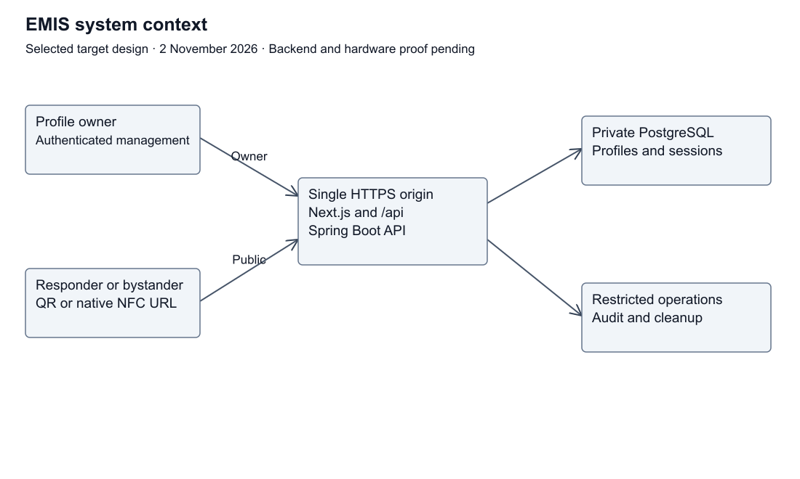
Figure 7.1 Current target context and component boundaries
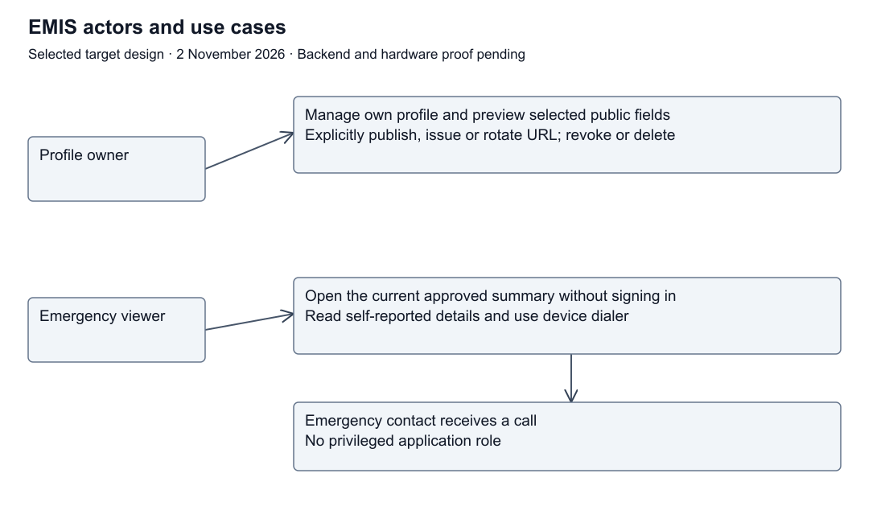
Figure 7.2 Target actor use cases
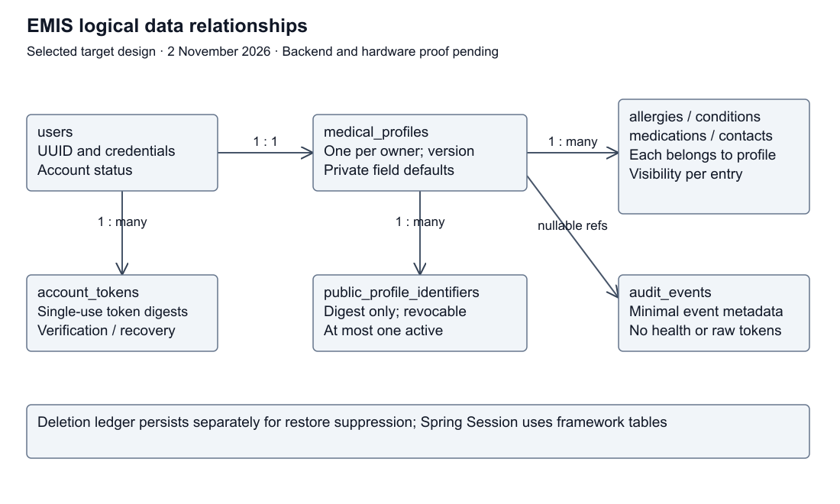
Figure 7.3 Logical entity relationships
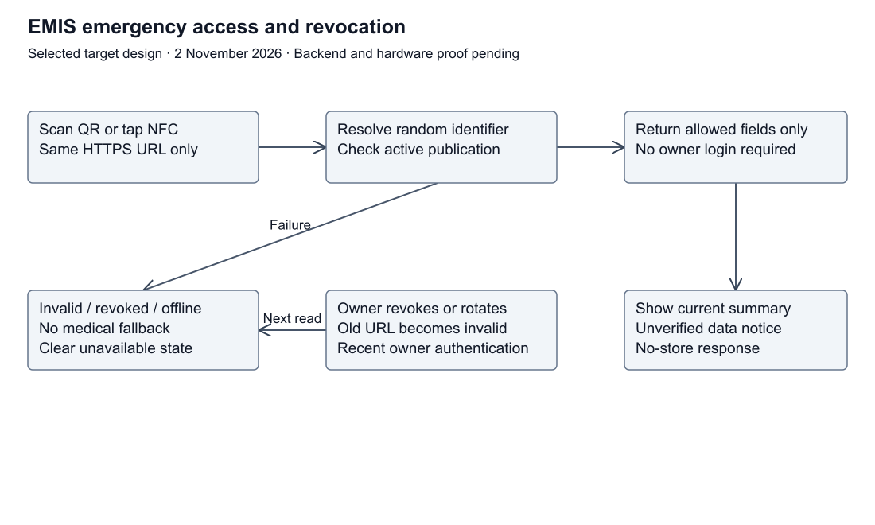
Figure 7.4 Public access and owner revocation workflow

7.1 Selected architecture decisions
Design baseline dated 2 November 2026. These are selected target-prototype decisions for team and supervisor review. They are documented here, not deployed or independently approved. Baseline implementation remains a static Next.js page; PR #21 contains separately tested UI corrections.
ID | Decision | Rationale and consequence | Verification
ADR-01 | Keep Next.js/React/TypeScript; use Java/Spring Boot/Maven and PostgreSQL for the target API | Matches report Section 5 and assigned backend skills. Backend source is still absent | Backend setup and migration checks before integration
ADR-02 | One public HTTPS origin, with /api routed to Spring Boot; database reachable only on a private network | Avoids cross-origin session complexity; a reverse proxy terminates HTTPS and routes requests | Deployment routing, TLS and private database-access tests
ADR-03 | Anonymous public view plus authenticated owner management; no clinician or contact privilege tier | A scan identifies a shared summary; it does not authenticate a responder or prove patient identity | Anonymous/owner A/owner B authorization matrix
ADR-04 | Explicit publication consent and private defaults; backend projects only an allowlist | Frontend hiding cannot prevent data exposure. No publication or new field is public by default | Public JSON, HTML and client-data inspection
ADR-05 | QR and NFC contain the same managed HTTPS URL with a 256-bit random opaque identifier | No health values or owner credentials on the card. A copied URL remains usable until revoked | QR/NFC payload inspection, device and copied-link tests
ADR-06 | Store SHA-256 identifier digests; return the raw URL only at issuance/rotation; one active identifier per profile | Database does not retain the printable secret. Reprinting without a saved card requires rotation and invalidates old cards | Transactional rotation/revocation and concurrency tests
ADR-07 | Use server-managed Spring Security sessions persisted by Spring Session JDBC | No owner bearer tokens in localStorage or QR payloads. Session cookie is Secure, HttpOnly, SameSite=Lax, Path=/, with __Host- prefix and no Domain | Cookie flags, CSRF, fixation, logout and expiry checks
ADR-08 | Hash passwords using Argon2id; implement bounded, single-use recovery tokens | Owner authentication is separate from public identifiers. Recovery invalidates sessions and public identifiers | Password/recovery and enumeration tests
ADR-09 | Do not cache medical responses at browser application, Next.js data, service worker or CDN layers | New reads must observe visibility and revocation changes. Previously copied information cannot be recalled | Cache-header and before/after revocation tests
ADR-10 | No offline health-record feature in the first integrated prototype | A URL-only tag cannot fetch a hosted record without connectivity. Card keeps a printed emergency-services instruction and QR fallback | Offline/unavailable tests and physical-card inspection
ADR-11 | Immediate public disablement on deletion; primary purge within 24 hours; encrypted backups expire within 30 days; minimal audit events expire in 30 days | These are prototype operational targets, not assertions of legal compliance. Restore must replay deletion records before serving traffic | Deletion, scheduled cleanup and restore exercises
ADR-12 | Keep first-aid content optional and editorially reviewed; no diagnosis or individualized treatment | FR-12 is Could scope. No clinical content is approved by architecture documentation | Source/reviewer/date record before publishing content

Detailed access policy: privacy-and-security.md (privacy-and-security.md). Schema: data-model.md (data-model.md). Flows: architecture.md (architecture.md). Tests: verification.md (verification.md).

Remaining approval and evidence work
The supervisor's initial feedback recommends requirements analysis and prototyping; it does not approve this revised architecture. Request follow-up review of these decisions, clinical field selection, the usability baseline and operational targets. Select a hosting provider, SMTP/recovery provider and exact compatible backend versions at implementation time. NFC remains Should in the specification, but the teacher's requested QR/NFC proof of concept is pending until both are demonstrated or deferral is explicitly agreed.
Technical references checked 2 November 2026: OWASP sessions (https://cheatsheetseries.owasp.org/cheatsheets/Session_Management_Cheat_Sheet.html), password storage (https://cheatsheetseries.owasp.org/cheatsheets/Password_Storage_Cheat_Sheet.html), authorization (https://cheatsheetseries.owasp.org/cheatsheets/Authorization_Cheat_Sheet.html), and logging (https://cheatsheetseries.owasp.org/cheatsheets/Logging_Cheat_Sheet.html). Numeric timeouts and retention periods above are EMIS design choices, not values mandated by those references.

7.2 Privacy and access policy

Actors and authorization
Actor | Public summary | Private data | Change, publish, revoke or delete
Anonymous viewer or responder with an active URL | Owner-approved allowlisted fields only | Denied | Denied
Signed-in owner | Same public view plus own private management view | Own record only | Own record only; sensitive actions require authentication within the last 5 minutes
Different signed-in owner | Same public fields as anyone with the URL | Denied | Denied
Listed emergency contact | May receive a call; has no special application role | Denied unless separately the owner of that record | Denied
Operator/developer | Operational metrics and restricted audit access | No patient-browsing application endpoint | No routine profile-management privilege

Database/service operators can potentially access plaintext while operating the application. Encryption at rest does not make the design end-to-end encrypted. Real-patient deployment would require additional governance and review.

Public-field allowlist and consent
An owner can explicitly publish a display name or alias, reported blood type, selected allergy entries, selected condition entries, selected medication entries and selected emergency contacts. All flags default to false. Each contact's name/relationship/phone is published as one approved entry; the owner must acknowledge permission to share the third party's contact details. This acknowledgement is not independent verification of that permission.
Account email, password/recovery material, owner IDs, internal profile IDs, private entries, sessions, audit records, birth date, address and medical documents are never in the public response. Birth dates, addresses and full medical documents are outside the prototype's collection scope.
The owner sees the public preview and an explanation that anyone holding or copying the URL may view the selected fields. Publishing records the privacy-notice version and acceptance time and requires at least one selected populated field. A material expansion of the disclosure scope requires renewed consent. Saving a new sensitive field does not automatically publish it. Withdrawal atomically disables publication and revokes the active identifier; later publication requires a new identifier. Anonymous readers do not supply consent on the owner's behalf.
The public response contains only published populated values plus lastUpdatedAt and an unverified-data notice. It does not list hidden field names, withheld counts or account metadata. Missing medical information is not represented as absence of a condition or medication. Blood type is self-reported and is not a basis for transfusion decisions.

7.3 Database constraints and API contract
Logical target schema, 2 November 2026. No tables or migrations are implemented. UUIDs below are internal keys, not public URL identifiers. The model follows architecture decisions (decisions.md) and privacy rules (privacy-and-security.md).

Entities
Table | Main fields | Constraints and lifecycle
users | id UUID PK, email, password_hash, status, created_at | Unique normalized email; status pending/active/disabled; no public account metadata
medical_profiles | id UUID PK, user_id FK, display_name nullable, blood_type nullable, display_name_public false, blood_type_public false, publication_enabled false, consent_version nullable, consent_at nullable, updated_at, version | One profile per user; blood type restricted to known ABO/Rh values or null; enabled publication requires consent; optimistic version for lost-update protection
allergies | id UUID PK, profile_id FK, label, is_public false | Explicit selected entries; label 1–200 characters; no inference from missing entries
conditions | id UUID PK, profile_id FK, label, is_public false | Same entry-level policy as allergies
medications | id UUID PK, profile_id FK, label, is_public false | Self-reported labels only; no dosing advice generated
emergency_contacts | id UUID PK, profile_id FK, name, relationship nullable, phone_e164, is_public false, sharing_permission_confirmed false | Publish only after owner acknowledgement; phone canonicalized and validated; one entry is one visibility unit
public_profile_identifiers | id UUID PK, profile_id FK, token_digest BYTEA, created_at, revoked_at nullable | UNIQUE token_digest; at most one active row per profile via partial unique index where revoked_at IS NULL; digest is 32 bytes; raw token not stored
account_tokens | id UUID PK, user_id FK, kind, token_digest, expires_at, consumed_at nullable | Verification/recovery only; independent of public identifiers; single-use, 30-minute expiry
audit_events | id UUID PK, occurred_at, event_type, outcome, actor_user_id nullable FK, resource_profile_id nullable FK, correlation_id | No medical values or secrets; FK references SET NULL on deletion; purge events after 30 days
deletion_jobs | id UUID PK, account_ref UUID, requested_at, purged_at nullable, retain_until | Restricted operational ledger; account_ref deliberately has no cascading FK; at most 30 days after purge; replay before restored data is served
Spring Session JDBC tables | Framework-managed session and session attributes | Separate from profiles; no medical values in session attributes; server expiry and invalidation

The full schema constraints and update semantics are in docs/data-model.md. Same-origin /api routes are defined by docs/api-contract.md and docs/openapi.yaml. Owner reads and writes use the authenticated session, never a client owner ID. Writes require CSRF and optimistic version checks. Sensitive actions require authentication within five minutes; sign in again to refresh this interval. Public reads resolve a random identifier and apply current consent and visibility on the server. No backend endpoint is implemented yet.

7.4 Threat model
Target prototype, 2 November 2026. Assessment precedes implementation. No row below claims a control has passed. Assets are private health entries, contact details, account credentials/sessions, public link values, publication choices and service availability. Trust boundaries TB-1–TB-5 are defined in architecture.md (architecture.md).
ID | Threat and boundary | Required mitigation | Residual risk | Verification
TM-01 | Copied/lost QR or NFC URL, TB-1 | Minimal opt-in summary, random identifiers, owner revoke/rotate | Anyone with an active copy can view approved fields; previously copied data cannot be recalled | T-05, T-06, T-12
TM-02 | Identifier enumeration, TB-2 | 256-bit random values, digest storage, neutral errors, request throttling | Rate limits can affect shared networks; not anonymity against a known URL | T-06, T-12
TM-03 | Owner A accesses owner B, TB-3 | Session-derived owner, object-scoped queries, deny by default | Misconfigured new endpoints could introduce leaks | T-03
TM-04 | Overbroad public serializer, TB-3 | Dedicated allowlisted response and private defaults; inspect HTML/client payloads too | A deliberately shared field is public even if medically sensitive | T-04
TM-05 | Session theft, fixation or CSRF, TB-2/3 | HTTPS, protected cookie, rotation, CSRF token, server expiry/revocation | XSS/application compromise can still act in-session | T-09
TM-06 | Injection/XSS and malformed fields, TB-3/4 | Typed validation, parameterized persistence, output escaping, no raw HTML/file upload | Medical statements can still be inaccurate | T-07
TM-07 | Raw URL/health values in logs, analytics or caches, TB-2/4 | Suppress sensitive paths, no external analytics, no-store and tested fresh-read behavior | Browser history, screenshots and card sharing remain possible | T-04, T-06, T-10
TM-08 | Database/backup compromise or operator misuse, TB-4 | Private DB, least privilege, encrypted volumes/backups, restricted audit and key separation | Runtime and privileged operators may still see plaintext; no end-to-end encryption claim | T-10, T-11
TM-09 | Incorrect/outdated self-reported facts, TB-1/3 | Unverified notices, last-updated indicator, explicit missing data | No clinical verification, no transfusion/diagnostic reliance | T-02
TM-10 | Network/service/card failure or denial of service, TB-1/2 | Clear unavailable state, QR alternative to NFC, printed emergency guidance, monitored limits | URL-based cards do not provide offline medical records | T-05, T-08, T-12
TM-11 | Forged recovery or email disclosure, TB-5 | Independent hashed single-use tokens, bounded expiry, neutral responses, no health details in email | Email compromise/provider failures remain risks | T-13
TM-12 | Data reappears after deletion/restore, TB-4 | Immediate disablement, primary purge, 30-day backup/audit expiry, replay deletion jobs before restore is exposed | Old copies outside EMIS cannot be erased | T-11

Baseline assumption: synthetic profiles only, ordinary internet attackers, potentially malicious card readers and malicious authenticated owners. No verified clinical identity, hospital integration, special emergency authority or trusted scanner is assumed. Review threats after any scope/API change, record reviewer/date and update the linked tests. Legal compliance, production incident response and clinical effectiveness are outside this prototype assessment.
Historical architecture figures retained from the supplied report for provenance. The current target design and constraints above take precedence.
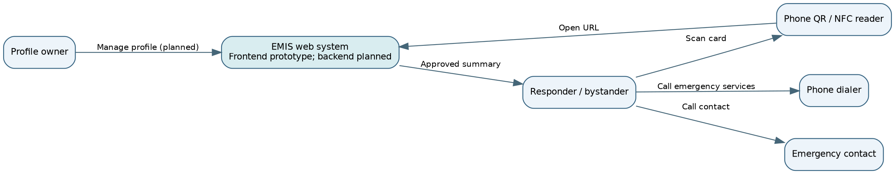
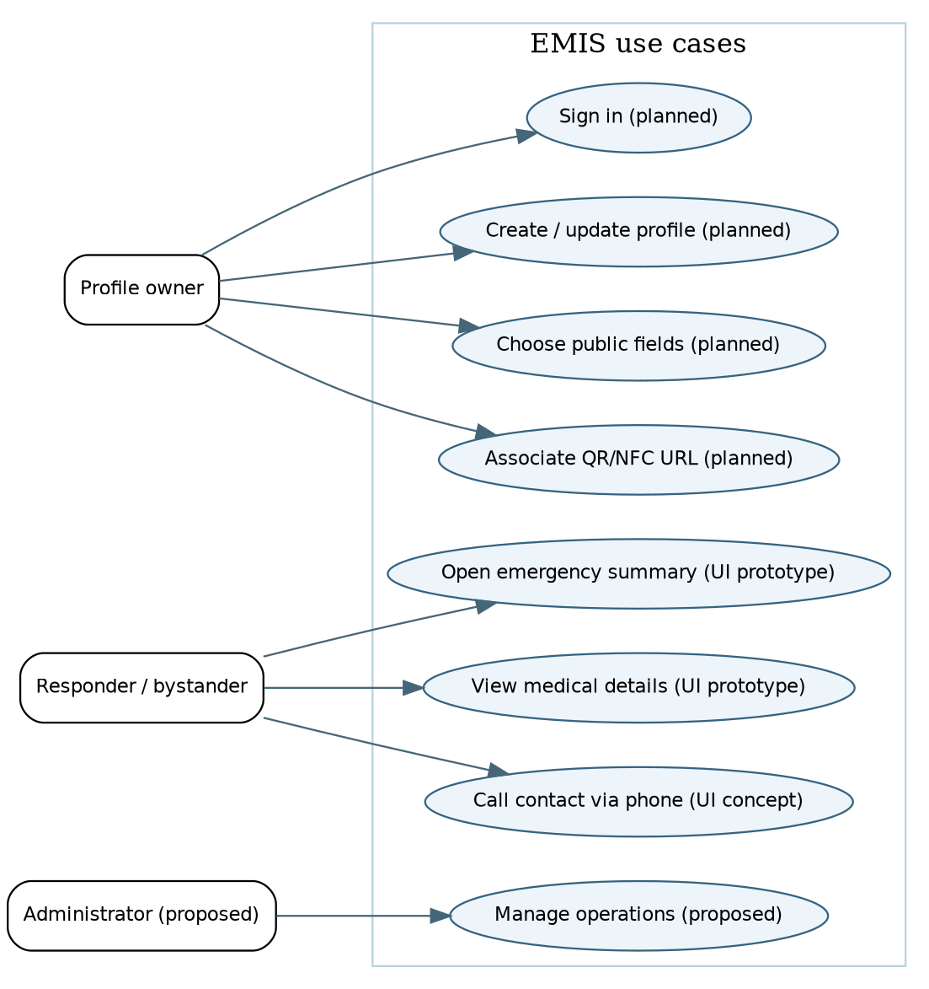
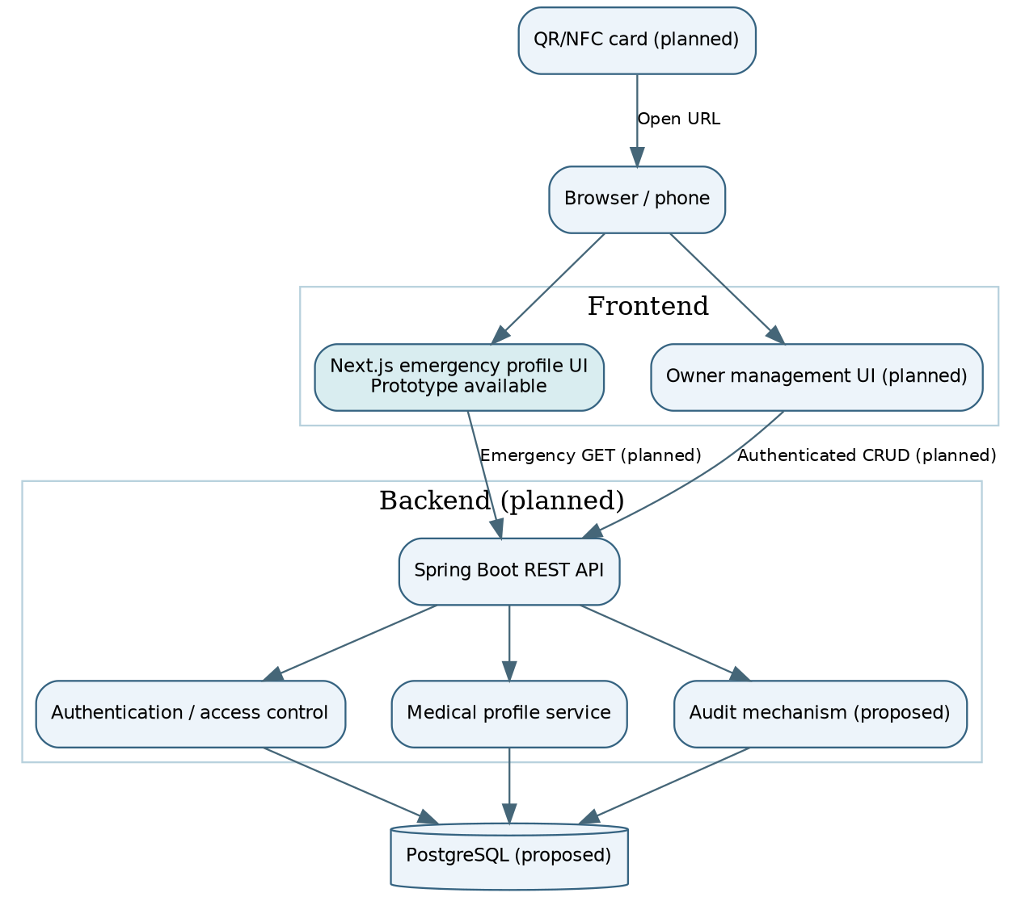

8. UX and Prototype
Figma source designs are linked at the beginning of this report. The screenshots below are preserved historical concept evidence; current source frames and clean exports remain to be checked.

1. Project Overview
EMIS is a university diploma prototype designed to provide quick access to selected emergency medical information through a QR code or NFC medical ID card. The interface prioritizes clarity, accessibility, and limited disclosure of personal information.

2. Prepared Design Materials
Four Figma concepts have been prepared: a mobile emergency profile, a desktop emergency profile, a QR/NFC scanning journey, and a medical ID card concept. The designs demonstrate the proposed interface and navigation flow; they do not establish that QR/NFC functionality is operational.

3. Interface Structure
The historical concepts present a patient name, allergies, reported blood type, conditions and emergency actions. Their layouts illustrate a limited public view; they do not demonstrate backend filtering or private-data authorization. The frontend correction is reviewed separately and must be checked against updated Figma frames before parity is claimed.

4. Visual Design and Usability
The visual concept uses navy typography, teal interface accents, light backgrounds, and red warning elements. Rounded cards and clear headings support quick scanning. The mobile layout uses a compact reading order, while the desktop layout separates medical information from emergency actions.

5. Privacy and Safety
The prototype uses fictional, self-reported information and includes notices that the details are not clinically verified. The proposed public profile contains only emergency-relevant information. Actual consent controls, data protection mechanisms, and backend integration remain outside the demonstrated design.

6. Review Findings and Next Steps
Historical mockups contain different blood types (B+ and O+) and contacts (Batman and Sarah Johnson). The frontend correction in separate PR #21 uses one explicitly fictional fixture, with no unverified callable demo number, medication availability and a demo update label. Shugyla and Bekbolat should synchronize the Figma source and four clean exports, then refresh these screenshots. Existing images are retained as historical evidence, not as approved current design or functioning QR/NFC proof.

7. Visual references

Mobile emergency profile
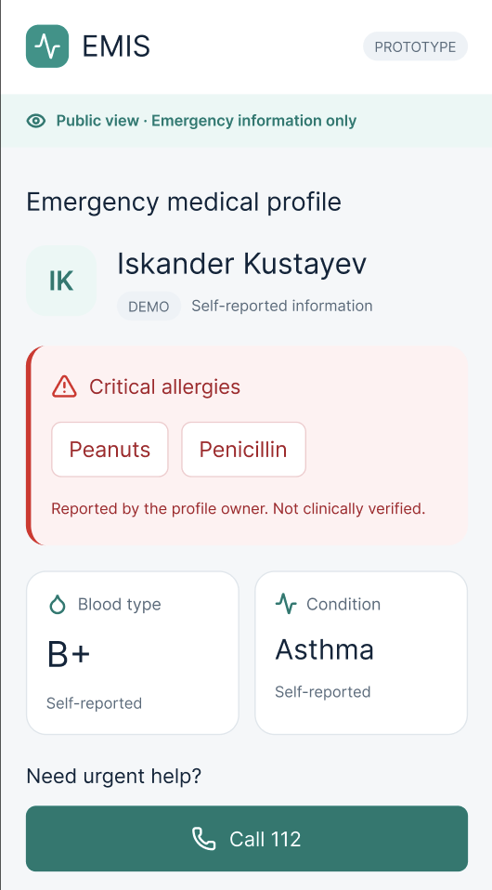

Desktop emergency profile and QR/NFC scanning journey
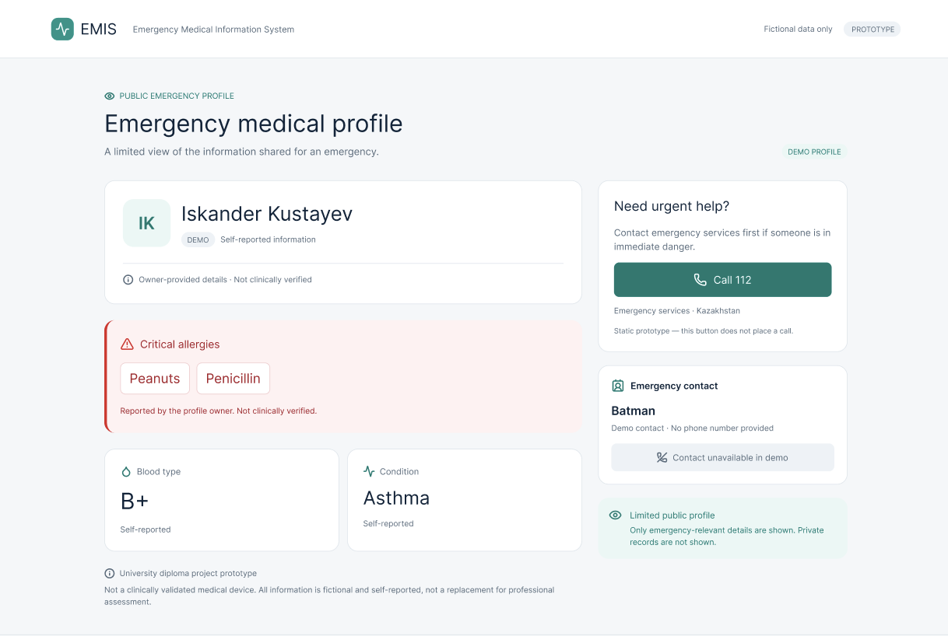
Scanning journey:
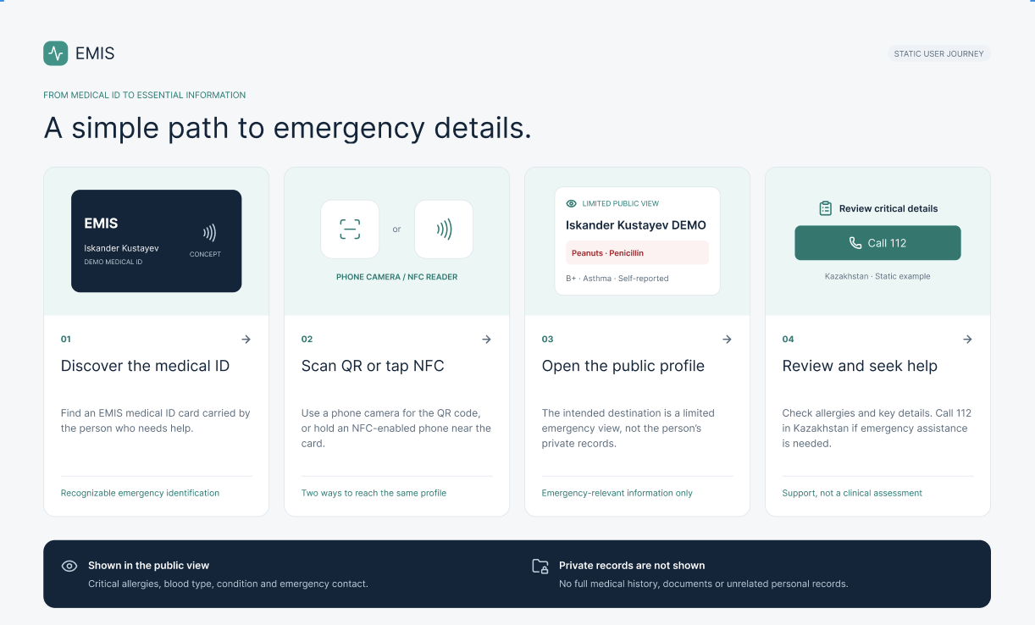

NFC medical ID card concept
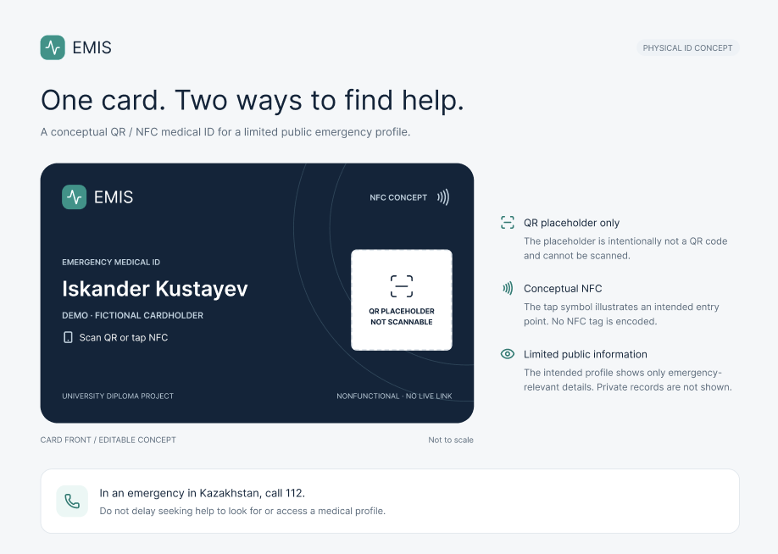

9. Verification and Evaluation Plan
Target plan, 2 November 2026. No integrated/backend/device tests have been executed. Static UI checks from PR #21 are recorded separately in that PR's frontend/PROTOTYPE_REVIEW.md and do not satisfy integrated security requirements.
Test | Requirements | Procedure and measurable acceptance | Status
T-01 | FR-01, NFR-01 | 375/768/1280 px, 200% zoom, keyboard and screen-reader review; no horizontal overflow, trapped focus or unlabeled action; assess WCAG 2.2 AA contrast | Planned; PR #21 has partial viewport/keyboard evidence
T-02 | FR-02/03/08, NFR-08/10 | Synthetic populated/missing profiles; unverified notice and update date visible; missing data not asserted as absence; displayed contact equals tel target, no automatic call | Planned integration; partial static checks in PR #21
T-03 | FR-04, NFR-03 | Anonymous and owner B attempt owner A reads/updates/deletes/child edits/revocations; zero unauthorized successes, owner A valid action succeeds | Not executed
T-04 | FR-05, NFR-02 | Set all sensitive fields private, vary each flag and inspect public JSON, HTML, client data and preview; zero private values/internal IDs disclosed; new entries remain private | Not executed
T-05 | FR-06/07 | QR: 10 attempts on each of 2 documented camera-capable phones, at least 9/10 correct openings on each and zero wrong profiles; NFC: 10 taps on each of 2 compatible documented phones, same criterion | Not executed; hardware checkpoint remains pending
T-06 | FR-09, NFR-05 | Valid, malformed, unknown, revoked and disabled links; neutral 404 without medical data for failures; subsequent requests after acknowledged revocation/visibility change use current state, including caches and browser-history restore | Not executed
T-07 | FR-11, NFR-04 | Oversized/invalid values, foreign child IDs, unknown properties, HTML payload and stale versions; reject invalid writes, escape text and reject stale updates with 409 | Not executed
T-08 | NFR-06/09 | Under recorded 150 ms latency, 1.6 Mbps down/750 kbps up and named browser/device, 30 cold loads per viewport: at least 27/30 usable within 3 seconds; simulate API/offline failure with clear unavailable state and no demo fallback | Not measured
T-09 | FR-04, NFR-03/04/11 | Cookie flags, fixation rotation, missing/invalid CSRF, logout, reset, 15-minute idle and 8-hour absolute expiry; all unauthorized actions denied server-side; no session token in URLs/storage | Not executed
T-10 | NFR-04/12 | Inspect TLS/storage/key access and canary medical values/tokens across logs, analytics and caches; zero canaries exposed; restricted runtime/audit access | Not executed
T-11 | FR-10, NFR-02/04/13 | Account deletion immediately denies public/owner reads; primary purge within 24 hours; audit/backup expiry within 30 days; restored snapshot stays private until deletions replayed | Not executed
T-12 | FR-06/07/09, NFR-09 | Copied link works only while deliberately public; old QR and NFC fail after rotate; concurrent issuance leaves one active identifier; configured rate caps return generic 429; damaged/offline cases show safe fallback | Not executed
T-13 | FR-04, NFR-03/04/11 | Verification/recovery tokens expire after 30 minutes, are single-use and separate from card IDs; neutral request responses; reset invalidates sessions and public identifiers | Not executed
T-14 | FR-12 | Before any first-aid text release: source/version, named qualified review, review date and general-information label present; no personalized treatment logic | Not conducted; Could scope

Usability study and baseline
Before recruitment obtain the required supervisor/ethics agreement. Plan at least five consenting adult participants using fictional profiles, record roles and eligibility, and avoid emergency patients. Each participant locates a critical allergy, determines whether medication information is supplied and finds the emergency-contact action. Compare EMIS with an equivalent static text card; counterbalance order and use equivalent scenarios to reduce learning effects.
Proposed targets are at least 90% successful tasks overall and median time at most 15 seconds per information-location task from a usable page. Record mistakes and 1–5 ease ratings. Separately measure QR/NFC scan-to-usable-page time. Thresholds and sample size are design targets requiring review, not established outcomes; a small convenience study cannot establish clinical effectiveness.

Evidence record
For each executed case record ID, canonical requirement, exact commit/build, date, tester, participant consent where relevant, device/OS/browser, network settings, input fixture, steps, expected outcome, actual outcome, result, evidence path and defect/PR link. Use Pass/Fail/Not executed/Blocked with a reason; never equate Planned or a Done tracker issue with Pass. Record actual denominators and failures, not only screenshots of successful runs.
Supervisor review status is consistent throughout: initial planning comments received; follow-up review of this revised baseline is pending. The comment-to-revision mapping is in feedback-response-matrix.md (feedback-response-matrix.md).

10. Project Management and Risks
Purpose: Document team responsibilities, milestone planning, task traceability, dependencies and risks. This document records reported progress; it is not evidence that planned backend or QR/NFC features are implemented.

1. Team and Responsibilities
Contributor | Primary responsibility | Evidence / expected outputs
Bekbolat Yergaliuly | Frontend and coordination | Next.js frontend setup, emergency profile interface, repository coordination
Shugyla Akhit Zhasulankyzy | UI/UX and design documentation | Mobile/desktop Figma mockups, card concept, scanning journey, design report
Olzhas Omerzak Zhunisbekuly | Backend architecture and planned implementation | Backend README / architecture plan; future Spring Boot API and persistence
Supervisor: Dana Yespenbetova | Academic review | Initial planning feedback received; follow-up review of revised baseline pending

2. Scope and Delivery Strategy
Current pre-defense emphasis: problem definition, prototype, architecture, technology rationale, requirements, planning and traceable contributions. A complete working application is not required at this stage.
In scope (planned system): public emergency summary accessed by QR/NFC; owner-managed private medical data; emergency contact; authentication and access controls; auditability and privacy safeguards.
Out of scope for the first pre-defense: operational Spring Boot API, production database, deployed QR/NFC cards, clinical validation, and real-patient medical data. All examples should use fictional data.

3. Current YouTrack Progress (reported 23 October 2026)
Issue | Work item | Status
EMIS-1 | Initialize Next.js frontend | Done
EMIS-2 | Design emergency profile in Figma | Done
EMIS-3 | Initialize Spring Boot backend | In development / not complete
EMIS-5 | Develop emergency medical profile UI | Done
EMIS-6 | Create UI/UX design documentation | Done
EMIS-7 | Develop emergency medical profile API | Backlog / not complete
EMIS-8 | Prepare backend architecture documentation | Done (per team report)

4. Milestones and Dependencies
Milestone | Target / stage | Dependencies
First pre-defense package | 24 October 2026 | Reviewed docs, GitHub PR evidence, YouTrack board, prototype, supervisor review
Backend foundation | After first pre-defense | Architecture confirmation, environment setup, collaborator access
Profile API and database | Next implementation stage | Backend foundation, approved data model, privacy rules
QR/NFC end-to-end integration | After API readiness | Stable URL resolution, public profile endpoint, frontend integration
Security, usability and evaluation | Before second defense | Integrated system, test data, defined baseline and metrics

5. Risk Register
Risk | Likelihood / impact | Mitigation and owner
Sensitive medical information exposed | Medium / High | Public/private field separation; access tests; no real patient data. Backend + frontend
Backend delayed | High / Medium | Submit architecture plan now; sequence API work after setup. Olzhas
QR/NFC card fails or becomes inaccessible | Medium / Medium | QR fallback, short stable URL, test multiple devices. Team
Inconsistent mockup data or terminology | Medium / Medium | Unify example patient, blood group and contacts. Shugyla + Bekbolat
Unverified clinical content | Medium / High | Avoid diagnosis/treatment claims; review emergency text with qualified sources. Team
Incomplete research or supervisor evidence | High / High | Track missing deliverables explicitly; request real feedback; no fabricated interviews. Team
Untraceable GitHub contributions | Medium / High | Individual accounts, task IDs, reviewed PRs and links to YouTrack. Team

11. Supervisor Feedback and Resulting Revisions
Initial project-planning feedback was supplied by the team on 2 November 2026. The original supervisor review date was not supplied; this date records receipt for this revision. The comments below are preserved once. They recommend proceeding to requirements analysis and prototyping; they do not approve this revised architecture or completed implementation. Follow-up review of the revised baseline remains pending.

Supervisor Feedback — Initial Project Planning
Project: Design and Development of a Privacy-Aware QR/NFC-Based Emergency Medical Information System

1. Strengths
The project addresses a meaningful real-world problem by aiming to make essential emergency medical information accessible when it may be difficult for a person to communicate. The proposed combination of QR codes, NFC-enabled identification cards, and user-managed medical profiles offers a practical direction for further investigation.
The team has identified the main system components, assigned initial responsibilities, and proposed a suitable starting technology stack.

2. Areas for Improvement

1. Requirements and target users
Clearly identify the primary users and stakeholders, including patients, emergency responders, and trusted emergency contacts. Define the main use cases and explain how the system will operate during an actual emergency.

2. Privacy and access control
Privacy is a central part of the project, not just an additional feature. Specify which medical information is visible to each type of user, how consent is obtained, how access is authorized, and how access can be revoked. Explain how the system will protect sensitive information against unauthorized access.

3. QR/NFC access mechanism
Describe the technical workflow for both QR codes and NFC-enabled cards. Clarify what the QR code or NFC tag contains, whether it references a protected online profile, how access is granted, and what happens if the identification card is lost or copied.

4. Security and data protection
Define the authentication and authorization mechanisms, encryption requirements, secure session handling, and audit logging strategy. Consider risks such as stolen identifiers, copied QR codes, unauthorized profile access, and exposure of sensitive medical information. Avoid storing readable medical details directly in publicly scannable QR codes or NFC tags.

5. Emergency usability and reliability
Design the interface for fast access under stressful conditions. Prioritize essential information, readable typography, clear navigation, and mobile responsiveness. Consider what happens when internet access is unavailable, the QR code is damaged, or the user cannot authenticate.

6. First-aid information resources
Define the scope and sources of the first-aid content. Ensure that information is reviewed against reputable medical guidance, clearly presented, and distinguished from personalized medical advice.

7. Testing and evaluation
Prepare a verification plan covering functional requirements, access-control rules, security testing, QR/NFC scanning, usability, and performance. Define measurable criteria for successful emergency-information retrieval.

3. Recommended Deliverables for the Next Checkpoint
1. A formal requirements specification with functional and non-functional requirements.
2. Use-case diagrams, system architecture, database design, and user-flow diagrams.
3. A threat model and privacy-by-design strategy.
4. A Figma prototype demonstrating the patient profile and emergency-access workflow.
5. A technical proof of concept demonstrating QR/NFC identification and controlled access to a sample medical profile.
6. A test plan with measurable acceptance criteria.

Overall Assessment
The project has a relevant application and a promising initial scope. However, the most important design challenge is balancing rapid access to essential emergency information with the protection of highly sensitive medical data.
The team should establish the privacy model, threat model, and emergency-access workflow before committing to the final architecture. Particular attention should be paid to the distinction between identifying a patient and authorizing access to that patient's medical information.
Recommendation: Proceed to requirements analysis and prototyping. Prioritize security, privacy, and emergency usability from the beginning rather than treating them as final-stage implementation tasks.

11.1 Response to feedback and completion evidence
Comment | Completed documentation revision | Requirement and report mapping | Outstanding work and lead
SF-01 target users and use cases | architecture.md defines owner/patient, anonymous responder/bystander, contact and operator, with use-case and sequence diagrams; contacts gain no app privilege | FR-01/04/08; report Sections 1, 6 and 7 | Team/supervisor validates scenarios; Bekbolat coordinates
SF-02 privacy and access | privacy-and-security.md defines actor access matrix, opt-in field allowlist, consent evidence, withdrawal and backend projection; data-model.md defines private defaults | FR-05/09, NFR-02/03; Sections 6 and 7 | Olzhas implements filtering/ownership; Shugyla verifies public payloads and privacy UX
SF-03 QR/NFC workflow | architecture.md documents URL-only QR/NFC, native-reader flow, digest storage, one-time issuance, copied/lost-card revoke/rotate and limits | FR-06/07/09; Section 7 | Bekbolat + Olzhas build PoC; Shugyla tests physical devices; NFC checkpoint evidence pending
SF-04 security and protection | decisions.md and privacy-and-security.md select sessions, password/recovery handling, CSRF, TLS/storage protection, log minimization, expiry/deletion; threat-model.md identifies abuse cases | NFR-03/04/11/12/13; Sections 6 and 7 | Olzhas implements controls; integrated security tests not executed
SF-05 emergency usability/reliability | architecture.md defines anonymous emergency access, connectivity/card failure and owner-authentication failure; verification.md defines responsive, usability and timed-load targets | FR-01/02/03, NFR-01/06/08/09; Sections 7, 8 and 9 | Shugyla synchronizes Figma and tests users/devices; PR #21 has only partial static UI checks
SF-06 first-aid resources | content/first-aid-sources.md defines general-information scope, IFRC candidate reference and qualified review gate; no treatment instructions added | FR-12 Could; Sections 6 and 9 | Shugyla obtains source-specific qualified review before any clinical content release
SF-07 verification | verification.md specifies T-01–T-14, measurable targets, baseline and evidence fields; traceability.md separates plans and executions | All FR/NFR; Section 9 | Whole team executes integrated tests; supervisor reviews study protocol

Requested checkpoint deliverables
Requested deliverable | Current evidence | Honest completion status
Formal FR/NFR specification | EMIS_Requirements_Specification.md and report Section 6 | Document revised; stakeholder/follow-up review pending
Use cases, architecture, database and user flows | architecture.md, data-model.md, diagrams/, architecture Word companion and report Section 7 | Target design documented; implementation not completed
Threat model and privacy strategy | threat-model.md, privacy-and-security.md, decisions.md | Documented target baseline; review/implementation pending
Figma patient and emergency workflow | Linked source and historical screenshots in report Section 8 | Existing concepts; synchronized frames and clean exports still pending
QR/NFC controlled-access PoC | API/flow contracts only | Not implemented or demonstrated; no completion claim
Test plan with measurable criteria | verification.md, verification Word companion and report Section 9 | Plan documented; integrated execution pending

The earlier contradiction between feedback “to be collected” and a completed positive review is corrected throughout. Initial comments are received; follow-up review is pending. Documentation changes are completed in this revision, while backend controls, synchronized Figma frames, the controlled-access QR/NFC PoC and integrated tests remain outstanding. Their completion requires actual evidence and cannot be inferred from this report.

References:
[1] A. T. Biju, A. Joy, M. Babu, M. Shaju, and H. John, “MEDxSWIFT: NFC Based Medical Card and Application,” Journal of Network and Information Security, vol. 12, no. 1, pp. 33–38, 2024.
[2] E. Raso et al., “Privacy-Aware Architectures for NFC and RFID Sensors in Healthcare Applications,” Sensors, vol. 22, art. 9692, 2022. doi: 10.3390/s22249692.
[3] A. Manes, I. Samra, E. Fedosova, J. Sran, and A. Behboudi, “Patient engagement and feasibility of a QR code–based digital information tool in the emergency department,” International Journal for Quality in Health Care, vol. 38, no. 3, art. mzag100, 2026. doi: 10.1093/intqhc/mzag100.
[4] N. Bedriova, M. Smetana, and D. Gombarska, “Design and Development of Technical Solution for NFC-Based Self-Management Therapy in Actual Oncology Treatment,” Applied Sciences, vol. 13, art. 2397, 2023. doi: 10.3390/app13042397.
[5] V. Balasubramanian, S. Vivekanandhan, and V. Mahadevan, “Pandemic tele-smart: a contactless tele-health system for efficient monitoring of remotely located COVID-19 quarantine wards in India using near-field communication and natural language processing system,” Medical & Biological Engineering & Computing, vol. 60, pp. 61–79, 2022. doi: 10.1007/s11517-021-02456-1.
[6] B. Çobanoğlu and N. Akalın, “Near Field Communication Usage in Telemedicine Systems,” publication details and year to be verified from original venue.
[7] Y.-W. Kuo et al., “Smart Health Monitoring and Management System for Organizations Using Radio-Frequency Identification (RFID) Technology in Hospitals or Emergency Applications,” Emergency Medicine International, art. 2177548, 2022. doi: 10.1155/2022/2177548.
[8] P. Shojaei, E. Vlahu-Gjorgievska, and Y.-W. Chow, “Security and Privacy of Technologies in Health Information Systems: A Systematic Literature Review,” Computers, vol. 13, art. 41, 2024. doi: 10.3390/computers13020041.
[9] R. Tertulino, N. Antunes, and H. Morais, “Privacy in electronic health records: a systematic mapping study,” Journal of Public Health, vol. 32, pp. 435–454, 2024. doi: 10.1007/s10389-022-01795-z.
[10] A. Mwogosi et al., “Data privacy in EHR systems: A TCCM systematic literature review of practices in developing countries,” Informatics and Health, vol. 3, pp. 133–141, 2026.
[11] S. R. Khan, A. L. Bernassau, and M. P. Y. Desmulliez, “Passive and Battery-Free RFID-Based Wireless Healthcare and Medical Devices: A Review,” IEEE Journal of Radio Frequency Identification, vol. 8, pp. 724–742, 2024. doi: 10.1109/JRFID.2024.3451230.
[12] A. U. Rehman et al., “Internet of Things in Healthcare Research: Trends, Innovations, Security Considerations, Challenges and Future Strategy,” International Journal of Intelligent Systems, art. 8546245, 2025. doi: 10.1155/int/8546245.

