EMIS Architecture and Diagrams
Selected target design, 2 November 2026. This document and the linked decision record define report Section 7. The existing implementation is a static Next.js page. PR #21 is a separate UI correction; the API, database, sessions, public projection and QR/NFC lifecycle remain planned.

Scope and stakeholders
The patient/card owner manages their own self-reported profile. An emergency responder or bystander opens an intentionally public summary without installing an application or signing in. A trusted emergency contact receives a call but gains no application permissions. The supervisor reviews academic scope and evidence; operators maintain infrastructure without a patient-browsing application role.
Identification and authorization are different: a card URL resolves a shared summary; it does not verify the patient's identity or authenticate the scanner. Owner authentication is required to manage private information. No clinician-specific full-record or break-glass access tier is included in this prototype.

Context and trust boundaries
TB-1: anyone can read/copy a card. TB-2: the public internet crosses the HTTPS boundary. TB-3: owner sessions and anonymous reads have different authorization rules inside the API. TB-4: the service reaches the private database and restricted event store. TB-5: recovery delivery is external and must not receive health details.

Component responsibilities and repository structure
Component | Target responsibility | Source/evidence today
Next.js | Public view, owner forms, visibility preview, errors and QR rendering | frontend/src/app/page.tsx static prototype; separate corrected fixture in PR #21
HTTPS reverse proxy | One origin, /api routing, TLS, safe headers, sensitive-path log suppression | Deployment configuration not implemented
Spring Security/session layer | Authentication, CSRF, session lifecycle, ownership gates | Backend plan only
Profile service | Transactions, validation, visibility projection, deletion | No backend application source
Identifier service | Random URL issuance, digest lookup, revoke/rotate | Planned
PostgreSQL | Profile integrity, session persistence and identifier constraints | Logical schema documented, no migrations
Audit/cleanup jobs | Minimal events, retention, purge and restore safeguards | Planned

Canonical source files live under docs/; Word companions are readable snapshots. The intended backend packages are security, profile, identifier and audit beneath one application package, with migrations in backend/src/main/resources/db/migration and tests under backend/src/test. These directories are planned; documentation does not create runnable backend stubs.

Use cases
UC-01: scan QR or tap NFC, open /emergency/{publicId}, retrieve only approved current information, read warnings and update time, optionally open the device dialer. Invalid/revoked/disabled identifiers return neutral unavailable output. No owner login is required for this intentionally public subset.
UC-02: owner authenticates, edits validated data, reviews public preview, selects fields and explicitly publishes. Authentication/ownership and CSRF checks precede any write. A different owner's IDs are rejected. Newly added fields remain private until selected.
UC-03: owner reports a lost/copied card, authenticates recently, revokes or rotates the active identifier and downloads a replacement. Old QR and NFC links both fail on subsequent reads. Existing copied data cannot be recalled.
UC-04: owner requests deletion after recent authentication. Publication, identifiers and sessions are disabled immediately; primary purge, minimal deletion ledger and backup expiry follow ADR-11.

QR and NFC workflow
QR generation happens in the owner UI from the issued URL; scanning uses the phone camera. NFC is an NDEF URI record read by a compatible phone and opens the same web route; Web NFC permission is not required for a native-reader URL journey. Provisioning and compatibility require physical tests. A printed QR is the fallback when NFC is unsupported; damaged QR can use NFC if it remains readable. No workflow promises that a destroyed card or absent network can retrieve a hosted record.

Data and privacy design
See data-model.md (data-model.md) for entities and constraints and privacy-and-security.md (privacy-and-security.md) for the access matrix, publication consent, sessions, encryption, audit and retention. Same-origin owner sessions are separate from opaque public identifiers. Every public read applies the backend allowlist; no cache or frontend-only privacy flag substitutes for it.

Failures and residual limits
Without connectivity show unavailable information and emergency-services guidance; do not load a fictional fallback as patient data. If the owner cannot authenticate, private management remains denied while a previously published public URL can still be viewed. Invalid, unknown and revoked links are neutral. Recovery does not identify a patient clinically. Outdated or incorrect self-reported data, copied URLs, prior screenshots and service failure remain risks.

Decisions, verification and feedback
decisions.md (decisions.md) records ADR-01–ADR-12. verification.md (verification.md) provides measurable checks tied to canonical FR/NFR IDs. feedback-response-matrix.md (feedback-response-matrix.md) maps initial supervisor comments to document revisions and outstanding implementation. The initial feedback is received; approval of this revised baseline and clinical/data field suitability remain pending follow-up.
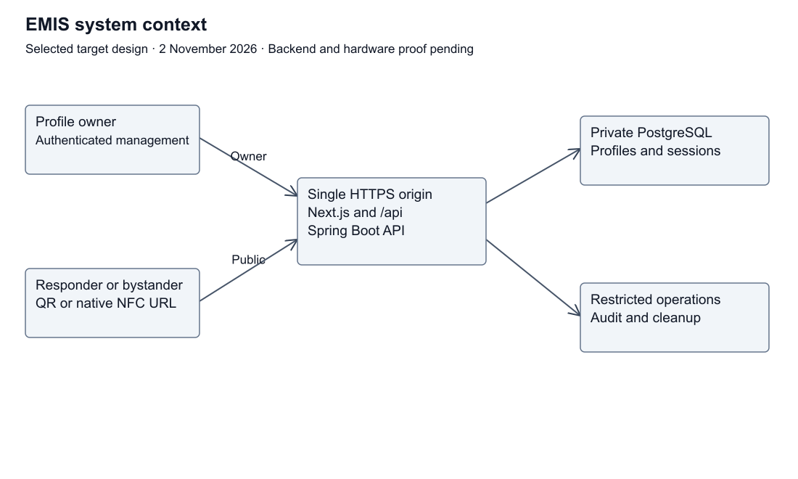
Target system context
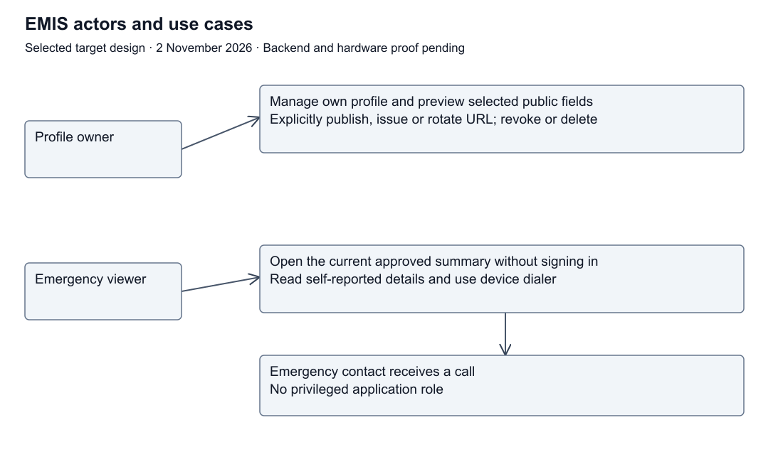
Target use cases
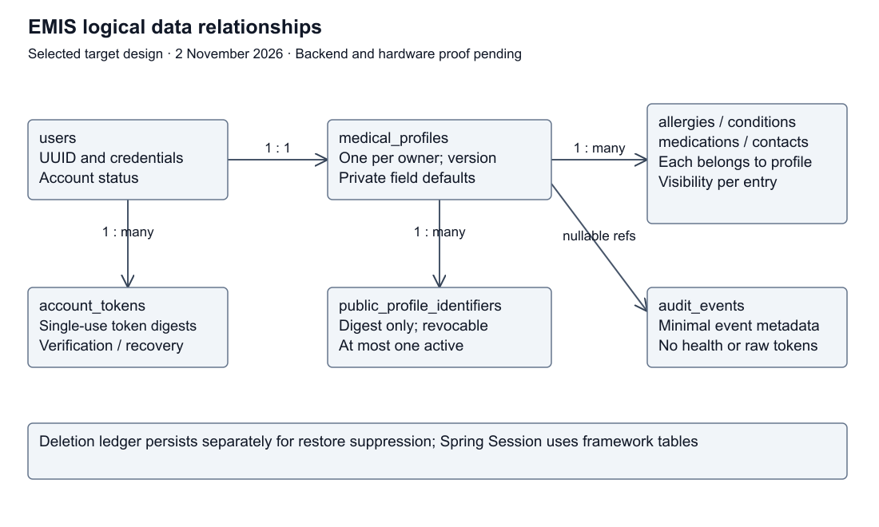
Logical data model
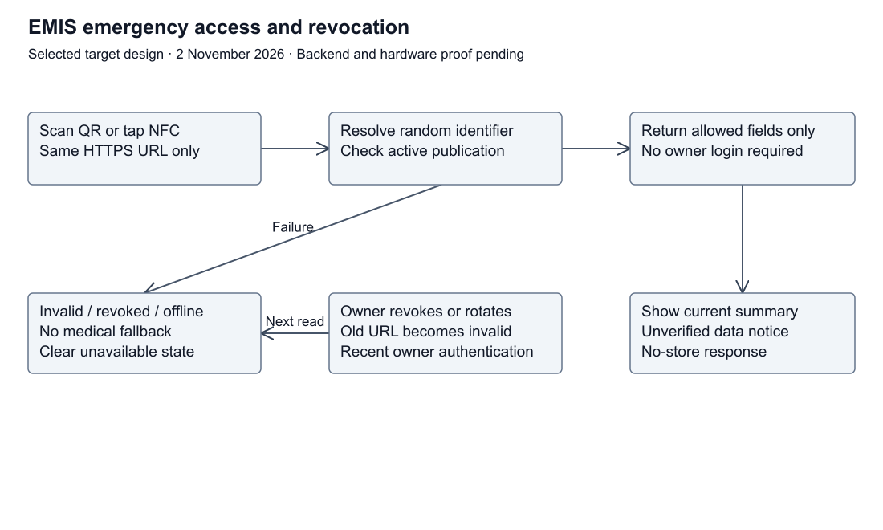
Target emergency workflow

Architecture decisions
Design baseline dated 2 November 2026. These are selected target-prototype decisions for team and supervisor review. They are documented here, not deployed or independently approved. Baseline implementation remains a static Next.js page; PR #21 contains separately tested UI corrections.
ID | Decision | Rationale and consequence | Verification
ADR-01 | Keep Next.js/React/TypeScript; use Java/Spring Boot/Maven and PostgreSQL for the target API | Matches report Section 5 and assigned backend skills. Backend source is still absent | Backend setup and migration checks before integration
ADR-02 | One public HTTPS origin, with /api routed to Spring Boot; database reachable only on a private network | Avoids cross-origin session complexity; a reverse proxy terminates HTTPS and routes requests | Deployment routing, TLS and private database-access tests
ADR-03 | Anonymous public view plus authenticated owner management; no clinician or contact privilege tier | A scan identifies a shared summary; it does not authenticate a responder or prove patient identity | Anonymous/owner A/owner B authorization matrix
ADR-04 | Explicit publication consent and private defaults; backend projects only an allowlist | Frontend hiding cannot prevent data exposure. No publication or new field is public by default | Public JSON, HTML and client-data inspection
ADR-05 | QR and NFC contain the same managed HTTPS URL with a 256-bit random opaque identifier | No health values or owner credentials on the card. A copied URL remains usable until revoked | QR/NFC payload inspection, device and copied-link tests
ADR-06 | Store SHA-256 identifier digests; return the raw URL only at issuance/rotation; one active identifier per profile | Database does not retain the printable secret. Reprinting without a saved card requires rotation and invalidates old cards | Transactional rotation/revocation and concurrency tests
ADR-07 | Use server-managed Spring Security sessions persisted by Spring Session JDBC | No owner bearer tokens in localStorage or QR payloads. Session cookie is Secure, HttpOnly, SameSite=Lax, Path=/, with __Host- prefix and no Domain | Cookie flags, CSRF, fixation, logout and expiry checks
ADR-08 | Hash passwords using Argon2id; implement bounded, single-use recovery tokens | Owner authentication is separate from public identifiers. Recovery invalidates sessions and public identifiers | Password/recovery and enumeration tests
ADR-09 | Do not cache medical responses at browser application, Next.js data, service worker or CDN layers | New reads must observe visibility and revocation changes. Previously copied information cannot be recalled | Cache-header and before/after revocation tests
ADR-10 | No offline health-record feature in the first integrated prototype | A URL-only tag cannot fetch a hosted record without connectivity. Card keeps a printed emergency-services instruction and QR fallback | Offline/unavailable tests and physical-card inspection
ADR-11 | Immediate public disablement on deletion; primary purge within 24 hours; encrypted backups expire within 30 days; minimal audit events expire in 30 days | These are prototype operational targets, not assertions of legal compliance. Restore must replay deletion records before serving traffic | Deletion, scheduled cleanup and restore exercises
ADR-12 | Keep first-aid content optional and editorially reviewed; no diagnosis or individualized treatment | FR-12 is Could scope. No clinical content is approved by architecture documentation | Source/reviewer/date record before publishing content

Detailed access policy: privacy-and-security.md (privacy-and-security.md). Schema: data-model.md (data-model.md). Flows: architecture.md (architecture.md). Tests: verification.md (verification.md).

Remaining approval and evidence work
The supervisor's initial feedback recommends requirements analysis and prototyping; it does not approve this revised architecture. Request follow-up review of these decisions, clinical field selection, the usability baseline and operational targets. Select a hosting provider, SMTP/recovery provider and exact compatible backend versions at implementation time. NFC remains Should in the specification, but the teacher's requested QR/NFC proof of concept is pending until both are demonstrated or deferral is explicitly agreed.
Technical references checked 2 November 2026: OWASP sessions (https://cheatsheetseries.owasp.org/cheatsheets/Session_Management_Cheat_Sheet.html), password storage (https://cheatsheetseries.owasp.org/cheatsheets/Password_Storage_Cheat_Sheet.html), authorization (https://cheatsheetseries.owasp.org/cheatsheets/Authorization_Cheat_Sheet.html), and logging (https://cheatsheetseries.owasp.org/cheatsheets/Logging_Cheat_Sheet.html). Numeric timeouts and retention periods above are EMIS design choices, not values mandated by those references.

Data model
Logical target schema, 2 November 2026. No tables or migrations are implemented. UUIDs below are internal keys, not public URL identifiers. The model follows architecture decisions (decisions.md) and privacy rules (privacy-and-security.md).

Entities
Table | Main fields | Constraints and lifecycle
users | id UUID PK, email, password_hash, status, created_at | Unique normalized email; status pending/active/disabled; no public account metadata
medical_profiles | id UUID PK, user_id FK, display_name nullable, blood_type nullable, display_name_public false, blood_type_public false, publication_enabled false, consent_version nullable, consent_at nullable, updated_at, version | One profile per user; blood type restricted to known ABO/Rh values or null; enabled publication requires consent; optimistic version for lost-update protection
allergies | id UUID PK, profile_id FK, label, is_public false | Explicit selected entries; label 1–200 characters; no inference from missing entries
conditions | id UUID PK, profile_id FK, label, is_public false | Same entry-level policy as allergies
medications | id UUID PK, profile_id FK, label, is_public false | Self-reported labels only; no dosing advice generated
emergency_contacts | id UUID PK, profile_id FK, name, relationship nullable, phone_e164, is_public false, sharing_permission_confirmed false | Publish only after owner acknowledgement; phone canonicalized and validated; one entry is one visibility unit
public_profile_identifiers | id UUID PK, profile_id FK, token_digest BYTEA, created_at, revoked_at nullable | UNIQUE token_digest; at most one active row per profile via partial unique index where revoked_at IS NULL; digest is 32 bytes; raw token not stored
account_tokens | id UUID PK, user_id FK, kind, token_digest, expires_at, consumed_at nullable | Verification/recovery only; independent of public identifiers; single-use, 30-minute expiry
audit_events | id UUID PK, occurred_at, event_type, outcome, actor_user_id nullable FK, resource_profile_id nullable FK, correlation_id | No medical values or secrets; FK references SET NULL on deletion; purge events after 30 days
deletion_jobs | id UUID PK, account_ref UUID, requested_at, purged_at nullable, retain_until | Restricted operational ledger; account_ref deliberately has no cascading FK; at most 30 days after purge; replay before restored data is served
Spring Session JDBC tables | Framework-managed session and session attributes | Separate from profiles; no medical values in session attributes; server expiry and invalidation

Relationships
Deletion jobs intentionally outlive primary account deletion and are not linked by a cascading FK. Session tables are framework-managed. Diagram cardinalities describe the logical model, not deployed tables.

Consistency and validation
Create/update the profile, entry visibility and publication consent in one transaction. Each child row is scoped through the session owner's profile. Validate child IDs against that profile before modifying or deleting them; a UUID alone is not authorization. Request bodies reject unknown fields, ownerId and password/audit fields. Profile update uses a version precondition and returns 409 for stale writes.
Limit each list to 50 entries; name/alias and contact name to 100 characters, relationship to 80, medical label to 200 and international phone to a validated E.164 value. Null, not an empty string, represents unknown blood type. The initial integration uses plain text fields and no file uploads. Frontend escaping and backend validation are both required.
Issuance checks publication consent and at least one selected populated field. Rotation revokes the existing row and inserts the new digest within one transaction. The database unique constraint is the final guard against concurrent issuance. Readers use a statement/transaction snapshot of identifier, publication state and selected fields. A request that starts after a successful revocation/visibility-change response must observe the new state; in-flight reads that began earlier cannot be recalled.
Primary profile deletion cascades to medical/contact/identifier records and account tokens. Session invalidation precedes purge. Audit references are cleared; restricted deletion jobs survive for backup replay and are themselves expired. Preserve deletion jobs independently of a restored database snapshot until the 30-day backup window closes.

Public response projection
Build a dedicated PublicProfileResponse from active identifier + active user + enabled publication + selected populated fields. Do not serialize ORM entities. The response contains no internal IDs or hidden-field metadata. Optional keys are omitted if not shared; the UI uses neutral missing-information text rather than claiming a medical fact is absent. A lastUpdatedAt value and unverified-data notice accompany a successful summary.

Privacy and security design
Target design, 2 November 2026. No backend controls described here are implemented yet. Decisions are recorded in decisions.md (decisions.md); threats and residual risks are recorded in threat-model.md (threat-model.md).

Actors and authorization
Actor | Public summary | Private data | Change, publish, revoke or delete
Anonymous viewer or responder with an active URL | Owner-approved allowlisted fields only | Denied | Denied
Signed-in owner | Same public view plus own private management view | Own record only | Own record only; sensitive actions require authentication within the last 5 minutes
Different signed-in owner | Same public fields as anyone with the URL | Denied | Denied
Listed emergency contact | May receive a call; has no special application role | Denied unless separately the owner of that record | Denied
Operator/developer | Operational metrics and restricted audit access | No patient-browsing application endpoint | No routine profile-management privilege

Database/service operators can potentially access plaintext while operating the application. Encryption at rest does not make the design end-to-end encrypted. Real-patient deployment would require additional governance and review.

Public-field allowlist and consent
An owner can explicitly publish a display name or alias, reported blood type, selected allergy entries, selected condition entries, selected medication entries and selected emergency contacts. All flags default to false. Each contact's name/relationship/phone is published as one approved entry; the owner must acknowledge permission to share the third party's contact details. This acknowledgement is not independent verification of that permission.
Account email, password/recovery material, owner IDs, internal profile IDs, private entries, sessions, audit records, birth date, address and medical documents are never in the public response. Birth dates, addresses and full medical documents are outside the prototype's collection scope.
The owner sees the public preview and an explanation that anyone holding or copying the URL may view the selected fields. Publishing records the privacy-notice version and acceptance time and requires at least one selected populated field. A material expansion of the disclosure scope requires renewed consent. Saving a new sensitive field does not automatically publish it. Withdrawal atomically disables publication and revokes the active identifier; later publication requires a new identifier. Anonymous readers do not supply consent on the owner's behalf.
The public response contains only published populated values plus lastUpdatedAt and an unverified-data notice. It does not list hidden field names, withheld counts or account metadata. Missing medical information is not represented as absence of a condition or medication. Blood type is self-reported and is not a basis for transfusion decisions.

Owner authentication and sessions
Select Spring Security form/JSON login with server-side sessions and Spring Session JDBC storage. Passwords use salted Argon2id with at least 19 MiB memory, 2 iterations and parallelism 1, benchmarked before use. Accept 15–128 character passwords including spaces; never silently truncate. Store only password hashes.
Use a random session ID in a __Host-EMISSESSION cookie with Secure, HttpOnly, SameSite=Lax and Path=/; omit Domain and persistent remember-me behavior. Rotate the session after authentication. Enforce a 15-minute idle timeout and 8-hour absolute lifetime on the server. Logout, password reset, account deletion and suspected compromise invalidate server sessions and clear the cookie. No owner session or password is placed in URLs, browser localStorage or physical cards.
Unsafe requests, including login and registration, require Spring Security's synchronizer CSRF token in a header. SameSite is additional protection rather than a replacement. CORS does not allow arbitrary origins; the selected deployment uses one origin. Repeat login to refresh the five-minute recent-authentication interval; obtain a fresh CSRF token after session rotation. Require ownership checks in the service/repository operation, not only at route level. /api/me identifies the account from the session, never a client-supplied ownerId.
Email registration/recovery is a target workflow whose delivery provider is not yet selected. Verification and recovery links use independent 32-byte random, hashed-at-rest, single-use tokens with 30-minute expiry. Responses do not reveal whether an account exists. Reset completion invalidates all sessions and public identifiers, requiring the owner to reissue cards. Recovery failures never grant access to private data.

Identifier and disclosure controls
Use a SecureRandom 32-byte token, base64url encoded without padding (43 characters). Store only its SHA-256 digest. Issuance and rotation return the raw public URL once; owner lists never echo the raw value. An owner who loses the saved printable card must rotate to reprint. The old QR and NFC URL then stop working. Rotation is one database transaction with a unique constraint preventing two active identifiers. No automatic expiry is selected for cards; explicit revocation, account disablement and consent withdrawal remain authoritative.
Validate token format, active account/profile/publication state and current visibility on every public read. Malformed, unknown, disabled and revoked URLs use the same neutral 404 response without health information. Availability failures use a generic 503 state, without a fallback medical fixture. Per-IP rate limits start at 60 public requests/minute and login/recovery limits at 10/account and 20/IP per 15 minutes, with generic 429 responses. These configurable prototype limits need shared-network testing; they are not a guarantee of emergency availability.
Use Cache-Control: no-store for health responses and pages, skip Next.js/application/CDN caches, avoid service-worker storage, and clear displayed health information on a page restored from browser history until a fresh read succeeds. A page left open or information photographed/copied before withdrawal cannot be recalled. Tests must distinguish subsequent server reads from pre-existing copies.
Use noindex/nofollow, Referrer-Policy: no-referrer, a restrictive self-hosted Content Security Policy and no third-party analytics on medical routes. Indexing restrictions are not authorization. Proxy/access logs must use route templates or suppress sensitive paths, including malformed attempts; never log raw URLs, identifiers, cookies, recovery tokens or medical payloads.

Encryption, audit and retention
Require HTTPS/TLS 1.2 or newer for external traffic, verified TLS where application/database traffic crosses a network, encrypted persistent volumes and encrypted backups. Encryption keys live outside source control and outside database backups, in the deployment's managed secret/key service. Least-privilege runtime database credentials cannot administer roles or backups. No real credentials belong in examples.
Audit successful/failed owner authentication, profile changes, consent/visibility changes, identifier issuance/revocation, deletion and public-read outcome categories. Events contain server time, event type, outcome, request correlation ID and minimal internal actor/resource references. They exclude changed medical values, raw URLs/tokens, contact details and passwords. Restrict audit access and protect the event store from ordinary profile edits; do not claim immutable logging without implementation evidence. IP rate-limit keys are transient, not permanent access-history records.
Deletion immediately disables public access and sessions. Purge the account/profile/contact/medical records from the primary database within 24 hours; retain a restricted deletion job containing only opaque account references for backup replay for at most 30 days after purge. Backups expire within 30 days. A restore stays private until deletion jobs are reapplied. Audit references to deleted records are cleared and events expire within 30 days. Retention limits are proposed prototype operations, subject to review before any real data use.

References
Design rationale: OWASP authorization (https://cheatsheetseries.owasp.org/cheatsheets/Authorization_Cheat_Sheet.html), sessions (https://cheatsheetseries.owasp.org/cheatsheets/Session_Management_Cheat_Sheet.html), password storage (https://cheatsheetseries.owasp.org/cheatsheets/Password_Storage_Cheat_Sheet.html), logging (https://cheatsheetseries.owasp.org/cheatsheets/Logging_Cheat_Sheet.html), checked 2 November 2026. EMIS-specific thresholds require evaluation. This document does not certify compliance or clinical suitability.

Threat model
Target prototype, 2 November 2026. Assessment precedes implementation. No row below claims a control has passed. Assets are private health entries, contact details, account credentials/sessions, public link values, publication choices and service availability. Trust boundaries TB-1–TB-5 are defined in architecture.md (architecture.md).
ID | Threat and boundary | Required mitigation | Residual risk | Verification
TM-01 | Copied/lost QR or NFC URL, TB-1 | Minimal opt-in summary, random identifiers, owner revoke/rotate | Anyone with an active copy can view approved fields; previously copied data cannot be recalled | T-05, T-06, T-12
TM-02 | Identifier enumeration, TB-2 | 256-bit random values, digest storage, neutral errors, request throttling | Rate limits can affect shared networks; not anonymity against a known URL | T-06, T-12
TM-03 | Owner A accesses owner B, TB-3 | Session-derived owner, object-scoped queries, deny by default | Misconfigured new endpoints could introduce leaks | T-03
TM-04 | Overbroad public serializer, TB-3 | Dedicated allowlisted response and private defaults; inspect HTML/client payloads too | A deliberately shared field is public even if medically sensitive | T-04
TM-05 | Session theft, fixation or CSRF, TB-2/3 | HTTPS, protected cookie, rotation, CSRF token, server expiry/revocation | XSS/application compromise can still act in-session | T-09
TM-06 | Injection/XSS and malformed fields, TB-3/4 | Typed validation, parameterized persistence, output escaping, no raw HTML/file upload | Medical statements can still be inaccurate | T-07
TM-07 | Raw URL/health values in logs, analytics or caches, TB-2/4 | Suppress sensitive paths, no external analytics, no-store and tested fresh-read behavior | Browser history, screenshots and card sharing remain possible | T-04, T-06, T-10
TM-08 | Database/backup compromise or operator misuse, TB-4 | Private DB, least privilege, encrypted volumes/backups, restricted audit and key separation | Runtime and privileged operators may still see plaintext; no end-to-end encryption claim | T-10, T-11
TM-09 | Incorrect/outdated self-reported facts, TB-1/3 | Unverified notices, last-updated indicator, explicit missing data | No clinical verification, no transfusion/diagnostic reliance | T-02
TM-10 | Network/service/card failure or denial of service, TB-1/2 | Clear unavailable state, QR alternative to NFC, printed emergency guidance, monitored limits | URL-based cards do not provide offline medical records | T-05, T-08, T-12
TM-11 | Forged recovery or email disclosure, TB-5 | Independent hashed single-use tokens, bounded expiry, neutral responses, no health details in email | Email compromise/provider failures remain risks | T-13
TM-12 | Data reappears after deletion/restore, TB-4 | Immediate disablement, primary purge, 30-day backup/audit expiry, replay deletion jobs before restore is exposed | Old copies outside EMIS cannot be erased | T-11

Baseline assumption: synthetic profiles only, ordinary internet attackers, potentially malicious card readers and malicious authenticated owners. No verified clinical identity, hospital integration, special emergency authority or trusted scanner is assumed. Review threats after any scope/API change, record reviewer/date and update the linked tests. Legal compliance, production incident response and clinical effectiveness are outside this prototype assessment.

API contract
Target contract version 0.2, 2 November 2026. These endpoints are not implemented. Machine-readable shape: openapi.yaml (openapi.yaml). All routes below are beneath the same-origin /api prefix. Decisions: decisions.md (decisions.md).
Method and path | Access | Behavior
GET /public/profiles/{publicId} | Anonymous | Dedicated filtered summary; neutral 404 for invalid/unknown/revoked/disabled; no-store
GET /auth/csrf | Anonymous or owner | Session-associated CSRF token; no health data; no-store
POST /auth/register | CSRF; rate limited | Start email verification, generic 202; provider selection pending
POST /auth/verify | CSRF; one-time verification token | Activate account after validation; consume token
POST /auth/login | CSRF; rate limited | Authenticate and rotate session; no owner token in JSON
POST /auth/logout | Owner + CSRF | Invalidate session and expire cookie
POST /auth/recovery/request | CSRF; rate limited | Generic 202 independent of account existence
POST /auth/recovery/complete | CSRF + single-use recovery token | Reset password; invalidate sessions and identifiers
GET /me/profile | Owner | Own private/editable profile; no-store
PUT /me/profile | Owner + CSRF | Create/update validated own data with version precondition; newly created entries private
PATCH /me/profile/visibility | Owner + CSRF + recent authentication | Set entry/scalar visibility and publication consent; withdrawal revokes identifier
DELETE /me/profile | Owner + CSRF + recent authentication | Delete account/profile workflow; immediate access disablement, purge queued; 202
GET /me/identifiers | Owner | Internal identifier-management IDs/status only; never raw token
POST /me/identifiers | Owner + CSRF + recent authentication | Issue once after consent; 409 if active identifier exists; 201 URL returned once
POST /me/identifiers/{identifierId}/rotate | Owner + CSRF + recent authentication | Atomic revoke/new issuance; 201 URL once
DELETE /me/identifiers/{identifierId} | Owner + CSRF + recent authentication | Revoke owned identifier; 204; no other-owner lookup disclosure

Recent authentication means within 5 minutes; repeat POST /auth/login with valid credentials and a current CSRF token to refresh authentication, rotate the session and obtain a fresh CSRF token. Profile DELETE is explicitly account closure for this prototype; it must say so in the owner confirmation UI. It is not an anonymous deletion endpoint. /me always derives ownership from the session; client owner IDs are rejected. Child-entry IDs must belong to the same profile.

Public projection
Successful output has lastUpdatedAt and informationStatus=self-reported-unverified, plus only selected populated displayName, bloodType, allergies, conditions, medications and emergencyContacts. No owner/internal profile IDs, password/session material, private field values or hidden-field names. Public arrays contain values, not editable entity IDs. Every response/page uses no-store and the public UI must not fabricate a medical fallback.

Writes and errors
Owner update bodies carry a profile version (0 for first creation); server update conflicts return 409. New child IDs are generated server-side. Existing child IDs are ownership-checked. Visibility changes carry the current version, approved field/entry selections and, when publishing, privacy-notice version plus explicit acknowledgement. Unselected data remain private. The server supplies consent timestamps and validates notice versions.
401 indicates no owner session, 403 CSRF or recent-authentication failure, 404 unavailable resource, 409 version/active-identifier conflict, 422 invalid input/consent, 429 configured throttling and 503 service unavailable. Public 404 bodies are identical across identifier failure reasons. Errors contain an application code and safe message, never stack traces, submitted health values or identifiers. Unknown body properties are rejected. No raw URL, request body or credential enters logs.
No real patient data appears in examples. OpenAPI is a design artifact; parsing it does not prove that endpoints exist or authorization works.

