Endterm Project
Course: Machine Learning (AMO 3208)
Instructor: Mimenbayeva A.B.
Topic: CNN Verifier for YOLOv8n Pedestrian Detections in a Danger-Zone Monitoring System
Group: SE-2405
Student: Bolatov Bekdaulet
05.11.2026
Code and data: github.com/BekdauletBol/ml-endterm-pedestrian-verifier

Table of Contents
- 1 Introduction
  - 1.1 Problem Definition
  - 1.2 Real-World Relevance
  - 1.3 Objectives and Progress after Assignment 2
- 2 Literature Review
- 3 Dataset Description
- 4 Methodology
  - 4.1 Data Preprocessing
  - 4.2 Models
  - 4.3 Training Setup
  - 4.4 Three Hyperparameter Configurations
  - 4.5 Improvement Techniques
  - 4.6 Evaluation Metrics
  - 4.7 Practical Application: Test on Real YOLOv8n Boxes
- 5 Results and Evaluation
  - 5.1 Comparison of the Three Configurations
  - 5.2 Effect of the Improvements
  - 5.3 Best Model: Detailed Evaluation
  - 5.4 Error Analysis
  - 5.5 Practical Application Results
- 6 Discussion
- 7 Conclusion
- References

1 Introduction

1.1 Problem Definition
This project is the last part of my Machine Learning course project, and it continues my Assignment 2. Everything is connected to my diploma project public.safe. In public.safe ordinary phones work as cameras. A laptop runs the YOLOv8n detector on the frames, finds people and checks if a person is inside a dangerous zone, for example a kerb or a loading area. If yes, the system creates a zone_entered event and the operator sees an alarm.
YOLOv8n is the smallest YOLOv8 model. It is fast, but it makes mistakes: sometimes it says “person” for a toy, a statue, an animal or a dark corner. Every wrong box inside a zone is a false alarm.
Problem type: supervised image classification with 3 classes. The input is the crop of one YOLOv8n box (128×128 RGB). The output is one of:
- pedestrian – a real person;
- other_object – an object that is not a person (car, chair, dog, bag, …);
- background – an empty place without an object (road, wall, grass).
Only boxes that my model calls pedestrian go to the zone rules of public.safe. I call this model a verifier, because it checks (verifies) the boxes of the detector.

1.2 Real-World Relevance
- Safety. Automatic monitoring of dangerous places can help to protect pedestrians and workers, but only if people trust the alarms. If the system gives a false alarm every few minutes, the staff start to ignore it.
- Cheap hardware. public.safe must work on a normal laptop and phones, so I cannot simply take a much bigger detector. A small second model that looks only at the boxes is much cheaper than a big detector for the whole frame.
- Same problem in research. Many papers about danger-zone systems use YOLO boxes directly with geometric rules and do not check if the box is really a person (see Section 2). Papers about pedestrian detection show that a second-stage check can remove many false positives.

1.3 Objectives and Progress after Assignment 2
In Assignment 2 I defined the problem, reviewed the literature and built the dataset PedCrops v1. In this endterm I:
- train my own CNN with the three hyperparameter configurations from the task and compare them;
- improve the model with BatchNorm, Dropout, data augmentation and transfer learning (MobileNetV2);
- evaluate all models on the test set with accuracy, precision, recall, F1, confusion matrices and curves;
- test the best model in a practical scenario: on real YOLOv8n boxes from the test photos, with the same detector weights that public.safe uses;
- write a drop-in detector class (VerifiedDetector) with the same detect() method as the detector of public.safe.

2 Literature Review
For Assignment 2 I reviewed 12 publications from 2021–2025 about pedestrian detection, light YOLO models, danger-zone intrusion detection and false-positive reduction. Table 1 is a short version of that review.
Table 1. Reviewed works (short version of the Assignment 2 review).
Authors, year | Data | Model | Main result | Key finding / limitation
Xiao & Feng, 2023 | CrowdHuman, MOT17/20 | YOLOv8n + Ghost convs, OC-SORT | mAP@0.5 79.3 %, −40 % parameters | smaller model, but lower recall
Liu et al., 2024 | WiderPerson + own images | YOLOv8-CB (YOLOv8n + attention) | mAP@0.5 54.7 % (YOLOv8n 52.3 %) | +2.4 mAP; speed only on a big GPU
Zhou et al., 2022 | WiderPerson, CityPersons | YOLOv4-TP-Tiny | AP 58.3 % at 31 FPS | pedestrian attention helps on edge GPUs
Yan et al., 2022 | own road-camera images | pruned YOLOv5s | mAP@0.5 83.4 %, 55.5 → 7.7 MB | extra class “others” for person-like objects
Mei et al., 2023 | construction-site video | YOLOv5 + rules | precision 96.1 %, recall 90.1 % | no check that a box is really a person
Tran et al., 2023 | own site videos | YOLOv8 + 4D-BIM zones | precision 95.3 %, recall 83.7 % | zones change over time automatically
Feng et al., 2024 | Roboflow, 103,500 images | YOLOv8s | mAP@0.5 84 %, recall 60.5 % | low recall
Khan et al., 2022 | CityPersons, Caltech, ECP | F2DNet | MR⁻² 8.7 % CityPersons | a light head that only removes false positives
Hasan et al., 2022 | 5 pedestrian datasets | Cascade R-CNN | MR⁻² 12.8 % cross-dataset | diverse web data (COCO-like) generalizes better
Apurv et al., 2021 | own car recordings | YOLOv3 → MobileNetV2 on crops | accuracy 0.91, F1 0.91 | closest to my pipeline; binary task, private data
Jiang et al., 2024 | Caltech, CityPersons | proposals → recognition network | false positives 13,969 → 4,392 | second network removes ~70 % of FPs
Guo et al., 2025 | Caltech, CityPersons, SY-Metro | MetroNext + PSTNet | MR 24.68 % on SY-Metro | better training reduces FPs; slow on Jetson
What I took from these works:
- Two-stage pipelines work. Apurv et al. (2021) used exactly the design I use: YOLO finds people, and a fine-tuned MobileNetV2 classifies each crop (accuracy 0.91). Jiang et al. (2024) and Khan et al. (2022) show that a separate second stage can remove many false positives. This is why I chose MobileNetV2 for transfer learning: it was designed for phones and it is already proven for crop classification.
- Danger-zone systems trust the detector. Mei et al. (2023), Tran et al. (2023) and Feng et al. (2024) put rules on top of YOLO boxes. None of them checks whether a box is really a person, and Yan et al. (2022) even needed an extra class for objects that look like pedestrians.
- Data diversity matters. Hasan et al. (2022) found that detectors trained on one driving dataset generalize badly, while diverse web images like COCO generalize better. This supports my choice of COCO.
Research gap. I did not find a work that adds a light crop verifier to a phone-camera danger-zone system and measures the effect on the boxes of the same YOLOv8n model that the system uses. This project does that.

3 Dataset Description
Source. COCO val2017 (Lin et al., 2014): 4,952 photos with 36,781 human-made boxes, 11,004 of them persons. I downloaded it from the Hugging Face mirror detection-datasets/coco, because the official server was too slow for me. The COCO annotations are under the CC BY 4.0 license.
How the crops were made (Assignment 2, data/build_dataset.py):
- pedestrian – COCO person boxes with height ≥ 48 px and width ≥ 16 px (smaller people are too small to classify from a crop);
- other_object – boxes of the other 79 COCO classes with the shorter side ≥ 32 px; objects that overlap a person (IoU > 0.1 or more than 20 % covered by a person) are removed, so that a chair with a sitting person is not labelled “other_object”;
- background – random windows with a person-like shape (height/width 0.3–0.7) that do not overlap any person (IoU < 0.05) and almost no object (IoU < 0.3).
Every crop gets 10 % context around the box, is padded to a square with gray color (114, like YOLO) and resized to 128×128. Duplicates were removed with an average hash (1,074 crops), and the classes were balanced to 7,223 crops each. The split is 70 / 15 / 15 by photo, so all crops of one photo are in one split and there is no data leakage between training and test.
Table 2. PedCrops v1: number of crops per class and split.
Class | Train | Validation | Test | Total
pedestrian | 5,163 | 1,140 | 920 | 7,223
other_object | 5,019 | 1,132 | 1,072 | 7,223
background | 5,078 | 1,052 | 1,093 | 7,223
Total (crops) | 15,260 | 3,324 | 3,085 | 21,669
Photos (41 photos gave no crops) | 3,437 | 736 | 738 | 4,911
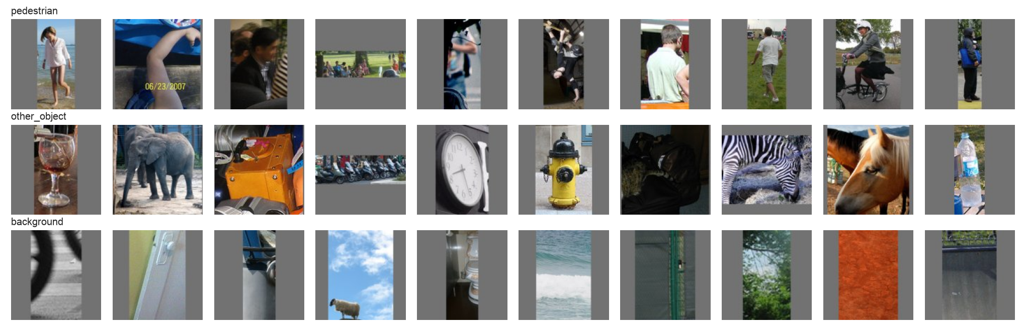
Figure 1. Random examples of the three classes (10 per class).
Second test set – real YOLOv8n boxes. For the practical part I also ran YOLOv8n on the 738 test photos (scripts/make_yolo_detections.py). It found 1,184 “person” boxes. I compared every box with the COCO labels: a box with IoU ≥ 0.5 with a real person is a true positive (939 boxes), all others are false positives (245 boxes). These boxes were cropped in exactly the same way as the training crops.

4 Methodology
All code is written in PyTorch (Paszke et al., 2019). I trained on my laptop (Apple M1, 8 GB) with the mps GPU backend. The notebook is also prepared for Google Colab: its first cell clones the repository with the data and the weights.

4.1 Data Preprocessing
- Resize. The crops are stored at 128×128. My own CNN uses 64×64 input, so that I could train all configurations on my laptop in reasonable time. MobileNetV2 uses 128×128.
- Normalization. For my CNN I use the mean and standard deviation of the training crops (mean 0.448 / 0.427 / 0.404, std 0.206 / 0.200 / 0.207). For MobileNetV2 I use the ImageNet values (0.485 / 0.456 / 0.406 and 0.229 / 0.224 / 0.225), because its pretrained weights expect them.
- Augmentation (training only). Random horizontal flip, rotation ±15°, scaling 0.85–1.15, shift ±10 %, brightness and contrast ±20 %. I do it on the GPU for every batch, so each epoch sees new versions of the images. Validation and test images are never augmented.
- Split. 70 / 15 / 15 by photo (Section 3). The test set is used only once, for the final evaluation.
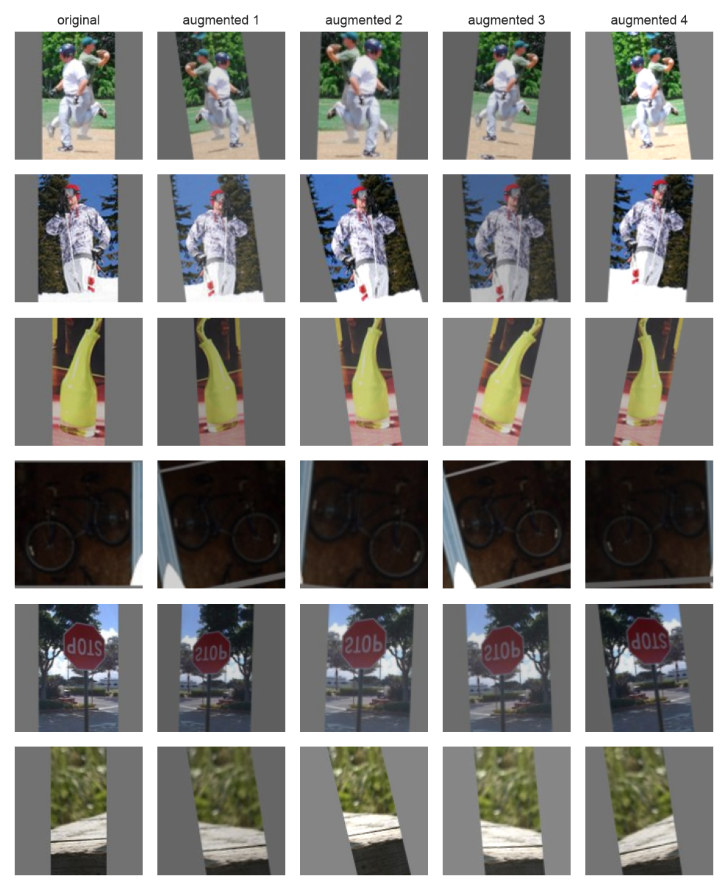
Figure 2. Data augmentation: two crops of each class (rows), the original on the left and four random augmented versions.

4.2 Models
Model A – my own CNN (PedCNN), trained from scratch. Four convolution blocks: 3×3 convolution → activation → 2×2 max-pooling, with 32, 64, 128 and 128 filters. Then global average pooling and a dense head: 128 → hidden layer → 3. The activation, the hidden size, the number of hidden layers and the weight initialization can be changed, so I can run the configurations of the task. The activation is used in the convolution blocks and in the hidden layer. The model has about 249 k parameters.
Model B – MobileNetV2 with transfer learning (Sandler et al., 2018). The network is pretrained on ImageNet. I replaced the last layer with Dropout(0.2) + Linear(1280 → 3). The model has 2.23 M parameters.

4.3 Training Setup
- Loss: cross-entropy. Validation: after every epoch on the validation set.
- Early stopping: if the validation loss does not improve for 6 epochs (4 for the MobileNetV2 fine-tuning), training stops, and the weights of the best epoch are restored.
- Gradient accumulation. A batch of 1,024 images does not fit into 8 GB of memory, so I process it in parts of 256 images and add up the gradients. The optimizer still makes one step per 1,024 images, so it is the same experiment as with a real batch of 1,024.

4.4 Three Hyperparameter Configurations
As required by the task, I trained my CNN with three sets of hyperparameters. All three use Adam with learning rate 0.001 (Kingma & Ba, 2015), Xavier-uniform initialization (Glorot & Bengio, 2010), one hidden layer, no augmentation and at most 30 epochs.
Table 3. The three hyperparameter configurations.
Configuration | Optimizer | Initialization | Activation | Hidden layer size | Batch size | Hidden layers
Config 1 | Adam | XavierUniform | tanh | 64 | 1024 | 1
Config 2 | Adam | XavierUniform | tanh | 32 | 128 | 1
Config 3 | Adam | XavierUniform | relu | 32 | 1024 | 1

4.5 Improvement Techniques
- Improved CNN. ReLU, batch 128, hidden size 64, BatchNorm after every convolution (Ioffe & Szegedy, 2015), Dropout 0.3 in the head (Srivastava et al., 2014), data augmentation, AdamW with learning rate 0.002 and weight decay 0.0001 (Loshchilov & Hutter, 2019) and a cosine learning-rate schedule (Loshchilov & Hutter, 2017).
- Transfer learning with MobileNetV2 in two stages, with augmentation, batch 64 and AdamW: stage 1 – the pretrained backbone is frozen and only the new head is trained (3 epochs, lr 0.001); stage 2 – the whole network is fine-tuned with a small learning rate (up to 10 epochs, lr 0.0001, cosine schedule).

4.6 Evaluation Metrics
- Accuracy – share of correct crops.
- Precision, recall and F1 per class and as a macro average (all classes count equally). For public.safe the most important numbers are the precision and recall of the pedestrian class: low precision means false alarms, low recall means missed people.
- Confusion matrix – which classes are mixed up.
- Loss and accuracy curves for training and validation – to see underfitting and overfitting.

4.7 Practical Application: Test on Real YOLOv8n Boxes
The real question is not “how good is the model on my crops”, but “does it help YOLOv8n”. So I took the same YOLOv8n weights as in public.safe (I checked the SHA-256 checksum) and the same confidence threshold 0.30, and ran them on the 738 test photos. The verifier looks at every box and keeps it only if P(pedestrian) ≥ threshold. A good filter removes many false positives and keeps almost all true ones.
I also split the false positives into two types: “part of a person” (the box overlaps a real person with IoU between 0.3 and 0.5, for example a box on half of a body) – 114 boxes; and “no person” (IoU < 0.3 with every labelled person) – 131 boxes.
Finally I wrote src/verified_detector.py. The class VerifiedDetector has the same detect(image, conf) method as the detector in public.safe, so the zone rules of the diploma system do not need any change.

5 Results and Evaluation

5.1 Comparison of the Three Configurations
Table 4. Results of the three configurations on the test set (3,085 crops).
Configuration | Accuracy (test) | Loss (test) | Training Time | Comments
Config 1 (tanh, 64, batch 1024) | 0.805 | 0.466 | 19.2 min, 30 epochs | slow start (15 weight updates per epoch); still improving at epoch 30 – under-trained
Config 2 (tanh, 32, batch 128) | 0.805 | 0.482 | 6.6 min, 18 epochs | learns fastest (120 updates per epoch); overfits after epoch 12 (train 96 %, validation 83 %); early stopping
Config 3 (relu, 32, batch 1024) | 0.808 | 0.463 | 8.6 min, 30 epochs | almost the same curves as Config 1; relu slightly better; still improving at epoch 30
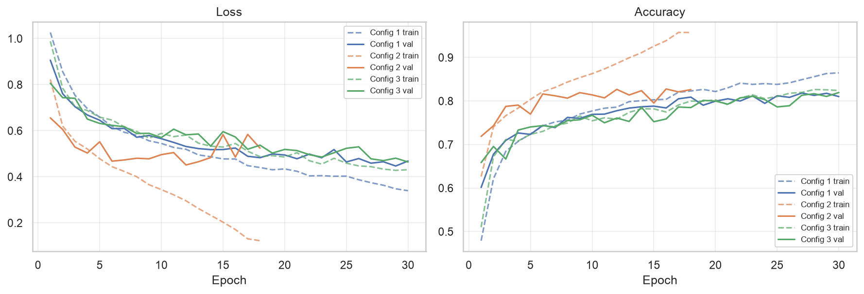
Figure 3. Loss and accuracy curves of the three configurations (dashed = training, solid = validation).
Analysis.
- All three reach almost the same test accuracy (80.5–80.8 %). The difference of 0.3 percentage points is about 10 of 3,085 test crops, so on the test set none of them is clearly better. With this small CNN and no augmentation, the limit is the model and the missing regularization, not these three hyperparameters.
- The batch size changes how the model learns. With 15,260 training images, batch 1,024 gives only 15 weight updates per epoch, batch 128 gives 120. Config 2 reached 79 % validation accuracy already in epoch 4; Config 1 needed 17 epochs for the same. But Config 2 also overfits quickly: its training accuracy went up to 96 % while the validation accuracy stayed at about 83 %, the validation loss was lowest in epoch 12, and early stopping ended the run in epoch 18. Configs 1 and 3 had their best epoch at 29–30, so they were still learning (under-trained, not overfitted). The validation curve of Config 2 is also more noisy, because a small batch gives a more noisy gradient.
- Activation (Config 1 tanh vs Config 3 relu, both batch 1,024). The curves are almost the same. ReLU is a little better (80.8 % vs 80.5 %, loss 0.463 vs 0.466). My network has only four convolution layers, and Xavier initialization keeps tanh in its linear range, so the vanishing-gradient problem of tanh is small here.
- Hidden size (64 vs 32). The head (128 → hidden → 3) has 8.5 k or 4.2 k weights out of about 249 k, so it changes almost nothing.
- Training time. All three configurations use the same part size of 256 images, so one epoch costs about the same. I timed two epochs of each again, one after another: after the first warm-up epoch it was 28–38 seconds per epoch for all three. So the different times per epoch in the original runs come from the state of my laptop, not from the hyperparameters. The total time mostly depends on the number of epochs: Config 2 was the fastest only because early stopping ended it after 18 epochs.

5.2 Effect of the Improvements
Table 5. All models on the test set. The fine-tuned MobileNetV2 starts from the frozen one, so its full training time is 4.2 + 28.0 = 32.2 min.
Model | Accuracy | Precision (macro) | Recall (macro) | F1 (macro) | Pedestrian precision | Pedestrian recall | Loss | Epochs | Time
Config 1 | 0.805 | 0.803 | 0.803 | 0.803 | 0.722 | 0.779 | 0.466 | 30 | 19.2 min
Config 2 | 0.805 | 0.805 | 0.803 | 0.803 | 0.719 | 0.776 | 0.482 | 18 | 6.6 min
Config 3 | 0.808 | 0.809 | 0.808 | 0.804 | 0.705 | 0.811 | 0.463 | 30 | 8.6 min
Improved CNN | 0.853 | 0.851 | 0.851 | 0.850 | 0.822 | 0.810 | 0.370 | 30 | 17.2 min
MobileNetV2, frozen backbone | 0.838 | 0.843 | 0.838 | 0.839 | 0.878 | 0.842 | 0.422 | 3 | 4.2 min
MobileNetV2, fine-tuned | 0.928 | 0.928 | 0.929 | 0.928 | 0.925 | 0.941 | 0.214 | 10 | 28.0 min
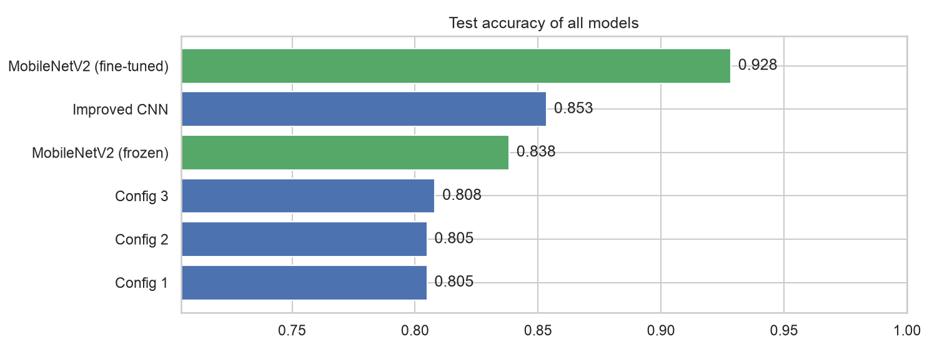
Figure 4. Test accuracy of all models.
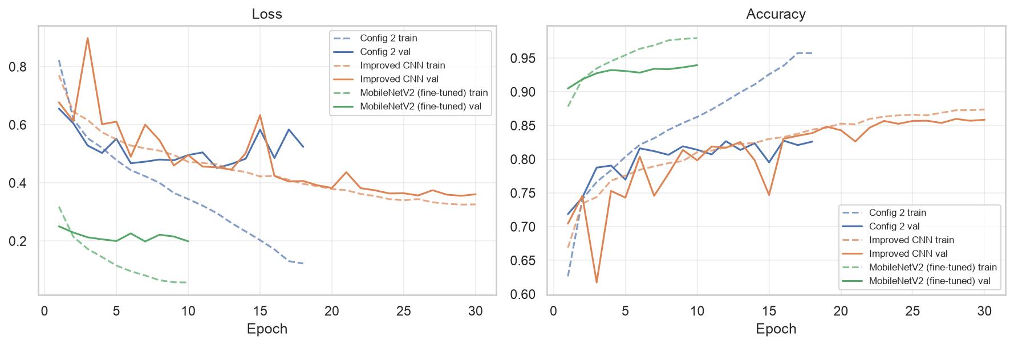
Figure 5. Curves of Config 2, the improved CNN and the fine-tuned MobileNetV2.
- BatchNorm + Dropout + augmentation raised the accuracy of my own CNN from 80.8 % to 85.3 % and the pedestrian precision from 0.71–0.72 to 0.82. In Figure 5 the improved CNN does not overfit: training and validation accuracy stay close (87 % and 86 %), while Config 2 had a gap of 13 percentage points. Augmentation makes the training task harder (the training accuracy is lower), but the model generalizes better. The improved CNN still had its best epoch at 29 of 30, so a longer training could help a bit more.
- Transfer learning gave the biggest step. Only training the new head (frozen backbone) already gave 83.8 % after 3 epochs. Fine-tuning the whole network gave 92.8 %, which is 7.5 percentage points better than my best own CNN. It started at 90.5 % validation accuracy in the first epoch, because the ImageNet features already know shapes of people and objects. After epoch 7 the validation loss stopped improving while the training accuracy grew to 98 %, so early stopping restored the weights of epoch 7.
- The price is speed: MobileNetV2 is about 9 times bigger, and one epoch took almost 3 minutes on my laptop (my CNN: about 30 seconds).

5.3 Best Model: Detailed Evaluation
Table 6. Per-class metrics of the fine-tuned MobileNetV2 on the test set (accuracy 0.928).
Class | Precision | Recall | F1-score | Support
pedestrian | 0.925 | 0.941 | 0.933 | 920
other_object | 0.924 | 0.899 | 0.912 | 1,072
background | 0.935 | 0.946 | 0.940 | 1,093
macro average | 0.928 | 0.929 | 0.928 | 3,085
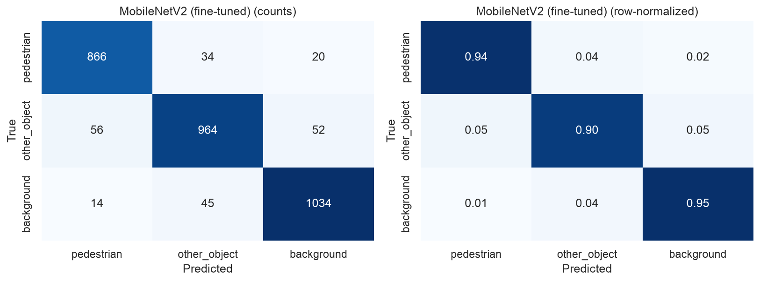
Figure 6. Confusion matrix of the fine-tuned MobileNetV2 (left: counts, right: share of each true class).
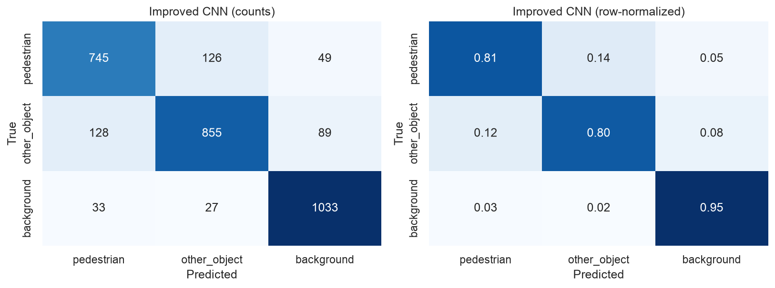
Figure 7. Confusion matrix of my best own CNN (improved CNN), for comparison.
- Pedestrian is the easiest class to find: 94 % of the real pedestrians are recognized.
- other_object is the hardest class (recall 0.90): 56 objects were called pedestrian and 52 were called background. COCO objects are very different (from a fork to a train), and some small objects look like background.
- For public.safe two numbers matter. 70 of 2,165 non-pedestrian crops (3.2 %) were called pedestrian; they would still give false alarms. 54 of 920 pedestrians (5.9 %) were called something else; they would be missed.

5.4 Error Analysis
The best model made 221 mistakes on 3,085 test crops. Figure 8 shows 16 random mistakes.
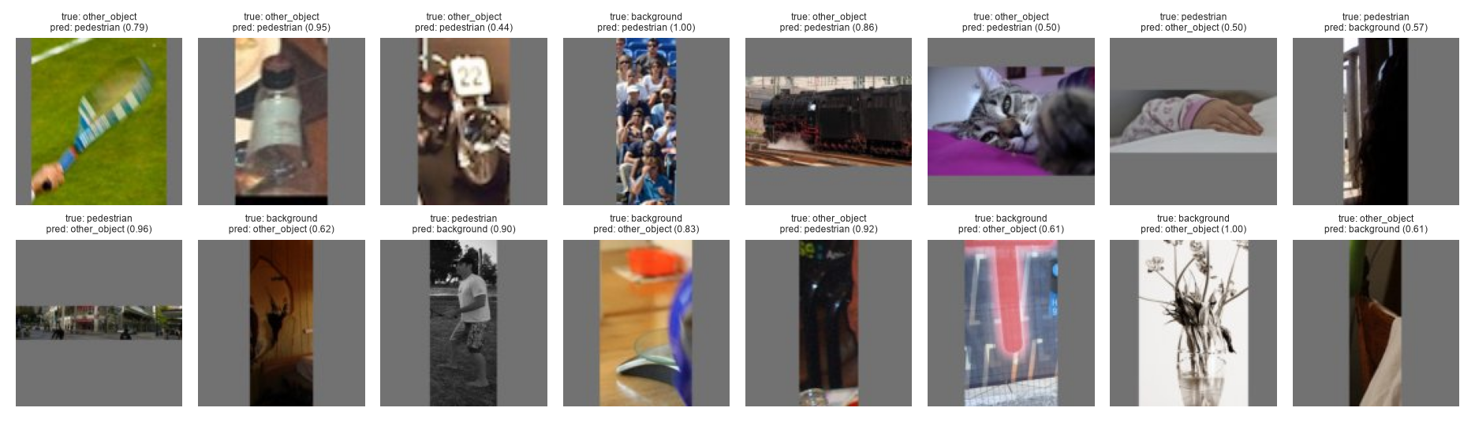
Figure 8. Random mistakes of the fine-tuned MobileNetV2 (true class, predicted class and probability).
- Some labels are not really correct. For example, a “background” crop full of spectators (4th crop in the first row) was predicted as pedestrian with probability 1.00. The people in it simply have no COCO boxes, so my rule for background windows did not see them. A bat held by a hand (1st crop) contains a part of a person. Here the model is closer to the truth than the label.
- Objects near people. The other_object mistakes come most often from horse (10), chair (9), potted plant (8) and umbrella (8). Horses, chairs and umbrellas are very often used by people in COCO photos, so parts of people can be inside these crops even after my overlap filter.
- Hard crops. Very dark, blurred or tiny crops, and people seen from an unusual angle (a hand on a bed, a person in a dark doorway).

5.5 Practical Application Results
YOLOv8n alone, on the 738 test photos: 1,184 boxes, 939 true and 245 false. Precision 0.793 and recall 0.603 (the recall is low because COCO also labels very small and hidden people). Table 7 shows what happens when the verifier filters these boxes.
Table 7. YOLOv8n + verifier on the 738 test photos.
Threshold on P(pedestrian) | True pedestrians kept | False positives left | FP removed | Precision | Recall
0 (YOLOv8n only) | 939 (100 %) | 245 | 0 % | 0.793 | 0.603
0.3 | 910 (96.9 %) | 220 | 10.2 % | 0.805 | 0.584
0.5 | 903 (96.2 %) | 213 | 13.1 % | 0.809 | 0.580
0.7 | 889 (94.7 %) | 206 | 15.9 % | 0.812 | 0.571
0.9 | 856 (91.2 %) | 190 | 22.4 % | 0.818 | 0.550
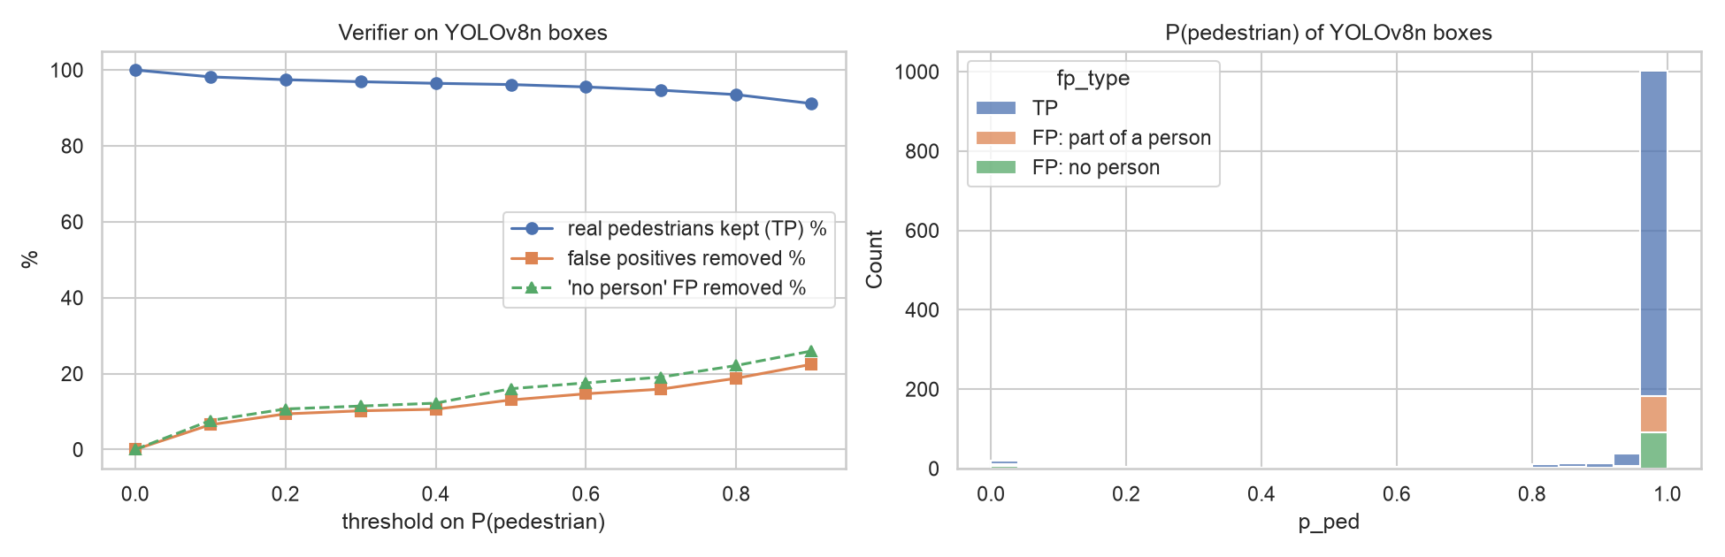
Figure 9. Left: true pedestrians kept and false positives removed for different thresholds. Right: P(pedestrian) of all YOLOv8n boxes.
At my default threshold 0.5 the verifier removes 13 % of the false positives (245 → 213) and loses 3.8 % of the true pedestrians (939 → 903). The precision goes from 0.793 to 0.809. On my laptop the verifier needs 32 ms for 16 boxes, about 2 ms per box, so it is fast enough for public.safe.
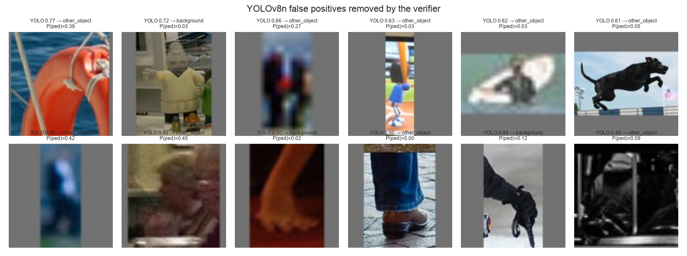
Figure 10. False positives of YOLOv8n that the verifier removed (YOLO confidence, predicted class, P(pedestrian)).
Most removed boxes (Figure 10) are what I wanted to remove: a life buoy, a statue, a toy figure, a dog and a boat, and also boxes that contain only a foot, a leg or a hand. A few of them look like blurred people, so not every removed box is a real mistake of YOLOv8n.
Why is the effect so small? This result was smaller than I expected, so I checked the boxes. Figure 9 (right) shows that most false positives get P(pedestrian) close to 1, just like the true ones. Two reasons:
- 114 of the 245 false positives are “part of a person”: the box overlaps a real person, but not enough for IoU ≥ 0.5 (for example a box on the upper body only, or two boxes on one person). There really is a person in these crops, so the verifier correctly says pedestrian. For a danger zone this is not even a false alarm, because a person is really there.
- Many “no person” boxes are people without a COCO label. The verifier kept 110 of the 131 “no person” boxes. I looked at 40 random ones of them (Figure 11) and counted by hand:
Table 8. My manual check of 40 “no person” boxes that the verifier kept.
What the crop shows | Count
a real person or a part of a person without a COCO box (spectators, people in a crowd, people at the image border) | 27
not a person – a real mistake (toy figure, dog, bronze statue, fire hydrant, donkey with a cart) | 5
too small, dark or blurred to decide | 8
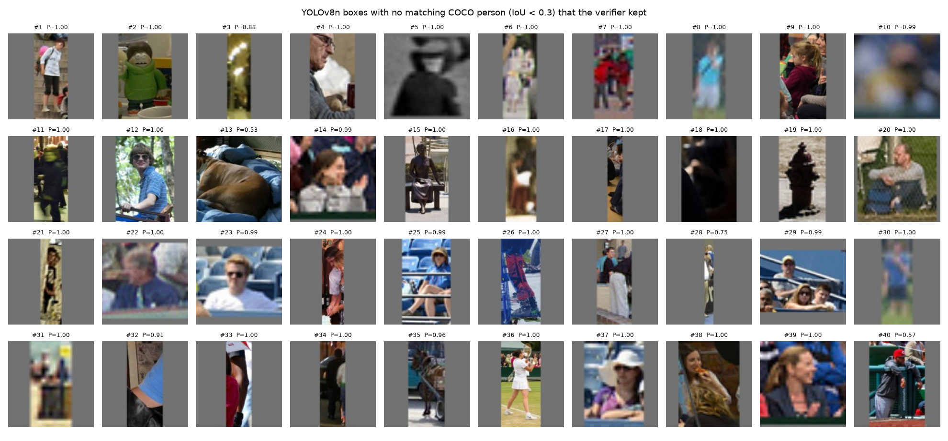
Figure 11. The 40 checked boxes: YOLOv8n “persons” with no matching COCO person that the verifier kept.
So for about two thirds of the kept “false positives” the verifier is right and the COCO labels are incomplete. If the same share is true for all 110 boxes, about 74 of them are real people. The real false positives – toys, statues, animals – are only a small part of the 245 boxes, and this is why the measured reduction is only 13 %. The numbers in Table 7 are therefore a pessimistic estimate.
The lost pedestrians. I also looked at the 36 true pedestrians that the verifier rejected. Many of them are only partly visible (only hands or legs, a person in the dark), 8 are smaller than 48 px (smaller than any pedestrian in my training set), and some are in unusual poses (lying, skiing). But a few are clear people, for example baseball players behind a net, so the model still has real misses.

6 Discussion
What worked. Transfer learning was the most effective technique: 92.8 % accuracy against 85.3 % for my best own CNN. Regularization (BatchNorm, Dropout) and augmentation together gave +4.5 percentage points to my own CNN and removed the overfitting. Of the three hyperparameter sets, the batch size had the biggest influence: it decided how fast the model learned and how fast it overfitted. The activation and the hidden size changed the result very little in this architecture.
Comparison with the literature. Apurv et al. (2021) reached accuracy 0.91 with a MobileNetV2 crop classifier for a 2-class task. My MobileNetV2 reaches 0.928 on 3 classes, so the result is at a similar level. Jiang et al. (2024) removed about 70 % of the false positives with a second-stage network on Caltech; my verifier removed 13 % of the COCO false positives of YOLOv8n. As Section 5.5 shows, the main reason is that most “false positives” of YOLOv8n on COCO are real people or parts of people. The results are therefore not directly comparable.
Limitations.
- Label noise in COCO. Not every person in COCO has a box. This affects the background class of my dataset and, even more, the evaluation of the practical test.
- Domain. COCO photos are not frames from phone cameras at a kerb or a loading area. The real false positives of public.safe can be different (poles, bags, shadows), and I could not test this without labelled frames from my own cameras.
- One run per model. I trained each model once with one random seed. Small differences such as 0.3 percentage points between the configurations are not reliable.
- Small input for my CNN. My own CNN used 64×64 images to save time; with 128×128 it could be better.
- Partial people. The verifier rejects some boxes that contain only a hand or a foot of a real person. In a danger zone such a box can still mean a real person, so it costs some recall (3.8 % at threshold 0.5).
Future work. Record and label frames from my own phone cameras and fine-tune the verifier on them; clean the COCO labels (add boxes for the unlabelled people); use the verifier only for boxes inside zones; combine it with tracking across frames; add VerifiedDetector to public.safe and measure false alarms per hour in a real test.

7 Conclusion
In this endterm project I continued my Assignment 2 and built a CNN verifier for the YOLOv8n person boxes of my diploma system public.safe.
- On my dataset PedCrops v1 (21,669 crops from COCO, 3 balanced classes, split by photo) I trained my own CNN with the three required hyperparameter configurations. They reached 80.5–80.8 % test accuracy. The batch size changed the learning speed and the overfitting the most.
- BatchNorm, Dropout and augmentation improved my own CNN to 85.3 %. Transfer learning with MobileNetV2 gave the best model: 92.8 % accuracy, macro F1 0.928, pedestrian recall 94.1 %.
- On real YOLOv8n boxes the verifier (threshold 0.5) removed 13 % of the false positives and kept 96.2 % of the true pedestrians, with about 2 ms per box. My manual check showed that most remaining “false positives” are real people without a COCO label, so the real effect is larger than the measured one. Still, the effect has to be measured on frames from the real cameras before I switch the verifier on in public.safe.
- The verifier is ready to use as VerifiedDetector with the same interface as the public.safe detector.
Compared with Assignment 2, where I only prepared the data, the project now has trained and evaluated models, a clear comparison of hyperparameters and improvement techniques, and a test in the real pipeline of my diploma project.

References
Apurv, K., Tian, R., & Sherony, R. (2021). Detection of e-scooter riders in naturalistic scenes (arXiv:2111.14060). https://arxiv.org/abs/2111.14060
Feng, R., Miao, Y., & Zheng, J. (2024). A YOLO-based intelligent detection algorithm for risk assessment of construction sites. Journal of Intelligent Construction, 2(4), 9180037. https://doi.org/10.26599/JIC.2024.9180037
Glorot, X., & Bengio, Y. (2010). Understanding the difficulty of training deep feedforward neural networks. In Proceedings of the 13th International Conference on Artificial Intelligence and Statistics (pp. 249–256). PMLR.
Guo, Q., Zhang, R., & Zhang, B. (2025). A pedestrian sensitive training algorithm for false positives suppression in two-stage CNN detection methods. Computers, Materials & Continua, 84(1), 1307–1327. https://doi.org/10.32604/cmc.2025.063288
Hasan, I., Liao, S., Li, J., Akram, S. U., & Shao, L. (2022). Pedestrian detection: Domain generalization, CNNs, transformers and beyond (arXiv:2201.03176). https://arxiv.org/abs/2201.03176
Ioffe, S., & Szegedy, C. (2015). Batch normalization: Accelerating deep network training by reducing internal covariate shift. In Proceedings of the 32nd International Conference on Machine Learning (pp. 448–456). PMLR.
Jiang, Z., Huang, S., & Li, M. (2024). A pedestrian detection network based on an attention mechanism and pose information. Applied Sciences, 14(18), 8214. https://doi.org/10.3390/app14188214
Jocher, G., Chaurasia, A., & Qiu, J. (2023). Ultralytics YOLOv8 (Version 8.0.0) [Computer software]. https://github.com/ultralytics/ultralytics
Khan, A. H., Munir, M., van Elst, L., & Dengel, A. (2022). F2DNet: Fast focal detection network for pedestrian detection. In 2022 26th International Conference on Pattern Recognition (ICPR) (pp. 4658–4664). IEEE. https://doi.org/10.1109/ICPR56361.2022.9956732
Kingma, D. P., & Ba, J. (2015). Adam: A method for stochastic optimization. In 3rd International Conference on Learning Representations (ICLR). https://arxiv.org/abs/1412.6980
Lin, T.-Y., Maire, M., Belongie, S., Hays, J., Perona, P., Ramanan, D., Dollár, P., & Zitnick, C. L. (2014). Microsoft COCO: Common objects in context. In Computer Vision – ECCV 2014 (pp. 740–755). Springer. https://doi.org/10.1007/978-3-319-10602-1_48
Liu, Q., Ye, H., Wang, S., & Xu, Z. (2024). YOLOv8-CB: Dense pedestrian detection algorithm based on in-vehicle camera. Electronics, 13(1), 236. https://doi.org/10.3390/electronics13010236
Loshchilov, I., & Hutter, F. (2017). SGDR: Stochastic gradient descent with warm restarts. In 5th International Conference on Learning Representations (ICLR). https://arxiv.org/abs/1608.03983
Loshchilov, I., & Hutter, F. (2019). Decoupled weight decay regularization. In 7th International Conference on Learning Representations (ICLR). https://arxiv.org/abs/1711.05101
Mei, X., Zhou, X., Xu, F., & Zhang, Z. (2023). Human intrusion detection in static hazardous areas at construction sites: Deep learning–based method. Journal of Construction Engineering and Management, 149(1), 04022142. https://doi.org/10.1061/(ASCE)CO.1943-7862.0002409
Paszke, A., Gross, S., Massa, F., Lerer, A., Bradbury, J., Chanan, G., … Chintala, S. (2019). PyTorch: An imperative style, high-performance deep learning library. In Advances in Neural Information Processing Systems 32 (pp. 8024–8035).
Sandler, M., Howard, A., Zhu, M., Zhmoginov, A., & Chen, L.-C. (2018). MobileNetV2: Inverted residuals and linear bottlenecks. In 2018 IEEE/CVF Conference on Computer Vision and Pattern Recognition (pp. 4510–4520). https://doi.org/10.1109/CVPR.2018.00474
Srivastava, N., Hinton, G., Krizhevsky, A., Sutskever, I., & Salakhutdinov, R. (2014). Dropout: A simple way to prevent neural networks from overfitting. Journal of Machine Learning Research, 15(56), 1929–1958.
Tran, S. V.-T., Lee, D., Bao, Q. L., Yoo, T., Khan, M., Jo, J., & Park, C. (2023). A human detection approach for intrusion in hazardous areas using 4D-BIM-based spatial-temporal analysis and computer vision. Buildings, 13(9), 2313. https://doi.org/10.3390/buildings13092313
Xiao, X., & Feng, X. (2023). Multi-object pedestrian tracking using improved YOLOv8 and OC-SORT. Sensors, 23(20), 8439. https://doi.org/10.3390/s23208439
Yan, X., He, Z., Huang, Y., Xu, X., Wang, J., Zhou, X., Wang, C., & Lu, Z. (2022). A lightweight pedestrian intrusion detection and warning method for intelligent traffic security. KSII Transactions on Internet and Information Systems, 16(12), 3904–3922. https://doi.org/10.3837/tiis.2022.12.007
Zhou, H., Wu, T., Sun, K., & Zhang, C. (2022). Towards high accuracy pedestrian detection on edge GPUs. Sensors, 22(16), 5980. https://doi.org/10.3390/s22165980

