Interfacing VILLASnode and Hypersim

1. Create a new UCM name “node” and save to the real-time simulator folder of HYPERSIM. C:\Users\auser\HYPERSIM\ucm

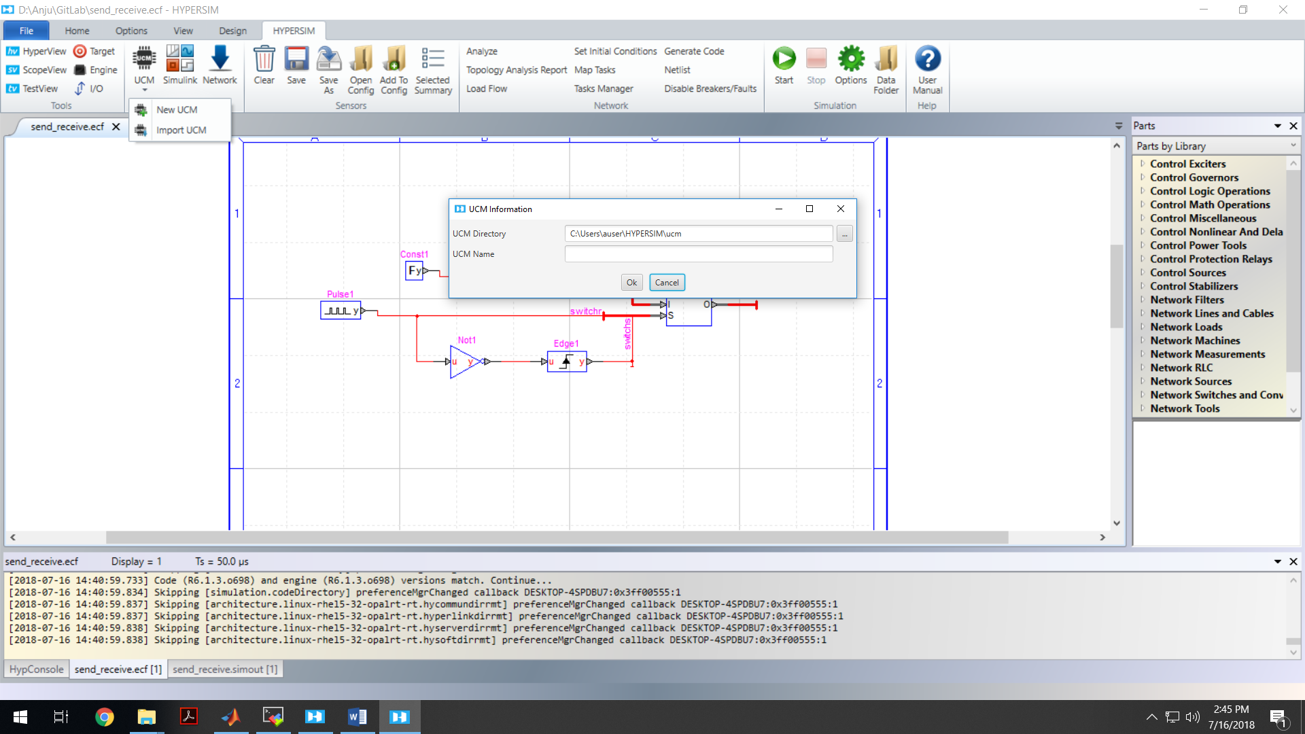

1. This will create a file name ucm_node.def
2. Open the file in editor and copy paste the downloaded code from \clients\Hypersim\models\ucm_node.def
3. Right click and update the code

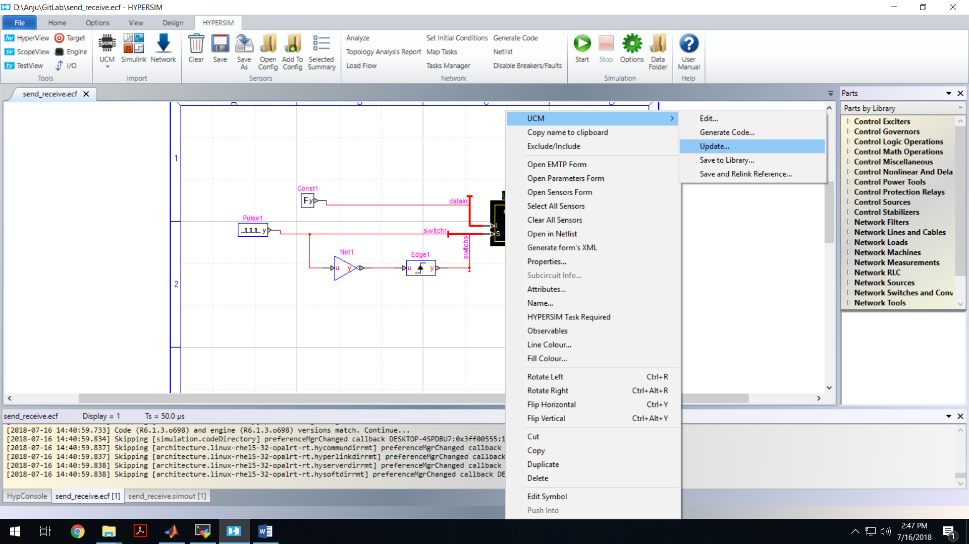

1. Go to options and set for real time

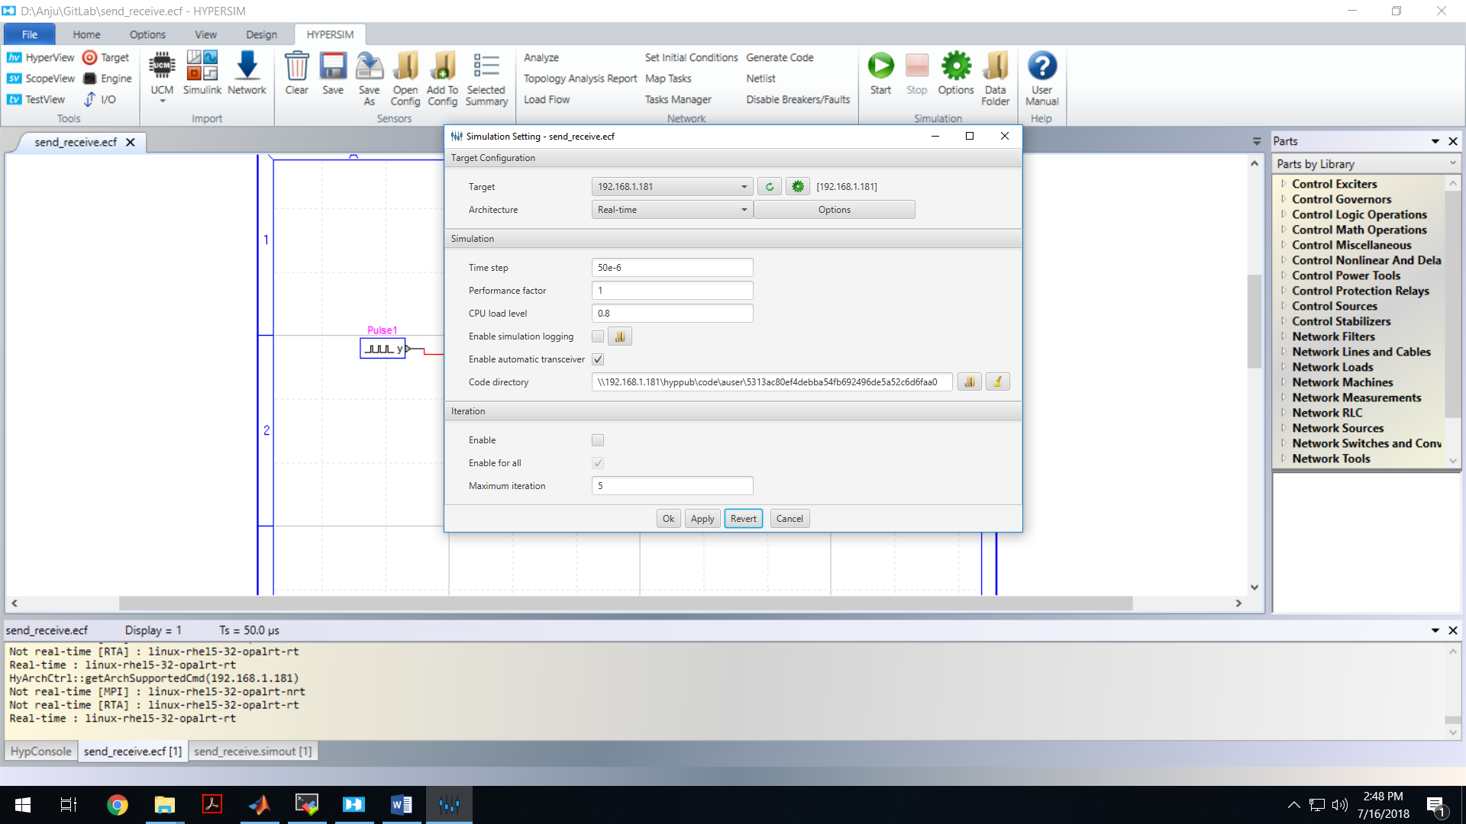

1. Start simulation on hypersim, and villasnode
2. The received data can be viewed on the scope view

