BARIŞ TİNCER

**PERSONAL INFORMATION**

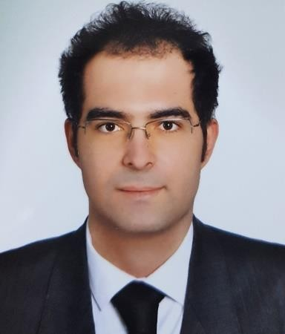**Nationatliy**: T.C

**Place of Birth**: Istanbul **Date of Birth**: 10.06.1994 **Martial Status**: Single

**Address**: ANKARA / CANKAYA **Military Status**: Postponed (20.03.2023) E-mail: [baristincer@gmail.com](mailto:baristincer@gmail.com) **Linkedin**: [linkedin.com/in/barış-tincer](https://www.linkedin.com/in/barış-tincer-a003b8177/) **Web Site:** [baristincer.com](https://baristincer.com/)

**Phone Number**: +90 542 508 80 07

**Driving Licence:** Category B

# EDUCATION

**Software Education:** Bilge Adam BOOST Star Software Development Program, Ankara 01.2022-

**Master**: Ufuk University, Management Information Systems, Ankara 09.2021- **Licence**: Ufuk University, Management Information Systems, Ankara 09.2016-06.2021 **ABOUT ME**

I am master student at Ufuk University, Department of Management Information Systems. I graduated from Management Information Systems at Ufuk University.

I am young, dynamic and has a sense of responsibility. I am an individual who wants to develop himself in the field of software, is open to innovations, solution-oriented, highly motivated, and prone to teamwork and single work.

# PROJECTS

**Building Management System**

We made as a team the Building Management System project in December 2020. The people living and working in the project apartment, site, business center and collective housing and the managers of these structures will easily access all information about the structure they live in. They will be able to access information such as income-expense system and tracking system at any time and from anywhere.

Team members: Barış TİNCER, Karya Bürkem ÖZTÜRK.

Technologies we used in the project

We’ve used Access data base and Microsoft Visual Studio C# software language.

# Cafe Web Site

We made as a team the Cafe Web Site project in June 2021. The project is the cafe's website that is open to use by everyone. You can access cafe information, menu and contact information by logging in with your username and password on this site. Users who want to access this website can connect from any device with an internet connection at any time and from anywhere.

Team members: Barış TİNCER. Karya Bürkem ÖZTÜRK, Emin Topaç.

Technologies we used in the project

We’ve used Xampp, SQL database program, brackets text editor, css, html and php software language.

# FOREIGN LANGUAGE

English- B2

# INFORMATION TECHNOLOGIES SKILLS

MS Office (Word, Excel, PowerPoint, Access) C#

.Net PHP HTML 5 CSS

JavaScript MYSQL MSSQL

# ARES OF INTEREST

Swimming, reading books, software, internet, information technologies, travelling.