# 

# **Overview**

* **About our web team:** 5 people took part in the creation of the “Damdi” canteen website.
  + **Members and their roles:**

|  |  |  |  |
| --- | --- | --- | --- |
| **name** | **student_id** | **email** | **role** |
| **Nussup Nazym** | **204022** | [**nussupnazym@gmail.com**](mailto:nussupnazym@gmail.com) | **Team leader** |
| **Basarov Bektas** | **204086** | [**basarov02@gmail.com**](mailto:basarov02@gmail.com) | **Programmer** |
| **Kazhybek Dyusenbai** | **204045** | [**kazhybek9@gmail.com**](mailto:kazhybek9@gmail.com) | **Web designer** |
| **Makhanova Albina** | **204081** | [**albi.makhan@gmail.com**](mailto:albi.makhan@gmail.com) | **Web psychologist** |
| **Raushanbekova Maira** | **204067** | [**mairau2402@gmail.com**](mailto:mairau2402@gmail.com) | **Content producer** |

* + **Communication strategy:** Our web team developed a website in a short time. From February 1 to February 7, there were 2 offline meetings in the territory of Astana IT University, 2 online meetings in Microsoft teams and 1 audio conference in telegram chat. From the first meeting, we wanted to competently distribute the role of each member. Nazym, the leader of the team, explained the plan for the website. Being present in all processes, she kept everything under control, which is the main quality of the leader. Bektas was appointed as the main coder of the Web site, as he was very good at html, css, and even java script. Kazhybek has vast experience in design, in creating an icon, so he was the web designer of our site. Albina is a very calm and wise member, the Web Psychologist of the team, thanks to her knowledge in psychology, helped to create a website that can positively influence clients. Content producer Myra collected the necessary information to fill the site.
* **Motivation:** A website gives us control over the image of our canteen. Customers will get a good idea of who we are, as well as get an idea of the overall atmosphere of the canteen. This is also a great opportunity to show how our web team can cope with web tasks by creating a website.
* **High-level project scope: “**Damdi” canteen website 100% brand new website. When creating a website, the web team, purely with the help of creativity, each proposed their own idea. Every detail, every page, color, design is all new. The most interesting thing, even the icon was created by our web designer Duisenbai Kazhybek.
* **Target audience/market**: This website is for those who want delicious “Damdi” canteen dishes, at affordable prices, with fast delivery, and most importantly, halal.

**Project goals and team interests**

**Project goals**

* To uniquely present the site of the “Damdi” canteen
* Meet the needs of people looking for halal food
* Providing online work for the canteen.

**Team interests**

* Practical demonstration of all knowledge of html, css
* Acquaintance with the intricacies of the restaurant business
* Acquaintance with the positive and negative psychology of clients in relation to sites

# **Phases**

* Phase 1 – Building a shared dining room based on our basic html knowledge
* Phase 2 – Use food images, icons, animations and beautiful fonts to decorate the site
* Phase 3 – Work with website content

# **Content structure**

**Site map**

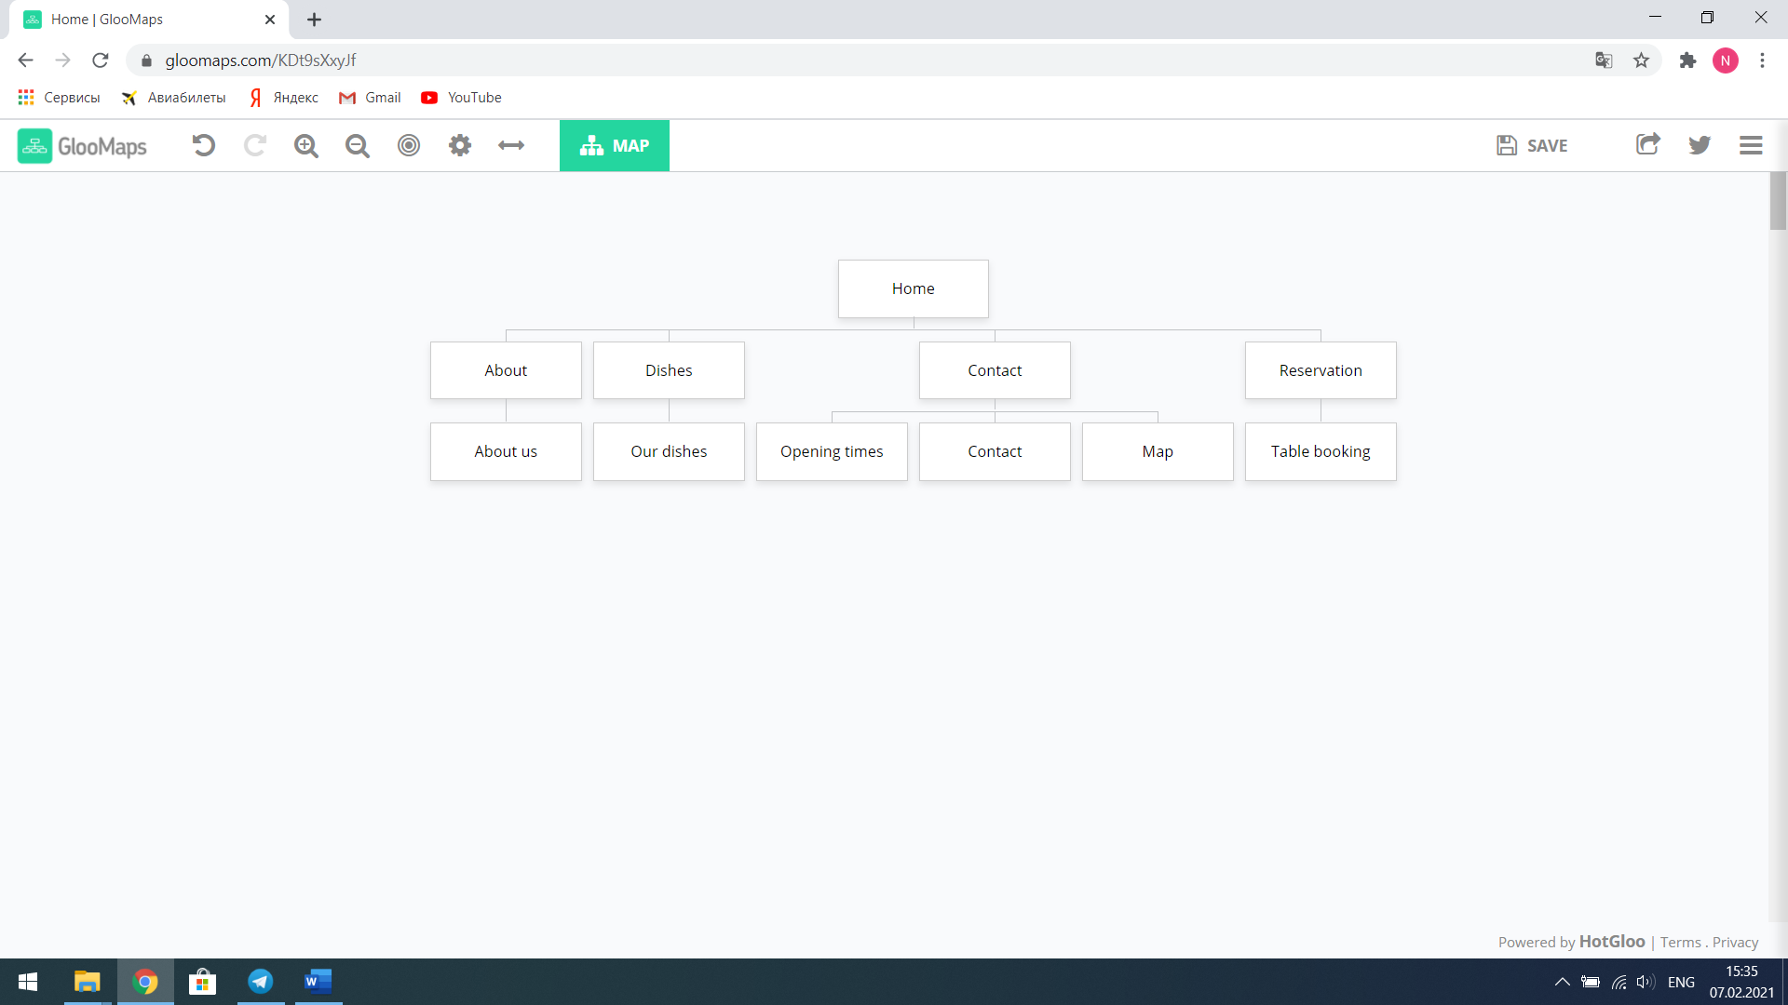

**Content types**

The main content type of our website is **"modern page content type"**. The canteen home page has the content of multiple site pages ("about us", "contact"), which is not new, but with this function we can easily work with multiple pages in the interface.

**Design**

As part of the corporate identity, the font is associated with the brand's products and is one of the most important means of communication between the company and consumers. According to recent research by psychologists, a well-chosen font adjusts a person to the mood when reading a text. We took into account that an important role is played by the fact that a person reads not individual letters, but groups of letters or the whole word as a whole. Therefore, serif fonts are easier to read in printed advertising materials – the letters look more separate. So we chose "Big Shoulders Text", cursive.

We believe that it is not for nothing that McDonald's, KFC, King Burger and many other successful fast food chains have chosen red and yellow colors for their logo, as well as for the design . The label on the package must also have these colors.

Red is a very emotionally intense and energetic color. Increases respiratory rate and increases blood pressure, as well as stimulates appetite. By the way, that is why it is recommended to use this color scheme in the design of kitchens, or in serving.

What other colors can I recommend??- This is of course orange, yellow Let's understand why: Orange increases the supply of oxygen to the brain, has an invigorating effect, and stimulates mental activity. Orange color increases appetite, fills with energy and even promotes the absorption of calcium! Therefore, the researchers recommend feeding capricious babies from orange dishes, or wearing orange clothes. This warm, welcoming color makes people feel comfortable.

Yellow color, according to the British, stimulates the nervous and digestive systems, promotes the development of logical thinking.

We chose brown color for the home page as it is the color of comfort and warmth. After clicking on the menu button in the navbar, we go to a page with a white background, this gives a signal to our brain that we need to cheer up and choose something to eat.

According to statistics, 13% of users are annoyed by the insufficient amount of information on the site. So, after conducting research, we realized what information should be placed on the "Contacts" page: address of the company and its representative offices; working hours and weekends; location on Google Maps or Yandex.Cards; phone numbers: landline, mobile.

**Functionality**

The site's function is very simple. This does not cause any difficulties or inconveniences. But it should be noted that in the dishes section, you need to double-click the browse button to see the ingredients and the price of each dish. Another thing to keep in mind is that you need to book in advance to get a special seat. All you have to do is leave your name, number and time. The site is equally convenient and understandable to everyone, regardless of the age of the clients.

**Hosting**

Github is a website for hosting source code. Firstly, we all have our github pages. We clicked the “New Repository” button, to create a new repository for hosting our files. Then, we gived repository a name and uploaded our files by altering main file to “index.html”.

**Accessibility**

What makes our site accessible? Firstly, there is not a lot of information and buttons on the site. This is because it can negatively affect visitors in choosing dishes. Secondly, a minimalistic style was chosen so that customers can feel free themselves 24/7. Most importantly, the map is displayed at the end of the page so you can easily find the address.

**Deadlines**

* Phase 1 – February 2, 00:00
* Phase 2 – February 4, 00:00
* Phase 3 – February 6, 00:00

# **Summary**

Concluding all of the above, we created a unique site for “Damdi” canteen using html and css, which we learned in the Web development lesson. In addition, we were able to show that the food on the site is made from pure ingredients in a halal way using the “ҚМДБ” label. “Talk is cheap, show me the code”, as Linus Torvalds said, we showed all our knowledge of html and css through code. Moreover, we have mastered many aspects of the restaurant business that, in our opinion, will be useful in the future. Working as a team, we felt like real web professionals.