Lab 1 Report
TCP Client/Server in Python
Format: Individual | Points: 25
Course: Distributed Systems
Goal: Master basic sockets and the client-server model: establish TCP connections, send and receive data, and handle basic network errors.

1. Architecture
The system consists of a single-threaded, sequential TCP server (server.py) and an interactive TCP client (client.py). The server accepts one client connection at a time: it calls accept(), fully handles that client's session in the handle_client() function, and only then loops back to accept() the next connection. Because of this design, clients are served sequentially — which is exactly what test_sequential.py exercises with 5 clients connecting one after another.
Both host and port are configurable via command-line arguments (--host, --port) on both the server and the client, with sensible defaults (127.0.0.1:9090).

1.1 Interaction Flow
The table below describes the message flow between a client and the server for a single session, covering both the normal (valid UTF-8) path and the malformed-data path:
Step | Client | Server
1 | connect() — TCP three-way handshake | accept() unblocks, logs 'Client connected: <ip>:<port>'
2 | Sends '<message>\n' | Buffers bytes until a full line is available
3 | — | Decodes UTF-8. If valid: uppercases the line and prefixes a timestamp
4 | Prints 'Server > [timestamp] MESSAGE' | Sends '[timestamp] MESSAGE\n'
4a (malformed input) | — | Sends 'ERROR: Malformed data (UTF-8 required)\n', keeps connection open
5 | Sends 'QUIT\n' | Logs termination request, sends 'BYE\n'
6 | Prints confirmation, closes socket | Closes socket, logs disconnect, calls accept() again for the next client

2. Protocol: Echo+
Echo+ is a simple, line-oriented text protocol built directly on top of TCP:
Property | Value
Transport | TCP, socket.SOCK_STREAM
Framing | Messages are delimited by '\n'; both sides buffer partial reads until a full line arrives
Encoding | UTF-8 text
Normal response format | [YYYY-MM-DD HH:MM:SS] <MESSAGE IN UPPERCASE>\n
Termination command | QUIT -> server replies BYE\n and closes the connection; client prints confirmation and closes its socket

On the implementation side, both client.py and server.py implement a receive_line()-style buffering loop: bytes are accumulated in a string buffer and only processed once a full '\n'-terminated line is present, since TCP is a stream protocol and a single recv() call is not guaranteed to return exactly one message.

3. Error Handling
The implementation explicitly detects and handles the following error classes, as required by the assignment (unavailable port, dropped connection, malformed data), plus several additional robustness cases:
# | Scenario | Detection | Response
1 | Requested port already in use | OSError raised on bind() | Server logs a critical error with the reason and exits (sys.exit(1)) instead of crashing with a traceback
2 | Client disconnects without QUIT (process killed, network drop) | recv() returns empty bytes (EOF) | Server logs a warning, closes that client's socket, and keeps listening for new connections
3 | Connection reset mid-exchange | ConnectionResetError | Caught on both client and server, logged/printed, resources released cleanly
4 | Server process dies while client is sending | BrokenPipeError on client sendall() | Client catches it, prints a network-lost message, and closes its socket
5 | Malformed / non-UTF-8 bytes received | UnicodeDecodeError on decode('utf-8') | Server replies with an ERROR: line and keeps the connection open (not treated as fatal)
6 | Server not running when client starts | ConnectionRefusedError on connect() | Client prints a friendly 'is the server running?' message
7 | Manual interruption (Ctrl+C) | KeyboardInterrupt | Both sides close their sockets cleanly before exiting

All server-side events (connections, disconnections, received/sent messages, errors) are logged to the console with a timestamp via Python's logging module, configured with level INFO and a '%(asctime)s [%(levelname)s] %(message)s' format.

4. Testing — 5 Sequential Clients
test_sequential.py opens 5 clients (Client-1 through Client-5) one after another against the running server. For each client it sends a small set of scripted messages, reads the server's response line, and closes the socket with QUIT before the next client connects — confirming that the server correctly frees the port/socket between sessions and processes each session independently.

4.1 test_sequential.py console output
The screenshot below shows all 5 clients connecting in order, exchanging their scripted messages, and receiving the expected uppercase + timestamped replies, followed by 'BYE' and a clean socket close:
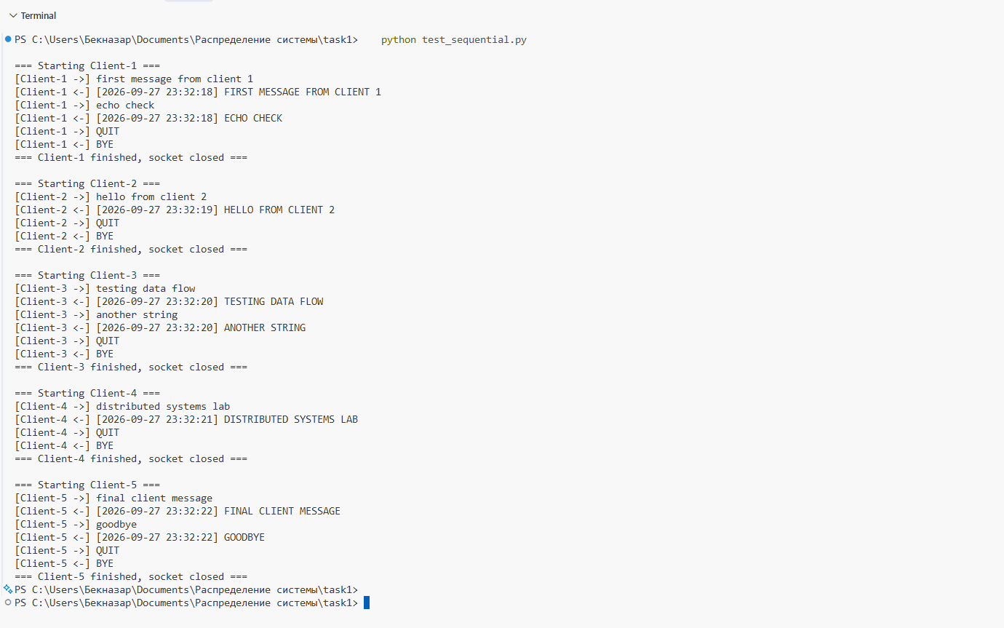
Figure 1. test_sequential.py output — Client-1 through Client-5 running sequentially.

4.2 server.py console log
The server-side log confirms the same session from its point of view: each client connects, sends its messages, receives correct responses, requests termination with QUIT, and the connection is closed before the next client is accepted. The final entries show an additional manual test performed afterwards with the interactive client (message 'hello world'):
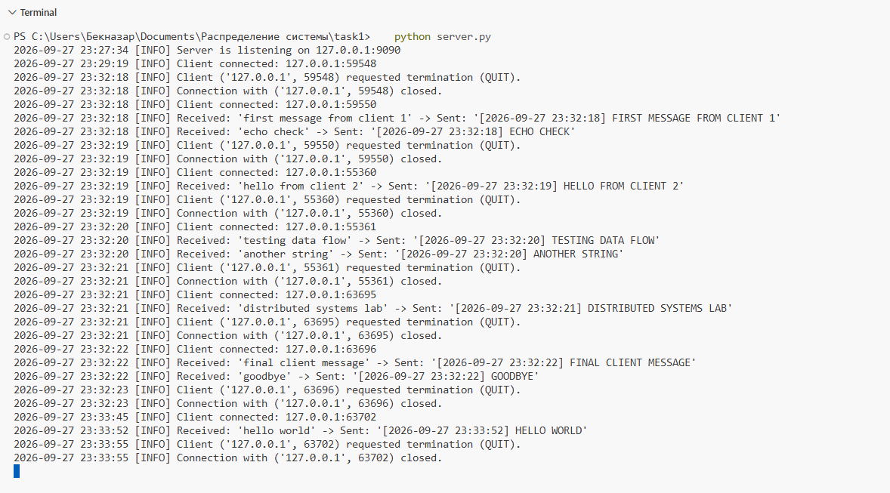
Figure 2. server.py log covering the 5 sequential clients and one manual client session.

4.3 Manual test with the interactive client
In addition to the automated test, the interactive client (client.py) was run manually against the server to confirm the QUIT handshake and a normal echo exchange:
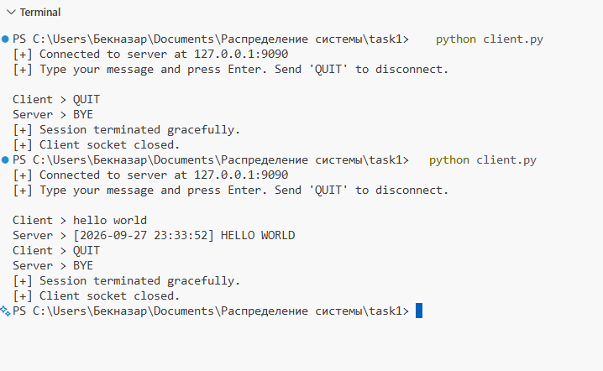
Figure 3. client.py interactive session — an immediate QUIT, then a normal exchange ('hello world') followed by QUIT.

4.4 Project structure
All deliverables are organized in a single project folder, as required by the assignment (code split into at least server.py and client.py, plus documentation):
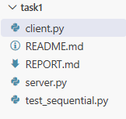
Figure 4. Project files: client.py, server.py, test_sequential.py, README.md, REPORT.md.

5. Run Instructions
Requirements: Python 3.x, standard library only (socket, argparse, logging, datetime) — no extra installs needed.

5.1 Start the server
python server.py --host 127.0.0.1 --port 9090
Both --host and --port are optional (defaults shown above). The server logs every connection, message, and error to the console with a timestamp.

5.2 Connect with the interactive client
python client.py --host 127.0.0.1 --port 9090
Type a message and press Enter — the server echoes it back in uppercase with a receipt timestamp. Type QUIT to close the connection gracefully.

5.3 Run the automated 5-client test
python test_sequential.py
With the server still running, this connects Client-1 through Client-5 one after another (not concurrently), sends each client's scripted messages, prints the server's replies, and closes each socket cleanly before moving to the next client. This satisfies the 'test with 5 clients connecting sequentially' requirement.

6. Requirements Checklist
- TCP server implemented with the socket module, accepting connections on a configurable port — done (server.py).
- TCP client implemented, connecting to the server and sending text messages — done (client.py).
- Echo+ protocol: each received line is returned in uppercase with a receipt timestamp — done.
- QUIT command lets the client close the connection gracefully while the server releases the socket — done.
- Basic error handling: unavailable port, dropped connection, malformed data — done, plus additional cases (Ctrl+C, refused connection, broken pipe).
- Server tested with 5 clients connecting sequentially — done (test_sequential.py, see Section 4).
- Python 3.x, standard library socket module only — confirmed, no external dependencies.
- Code organized into at least two files: server.py and client.py — done, plus test_sequential.py for testing.
- Port and host set via command-line arguments — done (argparse, --host / --port).
- Server events logged to console — done (logging module, timestamped).

6.1 Grading Criteria (reference)
Criterion | Points
Technical correctness of the solution | 10
Understanding of architecture and principles | 5
Code and documentation quality | 4
Testing and error handling | 4
Defense and Q&A | 2
Total | 25

7. Conclusion
The implementation satisfies all lab requirements: a standard-library-only TCP server/client pair, the Echo+ protocol with timestamped uppercase replies, a graceful QUIT handshake, handling for the required error classes (unavailable port, dropped connection, malformed data), console logging of server events, and sequential testing with 5 clients via test_sequential.py. The accompanying screenshots (Section 4) demonstrate both the automated 5-client test and a manual interactive session, confirming the protocol behaves correctly end to end.

