

1.

1. begin; □return; □abs(calc); □abs(pr); □end;
2. begin; □ □ □return; □ □ □ □ □ □ □abs(calc); □end;
3. begin; λ return; λ abs(pr); λ end;
4. begin; □return; □abs(pr); □abs(calc); □end;
5. begin; □return; □abs(pr); □abs(pr); □end;
6. begin; □return; □abs(calc); □abs(calc); □end;
7. begin; □return; □abs(pr); □abs(calc); □abs(pr); □end;

2.

КА М = ({S1,S2,S3,S4}, {begin’;’, λ, return’;’, λ, abs, pr, λ, end’;’}, δ,S0,S10)

{S0, begin; λ return; λ abs(pr); λ end;}

{S1, ; λ return; λ abs(pr); λ end;}

{S2, λ return; λ abs(pr); λ end;}

{S3, return; λ abs(pr); λ end;}

{S4, ; λabs; λ abs(pr); λ end}

{S5, λabs(pr); λend;}

{S6, abs(pr); λend;}

{S7, (pr); λ end;}

{S8, pr); λ end;}

{S9, ); λ end;}

{S10, ; λ end;}

{S11, λ end;}

{S12, end;}

{S13, ;}

{S14,0}

|  |  |  |  |
| --- | --- | --- | --- |
| begin | return | abs(pr) | end |
| a | b | c | d |

|  |  |  |  |  |  |
| --- | --- | --- | --- | --- | --- |
|  | a | b | c | d | λ |
| S0 | S1 | ∅ | ∅ | ∅ | ∅ |
| S1 | ∅ | S2 | ∅ | ∅ | ∅ |
| S2 | ∅ | ∅ | S3 | ∅ | ∅ |
| S3 | ∅ | ∅ | ∅ | S4 | ∅ |
| S4 | ∅ | ∅ | ∅ | ∅ | ∅ |

3.

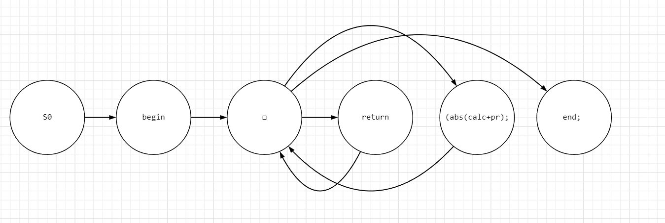

S0 S1 S2 S3 S4 S5