Week 3 Exploratory Data Analysis Findings
Group D Project: Rooftop Solar Variability and NSW Operational Demand
Prepared by: Bel Zhou | Data Engineer / Researcher
19,008  half-hourly records | Aug 2025–Aug 2026  analysis period | 0  missing intervals

1. Dataset Overview
The Week 3 modelling dataset combines NSW1 measured rooftop photovoltaic generation, NSW1 operational demand, Sydney Airport daily weather observations, and Sydney Airport North daily solar exposure. The common analysis period runs from 1 August 2025 to 31 August 2026 and contains 19,008 half-hourly records.
The merged time series has no duplicate timestamps and no missing 30-minute intervals. Operational demand is complete, while one rooftop PV value is missing. Solar exposure matches all records, and daily maximum temperature is available for 99.7% of records. The isolated missing values should be handled explicitly before model training rather than silently replaced.

2. Intraday Profiles
Rooftop PV follows a clear daylight pattern. Average generation is effectively zero overnight, rises rapidly after 05:00, and peaks at approximately 3,948 MW at 12:00. Generation then declines through the afternoon and returns to near zero by 19:30.
Operational demand moves in the opposite direction across much of the day. Average demand declines from 7,696 MW at 00:00 to its lowest half-hour average of approximately 6,215 MW at 12:30. Demand then rises sharply as rooftop PV falls, reaching its highest half-hour average of approximately 9,562 MW at 18:30. This opposing intraday pattern is consistent with rooftop PV reducing grid-observed demand during daylight hours, although EDA alone does not establish causality.

3. Seasonal Patterns
Seasonal averages show substantial variation in both variables. Average rooftop PV is highest in summer at 1,483 MW, followed by spring at 1,406 MW, autumn at 1,028 MW, and winter at 869 MW. Average operational demand is highest in winter at 8,381 MW and lowest in spring at 6,829 MW. Summer demand averages 7,492 MW, while autumn averages 7,366 MW.
Season | Average PV (MW) | Average demand (MW)
Summer | 1,483 | 7,492
Autumn | 1,028 | 7,366
Winter | 869 | 8,381
Spring | 1,406 | 6,829
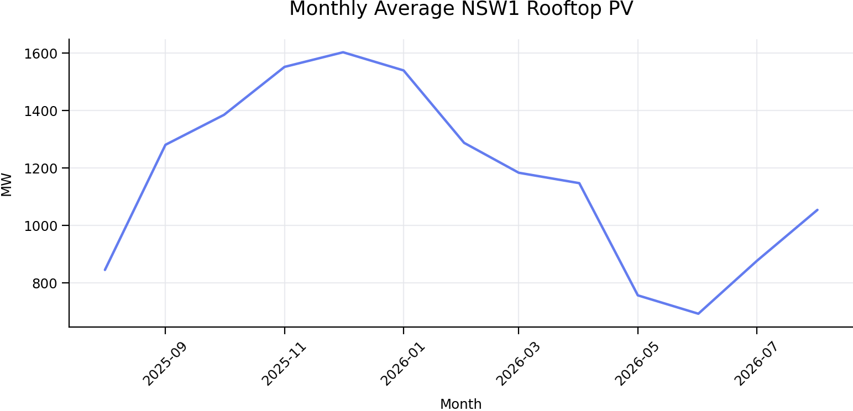
Figure 1. Monthly average NSW1 rooftop PV generation across the common analysis period.
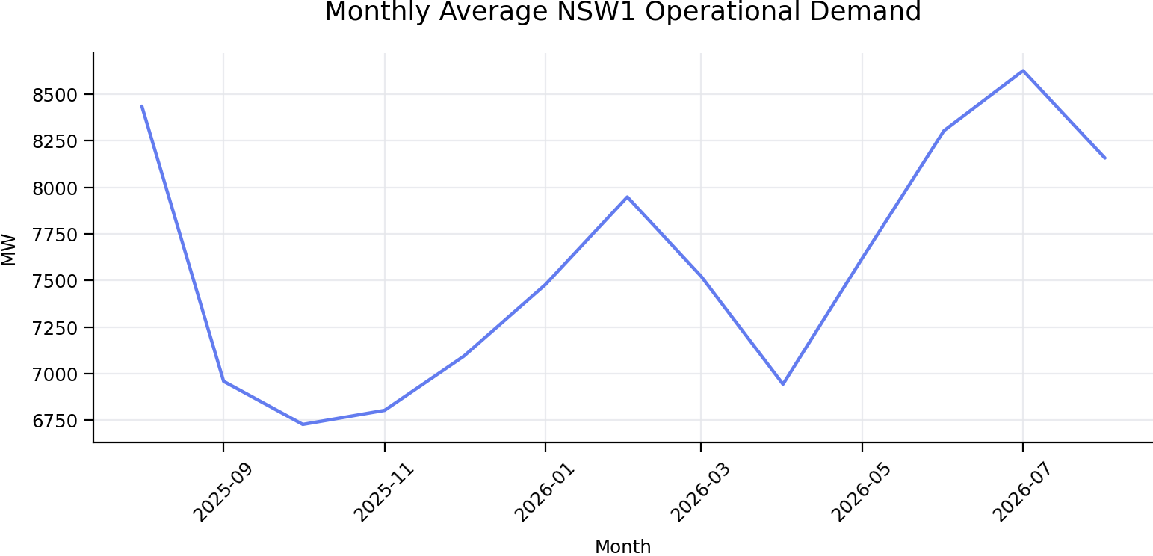
Figure 2. Monthly average NSW1 operational demand across the common analysis period.

4. Correlation Findings
The strongest relationship among the main project variables is the negative correlation between rooftop PV and operational demand (r = -0.536). This reflects their opposing half-hourly profiles, but the coefficient combines time-of-day, seasonal, weather, and behavioural effects and should not be treated as a causal estimate.
Rooftop PV has positive correlations with daily solar exposure (r = 0.242), sunshine hours (r = 0.186), and maximum temperature (r = 0.155). PV is negatively associated with 9am cloud amount (r = -0.119), 3pm cloud amount (r = -0.137), and rainfall (r = -0.063). These daily weather relationships are modest because one daily weather value is repeated across all 48 half-hour intervals and because rooftop PV is strongly driven by the intraday solar cycle.
Daily solar exposure is strongly related to sunshine hours (r = 0.706) and maximum temperature (r = 0.649), and negatively related to 9am cloud amount (r = -0.402) and 3pm cloud amount (r = -0.471). Sunshine hours and cloud amount are also strongly negatively correlated. These relationships indicate potential multicollinearity, so future models should avoid including all closely related weather variables without diagnostic testing or regularisation.
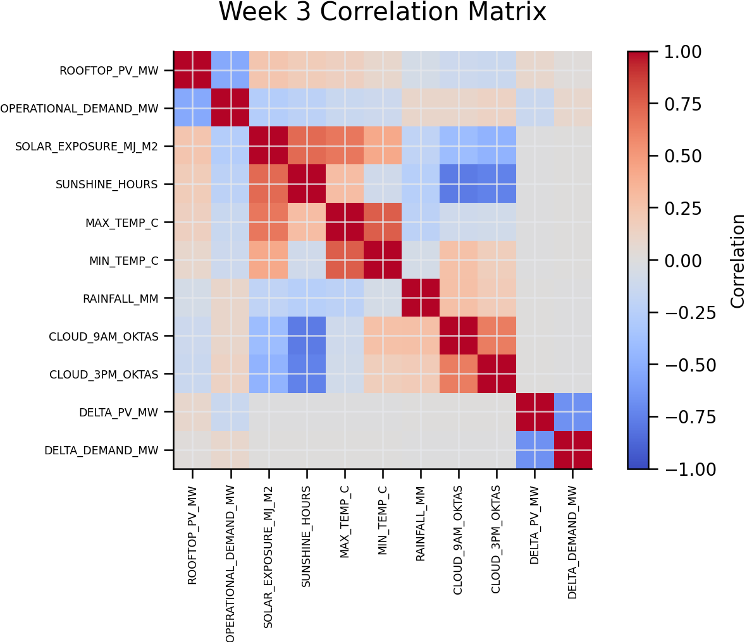
Figure 3. Correlation matrix for rooftop PV, operational demand, weather variables, and interval changes.

5. Feature Engineering Outcomes
The historical dataset was extended with features required for time-series and statistical modelling:
- Calendar features: year, month, month name, quarter, season, day of week, weekend flag, hour, minute, and half-hour slot.
- Weather features: minimum and maximum temperature, rainfall, sunshine hours, relative humidity, cloud amount, and solar exposure.
- Time-series features: 30-, 60-, and 120-minute lags for rooftop PV and operational demand.
- Change features: interval change in PV, interval change in demand, and PV ramp direction.
Lag and change variables provide a basis for examining short-term persistence and ramp events. They must be generated after chronological sorting and used with time-based train, validation, and test splits to avoid leakage.

6. Limitations
- The weather station represents Sydney Airport conditions and does not capture weather variation across the whole NSW1 region.
- Weather and solar exposure are daily measures repeated across half-hourly records, so they cannot explain within-day cloud movement or irradiance changes.
- The common modelling period begins in August 2025 because the combined weather dataset starts later than the AEMO PV and demand datasets.
- The analysis is observational. Correlations identify association, not the independent causal effect of rooftop PV on operational demand.
- One rooftop PV value and a small number of weather values are missing and require a documented treatment before modelling.

7. Implications for Week 4
The EDA supports progressing to chronological modelling that controls for hour, season, weekday or weekend status, and weather. The Week 4 workflow should begin with a transparent baseline regression, check residual patterns and multicollinearity, and compare the baseline against a non-linear benchmark. Model evaluation should use time-ordered holdout data rather than a random split.
Overall, the Week 3 dataset is suitable for the next modelling stage. The clearest descriptive finding is the inverse intraday relationship between rooftop PV and operational demand, alongside strong seasonal variation and meaningful weather associations.

