|  |  |
| --- | --- |
|  | **2014** |
|  | ITEVO, LLC  By Tanes Kanchanawanchai |

|  |
| --- |
| POSbravo Point of Sale System  Developer Guide |
| The guideline to develop POSbravo and documentations. |

# Source Code Repository

The latest source code can be found from.

<https://github.com/csc201/FinalProject.git> (public repository for education purpose only)

<https://posquick@bitbucket.org/posquick/posbravo.git> (private repository need to get permission and license from ITEVO, LLC)

Instructions on how to download and get the development environment setup can be found under readme.txt and youtube VDO (search by Tanes Kanchanawanchai keyword and look for Git, Bitbucket, and Eclipse setup).

# GUI Guide

## SystemInit JFrame (SystemInit.java)

First, to run the program start the program form SystemInit.java.

SystemInit is a JFrame with the following JPanels and JComponents (See Figure1: SystemInit JFrame)

added.

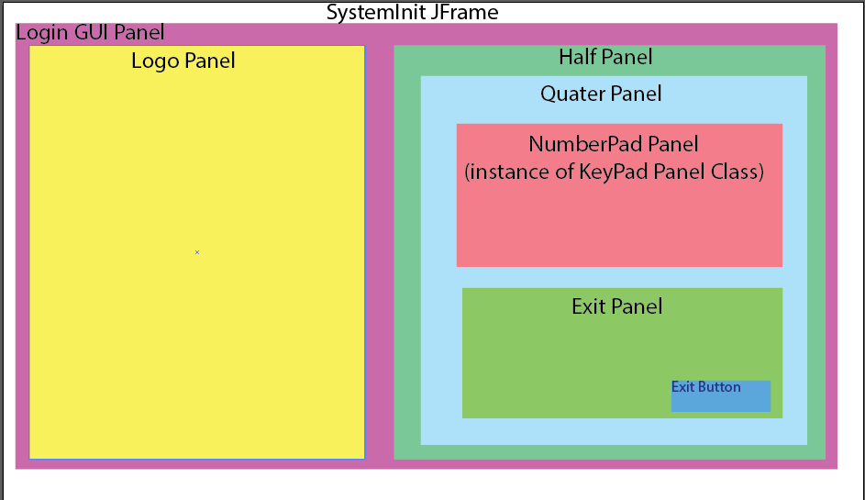

Figure 1 SystemInit JFrame

## Keypad Panel (Keypad.java)

Next, Keypad.java is the second class to read after SystemInit.java.

Keypad is a JPanel with the following JPanels and JComponents (See Figure2: Keypad Panel) added.

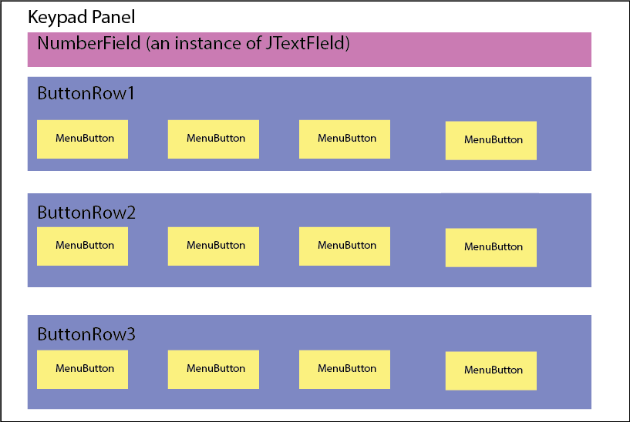

Figure 2 Keypad Panel

## TransactionGUI Panel (TransactionGUI.java)

Next, TransactionGUI.java is the third class to read after KeyPad.java.

TransactionGUI is a JPanel with the following JPanels and JComponents (See Figure3:

TransactionGUI Panel) added.