**Name of the Project**: HANGMAN

**Description of the Project**:

1. Play individually.
2. Have the individual select a letter of the alphabet.
3. If the letter is contained in the word/phrase,
4. The letter will get revealed.
5. No portion of the hangman is added.
6. The individual continues another turn guessing a letter.
7. If the letter is not contained in the word/phrase,
8. A portion of the hangman is added.
9. The individual continues another turn guessing a letter.
10. The game continues until:
11. The word/phrase is guessed (all letters are revealed) – WINNER

or,

1. All the parts of the hangman are displayed – LOSER

**Diagram of the Project**:

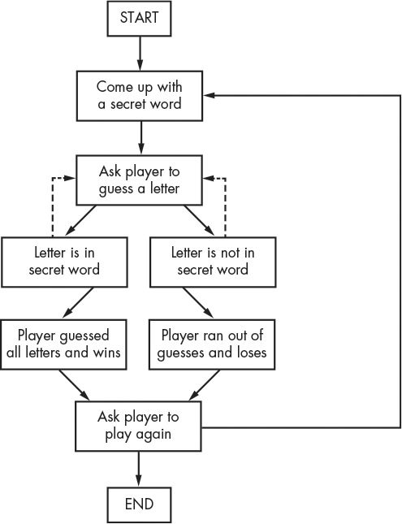

**Details of keyboard and mouse functions**:

1. User can give input any letter from the keyboard.
2. The given input will be read as a character by defined function.
3. By pressing the first letter as input, cloud will start moving.
4. When a user presses any letter, If the letter is contained in the word, the letter will show up as many times as there are. If the user presses the same letter furthermore, no effect will be happened.
5. If the word is guessed correctly, ”WINNER” string will show up automatically.
6. If all the parts of the hangman are displayed, ”LOSER” string will show up automatically.
7. No mouse functions have been used.

