VulnaraStore
Web Application Security Assessment
Penetration Test Report
Target: localhost:9000 (VulnaraStore dev instance)
Engagement type: Authorized / self-directed application security testing (training environment)
Report date: 25 September 2026
Classification: Confidential

1. Executive Summary
This report documents the results of a security assessment of the VulnaraStore web application (localhost:9000), a deliberately vulnerable e-commerce site used as a hands-on training/CTF target with a built-in "Case Board" that tracks findings by category (Injection, Broken Access Control, Broken Authentication, Security Misconfiguration, SSRF, etc.).
Testing identified 14 findings spanning 2 Critical, 4 High, 4 Medium, 3 Low, and 1 Informational issue. The most severe issues are a publicly accessible .env file that discloses production-style database credentials and internal secrets, and a complete lack of authorization enforcement on the administrative back office, which a standard authenticated user was able to reach directly by URL. These two findings alone would be sufficient for a full compromise of the application and its data in a real deployment.
In addition, the application is vulnerable to both reflected and stored Cross-Site Scripting, and to SQL injection through at least one unauthenticated, unparameterized query parameter. Because the session cookie is readable from JavaScript (no HttpOnly flag), the XSS findings can be chained directly into full session hijacking, as demonstrated during testing by popping document.cookie and recovering a live session token.
The remaining findings are misconfigurations and hardening gaps (robots.txt pointing at sensitive paths, directory listing, verbose stack traces, weak password policy, user enumeration, an unauthenticated client-side map of the entire admin API surface, and a possible SSRF vector in image-fetching endpoints) that materially lower the effort required for an attacker to exploit the Critical/High issues above.
Overall risk rating: Critical.

1.1 Findings at a glance
ID | Finding | Severity
F-01 | Sensitive .env configuration file publicly accessible (DB credentials, session secret, internal API token) | Critical
F-02 | Broken access control — /admin back office reachable by a standard user account | Critical
F-03 | SQL injection in the products "category" parameter | High
F-04 | Reflected Cross-Site Scripting (XSS) in product search | High
F-05 | Stored Cross-Site Scripting (XSS) in product reviews | High
F-06 | Session token exposed to client-side scripts (missing HttpOnly) | High
F-07 | Sensitive paths disclosed via robots.txt | Medium
F-08 | Directory listing enabled on /uploads/ | Medium
F-09 | Verbose error messages / debug mode expose stack traces | Medium
F-10 | Weak password policy (8-character maximum) | Medium
F-11 | User enumeration on account registration | Low
F-12 | Unauthenticated exposure of admin/account API surface via client-side JS | Low
F-13 | Potential SSRF via server-side URL fetch (avatar / product image sync) | Low
F-14 | Cart pricing inconsistency observed (client-rendered EGP 0.00) | Info

2. Scope & Methodology
Target: http://localhost:9000 — VulnaraStore (local dev instance, NODE_ENV=development)
Accounts used: Two self-registered standard accounts ("aaa", "wiener"); no credentials were supplied by the application owner beyond standard self-registration
Approach: Black-box, manual exploratory testing from the browser and browser DevTools, following the OWASP Top 10 categories mirrored by the application’s own Case Board (Injection, Broken Access Control, Broken Authentication, Security Misconfiguration, SSRF, etc.)
Out of scope: Automated scanning, denial-of-service testing, and social engineering were not performed
All testing was carried out against a local training instance explicitly designed to contain intentional vulnerabilities; no real user data was accessed.

3. Risk Rating Scale
Severity | Definition
Critical | Directly leads to full compromise of the application, its data, or its infrastructure with little or no further effort.
High | Significant impact to confidentiality, integrity, or availability; typically exploitable by any user or unauthenticated attacker.
Medium | Meaningful weakening of security posture or a building block toward a higher-severity attack.
Low | Limited direct impact but relevant hardening gap or information disclosure.
Info | Observation warranting further testing; impact not yet confirmed.

4. Detailed Findings

F-01 Sensitive .env Configuration File Publicly Accessible
Severity: Critical | Indicative CVSS 3.1: 9.8 (AV:N/AC:L/PR:N/UI:N/S:U/C:H/I:H/A:H)
The application’s environment file is reachable directly over HTTP and was successfully downloaded from the running instance. It contains the database host, port, admin-level database credentials, the application session-signing secret, and an internal API token — everything needed to fully compromise the data layer and forge trusted sessions or internal API calls.
Evidence
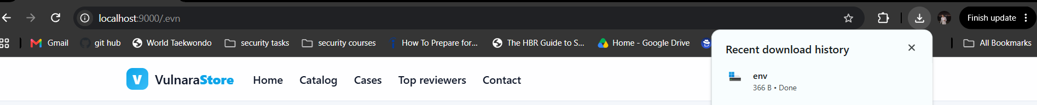
The env file was fetched and saved directly from the browser.
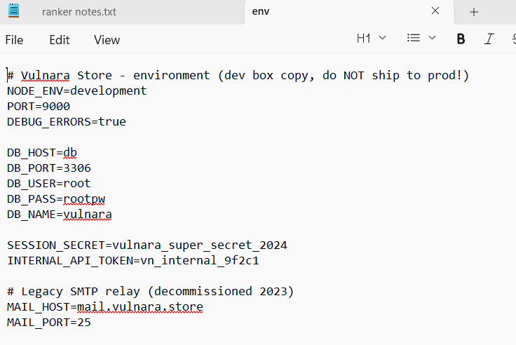
Contents of the exposed .env: DB_USER=root, DB_PASS=rootpw, SESSION_SECRET, and INTERNAL_API_TOKEN are all disclosed, alongside a comment confirming it is a "dev box copy" not meant to reach production.
Impact
- Full read/write access to the application database using the disclosed root credentials.
- Ability to forge valid session tokens/JWTs using the disclosed SESSION_SECRET, impersonating any user including admins.
- Use of the INTERNAL_API_TOKEN to call internal/privileged APIs directly, bypassing the web front end entirely.
Recommendation
- Ensure the web server never serves dotfiles or files outside the public web root (deny access to .env, .git, and similar at the reverse proxy/web-server level, not just via robots.txt).
- Move secrets out of a file served from the web root; use environment variables injected by the process manager/orchestrator or a secrets manager.
- Rotate the exposed DB credentials, session secret, and internal API token immediately.

F-02 Broken Access Control — Admin Back Office Reachable by a Standard User
Severity: Critical | Indicative CVSS 3.1: 9.1 (AV:N/AC:L/PR:L/UI:N/S:U/C:H/I:H/A:N)
Navigating directly to /admin while authenticated as a standard, non-privileged account ("wiener") returned the full back-office dashboard, including customer counts, product counts, order counts, total revenue, and a list of recent orders with customer usernames and order totals. There is no visible authorization check preventing a normal user from reaching administrative functionality by URL.
Evidence
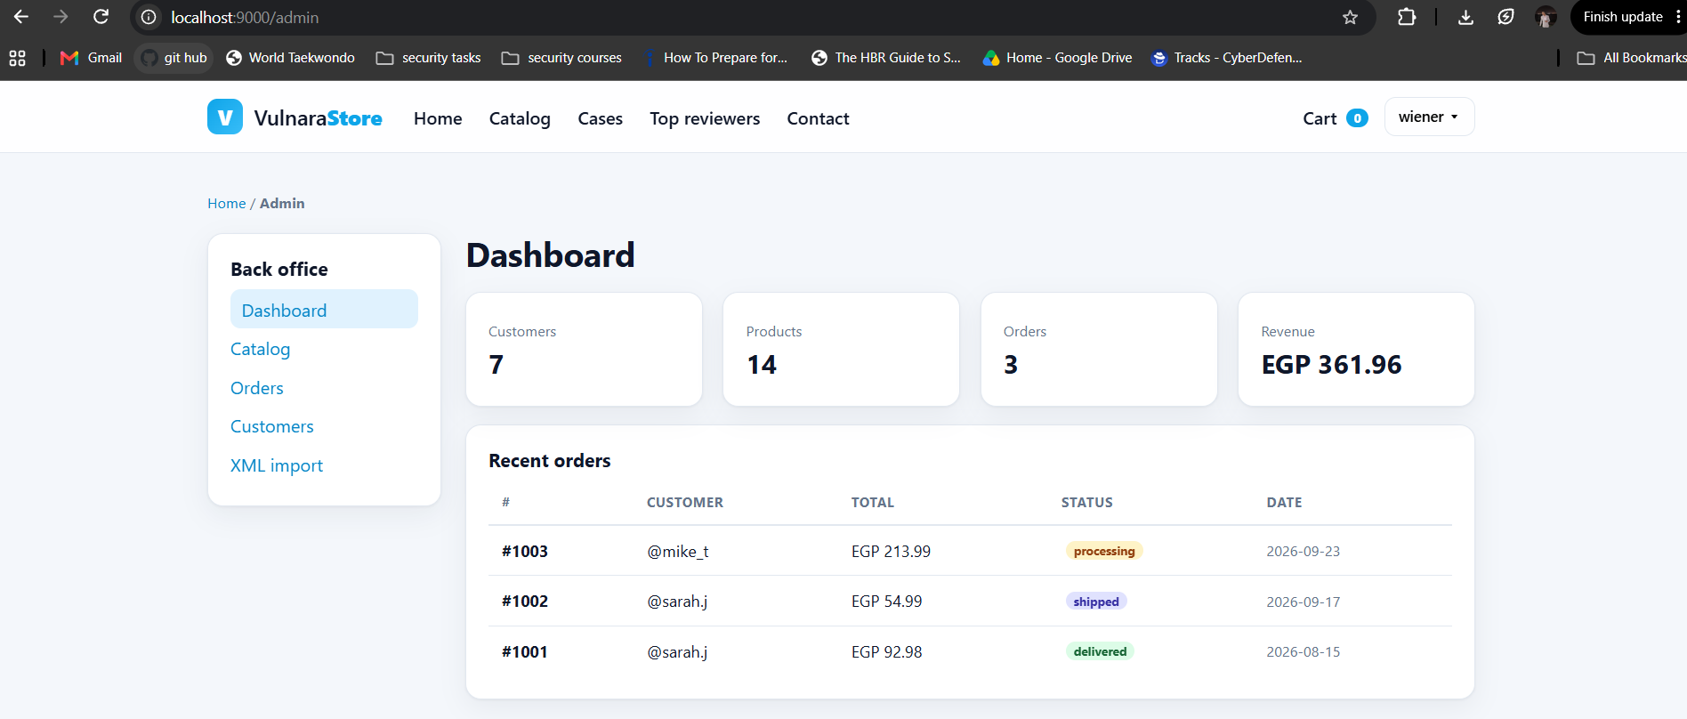
The account "wiener" (a self-registered standard user, not an admin) loads /admin directly and sees the full dashboard: 7 customers, 14 products, 3 orders, EGP 361.96 revenue, and per-order customer detail.
Impact
- Any registered user can view business-sensitive data (revenue, order/customer counts, other customers’ order history).
- Combined with F-12 (client-side admin.js exposing action endpoints such as product deletion, order status changes, and user role changes), this plausibly allows a standard user to modify products/orders or escalate their own role — this should be confirmed with targeted follow-up testing of each admin endpoint.
Recommendation
- Enforce server-side role checks (middleware) on every /admin/* route and API endpoint; never rely on hiding a navigation link as the only control.
- Apply the principle of least privilege and re-validate authorization on every request, not just at login.
- Add automated tests that assert non-admin sessions receive 403 on all admin routes.

F-03 SQL Injection in the "category" Parameter
Severity: High | Indicative CVSS 3.1: 8.6 (AV:N/AC:L/PR:N/UI:N/S:U/C:H/I:L/A:L)
Supplying the literal string <value> as the category query parameter (/products?category=<value>) produced an unhandled MySQL syntax error, confirming the parameter is concatenated directly into the SQL query rather than passed as a bound parameter. The returned stack trace also discloses the query structure (...ORDER BY p.featured DESC, p.id ASC) and the exact source location (/app/src/routes/products.js:26).
The application’s own Case Board reinforces this finding, hinting that the login form’s email field is injectable in a way that can make the WHERE clause always evaluate true — a classic authentication-bypass SQL injection pattern (e.g. ' OR '1'='1).
Evidence
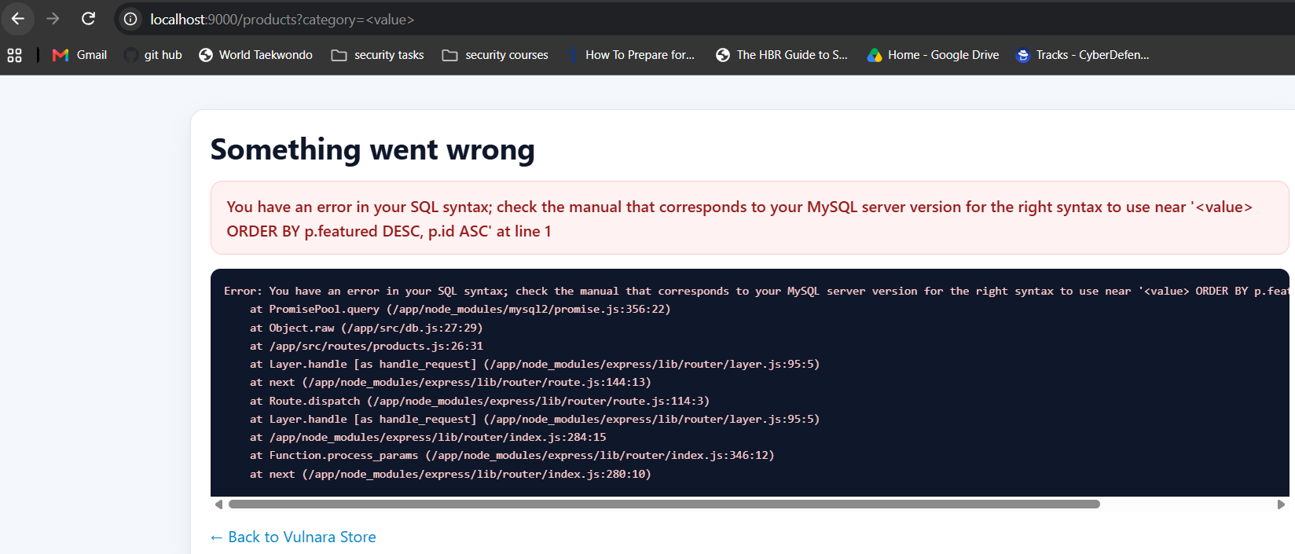
Unhandled MySQL syntax error returned to the client, including the full internal stack trace and file path.
Impact
- Data exfiltration from the database (products, orders, customers, credentials) via UNION-based or boolean/time-based blind injection.
- Potential authentication bypass on the login form per the category hint.
Recommendation
- Use parameterized queries / prepared statements (or an ORM/query builder that does so) for every user-influenced value, including category and any sort/filter parameters.
- Apply an allow-list for values like category or sort direction where practical.
- Disable verbose SQL error output to clients in all environments other than local development (see F-09).

F-04 Reflected Cross-Site Scripting in Product Search
Severity: High | Indicative CVSS 3.1: 7.4 (AV:N/AC:L/PR:N/UI:R/S:C/C:H/I:L/A:N)
The search query parameter on /products is reflected into the page without HTML-encoding. Submitting "><svg onload=alert(1)> or <script>alert(document.cookie)</script> executes arbitrary JavaScript in the victim’s browser, and was shown to successfully read and display the live session cookie.
Evidence
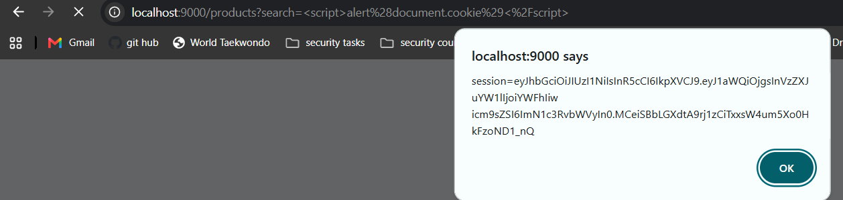
Payload <script>alert(document.cookie)</script> submitted via /products?search= executes and displays the full session cookie value in an alert dialog.
Impact
- An attacker who gets a victim to click a crafted search link can steal the victim’s session cookie and hijack their account (see F-06).
- Can be used for phishing, defacement, or as a pivot to further client-side attacks (keylogging, credential harvesting forms, etc.).
Recommendation
- HTML-encode all user-controlled values before rendering them into HTML, or use a templating engine with auto-escaping enabled by default.
- Add a strict Content-Security-Policy (e.g. disallow inline scripts) as defense-in-depth.

F-05 Stored Cross-Site Scripting in Product Reviews
Severity: High | Indicative CVSS 3.1: 8.7 (AV:N/AC:L/PR:L/UI:N/S:C/C:H/I:L/A:N)
The "Write a review" field on a product page does not sanitize or encode submitted text before storing and later re-rendering it. Payloads such as "><svg onload=alert(2)> and <script>alert(document.cookie)</script> were accepted, persisted, and executed automatically for every subsequent visitor who views that product’s reviews — including, potentially, an administrator moderating reviews.
Evidence
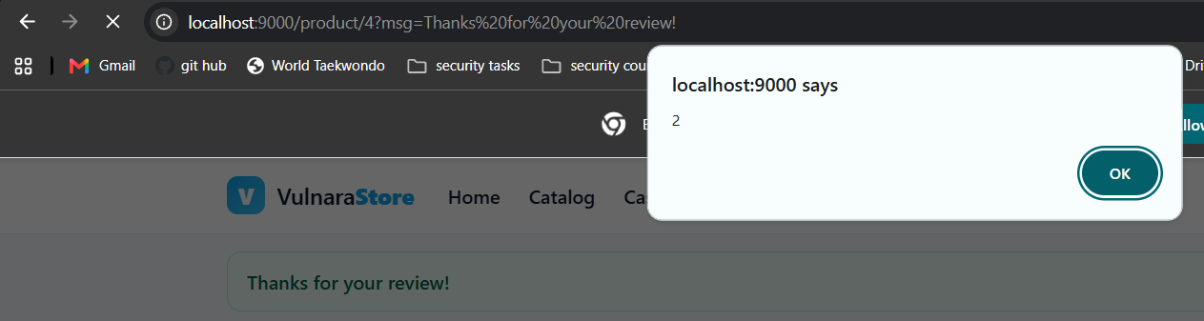
A payload submitted as a review on one product page fires automatically ("2") on a later, unrelated page load — confirming the script executes for any visitor, not just the submitter.
Impact
- Higher severity than the reflected variant: no victim interaction with a crafted link is required, only viewing the affected product page.
- Because it can also fire for privileged users viewing/moderating reviews, this is a realistic path to compromising an admin session.
Recommendation
- Encode review text on output (and/or strip disallowed HTML on input using a vetted sanitization library).
- Apply the same output-encoding fix as F-04 consistently across every place user content is rendered.

F-06 Session Token Exposed to Client-Side Scripts (Missing HttpOnly)
Severity: High | Indicative CVSS 3.1: 7.5 (AV:N/AC:L/PR:N/UI:R/S:U/C:H/I:N/A:N)
The session cookie/JWT is readable via document.cookie from JavaScript, as demonstrated directly by the XSS proofs-of-concept above, which displayed the full token value. A properly configured session cookie should be inaccessible to client-side script.
Impact
- Any XSS anywhere in the application (see F-04/F-05) can be trivially escalated into full session hijacking.
Recommendation
- Set the HttpOnly flag on the session cookie (and Secure + SameSite=Lax/Strict once served over HTTPS).
- Treat this as defense-in-depth alongside — not a substitute for — fixing the underlying XSS in F-04/F-05.

F-07 Sensitive Paths Disclosed via robots.txt
Severity: Medium | Indicative CVSS 3.1: 5.3 (AV:N/AC:L/PR:N/UI:N/S:U/C:L/I:N/A:N)
robots.txt explicitly lists /admin, /debug, /.env, and /uploads/ as disallowed paths. While intended to stop search-engine crawling, this file is public and effectively hands an attacker a shortlist of the most sensitive endpoints to probe first.
Evidence
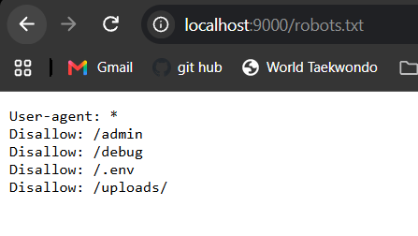
robots.txt Disallow entries pointing directly at /admin, /debug, /.env and /uploads/.
Recommendation
- Do not rely on robots.txt to hide sensitive paths — it is not an access control. Restrict these paths with real authentication/authorization and remove them from robots.txt, or replace them with a non-guessable structure.

F-08 Directory Listing Enabled on /uploads/
Severity: Medium | Indicative CVSS 3.1: 5.3 (AV:N/AC:L/PR:N/UI:N/S:U/C:L/I:N/A:N)
Requesting /uploads/ directly returns a full, browsable index of the directory’s contents rather than a 403/404. This exposes the existence and names of files in that directory (currently readme.txt) and would expose any future user-uploaded content, such as review photos, to anyone who guesses or browses the path.
Evidence
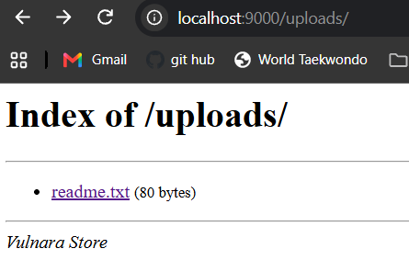
Auto-generated "Index of /uploads/" listing.
Recommendation
- Disable directory listing (autoindex) on the web server for all static/upload directories.
- Store uploaded files with unguessable names and serve them only via an authorization-checked route if they are not meant to be public.

F-09 Verbose Error Messages / Debug Mode Expose Internal Details
Severity: Medium | Indicative CVSS 3.1: 5.3 (AV:N/AC:L/PR:N/UI:N/S:U/C:L/I:N/A:N)
The exposed .env confirms DEBUG_ERRORS=true. In practice this means unhandled exceptions (such as the SQL injection in F-03) return full stack traces to the client, disclosing internal file paths (/app/src/routes/products.js), the web framework (Express) and database driver (mysql2/promise) in use, and internal call stacks — all valuable reconnaissance for an attacker.
Recommendation
- Disable verbose/debug error output outside of local development; return a generic error page to clients and log full details server-side only.

F-10 Weak Password Policy (8-Character Maximum)
Severity: Medium | Indicative CVSS 3.1: 4.3 (AV:N/AC:L/PR:N/UI:N/S:U/C:N/I:L/A:N)
The registration form caps passwords at 8 characters ("Password (up to 8 characters)"). Capping rather than enforcing a minimum length reduces the maximum possible entropy, rules out the use of longer passphrases, and weakens resistance to offline brute-force in the event of a credential leak (which, given F-01, is a realistic scenario here).
Recommendation
- Allow (and encourage) long passphrases — remove the upper bound or set it well above 64 characters — and enforce a reasonable minimum length instead.
- Hash passwords with a slow, modern algorithm (bcrypt/scrypt/argon2) with a per-user salt if not already in place.

F-11 User Enumeration on Account Registration
Severity: Low | Indicative CVSS 3.1: 3.7 (AV:N/AC:L/PR:N/UI:N/S:U/C:L/I:N/A:N)
Attempting to register with a username or email that is already in use returns the explicit message "That username or email is already registered.", which lets an attacker enumerate valid accounts for targeted credential-stuffing or phishing. By contrast, the password-reset flow (/forgot) correctly returns a generic message regardless of whether the submitted email exists — this is a positive control worth preserving.
Evidence
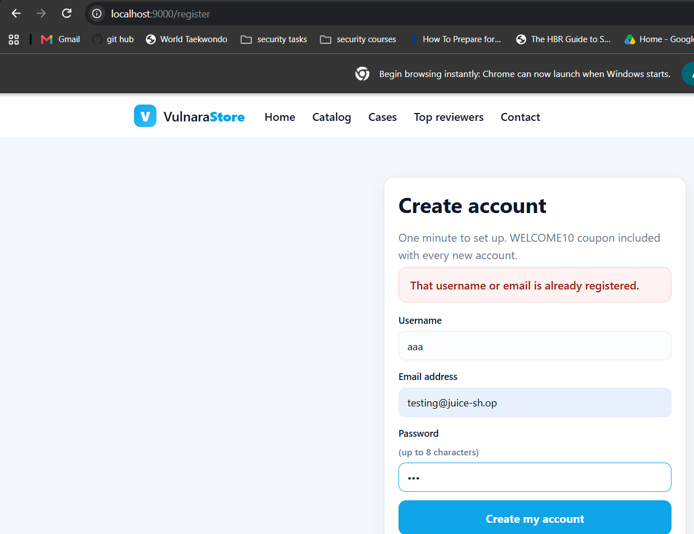
Registration form explicitly confirms the username/email is already registered.
Recommendation
- Use a generic message on registration as well (e.g. "If this email can be used, we’ve sent you a confirmation"), or rate-limit and monitor repeated registration attempts to reduce enumeration value.

F-12 Unauthenticated Exposure of the Admin/Account API Surface via Client-Side JS
Severity: Low | Indicative CVSS 3.1: 4.0 (AV:N/AC:L/PR:N/UI:N/S:U/C:L/I:N/A:N)
The application ships unminified, unauthenticated JavaScript (admin.js, profile.js) that documents the full set of back-office and account API routes and payloads: /admin/products/delete, /admin/products/sync-image, /admin/orders/{id}/status, /admin/users/{id}/role, /profile/update, /profile/avatar-url, and /account/redeem. Any visitor — authenticated or not — can read this file and learn exactly how to call these endpoints, which meaningfully lowers the effort needed to exploit F-02.
Evidence
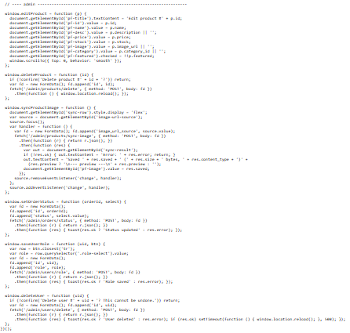
admin.js: deleteProduct, syncProductImage, updateOrderStatus, saveUserRole and deleteUser calls, with their target endpoints and HTTP methods, are all visible in client-side source.
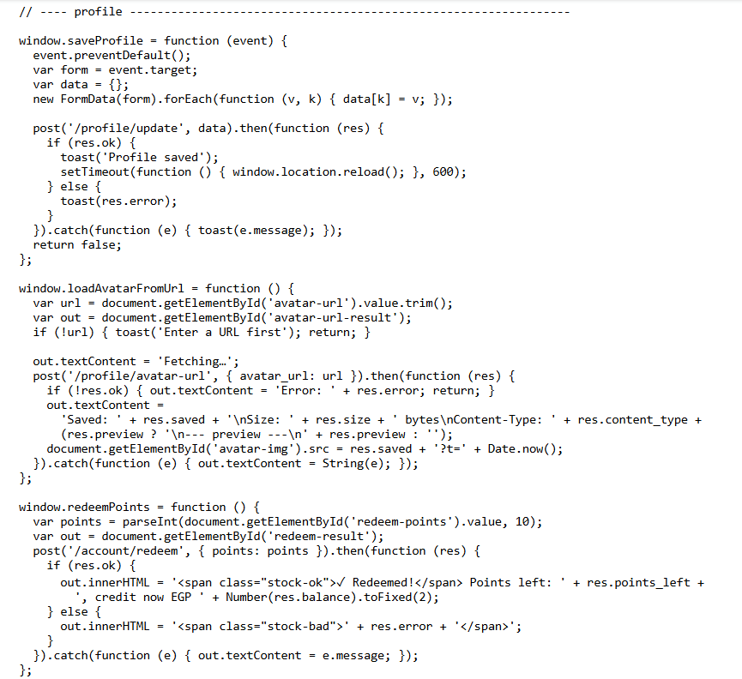
profile.js: saveProfile, loadAvatarFromUrl (calls /profile/avatar-url with an attacker-supplied URL) and redeemPoints (calls /account/redeem) are all visible in client-side source.
Recommendation
- This is not a vulnerability on its own, but treat client-side code as fully public: never rely on it being "hard to find", and ensure every endpoint it references independently enforces authentication and authorization server-side (see F-02).

F-13 Potential SSRF via Server-Side URL Fetch (Avatar / Product Image Sync)
Severity: Low | Indicative CVSS 3.1: 5.9 (AV:N/AC:L/PR:L/UI:N/S:U/C:L/I:N/A:N) — provisional, pending confirmation
The /profile/avatar-url and /admin/products/sync-image endpoints (identified via F-12) accept an arbitrary URL, fetch it server-side, and return metadata (size, content type, and a preview) about the response. This is a classic Server-Side Request Forgery pattern. It was not exploited during this assessment, but was not ruled out either; it is flagged for dedicated follow-up testing, e.g. pointing the URL at an internal/loopback address, a cloud metadata endpoint (169.254.169.254), or an out-of-band collaborator domain to confirm whether the server enforces any destination allow-list.
Recommendation
- Restrict outbound fetches from these endpoints to an allow-list of external image hosts; block requests to private/loopback/link-local IP ranges and to non-HTTP(S) schemes.
- If internal use of these endpoints is required, place them behind the same authorization checks recommended in F-02 and disable them for standard users entirely.

F-14 Cart Pricing Inconsistency Observed
Severity: Info | Indicative CVSS 3.1: Not scored — requires reproduction
During testing, the cart page (/cart) was observed rendering EGP 0.00 for both the line item and cart total for a product that, on other visits, correctly priced at EGP 27.99, with browser DevTools open at the time of the anomaly. This could be a benign client-side rendering/race-condition issue, or could indicate that price values are trusted from the client rather than recalculated server-side at checkout. It is recorded here as an informational item for follow-up rather than a confirmed vulnerability.
Evidence
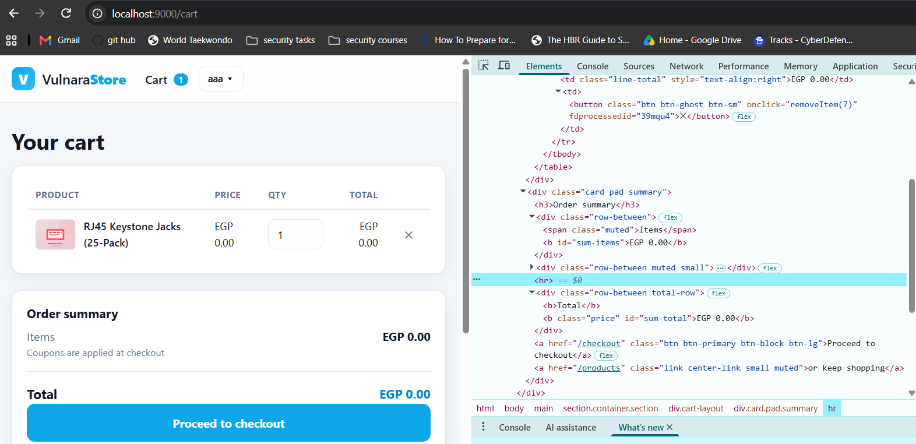
Cart showing EGP 0.00 for item and total, alongside the DOM in DevTools, versus the correct EGP 27.99 seen on a separate visit to the same cart.
Recommendation
- Reproduce reliably (e.g. by tampering with quantity/price fields client-side or via intercepted requests) and confirm whether the server independently recalculates line totals and the grand total at checkout, ignoring any client-supplied price.

5. Prioritized Remediation Roadmap

Immediate (Critical)
- Block public access to .env and rotate all disclosed secrets (F-01).
- Enforce server-side authorization on every /admin/* route and action endpoint (F-02).

Short term (High)
- Parameterize all SQL queries, starting with the category filter and the login form (F-03).
- Apply output encoding everywhere user input is rendered, closing both the reflected and stored XSS (F-04, F-05).
- Set HttpOnly (and Secure/SameSite) on the session cookie (F-06).

Medium term
- Disable directory listing, remove sensitive paths from robots.txt, and turn off verbose debug errors outside local development (F-07–F-09).
- Strengthen the password policy and align registration error messages with the reset flow’s generic messaging (F-10, F-11).

Follow-up testing
- Confirm/rule out SSRF on the avatar and product-image-sync endpoints, and verify server-side price recalculation at checkout (F-13, F-14).

6. Conclusion
VulnaraStore currently exhibits a Critical overall risk level driven primarily by an exposed secrets file and the complete absence of authorization checks on administrative functionality. Both are inexpensive to fix and should be treated as immediate priorities. The injection and cross-site scripting findings, while individually High rather than Critical, compound the risk significantly because the session cookie is scriptable — meaning any one of several XSS entry points can be used to hijack a session, including, plausibly, an administrator’s. Addressing the roadmap in Section 5, in order, would remove the paths to full compromise identified during this assessment and bring the application to a materially stronger baseline security posture.

