Real-time Particle System using OpenGL (Legacy)
BY:
Belal Hesham 232465
Abdelrahman Mohamed 233729
Supervisor: Prof. Tamer M. Nassef
TA Supervisor: ENG. Youssef Amer

1. Introduction
This project presents a real-time 3D particle-based fire simulation implemented using OpenGL Legacy (Fixed Pipeline) and CPU-based physics calculations. The system fully incorporates 3D particle movement, vortex motion, and lateral user-controlled forces for a realistic visual effect. The goal of the project is to demonstrate fundamental concepts in computer graphics, particle systems, physics-based animation, and interactive camera control, while maintaining real-time performance.

2. System Overview
The system consists of the following main components:
- CPU-based 3D particle simulation loop
- OpenGL fixed-function rendering pipeline
- Interactive orbit camera with mouse and keyboard controls
- Lateral wind control using keyboard input (A/D keys)
- Optional vortex motion (Left/Right arrow keys)

3. Particle Structure
Each particle has the following properties:
struct Particle {
float x, y, z; // Position in 3D space
float vx, vy, vz; // Velocity in 3D
float life, maxLife; // Lifetime management
float angle; // Rotation for visual variation
float spin; // Rotational speed
};
Particles are initialized with randomized positions around a 3D emitter volume, randomized velocities, lifetime, and rotation to create natural-looking fire behavior.

4. Particle Simulation and Physics
4.1 Update Loop
For each frame, the simulation performs:
- Lifetime decrement: particles that reach zero lifetime are respawned.
- Movement update:
p.x += p.vx * dt * (0.6f + t * 2.2f) + sideForce * dt * (0.8f + t * 2.5f);
p.y += p.vy * dt;
p.z += p.vz * dt * (0.6f + t * 2.2f);
- Vortex rotation (if activated): particles rotate around the emitter center on the Y-axis.
- Angle update: each particle rotates by its spin to enhance visual realism.
4.2 Lateral Force Control
- sideForceTarget is updated using A/D keys:
  - A → -1 (left)
  - D → +1 (right)
- sideForce is smoothly interpolated toward the target for fluid motion:
sideForce += (sideForceTarget - sideForce) * dt * 6.0f;
- This creates the effect of fire swaying left and right.
4.3 Vortex Motion
- Activated by Left/Right arrow keys:
  - Left → negative angular velocity
  - Right → positive angular velocity
- Particles rotate around the Y-axis of the emitter using rotation matrices.

5. Rendering
- Each particle is drawn as a quad in 3D space with additive blending:
glColor4f(1.0f, 0.5f*alpha, 0.1f, alpha);
glVertex3f(p.x + rx, p.y + ry, p.z);
- The size of each particle scales with its remaining life.
- Depth testing ensures proper occlusion and perspective rendering.

6. Camera System
6.1 Orbit Camera
- Implemented using spherical coordinates:
float cx = camDist * cosf(pitchRad) * sinf(yawRad);
float cy = camDist * sinf(pitchRad);
float cz = camDist * cosf(pitchRad) * cosf(yawRad);
gluLookAt(cx, cy, cz, 0, 0, 0, 0, 1, 0);
- Yaw and pitch are controlled by mouse drag.
- Zoom controlled via mouse wheel.
6.2 Camera Constraints
- Pitch clamped between -89° and +89° to avoid flipping.
- Distance clamped between 0.8 and 6.0 units for optimal view.

7. User Interaction
- Particle count: +/- keys to increase/decrease particle number.
- Particle size: Up/Down keys.
- Vortex motion: Left/Right keys.
- Lateral wind: A/D keys.
- Camera control: Mouse drag for yaw/pitch, mouse wheel for zoom.

8. Demonstration Images
- Figure 1: Initial particle state before user interaction.
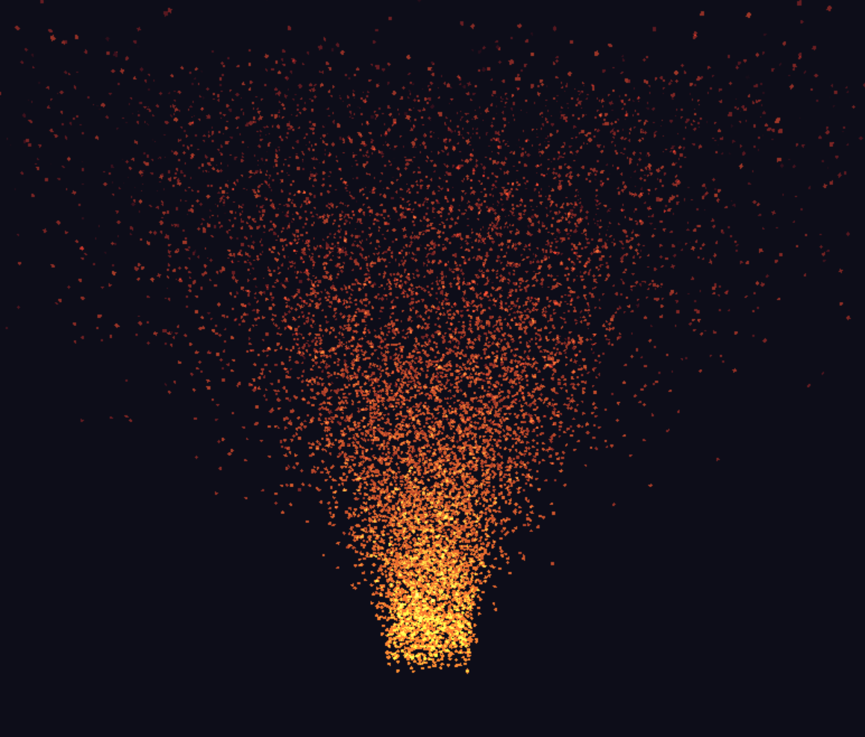

- Figure 2: Particle system after user interaction.

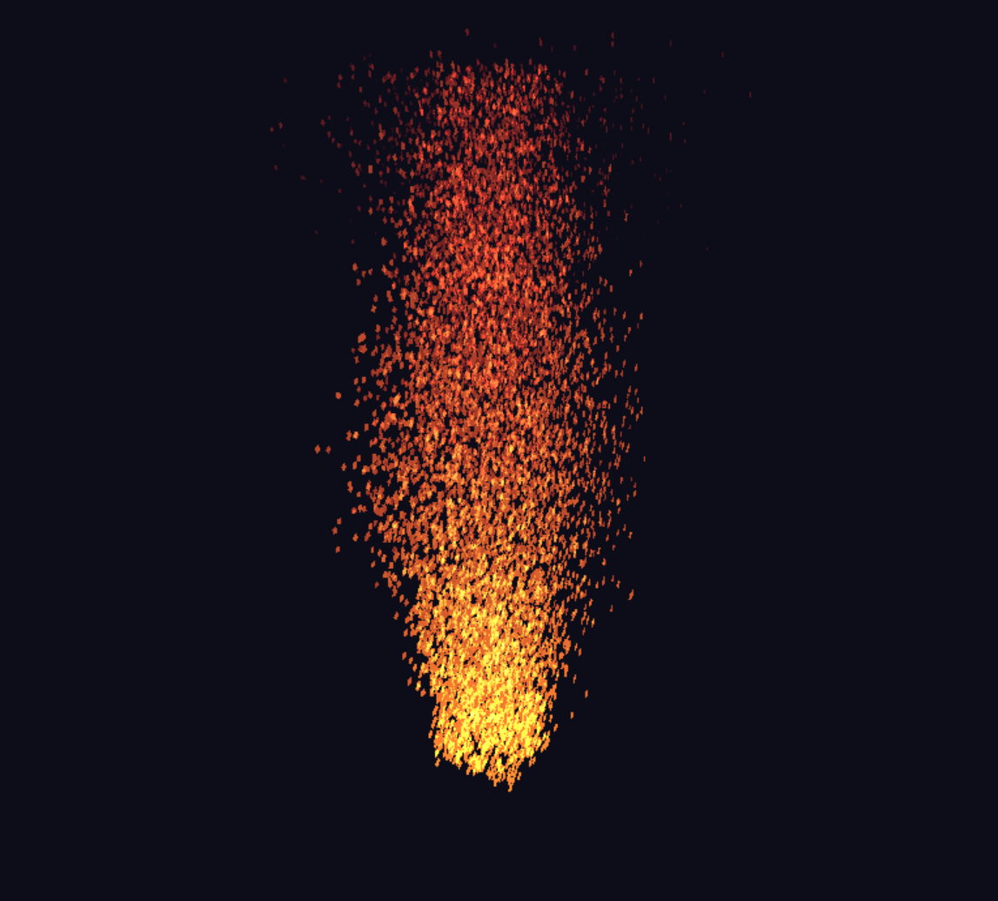

9. Summary
The updated 3D particle system demonstrates realistic fire simulation in a CPU-based OpenGL legacy environment. The combination of vortex motion, lateral wind control, particle spin, and an interactive camera provides both visual appeal and interactivity suitable for educational and demonstration purposes.

