BELAM-RĪGA
BLM Business Central Extensions
Deployment Guide — Publishing to Production

Why this guide exists
Today, only one person can build and publish these apps to production, because doing so required a local development setup and personal Business Central credentials. If that person is unavailable — for example right after a Business Central version upgrade removes our custom extensions — nobody else could restore them.
This is now fixed. Publishing any of the 4 apps below to production is a single button click on GitHub, from any web browser. No installed software, no AL/Business Central knowledge, and no credentials are ever typed in — the deployment credential lives securely on GitHub and is used automatically.
What you need:
• A web browser
• A GitHub account that's a member of the Belam-Riga organization (you already have this)
• Nothing else

The 4 apps
Each app lives in its own GitHub repository and is deployed independently. Repeat the steps in this guide once per app you need to (re)publish.
App | GitHub repo | What it does
BLM Registers | blm_registers | Counteragents, Invoices IN/OUT, Payments, Projects, Contact/SharePoint sync. The main, most actively used extension.
BLM Tools | blm_tools | Employee records and diagnostics.
BLM Lursoft | blm_lursoft | Looks up Baltic company registry (Lursoft) data for Latvia, Lithuania and Estonia.
BLM VAT Advance Payments | blm_vat_advance_payments | VAT reporting for advance payments.

Each repository's web address is: github.com/Belam-Riga/<repo name> — for example, github.com/Belam-Riga/blm_registers.

Understanding the version number
Each app has a version number with 4 parts, for example 1.10.1.23. Only the first 3 numbers matter — that's the real version, and it's what changes whenever a real feature or fix ships.
1 . 10 . 1 . 23
│ │ │ └─ automatically generated, means nothing on its own
│ │ └─ the real version ──────────────────┘
The last number is filled in automatically by the deployment system — it's just a counter for how many times the system has run, not something anyone chooses. It will often look different between the test environment and production, and that's completely normal — don't try to make them match. If you want to check “is production running the latest version”, compare only the first three numbers.

How to publish an app to Production
Repeat these steps for each app you need to publish. It takes about 2–5 minutes per app.

Step by step
- Open a web browser and go to github.com/Belam-Riga/<repo name> (see the table on page 2 for the exact name, e.g. blm_registers).
- Click the “Actions” tab near the top of the page.
- In the left-hand list of workflows, click “Publish To Environment”. If it is not listed press “Show more workflows”, find “Publish to Environment” there. This option can be pinned so next time it is at the top of the list
- Click the “Run workflow” button (top right of the list, has a small dropdown arrow).
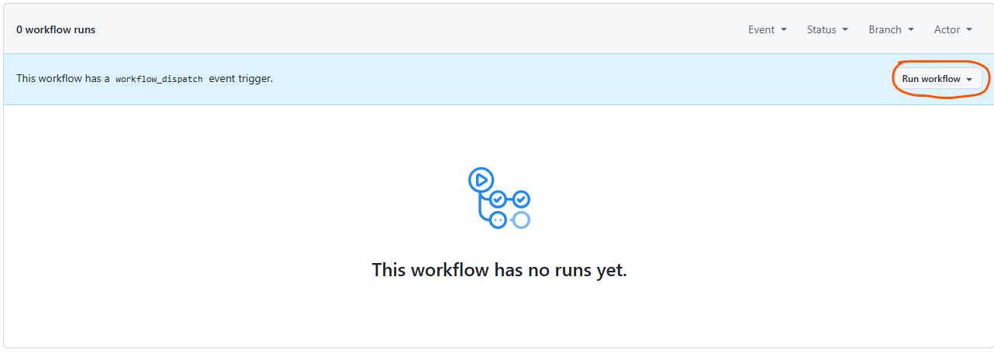
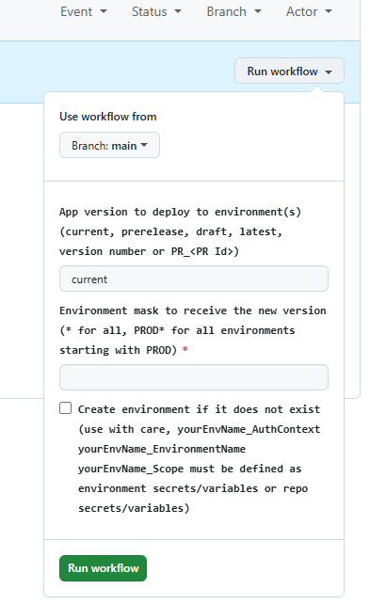
- A small panel opens. Leave “Use workflow from” as Branch: main.
- Leave “App version to deploy to environment(s)” as current.
- In the “Environment mask” box, type exactly: Belam_live
- Leave the “Create environment if it does not exist” checkbox UNCHECKED.
- Click the green “Run workflow” button inside the panel.
- Wait 2–5 minutes, then refresh the page. You should see a listing looking like this
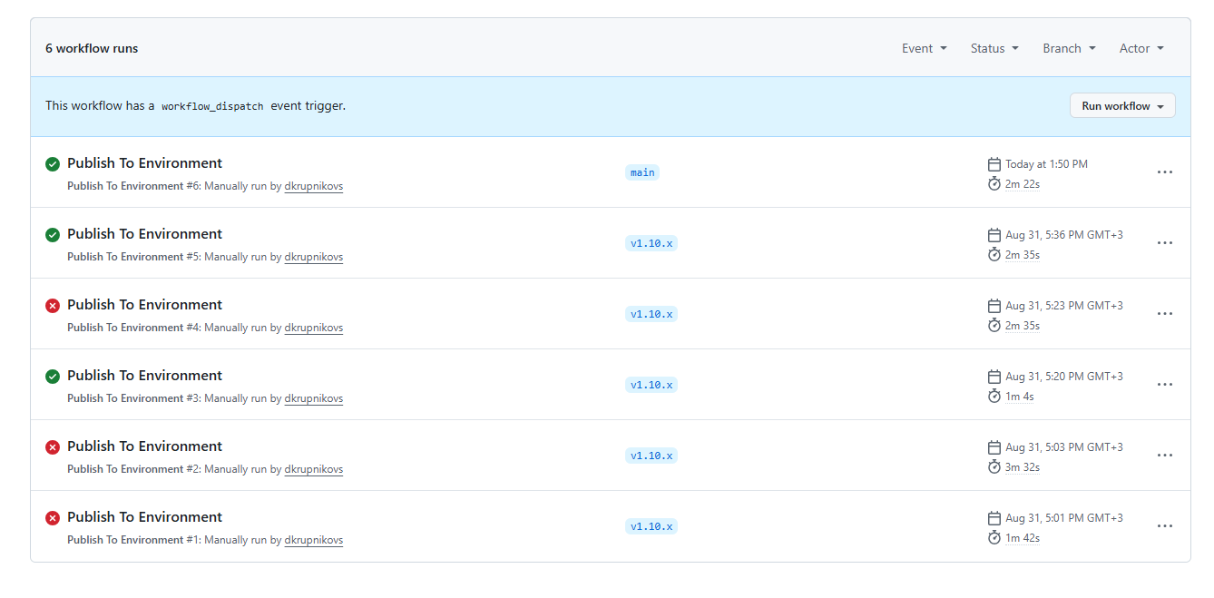
- Look for a green checkmark (✓) next to the run that just started — that means it finished successfully.
If you see a red ✖ instead of a green ✓:
Click into that run to see what failed, and contact Dmitrijs Krupņikovs. This process only ever touches the app's own code — it never affects your data, and it's always safe to fix the issue and run it again.

When to use this
- After a Business Central version upgrade — upgrades can remove our custom (per-tenant) extensions, and this is how they get reinstalled.
- Whenever you're told a new version of one of the 4 apps is ready to go live.

Nothing here ever happens automatically — an app only reaches production when someone deliberately runs these steps. Day-to-day development and testing continues exactly as before and never touches production on its own.

