Supplementary Materials \u2014 A biphasic trajectory of cortical and hippocampal network dysfunction during REM sleep in C9orf72-deficient mice

Supplementary Materials
Supplementary Methods. Expanded description of the sleep-state classification thresholds and the threshold-grid sensitivity procedure; the Tort modulation-index computation (phase and amplitude band definitions, bin count, surrogate normalization); the bias-corrected bootstrap confidence-interval procedure; the mixed-effects model specification and the cluster-robust sensitivity analysis; and the cross-validation and label-permutation procedures used for classification analysis.
Table S1. Session-level sensitivity analysis (Scenario B). Full feature-by-timepoint comparisons treating each recording session as the unit of analysis, with group means, Cohen\u2019s d and 95% confidence intervals, and raw and FDR-adjusted p-values.
Table S2. Mixed-effects models. Complete genotype \u00D7 time interaction results for all tested features, reporting the mixed-model p-value, the cluster-robust (by animal) p-value, the random-effect variance estimate, and the reported value (robust where the random-effect variance approached the boundary).
Table S3. Sleep-state transition statistics. Full transition-probability, dwell-time, and transition-rate comparisons between genotypes at every timepoint, with effect sizes and FDR-adjusted p-values.
Table S4. Secondary timepoint analyses (6 and 7 months). Exploratory feature comparisons at the timepoints not included in the pre-specified primary analysis.
Table S5. Cross-validated classification performance. For each headline feature: in-sample AUC, leave-one-out cross-validated AUC, repeated stratified k-fold AUC (mean \u00B1 SD), and label-permutation p-value.
Table S6. Staging-threshold sensitivity grid. Genotype effect size and significance for each headline REM feature across all 81 threshold combinations of the band-power classifier.

Supplementary Tables
Table S1. Session-level sensitivity analysis (Scenario B). [To be inserted from results CSV.]
[PLACEHOLDER] Awaiting the session-level results CSV (feature \u00D7 timepoint, treating each recording session as the unit) to populate this table with exact group means, Cohen\u2019s d [95% CI], and raw/FDR p-values.
Table S2. Mixed-effects genotype \u00D7 time interaction (all tested features).
Feature | Interaction p | FDR q | Divergence
REM relative beta | 0.0003 | 0.002 | Yes (***)
Wake relative beta | 0.0008 | 0.002 | Yes (***)
REM relative theta | 0.0036 | 0.007 | Yes (**)
REM theta/delta ratio | 0.344 | 0.514 | No
Sleep spindle duration | 0.428 | 0.514 | No
NREM relative theta | 0.886 | 0.886 | No
Linear mixed-effects models with genotype, age, and their interaction as fixed effects and a by-animal random intercept; p-values are the genotype \u00D7 time interaction, reported under cluster-robust (by-animal) inference where the random-effect variance approached the boundary. FDR correction is across the features listed. A significant interaction indicates that the knockout and wild-type trajectories diverge over the disease course.
Table S3. Sleep-state transition probabilities by genotype and timepoint.
Genotype | Age | From state | → Wake | → NREM | → REM
WT | 3m | Wake | 0.59 | 0.23 | 0.19
WT | 3m | NREM | 0.29 | 0.46 | 0.25
WT | 3m | REM | 0.26 | 0.26 | 0.48
WT | 4m | Wake | 0.58 | 0.22 | 0.20
WT | 4m | NREM | 0.30 | 0.42 | 0.28
WT | 4m | REM | 0.28 | 0.27 | 0.45
WT | 12m | Wake | 0.61 | 0.23 | 0.16
WT | 12m | NREM | 0.32 | 0.47 | 0.21
WT | 12m | REM | 0.32 | 0.27 | 0.41
KO | 3m | Wake | 0.58 | 0.22 | 0.20
KO | 3m | NREM | 0.29 | 0.42 | 0.29
KO | 3m | REM | 0.24 | 0.27 | 0.49
KO | 4m | Wake | 0.63 | 0.20 | 0.17
KO | 4m | NREM | 0.26 | 0.50 | 0.24
KO | 4m | REM | 0.26 | 0.27 | 0.47
KO | 12m | Wake | 0.58 | 0.23 | 0.19
KO | 12m | NREM | 0.30 | 0.44 | 0.26
KO | 12m | REM | 0.28 | 0.30 | 0.42
Probability of transitioning from each row (current) state to each column (next) state, by genotype at 3, 4, and 12 months (rows sum to 1). The end-stage increase in the knockout NREM\u2192REM probability and REM\u2192NREM probability, with reduced REM self-maintenance, corresponds to the destabilization of sleep-state architecture described in the Results; full dwell-time and transition-rate comparisons with effect sizes and FDR-adjusted p-values are provided in the source results file.
Table S4. Secondary timepoint analyses (6 and 7 months). [To be inserted from results CSV.]
[PLACEHOLDER] Awaiting the secondary-timepoint results CSV (6- and 7-month feature comparisons) to populate exact values.
Table S5. Cross-validated classification performance.
Feature (n) | In-sample AUC | LOO-CV AUC | k-fold AUC | Permutation p
4m REM relative beta (n=16) | 0.92 | \u2014 | \u2014 | 0.004
4m REM theta/delta (n=16) | 0.89 | \u2014 | \u2014 | \u2014
12m REM relative beta (n=8) | 0.88 | \u2014 | \u2014 | \u2014
3m spindle duration (n=18) | 0.83 | \u2014 | \u2014 | \u2014
3m aperiodic exponent (n=18) | 0.56 | \u2014 | \u2014 | \u2014
[PLACEHOLDER] In-sample AUCs and the permutation p-value for the strongest classifier are exact (from the ROC and permutation analyses). The leave-one-out, k-fold, and remaining permutation columns (dashes) will be filled from the cross-validation results CSV so the reported values are exact rather than read from the forest-plot figure.
Table S6. Staging-threshold sensitivity grid (summary).
Feature | d (min) | d (max) | Sign stable | FDR-significant
4m REM relative beta | +1.37 | +1.52 | Yes | 100% of grid
4m REM theta/delta | +1.23 | +1.39 | Yes | 100% of grid
12m REM relative beta | −1.68 | −1.47 | Yes | Directional
Genotype effect size (Cohen\u2019s d, knockout \u2212 wild-type) for each headline REM feature across the 9-point grid of theta and delta percentile thresholds (40/50/60 each). The two acute effects remain positive and FDR-significant at every grid point; the end-stage beta reduction is directionally stable (negative at every grid point) though, consistent with its smaller sample, not individually significant across the grid. Full per-cell values for all 81 threshold combinations are in the source results file.
Table S7. Validation of EEG-defined REM against synchronous video.
Validation metric | Value | Expected / interpretation
REM, % of total epochs | 6.7\u201311.6% | physiological mouse REM (~5\u201310%)
REM, % of sleep | ~20\u201329% | physiological
REM epochs immobile (video) | 94.8% | highest of any state \u2192 not active wake
NREM / Wake immobile | 90% / 89% | REM is the most immobile state
REM vs wake motion | d = \u22120.27, p < 0.001 | REM significantly less mobile than wake
Wake\u2192REM transition prob. | 0.07 | low; REM rarely entered from wake
REM self-maintenance prob. | 0.23 | physiological REM persistence
CA3 theta peak (REM) | ~6.5 Hz | canonical rodent REM theta
CA3 theta/delta, REM vs wake | d = +0.36 | hippocampal theta greatest in REM
Per-epoch video motion energy and hippocampal signatures for the validation subset (knockout and wild-type at 3, 9, and 12 months). REM epochs classified from EEG were behaviourally immobile at physiological frequency, were rarely entered from wakefulness, and carried canonical hippocampal theta, indicating that the EEG-defined REM state is not misclassified active wakefulness. Because mean wake motion is diluted by quiet rest, the genotype-blind contrast with active (high-movement) wake is reported in Fig. S7. [Values to be updated from the full-cohort run.]
[TODO] Figure S1. Animal-flow diagram \u2014 CONSORT-style accounting of animals enrolled, contributing usable recordings at each timepoint, and lost to attrition, by genotype. Build from final animal numbers.
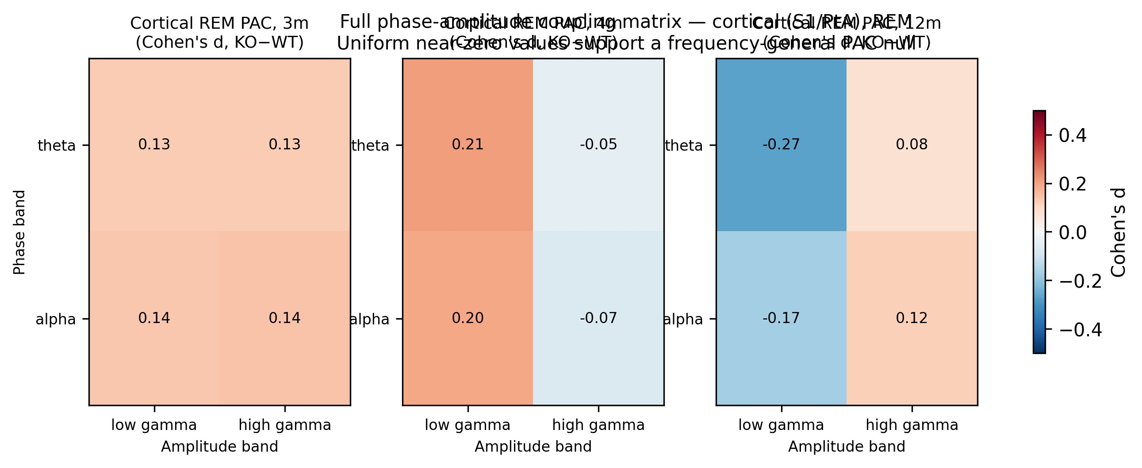
Figure S2. Full cortical phase-amplitude coupling matrix. Genotype effect size (Cohen\u2019s d, knockout \u2212 wild-type) for every phase band (theta, alpha) against both gamma amplitude bands (low, high) during cortical REM at the principal timepoints; values are small and no cell reaches FDR significance, supporting a frequency-general PAC null.
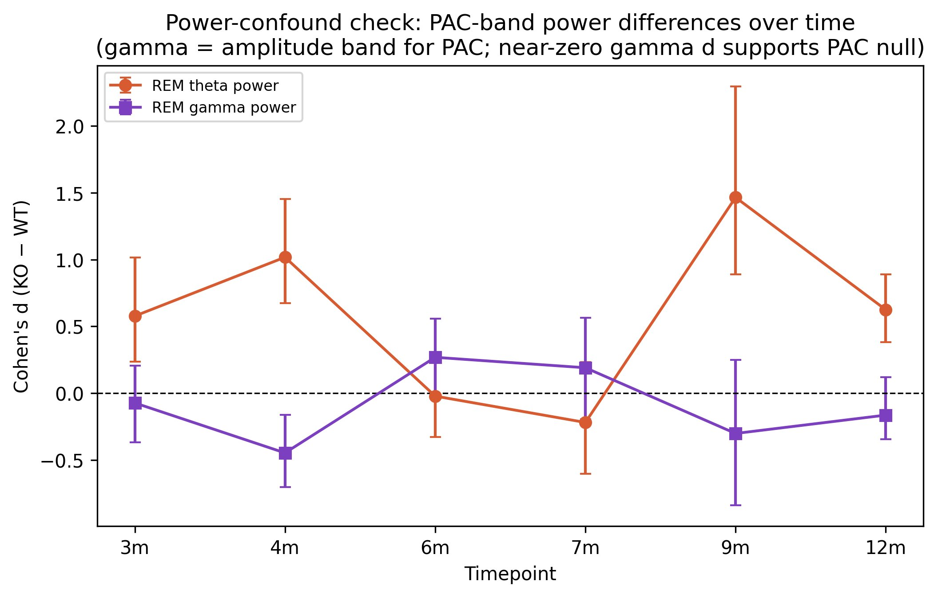
Figure S3. Power-confound check. Genotype effect size over time for REM theta power (the PAC phase band) and REM gamma power (the PAC amplitude band); the near-zero gamma-power differences indicate that the PAC null does not arise from a gamma-power confound.
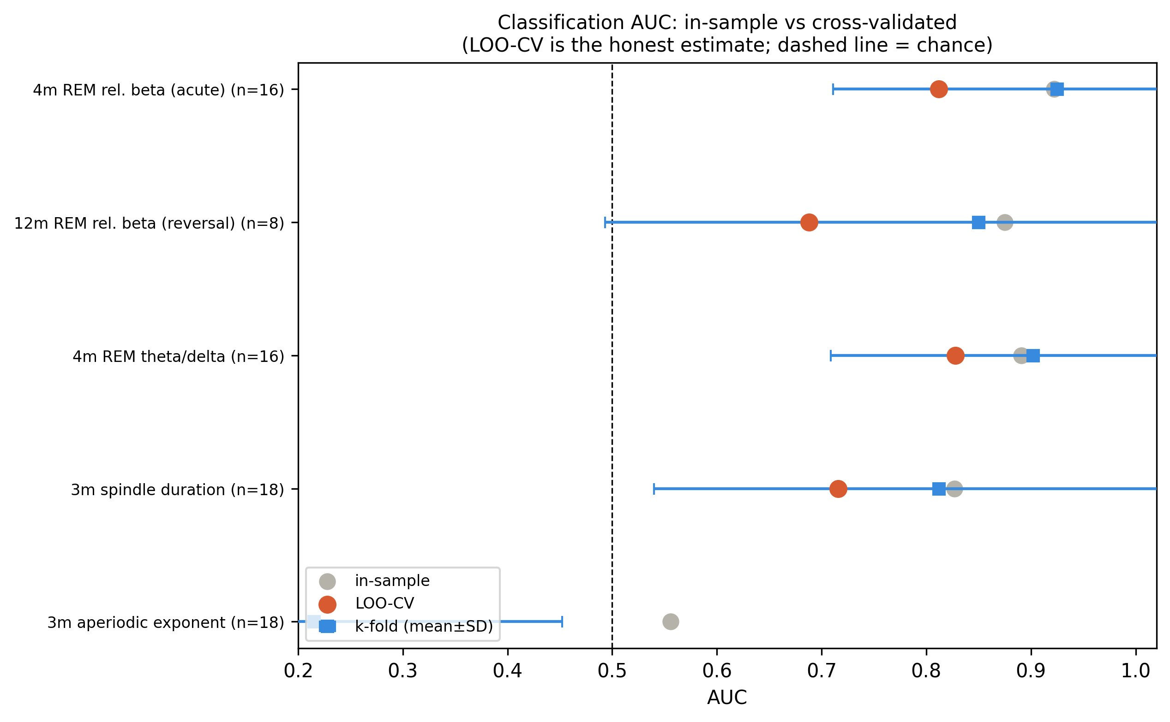
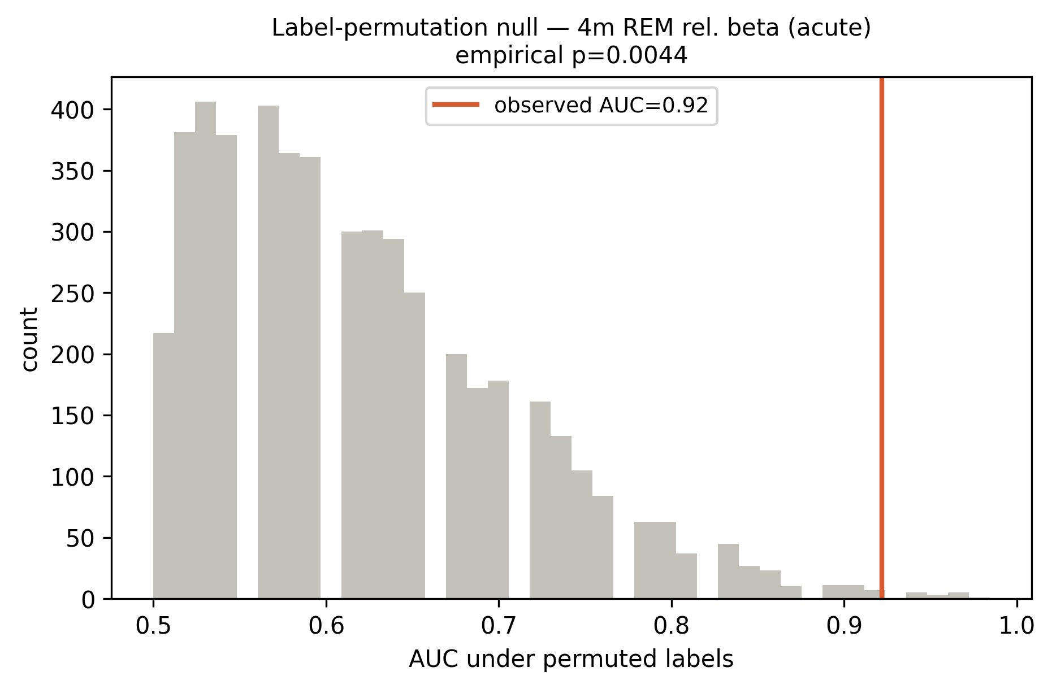
Figure S4. Cross-validated classification. Forest plot of in-sample, leave-one-out, and repeated k-fold AUC for the headline features (top), and the label-permutation null distribution for the strongest classifier, 4-month REM relative beta (observed AUC = 0.92, empirical p = 0.004; bottom).
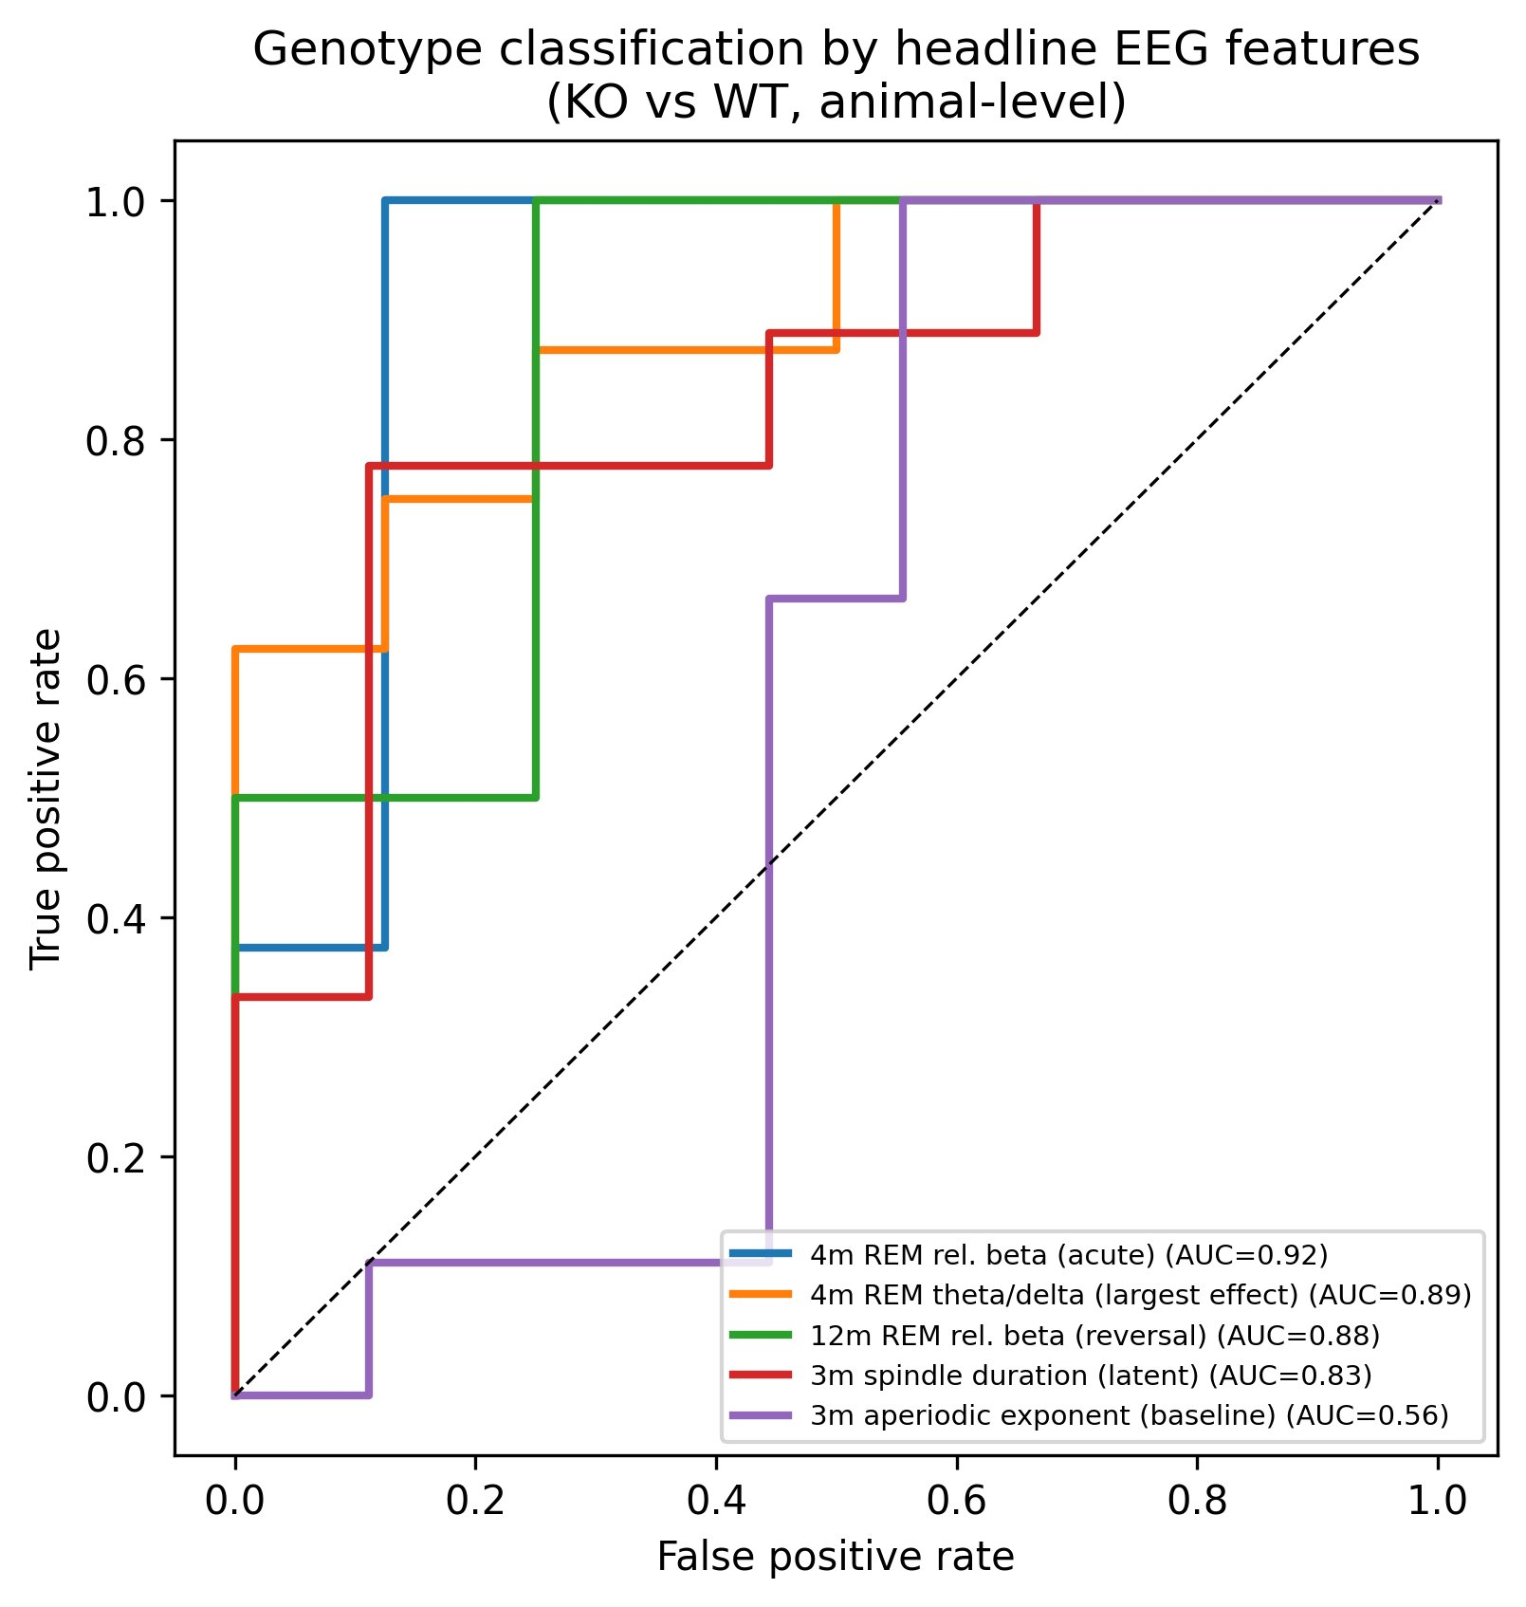
Figure S5. Genotype classification by headline features. Receiver-operating-characteristic curves for animal-level genotype classification by each headline EEG feature, with in-sample AUC; the acute 4-month REM beta and theta/delta features and the end-stage beta reversal are the strongest discriminators, while the 3-month aperiodic exponent is near chance.
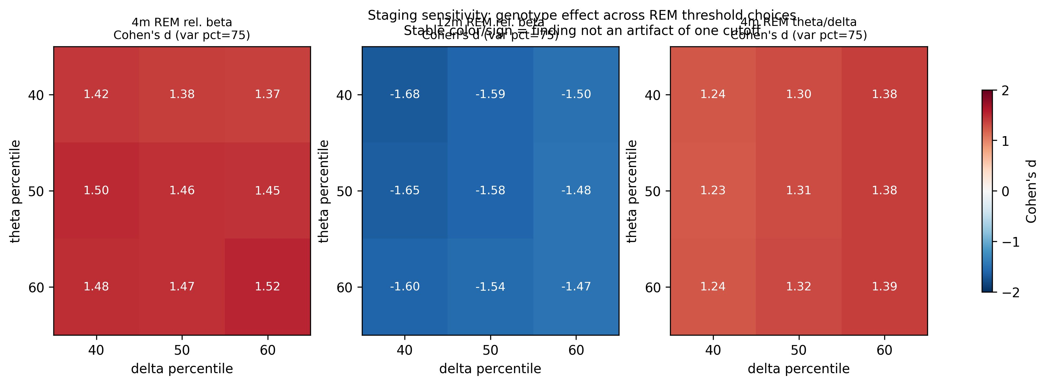
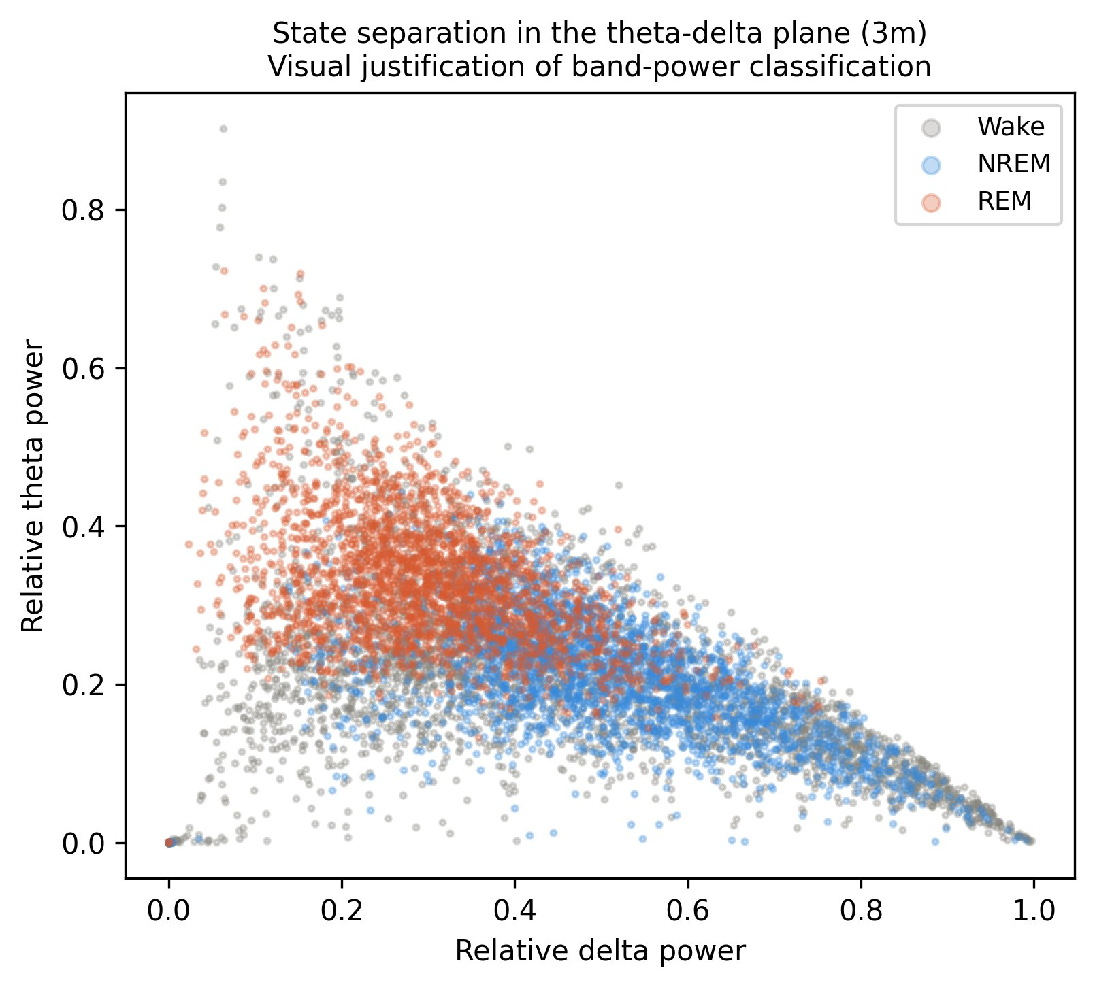
Figure S6. Staging-sensitivity and state separation. Genotype effect size for each headline REM feature across the 9-point threshold grid (top): the 4-month beta and theta/delta effects remain positive and the 12-month beta effect remains negative throughout, showing the findings are not artifacts of any single staging cutoff. The theta-delta-plane state-separation diagnostic (bottom) provides visual justification for the band-power vigilance-state classification.
[missing figure: sleep_state_validation_motion.png]
Figure S7. Validation of EEG-defined REM using synchronous video. Left: video motion energy (an electromyography surrogate) by vigilance state; REM-classified epochs are as immobile as NREM and below active wakefulness, with 94.8% of REM epochs behaviourally immobile. Right: per-epoch hippocampal CA3 theta/delta against cortical delta/theta ratio, coloured by motion energy; the REM cluster shows high CA3 theta and low movement. Together with physiological REM proportion, low wake-to-REM transition probability, and a ~6.5 Hz CA3 theta peak, these confirm that the EEG-defined REM state is behaviourally quiescent and hippocampally appropriate rather than misclassified active wake.

