Capstone

##   
## Attaching package: 'dplyr'

## The following objects are masked from 'package:stats':  
##   
## filter, lag

## The following objects are masked from 'package:base':  
##   
## intersect, setdiff, setequal, union

## Loading required package: lattice

## -- Attaching packages --------------------------------------- tidyverse 1.3.1 --

## v tibble 3.1.4 v purrr 0.3.4  
## v tidyr 1.1.3 v stringr 1.4.0  
## v readr 2.0.2 v forcats 0.5.1

## -- Conflicts ------------------------------------------ tidyverse_conflicts() --  
## x dplyr::filter() masks stats::filter()  
## x dplyr::lag() masks stats::lag()  
## x purrr::lift() masks caret::lift()

##   
## Attaching package: 'boot'

## The following object is masked from 'package:lattice':  
##   
## melanoma

## randomForest 4.6-14

## Type rfNews() to see new features/changes/bug fixes.

##   
## Attaching package: 'randomForest'

## The following object is masked from 'package:dplyr':  
##   
## combine

## The following object is masked from 'package:ggplot2':  
##   
## margin

## Loading required package: leaps

## Loading required package: caTools

##   
## Attaching package: 'AMR'

## The following objects are masked from 'package:e1071':  
##   
## kurtosis, skewness

## Type 'citation("pROC")' for a citation.

##   
## Attaching package: 'pROC'

## The following objects are masked from 'package:stats':  
##   
## cov, smooth, var

## Installing package into 'C:/Users/Will/Documents/R/win-library/4.1'  
## (as 'lib' is unspecified)

## package 'devtools' successfully unpacked and MD5 sums checked  
##   
## The downloaded binary packages are in  
## C:\Users\Will\AppData\Local\Temp\RtmpuU6sez\downloaded_packages

## Loading required package: usethis

## WARNING: Rtools is required to build R packages, but is not currently installed.  
##   
## Please download and install Rtools 4.0 from https://cran.r-project.org/bin/windows/Rtools/.

## Skipping install of 'ggbiplot' from a github remote, the SHA1 (7325e880) has not changed since last install.  
## Use `force = TRUE` to force installation

## Loading required package: plyr

## ------------------------------------------------------------------------------

## You have loaded plyr after dplyr - this is likely to cause problems.  
## If you need functions from both plyr and dplyr, please load plyr first, then dplyr:  
## library(plyr); library(dplyr)

## ------------------------------------------------------------------------------

##   
## Attaching package: 'plyr'

## The following object is masked from 'package:purrr':  
##   
## compact

## The following objects are masked from 'package:dplyr':  
##   
## arrange, count, desc, failwith, id, mutate, rename, summarise,  
## summarize

## Loading required package: scales

##   
## Attaching package: 'scales'

## The following object is masked from 'package:purrr':  
##   
## discard

## The following object is masked from 'package:readr':  
##   
## col_factor

## Loading required package: grid

##   
## Attaching package: 'ggbiplot'

## The following object is masked from 'package:ggfortify':  
##   
## ggbiplot

## # A tibble: 11 x 2  
## f n  
## <fct> <int>  
## 1 "Asian" 123  
## 2 "Black" 43  
## 3 "Hispanic" 13  
## 4 "Latino" 20  
## 5 "Middle Eastern " 92  
## 6 "others" 1  
## 7 "Others" 30  
## 8 "Pasifika" 11  
## 9 "South Asian" 36  
## 10 "Turkish" 6  
## 11 "White-European" 233

## # A tibble: 4 x 2  
## f n  
## <fct> <int>  
## 1 Asian 159  
## 2 Black 141  
## 3 Other 75  
## 4 White 233

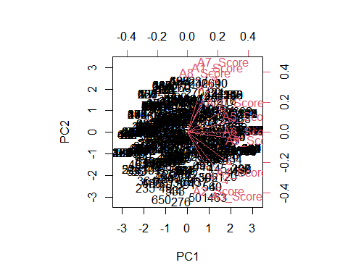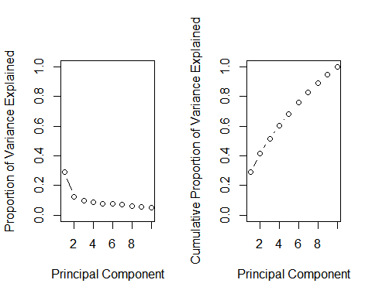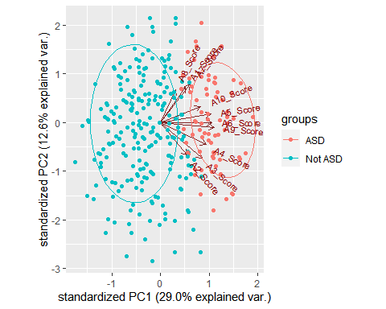

## Morgan-Tatar search since family is non-gaussian.

## Note: factors present with more than 2 levels.

## Warning: glm.fit: fitted probabilities numerically 0 or 1 occurred  
  
## Warning: glm.fit: fitted probabilities numerically 0 or 1 occurred  
  
## Warning: glm.fit: fitted probabilities numerically 0 or 1 occurred  
  
## Warning: glm.fit: fitted probabilities numerically 0 or 1 occurred  
  
## Warning: glm.fit: fitted probabilities numerically 0 or 1 occurred  
  
## Warning: glm.fit: fitted probabilities numerically 0 or 1 occurred  
  
## Warning: glm.fit: fitted probabilities numerically 0 or 1 occurred  
  
## Warning: glm.fit: fitted probabilities numerically 0 or 1 occurred  
  
## Warning: glm.fit: fitted probabilities numerically 0 or 1 occurred  
  
## Warning: glm.fit: fitted probabilities numerically 0 or 1 occurred  
  
## Warning: glm.fit: fitted probabilities numerically 0 or 1 occurred  
  
## Warning: glm.fit: fitted probabilities numerically 0 or 1 occurred  
  
## Warning: glm.fit: fitted probabilities numerically 0 or 1 occurred  
  
## Warning: glm.fit: fitted probabilities numerically 0 or 1 occurred  
  
## Warning: glm.fit: fitted probabilities numerically 0 or 1 occurred  
  
## Warning: glm.fit: fitted probabilities numerically 0 or 1 occurred  
  
## Warning: glm.fit: fitted probabilities numerically 0 or 1 occurred  
  
## Warning: glm.fit: fitted probabilities numerically 0 or 1 occurred  
  
## Warning: glm.fit: fitted probabilities numerically 0 or 1 occurred  
  
## Warning: glm.fit: fitted probabilities numerically 0 or 1 occurred  
  
## Warning: glm.fit: fitted probabilities numerically 0 or 1 occurred  
  
## Warning: glm.fit: fitted probabilities numerically 0 or 1 occurred  
  
## Warning: glm.fit: fitted probabilities numerically 0 or 1 occurred  
  
## Warning: glm.fit: fitted probabilities numerically 0 or 1 occurred  
  
## Warning: glm.fit: fitted probabilities numerically 0 or 1 occurred  
  
## Warning: glm.fit: fitted probabilities numerically 0 or 1 occurred  
  
## Warning: glm.fit: fitted probabilities numerically 0 or 1 occurred  
  
## Warning: glm.fit: fitted probabilities numerically 0 or 1 occurred  
  
## Warning: glm.fit: fitted probabilities numerically 0 or 1 occurred  
  
## Warning: glm.fit: fitted probabilities numerically 0 or 1 occurred  
  
## Warning: glm.fit: fitted probabilities numerically 0 or 1 occurred  
  
## Warning: glm.fit: fitted probabilities numerically 0 or 1 occurred  
  
## Warning: glm.fit: fitted probabilities numerically 0 or 1 occurred  
  
## Warning: glm.fit: fitted probabilities numerically 0 or 1 occurred  
  
## Warning: glm.fit: fitted probabilities numerically 0 or 1 occurred  
  
## Warning: glm.fit: fitted probabilities numerically 0 or 1 occurred  
  
## Warning: glm.fit: fitted probabilities numerically 0 or 1 occurred  
  
## Warning: glm.fit: fitted probabilities numerically 0 or 1 occurred  
  
## Warning: glm.fit: fitted probabilities numerically 0 or 1 occurred  
  
## Warning: glm.fit: fitted probabilities numerically 0 or 1 occurred  
  
## Warning: glm.fit: fitted probabilities numerically 0 or 1 occurred  
  
## Warning: glm.fit: fitted probabilities numerically 0 or 1 occurred  
  
## Warning: glm.fit: fitted probabilities numerically 0 or 1 occurred  
  
## Warning: glm.fit: fitted probabilities numerically 0 or 1 occurred  
  
## Warning: glm.fit: fitted probabilities numerically 0 or 1 occurred  
  
## Warning: glm.fit: fitted probabilities numerically 0 or 1 occurred  
  
## Warning: glm.fit: fitted probabilities numerically 0 or 1 occurred  
  
## Warning: glm.fit: fitted probabilities numerically 0 or 1 occurred  
  
## Warning: glm.fit: fitted probabilities numerically 0 or 1 occurred  
  
## Warning: glm.fit: fitted probabilities numerically 0 or 1 occurred  
  
## Warning: glm.fit: fitted probabilities numerically 0 or 1 occurred  
  
## Warning: glm.fit: fitted probabilities numerically 0 or 1 occurred  
  
## Warning: glm.fit: fitted probabilities numerically 0 or 1 occurred  
  
## Warning: glm.fit: fitted probabilities numerically 0 or 1 occurred  
  
## Warning: glm.fit: fitted probabilities numerically 0 or 1 occurred  
  
## Warning: glm.fit: fitted probabilities numerically 0 or 1 occurred  
  
## Warning: glm.fit: fitted probabilities numerically 0 or 1 occurred  
  
## Warning: glm.fit: fitted probabilities numerically 0 or 1 occurred  
  
## Warning: glm.fit: fitted probabilities numerically 0 or 1 occurred  
  
## Warning: glm.fit: fitted probabilities numerically 0 or 1 occurred  
  
## Warning: glm.fit: fitted probabilities numerically 0 or 1 occurred  
  
## Warning: glm.fit: fitted probabilities numerically 0 or 1 occurred  
  
## Warning: glm.fit: fitted probabilities numerically 0 or 1 occurred  
  
## Warning: glm.fit: fitted probabilities numerically 0 or 1 occurred  
  
## Warning: glm.fit: fitted probabilities numerically 0 or 1 occurred  
  
## Warning: glm.fit: fitted probabilities numerically 0 or 1 occurred  
  
## Warning: glm.fit: fitted probabilities numerically 0 or 1 occurred  
  
## Warning: glm.fit: fitted probabilities numerically 0 or 1 occurred

## Warning: glm.fit: algorithm did not converge

## Warning: glm.fit: fitted probabilities numerically 0 or 1 occurred

## Warning: glm.fit: algorithm did not converge

## Warning: glm.fit: fitted probabilities numerically 0 or 1 occurred

## Warning: glm.fit: algorithm did not converge

## Warning: glm.fit: fitted probabilities numerically 0 or 1 occurred  
  
## Warning: glm.fit: fitted probabilities numerically 0 or 1 occurred  
  
## Warning: glm.fit: fitted probabilities numerically 0 or 1 occurred  
  
## Warning: glm.fit: fitted probabilities numerically 0 or 1 occurred  
  
## Warning: glm.fit: fitted probabilities numerically 0 or 1 occurred  
  
## Warning: glm.fit: fitted probabilities numerically 0 or 1 occurred

## Warning: glm.fit: algorithm did not converge

## Warning: glm.fit: fitted probabilities numerically 0 or 1 occurred

## Warning: glm.fit: algorithm did not converge

## Warning: glm.fit: fitted probabilities numerically 0 or 1 occurred

## Warning: glm.fit: algorithm did not converge

## Warning: glm.fit: fitted probabilities numerically 0 or 1 occurred

## Warning: glm.fit: algorithm did not converge

## Warning: glm.fit: fitted probabilities numerically 0 or 1 occurred  
  
## Warning: glm.fit: fitted probabilities numerically 0 or 1 occurred  
  
## Warning: glm.fit: fitted probabilities numerically 0 or 1 occurred  
  
## Warning: glm.fit: fitted probabilities numerically 0 or 1 occurred  
  
## Warning: glm.fit: fitted probabilities numerically 0 or 1 occurred

## Warning: glm.fit: algorithm did not converge

## Warning: glm.fit: fitted probabilities numerically 0 or 1 occurred

## Warning: glm.fit: algorithm did not converge

## Warning: glm.fit: fitted probabilities numerically 0 or 1 occurred

## Warning: glm.fit: algorithm did not converge

## Warning: glm.fit: fitted probabilities numerically 0 or 1 occurred

## Warning: glm.fit: algorithm did not converge

## Warning: glm.fit: fitted probabilities numerically 0 or 1 occurred  
  
## Warning: glm.fit: fitted probabilities numerically 0 or 1 occurred

## Warning: glm.fit: algorithm did not converge

## Warning: glm.fit: fitted probabilities numerically 0 or 1 occurred  
  
## Warning: glm.fit: fitted probabilities numerically 0 or 1 occurred

## Warning: glm.fit: algorithm did not converge

## Warning: glm.fit: fitted probabilities numerically 0 or 1 occurred

## Warning: glm.fit: algorithm did not converge

## Warning: glm.fit: fitted probabilities numerically 0 or 1 occurred

## Warning: glm.fit: algorithm did not converge

## Warning: glm.fit: fitted probabilities numerically 0 or 1 occurred

## Warning: glm.fit: algorithm did not converge

## Warning: glm.fit: fitted probabilities numerically 0 or 1 occurred

## Warning: glm.fit: algorithm did not converge

## Warning: glm.fit: fitted probabilities numerically 0 or 1 occurred

## AIC  
## Best Model:  
## Df Sum Sq Mean Sq F value Pr(>F)   
## PC1 1 66.98 66.98 1024.199 < 2e-16 ***  
## PC2 1 0.08 0.08 1.196 0.274761   
## PC3 1 0.95 0.95 14.596 0.000151 ***  
## ethnicity 3 0.31 0.10 1.571 0.195520   
## Residuals 478 31.26 0.07   
## ---  
## Signif. codes: 0 '***' 0.001 '**' 0.01 '*' 0.05 '.' 0.1 ' ' 1

## Warning: glm.fit: fitted probabilities numerically 0 or 1 occurred

## [1] 0.9837398

## [1] 0.9764706

## [1] 1

## Warning: glm.fit: fitted probabilities numerically 0 or 1 occurred  
  
## Warning: glm.fit: fitted probabilities numerically 0 or 1 occurred  
  
## Warning: glm.fit: fitted probabilities numerically 0 or 1 occurred  
  
## Warning: glm.fit: fitted probabilities numerically 0 or 1 occurred  
  
## Warning: glm.fit: fitted probabilities numerically 0 or 1 occurred

## [1] 0.9814433

## Warning: glm.fit: fitted probabilities numerically 0 or 1 occurred

## [1] 0.9918699

## [1] 0.9880952

## [1] 1

## [1] 0.9525773

## [1] 0.9756098

## [1] 0.9761905

## [1] 0.974359

## [1] 0.9835052

## [1] 0.9756098

## [1] 0.9761905

## [1] 0.974359

## [1] 0.9814433

## [1] 0.9814433

## [1] 0.9855491

## [1] 0.971223

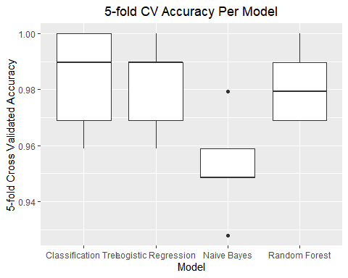

## Setting levels: control = NO, case = YES

## Setting direction: controls < cases

## Setting levels: control = NO, case = YES

## Setting direction: controls > cases

## Setting levels: control = NO, case = YES

## Setting direction: controls > cases

## Setting levels: control = NO, case = YES

## Setting direction: controls > cases

