**Лаборатори 13**

**https://spring.io/guides/gs/accessing-data-rest/**

**https://spring.io/guides/gs/accessing-data-mysql/**

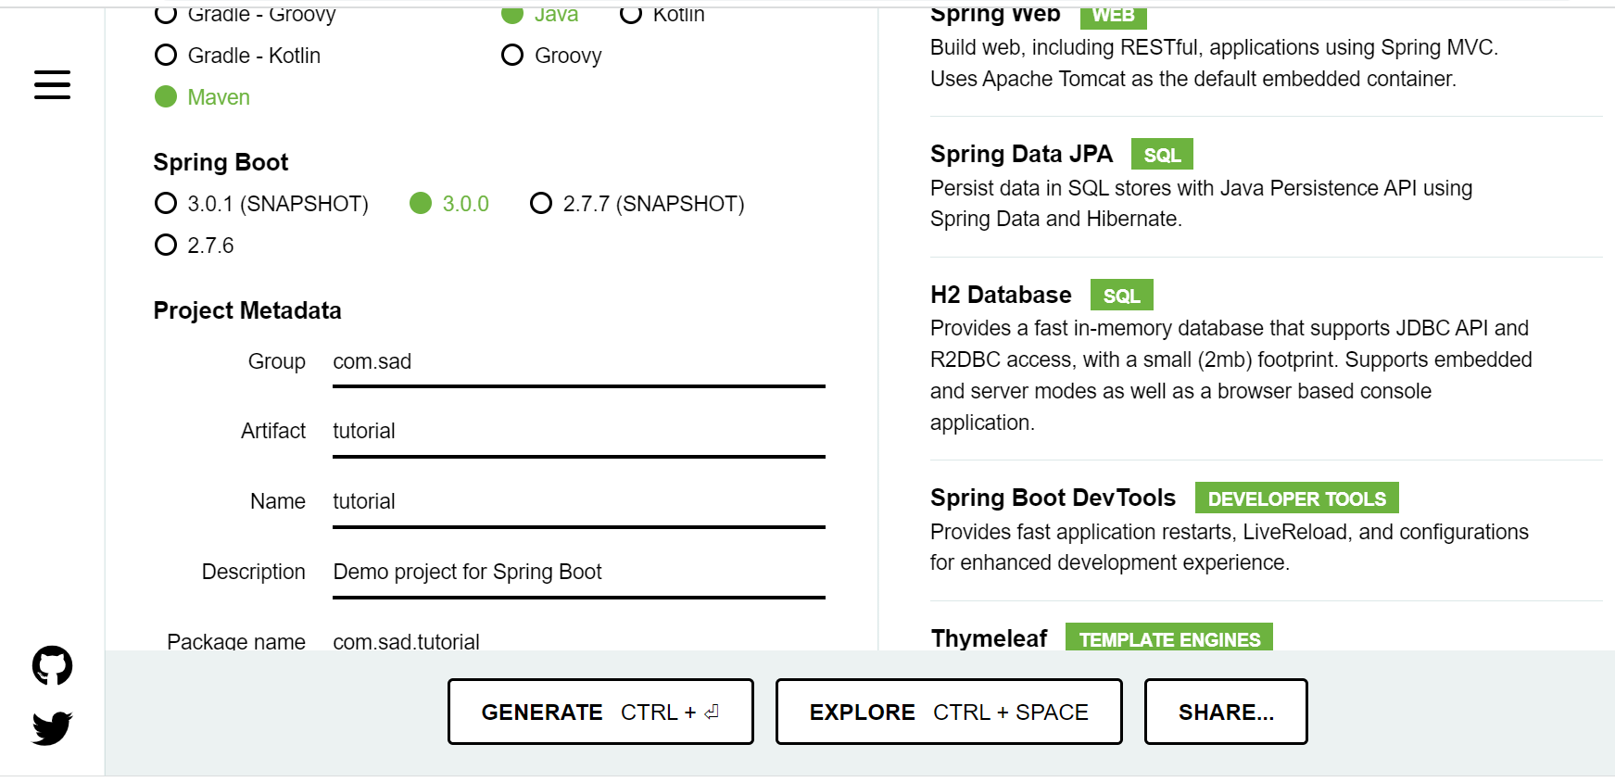

1. Group нь sad, Name нь tutorial нэртэй аррlication үүсгэ.

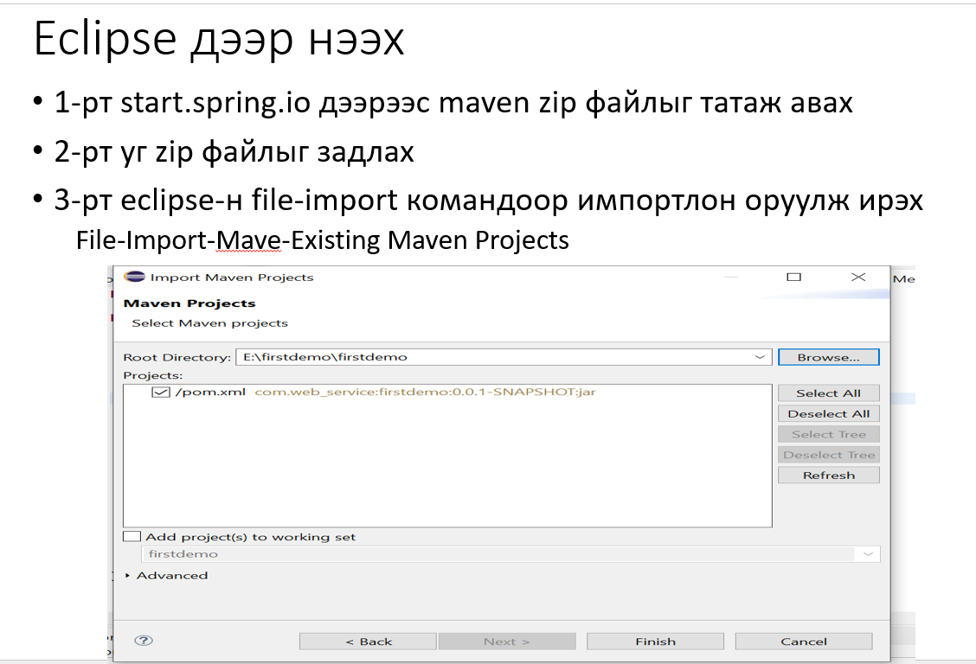

1. **Scr каталог дотор domain эсвэл model, controller, service, repository гэсэн каталогиудыг үүсгэ.**
2. **Controller каталоги дотор** HelloWorldRestController үүсгэ.

@RestController

**public** **class** HelloWorldRestController {

@RequestMapping("/myFirstFunction")

**public** String helloWorld() {

**return** "Сайн байна уу танд энэ өдрийн мэнд хүргэе.";

}

@RequestMapping("/mul")

**public** HelloWorldBean mul()

{

**int** sum = **new** Calculator(2,3).mul();

**return** **new** HelloWorldBean("Tanii niit udga " + sum);

}

@RequestMapping("/division")

**public** HelloWorldBean division()

{

**int** sum = **new** Calculator(2,3).division();

**return** **new** HelloWorldBean("Tanii niit udga " + sum);

}

@RequestMapping("/minus")

**public** HelloWorldBean minus()

{

**int** sum = **new** Calculator(2,3).minus();

**return** **new** HelloWorldBean("Tanii niit udga " + sum);

}

@RequestMapping("/sum")

**public** HelloWorldBean sum()

{

**int** sum = **new** Calculator(2,3).add();

**return** **new** HelloWorldBean("Tanii niit udga " + sum);

}

@RequestMapping("/hello-world-bean")

**public** HelloWorldBean helloWorldBean() {

**return** **new** HelloWorldBean("Hello World Bean");

}

@RequestMapping("/hello-world/my_second/{name}")

**public** HelloWorldBean helloWorldPathVariable(@PathVariable String name){

**return** **new** HelloWorldBean(String.*format*("Hello world path, %s", name));

}

}

4-р алхам domain каталог дотор HelloWorldBean, Calculator классуудыг үүсгэ.

**public** **class** HelloWorldBean

{

String message;

**public** HelloWorldBean(String message) {

**super**();

**this**.message = message;

}

**public** String getMessage() {

**return** message;

}

**public** **void** setMessage(String message) {

**this**.message = message;

}

@Override

**public** String toString() {

**return** "HelloWorldBean [message=" + message + "]";

}

}

public class Calculator

{

**int** x;

**int** y;

**public** Calculator() {

}

**public** Calculator(**int** x, **int** y) {

**this**.x = x;

**this**.y = y;

}

**public** **int** add()

{

**return** **this**.x +**this**.y;

}

**public** **int** mul()

{

**return** **this**.x * **this**.y;

}

**public** **int** division()

{

**return** **this**.x / **this**.y;

}

**public** **int** minus()

{

**return** **this**.x - **this**.y;

}

Ажиллуулаад web browser-н хаягийн мөрөн дээр

<http://localhost:8080/myFirstFunction>

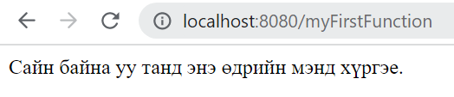

<http://localhost:8080/mul>

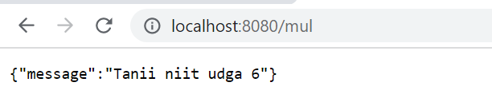

Гэх мэтчилэн бусад URL-уудыг туршаарай.

5-р алхам POJO object үүсгэх

Book class нь id, title, isbn, price талбаруудтай.

**package** com.sad.tutorial.model;

**import** jakarta.persistence.Entity;

**import** jakarta.persistence.GeneratedValue;

**import** jakarta.persistence.GenerationType;

**import** jakarta.persistence.Id;

@Entity

**public** **class** Book {

@Id

@GeneratedValue(strategy=GenerationType.***AUTO***)

**private** **int** id;

**private** String title;

**private** String isbn;

**private** **double** price;

**public** Book() {

**super**();

}

**public** Book(String title, String isbn, **double** price) {

**super**();

**this**.title = title;

**this**.isbn = isbn;

**this**.price = price;

}

**public** String getTitle() {

**return** title;

}

**public** **void** setTitle(String title) {

**this**.title = title;

}

**public** String getIsbn() {

**return** isbn;

}

**public** **void** setIsbn(String isbn) {

**this**.isbn = isbn;

}

**public** **double** getPrice() {

**return** price;

}

**public** **void** setPrice(**double** price) {

**this**.price = price;

}

@Override

**public** String toString() {

**return** "Book [id=" + id + ", title=" + title + ", isbn=" + isbn + ", price=" + price + "]";

}

}

**6-р алхам H2-console өгөгдлийн санг тохируулах**

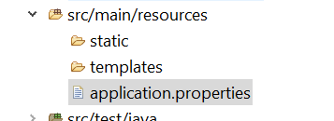

# H2 Database

spring.h2.console.enabled=true

spring.datasource.url=jdbc:h2:mem:dcbapp

spring.datasource.username=sa

spring.datasource.password=123

Вэб браузер дээр

http://localhost:8080/h2-console

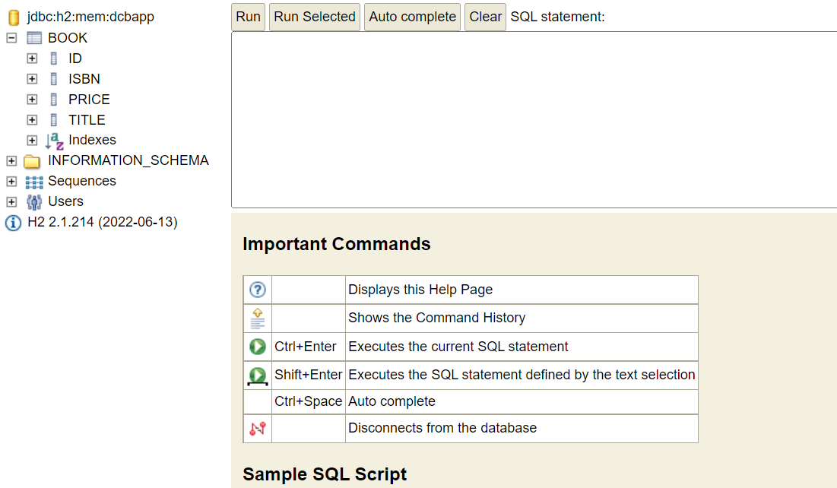

insert into book values (1,'ISBN-2', 10000, 'Алгоритм');

insert into book values (2,'ISBN-2', 20000, 'Математик');

insert into book values (3,'ISBN-3', 30000, 'Хайрын түүх');

insert into book values (4,'ISBN-4', 40000, 'Spring boot сурах бичиг');

insert into book values (5,'ISBN-5', 45000, 'Монголын нууц товчоо');

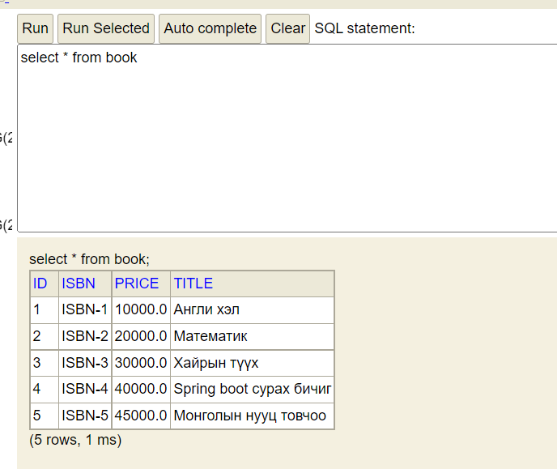

**7-р алхам Repository үүсгэх**

BookRepository interface-г үүсгэж CRUDRepository гоос удамшуулна**.**

**import** org.springframework.data.repository.CrudRepository;

**import** com.sad.tutorial.model.Book;

**public** **interface** BookRepository **extends** CrudRepository <Book,Long > {

}

**8-р алхам** Service catalog үүсгэн программын логик хэсгийн хийх

BookService-Interface

ImplBookService- class-уудыг үүсгэх

**import** java.util.List;

**import** com.sad.tutorial.model.Book;

**public interface BookService {**

**List<Book> getAllExpensive();**

**List<String> getTitleBooks();**

**void addBook(Book book);}**

**package com.sad.tutorial.service;**

**import java.util.ArrayList;**

**import java.util.List;**

**import com.sad.tutorial.model.Book;**

**import com.sad.tutorial.repository.BookRepository;**

**@Service**

**public class ImplBookService implements BookService {**

**private BookRepository bookRepository;**

**public ImplBookService(BookRepository bookRepository) {**

**super();**

**this.bookRepository = bookRepository;**

**}**

**@Override**

**public List<Book> getAllExpensive() {**

**// TODO Auto-generated method stub**

**List<Book> expensiveBooks = new ArrayList<>();**

**for (Book book : bookRepository.findAll()){**

**if (book.getPrice() > 30000){**

**expensiveBooks.add(book);**

**}**

**}**

**return expensiveBooks;**

**}**

**@Override**

**public List<String> getTitleBooks() {**

**// TODO Auto-generated method stub**

**List <String> bookTitles = new ArrayList<>();**

**for(Book book : bookRepository.findAll()){**

**bookTitles.add(book.getTitle());**

**}**

**return bookTitles;**

**}**

**@Override**

**public void addBook(Book book) {**

**// TODO Auto-generated method stub**

**try {**

**bookRepository.save(book);**

**}**

**catch (Exception e){**

**throw e;**

**}**

**}**

**}**

**9-р алхам**

**HelloWorldController**

**package** com.sad.tutorial.controller;

**import** org.springframework.stereotype.Controller;

**import** org.springframework.ui.Model;

**import** org.springframework.web.bind.annotation.RequestMapping;

**import** com.sad.tutorial.service.ImplBookService;

@Controller

**public** **class** HelloWorldController {

**private** ImplBookService bookService;

**public** HelloWorldController(ImplBookService bookService) {

**this**.bookService = bookService;

}

@RequestMapping("/myFirstFunction2")

**public** String helloWorld() {

**return** "hello";

}

@RequestMapping({"/bookExpAll"})

String listBooks(Model model){

model.addAttribute("bookExpAll", bookService.getAllExpensive());

**return** "booksExpAll";

}

@RequestMapping("/bookTitle")

String listTitles(Model model){

model.addAttribute("bookTitle", bookService.getTitleBooks());

**return** "bookTitle";

}

}

**10-р алхам thymeleaf template үүсгэх**

Hello.html

<!DOCTYPE html>

<html lang=*"en"* xmlns:th=*"https://www.thymeleaf.org"*>

<head>

<meta charset=*"UTF-8"*>

<title>Номнуудын гарчиг</title>

</head>

<body>

<h1> Сайн байна уу</h1>

</body>

</html>

**bookExpAll.html**

<!DOCTYPE html>

<html lang=*"en"* xmlns:th=*"https://www.thymeleaf.org"*>

<head>

<meta charset=*"UTF-8"*>

<title>Номнууд</title>

</head>

<body>

<h1 th:text=*"'Үнэтэй номнуудын жагсаалт!!!'"* >Номнуудын жагсаалт </h1>

<table>

<tr>

<th style="color:*red*">Гарчиг</th>

<th>Үнэ</th>

<th>ISBN</th>

</tr>

<tr th:each=*"book : ${books}"*>

<td th:text=*"${book.getTitle()}"*>Title</td>

<td th:text=*"${book.getPrice}"*>100</td>

<td th:text=*"${book.getIsbn}"*>Isbn1</td>

</tr>

</table>

</body>

</html>

**bookTitle.html**

<!DOCTYPE html>

<html lang=*"en"* xmlns:th=*"https://www.thymeleaf.org"*>

<head>

<meta charset=*"UTF-8"*>

<title>Номнуудын гарчиг</title>

</head>

<body>

<h1 th:text=*"'Бүх номнуудын жагсаалт!!!'"* >Номнуудын гарчгийн жагсаалт </h1>

<table>

<tr>

<th style="color:*green*">Гарчиг</th>

<th>Үнэ</th>

</tr>

<tr th:each=*"title : ${titles}"*>

<td th:text=*"${title.getTitle()}"*>Title</td>

</tr>

</table>

</body>

</html>