Galati pollution

Belei Andrei(341C2)
Scinteie Sebastian(341C5)
Irimia Tudor(341C5)
Project Description

Galati is the capital city of Galați County, in the historical region of Moldavia, eastern Romania. Galați is a port town on the Danube River. In 2011, the Romanian census recorded 249,432 residents, making it the 8th most populous city in Romania. Having so many citizens, it’s also one of the most polluted city in Romania.
Galați is an economic centre based around the port of Galați, the naval shipyard, and the largest steel mill in Romania, Galați steel works.

In the socialist period, Galati experienced high industrial revolution. Because of that, pollution level become a worrying matter, growing every year.

Below you can find some statistics about the current state:

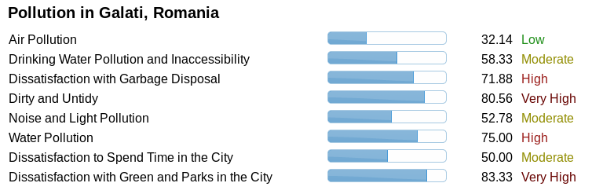
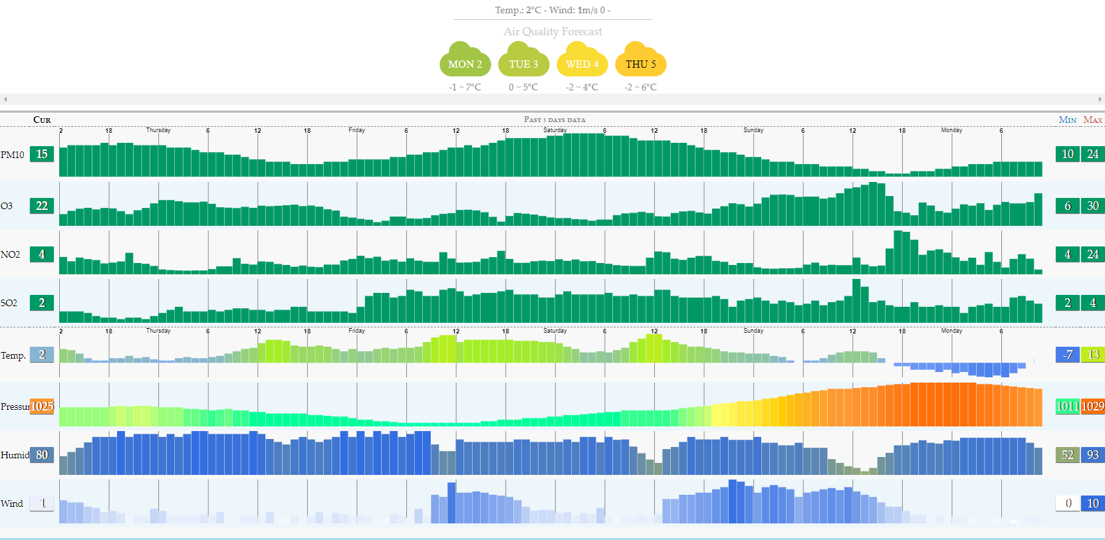
Even if average air pollution rate is not that bad, some areas of the city are highly polluted because of industrial development but also because of population density, as in the picture below:

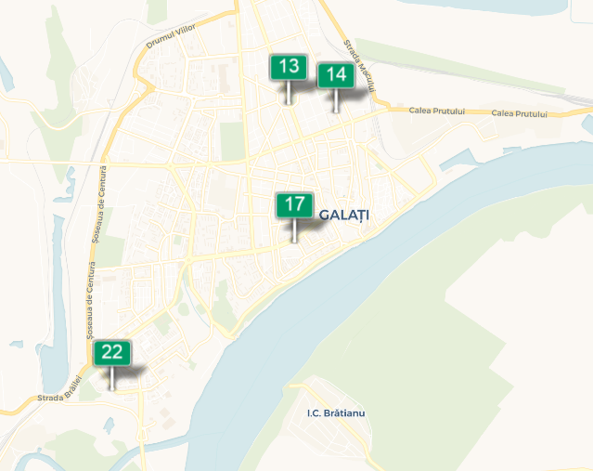

Our plan is to illustrate the critical zones by making an ArcGIS map.

User interface

As presented in the before mentioned mock-up the user's expertise will not be required when using the UI. The UI will only provide the users with the tools required to extract information regarding the pollution levels in the Great State of Galati.

Data Model

For each defined period of time we store PM10, O3, SO2 and NO2 levels detected around different areas. The data containing pollution levels will be stored in a tabular structure in relationship with a table containing the time-space coordinates and one containing the date.

The tabular structure contains a table filled with monitored locations around the entirety of the city Galati in relationship with another table that contains pollution level information(PM10, O3, SO2 and NO2) distributed over each week.

Tables:
- locations (id, name, coordinates);
- week (id, id_location, id_pollution, period_start, period_end);
- pollution (id, PM10, O3, SO2, NO2);
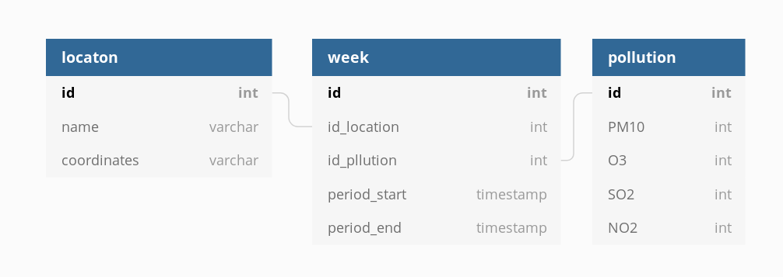

Architecture of the project based on components

The architecture of the project based on components is represented, in short, by the model bellow. As you can see it will be so easy to use even a monkey will have an easy time with it.
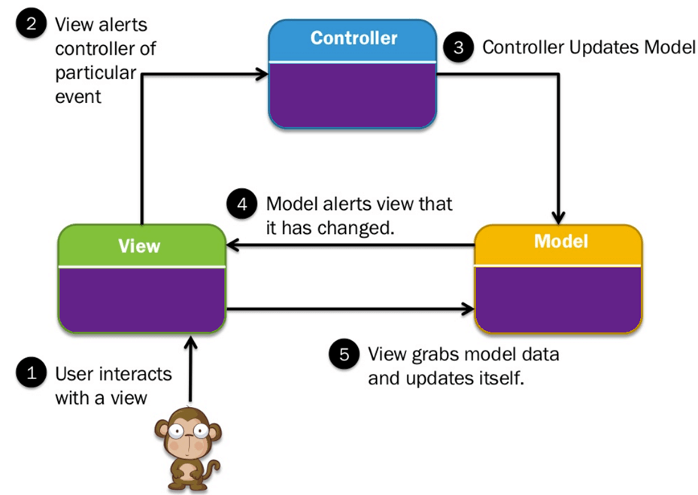
Model component:
- tabular structure saved in a mySQL database;
Controller component:
- managing the dataflow;
- data operations;
- works like an endpoint (called from the UI)
View component
- The part that the monkey communicates with;
- Presents queried data from the controller
- Graphic representation of the most polluted zones

Technologies used in this project

ArcGIS, javascript, javascript ArcGIS API, SQLmy invers, html, css, Wikipedia and talktotransformer

Distribution of tasks on each team member

Distribution of tasks on each team member is as follows:
- Belei Andrei Iulian – Tech lead
  - writing the functional specification for the project – deadline: 15/12/2019
  - implementing connection between server and database – deadline: 18/12/2019
- Scinteie Sebastian – Infrastructure Manager
  - designing database model – deadline: 16/12/2019
  - implementing connection between UI and server – deadline: 28/12/2019
  - writing technical documentation - deadline: 09/12/2019
- Irimia Tudor – Deployment Manager
  - designing UI interface – deadline: 23/12/2019
  - implementing data parser – deadline: 28/12/2019
  - writing technical documentation -deadline: 09/12/2019
- Anonymous – Testing and data collector volunteer

Use-case diagram

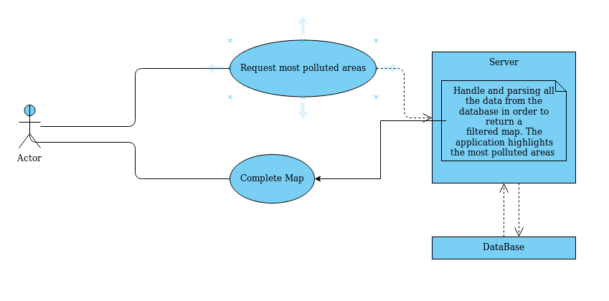

Risks

Several reasons that the application might not be finished by the time we reach the deadline are as follows:
- Galati is a Megalopolis of unmatched proportions and measuring it through and through might prove to be the most difficult issue we must overcome. (European project to downscale the effort of pollution measuring in Galati)
- Team members concurrency issues. (Having 2 minutes meetings after every development sprint)
- Development may be slow due to the fact that we are going to be using technologies that we are not familiar with. (Starting learning unknown technologies using online tutorials )
- The great holiday of Christmas is upon us and being the men of God that we are, we won't be able to help ourselves from filling our bellies upon delicious bacon, pigskin and cheap mulled country wine. (holy abstinence)

References

http://aqicn.org/map/romania/
https://air.plumelabs.com/air-quality-in-galati-2QiB
https://en.wikipedia.org/wiki/Gala%C8%9Bi
https://devdocs.io/javascript/

