Development of a software module for creating of process diagrams according to the specification in the reflex language

Sofia Evgenievna Belenkaia
Novosibirsk state university
Institute of automation and Electrometry of the Siberian department of the Russian Academy of Science
Novosibirsk, Russia
s.belenkaia8@g.nsu.ru
Vladimir Evgenievich Zyubin
Institute of automation and Electrometry of the Siberian department of the Russian Academy of Science
Novosibirsk, Russia
zyubin@iae.nsk.su
Andrey Sergeevich Rozov
Institute of automation and Electrometry of the Siberian department of the Russian Academy of Science
Novosibirsk, Russia
rozov@iae.nsk.su

Abstract— There are tasks of reverse engineering and code refactoring in a process of developing and supporting projects. There is a need to create documentation (and, especially, graphical documentation) for the existing source code of programs. A task to develop code analysis tools in industrial automation, writing control algorithms and programming embedded systems is actual because problem-oriented languages (DSL) are used here. In particular, this problem is relevant for process-oriented programming (POP). Code analysis is being done by people in current projects, it takes a lot of time, and documentation, that is created, contains errors.
The purpose of work was to develop a software module for creaing process diagrams according to the specification in the Reflex language.
As a result, the module was created for the Reflex language to generate process relationship diagrams for data, management, and state diagrams. Also, parts of graphs that don’t share nodes are automatically written to different files. The module automates the creation of graphical documentation and simplifies the support of projects in the Reflex language.
Practical testing has shown that using the module decrease the time for creating process diagrams (from a few hours to a couple of seconds) and guarantees that there are no errors caused by human factor.
Keywords— automation, diagrams, documentation, process-oriented, refactoring, engineering, analysis

Introduction
There are tasks of reverse engineering and code refactoring in a process of developing and supporting projects. There is a need to create documentation (and, especially, graphical documentation) for the existing source code of programs. Many software tools for common object-oriented languages (Java, C++, C#, etc.), were already created and included in the IDE.
A task to develop code analysis tools in industrial automation, writing control algorithms and programming embedded systems is actual because problem-oriented languages (DSL) or common languages as a low-level tool are used here. In particular, this problem is relevant for process-oriented programming (POP), which is active developed in the Institute of automation and Electrometry of the Siberian department of the Russian Academy of Science [2]. Code analysis is being done by people in current projects, but it takes a lot of time, and documentation, that is created, contains errors because of human factor.

Purpose of work and tasks
The purpose of work was to develop a software module for building process diagrams according to the specification in the Reflex language. To achive that goal, such tasks were set.

Analyze:

- POP specific;
- Existing tools for generating diagrams by code;
- Types of diagram’s notations which is used for code analyze.

Deign the module:
- Formulate requirements for software module;
Identify applicable funding agency here. If none, delete this text box.
- Develop diagram’s notation for showing communications between processes;
- Choose the file format for saving diagrams.

Develop module’s architecture and realize it.

Test the module.

Specific of the Reflex language.
Program consists of descriptions of processes, which is defined by state machines. Processes run in the cooperative model of multithreading and communicate with each other by managing and data (they can start and stop each other and themselves, and import variables from another processes).

Analyze of existing tools for generating diagrams by code
We found that not all tools for generating diagrams by code for common programming languages have ability to code generation, dynamic diagram’s building and hiding diagram’s components, but all have ability to modify diagrams. Result of analysis of existing tools for generate diagrams by code for common programming languages is showed in the Table 1.
- tools for generate diagrams by code for common languages
Tool’s name | Tool’s abilities
Tool’s name | Code generation | Modify diagrams | Hiding diagram’s components | Dynamic building
Class Designer for Visual Studio | - | + | + | +
Astah UML | + | + | ? | ?
MagicDraw | + | + | ? | +
Software Ideas Modeler | + | + | + | +
BOUML | + | + | + | -
Visual paradigm | + | + | ? | ?
Rational Rose | + | + | + | +
Enterprise Architect | + | + | ? | ?
IntelliJ Idea | - | + | + | +
Sybase PowerDesigner | + | + | + | -
NetBeans | - | + | - | -
Lab view | + | + | - | ?
Altova UModel 2008 | + | + | ? | ?
By analyzing software development tools for writing control algorithms and programming embedded systems, we found, that a very small percent of them provides reverse engineering, including tools for commercial use. In General, reverse engineering is supported by object-oriented SCADA packages, which was referred to that sphere only symbolically.

requirements for software module
Based on the analysis results, there are requirements for software module. It has to be able to:
- Modify diagrams;
- Doing auto layout;
- Create diagrams of:
  - Communication between processes by data;
  - Communication between processes by managing;
  - Processes states;
- Save diagrams to the file;
- Divide diagrams into parts and save them to different files, if parts haven’t got any shared nodes.

Process diagrams

Process state diagram
For process states diagram we will use UML statechart diagram [1][3][4]. An example of such diagram is showed on the Fig. 1.
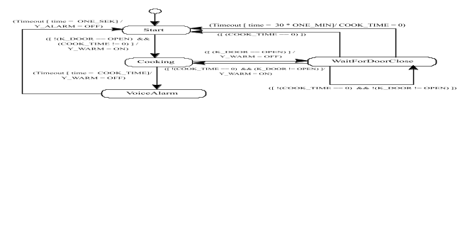
- Example of the process state diagram
Names of process states are inside the nodes. They are connected by arrows, and conditional expressions (switch conditions) in square brackets are above them. Actions which will be done with switching to that state are wrote after the slash.

Diagram of communication between processes by data
Graphical notation, which was created for data diagram of communication between processes, based on the UML state machine diagram [1][3][4] and on the activity UML diagram. An example of such diagram is showed on the Fig. 2.

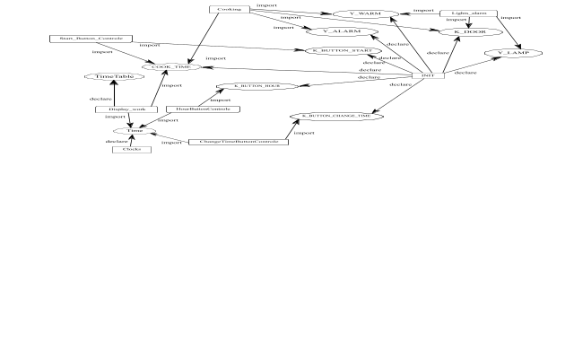
- Example of the process data connection diagram
Processes names are written in square nodes, variable’s names are written in elliptical diagram nodes. Processes nodes are connecting with variable’s nodes by arrows, and connection type is written above them (like imported variables are marked as ‘import’, declared variables are marked as ‘declare’).

Diagram of communication between processes by managing
Graphical notation, which was created for managing diagram of communication between processes, based on the UML state machine diagram [1][3][4] and on the activity UML diagram. An example of such diagram is showed on the Fig. 3.
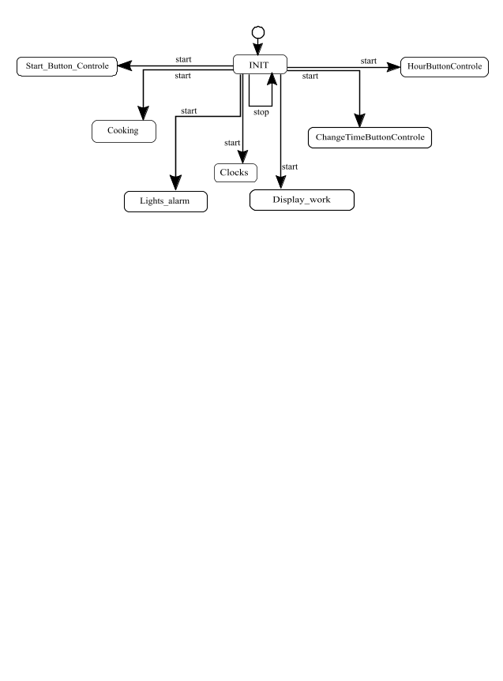
- Example of the process managing connection diagram

Graph storage formats
For choose the graph storage format for module’s output diagram files, we have done analysis of graph representation formats. The result of analisis is showed in the Table 2. The following formats were considered: GraphML [9][10], Gv [11], Xgml [12], Gml [13], Node list [18], Edge list [18], Pajek [14], Leda [15][19][20], TLP [15][17], Gw [15][19][20] and GEXF[21][22].
- Graph representation formats
Format name | Format’s abilities
Format name | Saving coordinates | Right node’s shape | Oriented graph | Edge labels | Tools that use format
GraphML | + | + | + | + | Gephi, Igraph, OGDF, Yed, NetworkX
Gv | - | + | + | + | GraphViz, Gephi, Igraph, OGDF, ZGRViewer, NetworkX
Xgml | + | + | + | + | Yed
Gml | + | + | + | + | Gephi, Igraph, OGDF, Yed, NetworkX, Tulip, LEDA
Node list | - | - | + | - | Yed, NetDraw
Edge list | - | - | + | - | OGDF, Yed, NetworkX, NetDraw
Pajek | + | + | + | + | Gephi, Igraph, NetworkX, NetDraw
Leda | + | + | + | + | Igraph, OGDF, NetworkX, LEDA
TLP | + | + | + | + | OGDF, Gephi, Tulip
Gw | + | + | + | + | LEDA
GEXF | + | + | + | - | Gephi, OGDF, NetworkX, Tulip
Such evaluation criterion like ability to save coordinates is important because it makes possible to save graph layout (by a third-party layout tool) and diagram’s modifications after closing the file. We also analyzed notation criterions to understand which formats may storage graphs in our notations. The last criterion was a list of tools that are able to use the format [5][6][7].
An ability to convert file format to another is showed on the Fig. 4. We found that here is a two families of graph file formats, inside which converting is possible.
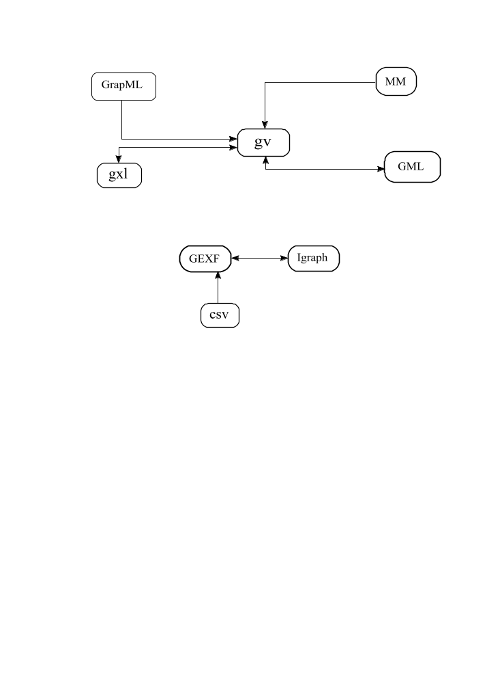
- Example of the process managing connection diagram
GraphML and GML file formats look most suitable for use in that work. We made more detailed analysis of that file formats, the result of which is showed on the Table 3.
- Comparison of GraphML and GML file formats
Comparison criterion | Name of the file format
Comparison criterion | GML | GraphML
File size | x | 2 * x
Easy to read by human | + | -
Can store links | - | +
GML format has a language with a human-like syntax; GraphML format has a language with XML-like syntax. The same diagrams in the GraphML file format have twice as much size. Also GraphML is able to store links, and that’s important, because in each processes diagram node we want to have a link to the state diagram for that process.
As a result, GML was chosen for the process state diagram because of small file’s sizes (module will generate such diagram for every process in the program). GraphML was chosen for processes communication diagrams by data and managing, because it can store the links in graph’s nodes.

Module’s architecture
Module uses the Model–view–controller (MVC) software design pattern, in such way modifications will need less time. Firstly, controller starts the model generator for processes state diagrams, then view part creates GML files of that diagrams. After that controller starts model generators for diagrams of connection between processes. Then it uses a graph separator module for divide diagram’s models if they have independent parts. After that diagram generators create GraphML files of diagrams with links in each process diagram node to state diagram for that process (which was generated before).

Module’s realisation
The module was implemented as an Eclipse plugin (to simplify integration in the Reflex IDE) using Xtext and Xtend technologies. After opening the Reflex IDE and writing code, you can click the save file button, and then processes diagrams of connection by data and managing, and state diagram will be automatically generate. We recommend opening them with the yEd [8] tool that supports automatic graph layout. User steps scheme was showed on the Fig. 5.
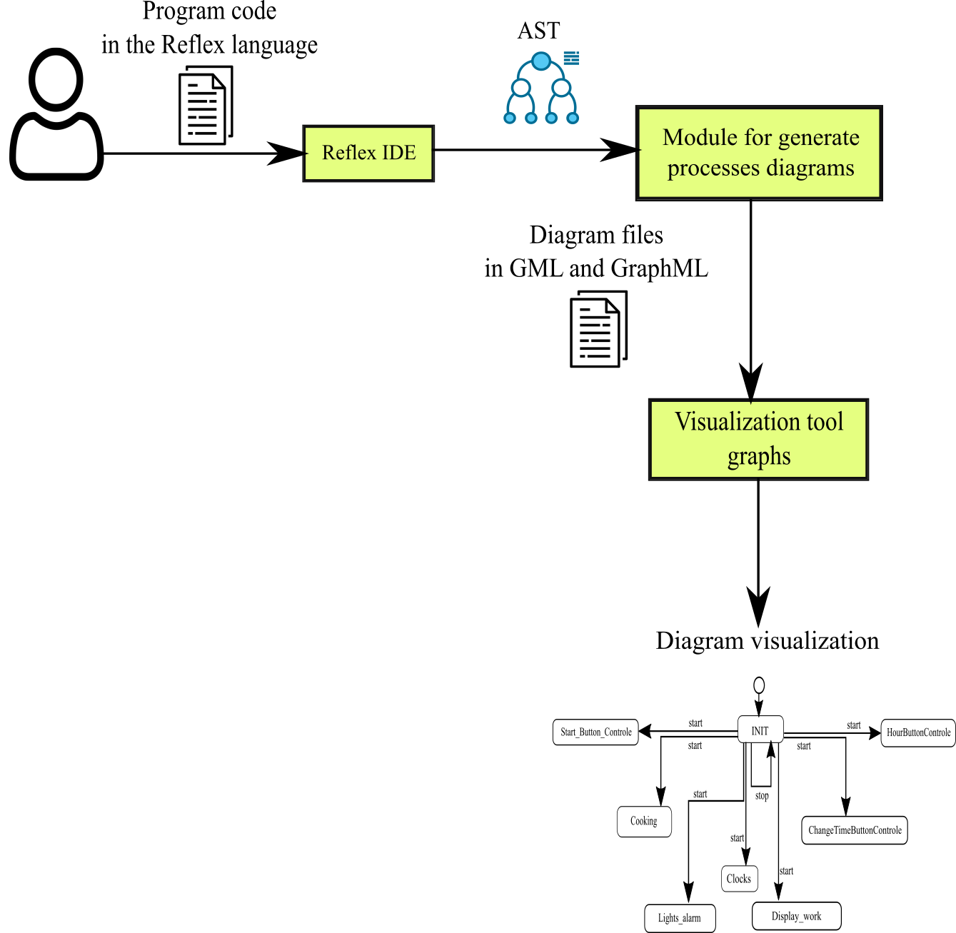
- User steps scheme

The conclusion
As a result, the software module for building process diagrams according to the specification in the Reflex language was created. It creates processes diagrams of connection by data and managing, and state diagram. It automates the creation of the graphical documentation and simplifies the support of projects in the Reflex language. Practical testing has shown that using the module decreased the time for creating processes diagrams (from a few hours to a couple of seconds) and guarantees that there are no errors caused by human factors.

References
- V. E. Zyubin, “Process-orinted programming: Tutorial”. Novosibirsk state university. (in Russian), 2011.
- V. E. Zyubin, T. V. Liakh, A. S. Rozov, "Reflex Language: a Practical Notation for Cyber-Physical Systems." System Informatics 12 (2018): 85-104.
- D. Harel “Statecharts: A visual formalism for complex systems. Science of computer programming”, 8(3), 231-274, 1987.
- D. Drusinsky, Modelling and verification using UML statecharts, Elsevier, 2006.
- S. M. Miro (March 2009). "A crash course in UML state machines".
- Habr: Visualization of large graphs for the smallest (2019). Available at: https://habr.com/ru/company/ods/blog/464715/ (in Russian), (accessed 27 April 2020).
- H. Gibson, J. Faith, P. Vickers, “A survey of two-dimensional graph layout techniques for information visualization” Information Visualization, 2012. Available at: http://leonidzhukov.net/hse/2018/sna/papers/gibson2013 (accessed 27 April 2020).
- M. Chimani, Cger, M. Jünger, G. W. Klau, K. Klein, P. Mutzel. The Open Graph Drawing Framework (OGDF). Chapter 17 in: R. Tamassia (ed.), Handbook of Graph Drawing and Visualization, CRC Press, 2014.
- yWorks: yEd Graph Editor (2020). Available at: https://www.yworks.com/products/yed (accessed 27 April 2020).
- The GraphML File Format (2019). Available at: http://graphml.graphdrawing.org (accessed 27 April 2020).
- V. N. Kasyanov, “V. N. Kasyanov GRAPH REPRESENTATION LANGUAGE GRAPHML: BASIC TOOLS 1” (2012). Available at: https://docplayer.ru/31018473-V-n-kasyanov-yazyk-predstavleniya-grafov-graphml-bazovye-sredstva-1.html (accessed 27 April 2020).
- The DOT Language. Available at: https://graphviz.gitlab.io/_pages/doc/info/lang.html (accessed 27 April 2020).
- yFiles for Java Developer's Guide: XGML : Chapter 9. Input and Output (2016). Available at: https://docs.yworks.com/yfiles/doc/developers-guide/xgml.html (accessed 27 April 2020).
- yFiles for Java Developer's Guide: GML : Chapter 9. Input and Output (2016). Available at: https://docs.yworks.com/yfiles/doc/developers-guide/gml.html (accessed 27 April 2020).
- V. Batagelj, A. Mrvar, “Pajek: Exporting pictures from Pajek to EPS”. Available at: http://vlado.fmf.uni-lj.si/pub/networks/pajek/doc/draweps.htm (accessed 27 April 2020).
- Native File Format for Graphs: Algorithmic Solutions Software GmbH (2006). Available at: http://www.algorithmic-solutions.info/leda_guide/graphs/leda_native_graph_fileformat.html (accessed 27 April 2020).
- D. Auber, P. Mary, “Tulip: Tulip software graph format (TLP)”. Available at: https://tulip.labri.fr/TulipDrupal/?q=tlp-file-format (accessed 27 April 2020).
- D. Auber, P. Mary, “Tulip: LGPL: License”, Available at: https://tulip.labri.fr/TulipDrupal/?q=licence (accessed 27 April 2020).
- A. Prokhorov, N. Larichev, “Computer visualization of social networks”, 2020, Available at: https://compress.ru/article.aspx?id=16593#NetDraw (accessed 27 April 2020).
- Algorithmic solutions software GMBH: LEDA Graphs for Java / Algorithmic Solutions Software GmbH (2020). Available at: https://algorithmic-solutions.com/index.php/products/leda-graphs-for-java (accessed 27 April 2020).
- Algorithmic solutions software GMBH: LEDA Graphs for C++ / Algorithmic Solutions Software GmbH (2020). Available at: https://algorithmic-solutions.com/index.php/products/leda-for-c (accessed 27 April 2020).
- S. Heymann, M. Bastian, M. Jacomy, C. Maussang, A. Rohmer, J. Bilcke, A. Jacomy, “GEXF File Format”. Available at: https://gephi.org/gexf/format/schema.html (accessed 27 April 2020).
- S. Heymann, M. Bastian, M. Jacomy, C. Maussang, A. Rohmer, J. Bilcke, A. Jacomy, “GEXF 1.2draft Primer”. Available at: https://gephi.org/gexf/1.2draft/gexf-12draft-primer.pdf (accessed 27 April 2020).

