Views
A view is a representation of a coherent set of architectural elements, as written by and read by system stakeholders.
There are many views for an architecture.
Documenting an architecture is a matter of documenting the relevant views and then adding documentation that applies to more than one view.

Categories of View Styles
- Module views
- Component-and-connector (C&C) views
- Allocation views
Module Views
- A module is an implementation unit that provides a coherent set of responsibilities (examples: classes, layers,…)
- It is unlikely that the documentation of any software architecture can be complete without at least one module view
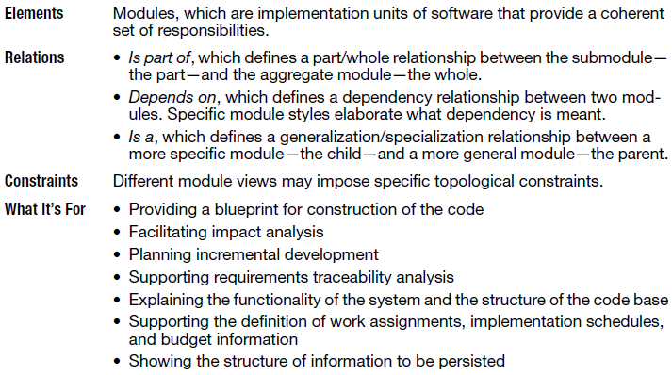
Module View Styles
- Decomposition
- Uses
- Generalization
- Layers
- Aspects
- Data model
Notations for Module Views
- Informal notations
- Dependency Structure Matrix
- UML
- Entity-Relationship Diagram
Dependency Structure Matrix

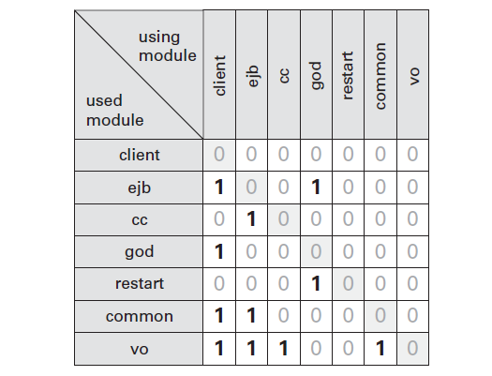
Module Notations in UML

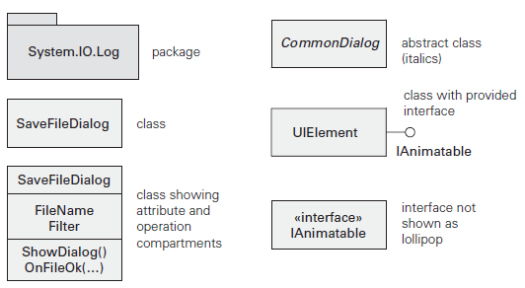
Module Relations in UML
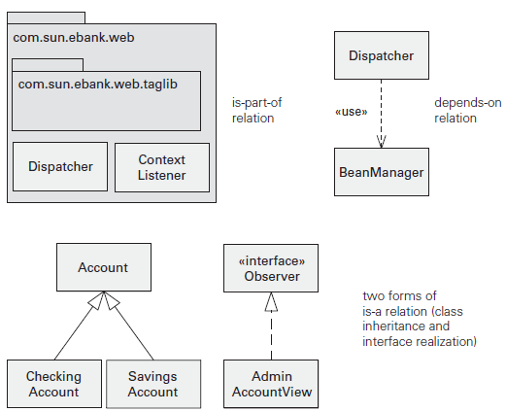
Component and Connector Views
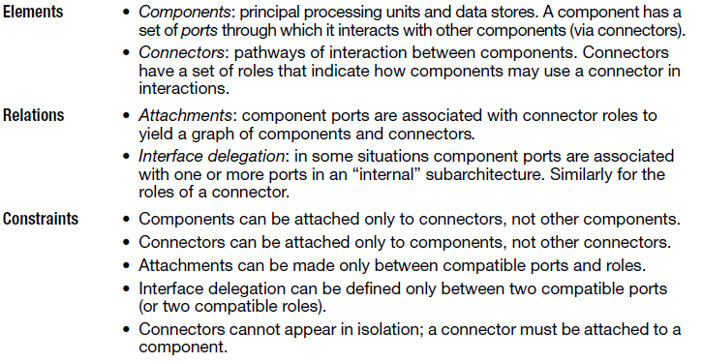
Component and connector views in UML
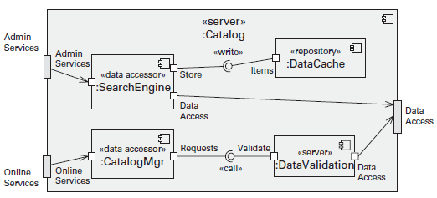
Allocation Views
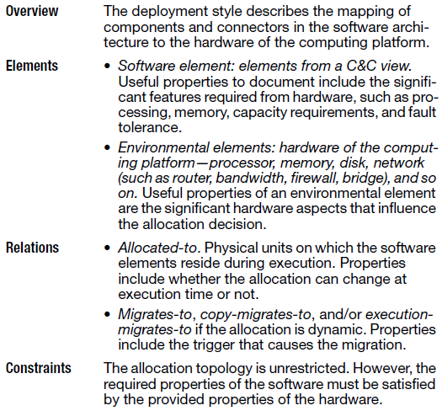
Allocation View Styles
- Deployment
- Install
- Work assignment
Notations for Allocation Views
- Informal notations
- Formal notations
- UML
Informal Notation
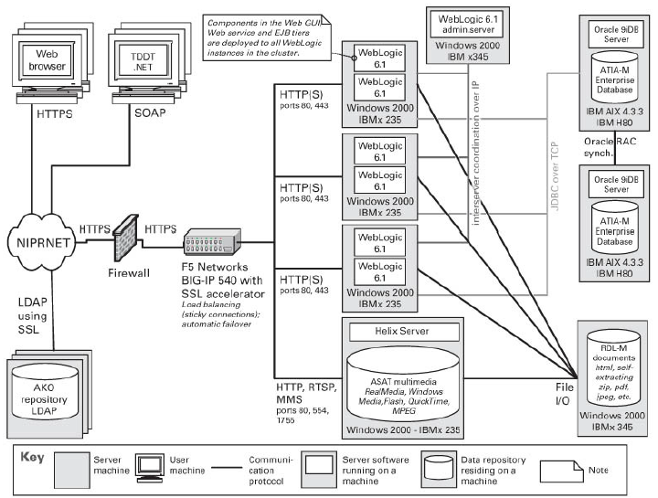
UML Notations
