Create class

public class Employee

{

[Key]

[DatabaseGenerated(DatabaseGeneratedOption.Identity)]

public int Id { get; set; }

[Column(TypeName ="varchar(50)")]

public string FirstName { get; set; }

public string LastName { get; set; }

public DateTime DateOfBirth { get; set; }

public string Email { get; set; }

public double Salary { get; set; }

[Column(TypeName = "varchar(50)")]

public string Remark { get; set; }

}

Create Db context

public class Context:DbContext

{

public Context(DbContextOptions options):base(options)

{

}

public DbSet<Employee> Employees { get; set; }

}

Install these packages

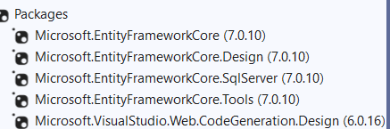

Run nuget console

add-migration "employee table created"

update-database

for alter table

add-migration "employee table Remark column added"

update-database

Add these in program.cs

//DI

builder.Services.AddDbContext<CoreMvcDbFirstContext>(options =>

{

options.UseSqlServer(builder.Configuration.GetConnectionString("DefualtConnection"));

});

Add this in app.settings.json

"ConnectionStrings": {

"DefualtConnection": "Server=DEEPAK;Database=CoreMvcCodeFirst;Trusted_Connection=True;TrustServerCertificate=True"

}

Create new controller Register without entity and a Register class

public class Register

{

public int Id { get; set; }

[Required]

public string RollNo { get; set; }

[Required]

public string Name { get; set; }

[Required]

public string Gender { get; set; }

[Required]

public DateTime DOB { get; set; }

[Required]

[RegularExpression("([0-9]+)", ErrorMessage = "Please Enter Numeric Value")]

public int Class { get; set; }

[Required]

public string Address { get; set; }

[Required]

public string Transport { get; set; }

public bool Cricket { get; set; }

// [Display(Name ="VollyBall")]

public bool Football { get; set; }

public bool Kabadi { get; set; }

public bool Coco { get; set; }

[Required]

public string Comments { get; set; }

[Required]

public byte[] Photo { get; set; }

}

Create a index view with create template

It auto generates the form