Create database

Create table

CREATE TABLE [dbo].[Employees](

[Id] [int] IDENTITY(1,1) NOT NULL,

[FirstName] [varchar](50) NOT NULL,

[LastName] [nvarchar](max) NOT NULL,

[DateOfBirth] [datetime2](7) NOT NULL,

[Email] [nvarchar](max) NOT NULL,

[Salary] [float] NOT NULL,

[Remark] [varchar](50) NOT NULL,

CONSTRAINT [PK_Employees] PRIMARY KEY CLUSTERED

(

[Id] ASC

)WITH (PAD_INDEX = OFF, STATISTICS_NORECOMPUTE = OFF, IGNORE_DUP_KEY = OFF, ALLOW_ROW_LOCKS = ON, ALLOW_PAGE_LOCKS = ON, OPTIMIZE_FOR_SEQUENTIAL_KEY = OFF) ON [PRIMARY]

) ON [PRIMARY] TEXTIMAGE_ON [PRIMARY]

GO

Install required nuget

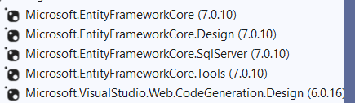

Run in package manager console

Scaffold-DbContext "Server=DEEPAK;Database=CoreMvcDbFirst;Trusted_Connection=True;TrustServerCertificate=True" Microsoft.EntityFrameworkCore.SqlServer -OutputDir Models

Add these in program.cs

//DI

builder.Services.AddDbContext<CoreMvcDbFirstContext>(options =>

{

options.UseSqlServer(builder.Configuration.GetConnectionString("DefualtConnection"));

});

Add this in app.settings.json

"ConnectionStrings": {

"DefualtConnection": "Server=DEEPAK;Database=CoreMvcCodeFirst;Trusted_Connection=True;TrustServerCertificate=True"

}