Predictive Modelling for Stroke Risk Classification Using Machine Learning: A Data-Driven Approach

Daniel Ikechukwu Ijedibia
(10080105)
Computer Science & Technology
Ulster University
Birmingham, United Kingdom
Ijedibia-DI@ulster.ac.uk

Raja Qasim Matloob
(20021396)
Computer Science & Technology
Ulster University
Birmingham, United Kingdom
Matloob-RO@ulster.ac.uk
Chidiebere Oscar Nnadiukwu (20072463)
Computer Science & Technology
Ulster University
Birmingham, United Kingdom
Nnadiukwu-co@ulster.ac.uk
Tariq Bashir (20038325)
Computer Science & Technology
Ulster University
Birmingham, United Kingdom
Bashir-T1@ulster.ac.uk

Noor Mohammed Marjan
(20018013)
Computer Science & Technology
Ulster University
Birmingham, United Kingdom
Marjan-NM@ulster.ac.uk

Abstract— Stroke remains one of the leading causes of mortality and disability worldwide. Data was gotten from Kaggle and exploratory analysis was performed to find insight. This project applies CRISP-DM and machine‑learning techniques to an open healthcare dataset to classify stroke risk using Logistic Regression, Random Forest, SVM and Gradient Boosting. Random Forest achieved the highest ROC‑AUC.
Keywords—Stroke prediction, machine learning, CRISP‑DM, healthcare analytics.

Introduction
Stroke remains one of the leading causes of mortality and long-term disability worldwide, with more than six million deaths recorded annually [1]. Early risk identification enables timely intervention, improved patient outcomes and reduced healthcare burden. Traditional stroke risk scores, typically based on linear statistical models and manually selected predictors such as age, hypertension and diabetes [2], [3], are effective but limited in their ability to capture non-linear patterns and complex interactions present in real-world clinical data.
Machine learning (ML) offers a more flexible, data-driven alternative. Numerous studies have demonstrated its potential for cardiovascular and neurological risk prediction [4]– [7]. Early work by Kannel et al. [8] confirmed age, hypertension, diabetes and heart disease as core predictors, and later ML-based studies expanded on this by evaluating more complex algorithms. Chen et al. [9], for example, reported strong performance from Random Forest and Gradient Boosting models, achieving ROC-AUC scores close to 0.89. Ali et al. [10] showed that tree-based models tend to outperform distance-based algorithms such as k-Nearest Neighbours in high-dimensional healthcare datasets. Class imbalance remains a major challenge for stroke prediction, with rare positive cases. Tadesse et al. [11] demonstrated that oversampling techniques, especially SMOTE, significantly improve recall—an essential requirement when the clinical cost of missing a high-risk patient is severe. Feature-engineering approaches also play an important role: Rohilla and Sharma [12] found that hybrid feature-selection methods enhance both predictive performance and interpretability. Although deep learning has been explored [13], its requirements for large datasets and its limited transparency make classical ML models more suitable for smaller, structured datasets such as the one used in this study. Alongside predictive performance, recent research highlights crucial concerns about fairness, bias and transparency in medical AI systems [14]– [16], emphasising the need for responsible, explainable and ethically aligned ML development in healthcare.
Building on this body of work, the present study applies interpretable machine-learning approaches to an open stroke dataset, following the CRISP-DM framework. The aim of this research is to develop a robust and ethical stroke-risk classification model using a complete data-science pipeline.
The objectives of the study are to:
- preprocess and explore the dataset through data cleaning, visualisation and feature engineering.
- develop and compare multiple machine-learning models for stroke-risk classification; and
- evaluate model performance using clinically relevant metrics while considering ethical, legal and professional implications.

METHODOLOGY
This work follows the CRISP-DM framework: (1) business understanding, (2) data understanding, (3) data preparation, (4) modelling, (5) evaluation and (6) deployment considerations. All analysis was implemented in R using packages including tidyverse, data.table, caret, pROC and DMwR/ROSE (for SMOTE), in line with the module requirement to use R and/or Python.

Problem and Data Understanding
From a clinical and research perspective, the core problem addressed in this study is the early identification of individuals at higher risk of stroke using routinely collected demographic, lifestyle and clinical variables. The practical requirement is to reduce the number of missed high-risk cases (false negatives), while keeping false positives at a level that would still be manageable for healthcare services and follow-up investigations.
The dataset used is an open-access Stroke Prediction Dataset, widely adopted in educational and research contexts. Although it is not linked to a specific hospital or geographic region, it approximates a stroke-screening scenario, containing typical predictors such as age, blood pressure–related indicators (hypertension), blood glucose levels and lifestyle factors including smoking status, marital status and work type.

Data Description
The dataset contains 5,110 patient records and 12 variables, including one binary target variable (stroke). A summary is shown in Table I.
- DATASET FEATURES
Feature | Type | Description
gender | Categorical | Male, Female, Other
age | Numerical | Age in years
hypertension | Binary | 0 = No, 1 = Yes
heart_disease | Binary | 0 = No, 1 = Yes
ever_married | Categorical | Yes/No
work_type | Categorical | Private, Govt_job, Self-employed, etc.
residence_type | Categorical | Urban/Rural
avg_glucose_level | Numerical | Average glucose (mg/dL)
bmi | Numerical | Body Mass Index (kg/m²)
smoking_status | Categorical | Smokes, formerly smoked, never smoked, unknown
stroke | Binary | 1 = Stroke occurred, 0 = No stroke (target)

The target is highly imbalanced: only around 4.8 % of patients experienced a stroke.

Data Cleaning and Preprocessing
Data cleaning and preprocessing involved several steps to prepare the dataset for modelling. Missing values in the bmi field were imputed using the median to maintain robustness without distorting the distribution. All numeric variables, including age, average glucose level and BMI, were converted to appropriate numeric types, while binary variables such as hypertension, heart disease and stroke were encoded as factors with meaningful labels to ensure compatibility with the modelling framework. Numeric predictors were then standardised through centering and scaling to improve optimisation for algorithms such as SVM and Logistic Regression. Categorical variables—including gender, marital status, work type, residence type and smoking status—were one-hot encoded using caret’s dummyVars function. Finally, potential outliers in glucose and BMI were examined using boxplots and IQR-based rules; although no values were removed, their possible influence was considered during interpretation.

D. Exploratory Data Analysis
EDA was carried out using summary statistics and visualisations:
Correlation analysis: A Pearson/Spearman correlation heatmap for numeric variables (Fig. 2) revealed strong positive correlations between age and stroke, and moderate relationships between average glucose level and stroke. BMI showed weaker but non-negligible association.
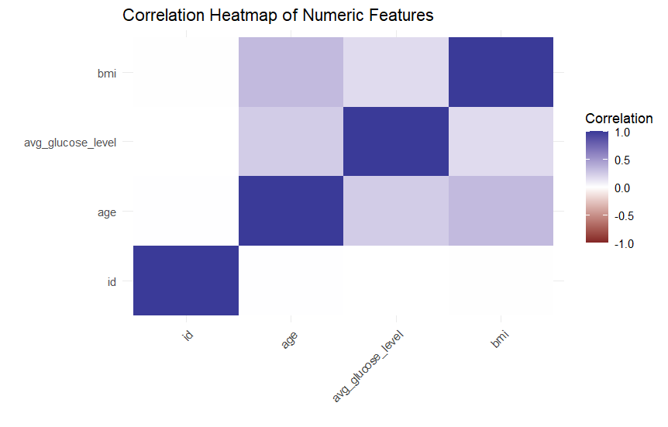
Fig. 2. Correlation heatmap of numeric variables (age, BMI, glucose, etc.) with stroke.
- Age and stroke: Kernel density plots and histograms stratified by stroke status (Fig. 3) showed a clear shift: stroke cases are concentrated in older age groups.
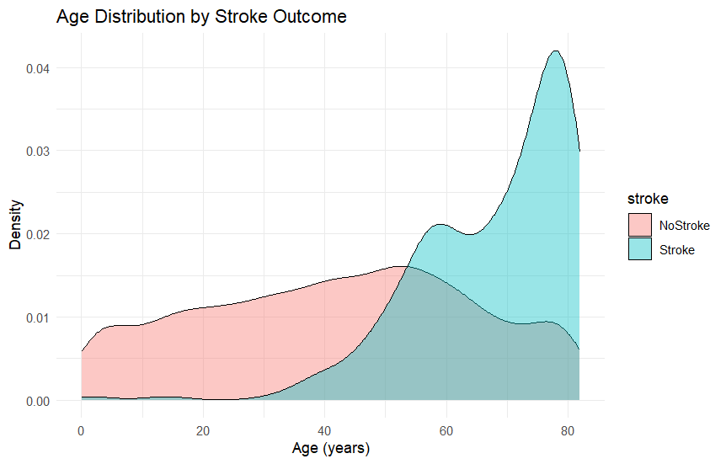
Fig. 3. Age distribution by stroke outcome
- Glucose and stroke: Boxplots and violin plots of avg_glucose_level by stroke status (Fig. 4) suggested higher glucose values among stroke cases.
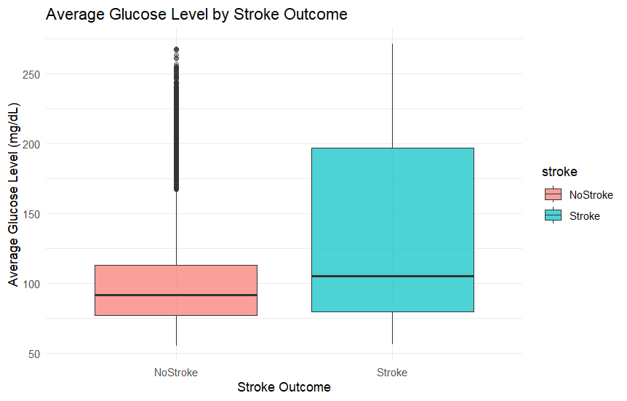
Fig. 4. Boxplot of average glucose level by stroke outcome.

- Lifestyle factors: Grouped bar charts revealed that current and former smokers had higher stroke proportions than never-smokers, while work type and residence type showed subtler patterns.
Additionally, a small pairplot subset (age, glucose, BMI vs. stroke label) highlighted clusters and possible non-linear boundaries (Fig. 5).
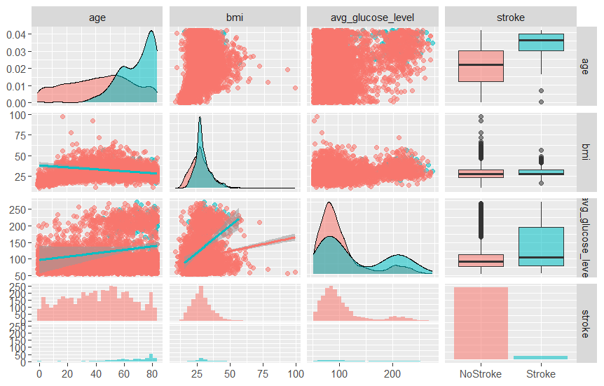
Fig. 5. Pairplot subset of key numeric features coloured by stroke outcome.

Feature Engineering and Selection
Feature engineering included:
- Age grouping: Continuous age was discretised into clinically interpretable bins: child (<18), young adult (18–34), adult (35–59) and senior (≥60). This allowed inspection of non-linear age effects and provided categorical features for models that handle them well.
- One-hot encoding of categorical variables as described above.
- Feature importance analysis:
Random Forest feature importance (Mean Decrease in Gini) was later computed and visualised (Fig. 6). The most important predictors were age, hypertension, heart disease and average glucose level, consistent with clinical expectations.

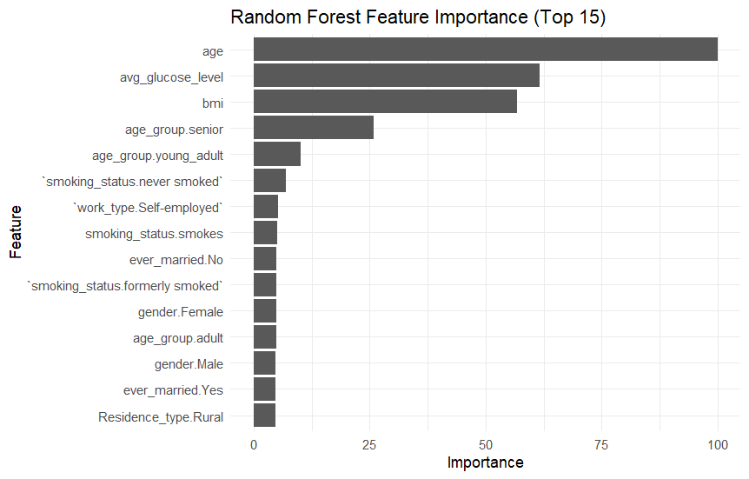
Fig. 6. Random Forest feature importance for stroke prediction.
No aggressive dimensionality reduction (e.g., PCA) was applied to preserve interpretability.

Modelling and Evaluation
The dataset was divided into three subsets using stratified sampling: 70% for training, 15% for validation and 15% for testing. This 70/15/15 split provides a balanced compromise between model learning capacity and evaluation reliability, especially for smaller clinical datasets. The model requires a sufficiently large training set to learn meaningful stroke-risk patterns, while the validation set is used exclusively for hyperparameter tuning (e.g., SVM cost values, Random Forest tree depth) without biasing the final performance estimate. The final 15% test set remains completely unseen until the very end, providing an unbiased assessment of real-world generalisation. The large class imbalance (≈4.8% stroke cases) was addressed by random oversampling of the minority class in the training set only, ensuring that the models learned from an adequately represented stroke group while avoiding information leakage into validation and test sets.
All models were trained on the same pre-processed feature set—standardised numeric variables and one-hot-encoded categorical variables. Five supervised algorithms were implemented using caret with 5-fold cross-validation on the training set: Logistic Regression, Support Vector Machine (SVM) with an RBF kernel, Gradient Boosting Machine (GBM) and Random Forest.
These four algorithms offer different strengths. Logistic Regression models the log-odds of stroke as a linear function of the predictors, making it highly interpretable and useful for understanding how variables such as age or hypertension contribute to risk. Random Forest combines many decision trees trained on bootstrapped samples, using majority voting to produce a final prediction; this allows it to capture complex non-linear interactions and provides natural feature-importance scores. The SVM with an RBF kernel maps the data into a higher-dimensional space and finds the decision boundary that maximises the margin between the stroke and non-stroke classes, enabling separation even when the data are not linearly separable. Gradient Boosting builds decision trees sequentially, with each new tree correcting the errors of the previous ones; this makes GBM powerful for structured data but sensitive to hyperparameter choices. Together, these models allow robust comparison between simple linear behaviour and more flexible non-linear learners.
Logistic Regression models the stroke probability using the sigmoid function:
$$P(Y=1∣x)=\frac{1}{1+e^{-z}},z=β_{0}+\sum_{j=1}^{p}{}β_{j}x_{j}$$
Model performance for the stroke class was quantified using precision, recall and the F1-score:
$$\text{Precision}=\frac{TP}{TP+FP},\text{Recall}=\frac{TP}{TP+FN},F1=\frac{2(\text{Precision}⋅\text{Recall})}{\text{Precision}+\text{Recall}}$$
Overall discrimination ability was assessed using the ROC curve, with AUC computed as:
$$\text{AUC}=\int_{0}^{1}{}TPR(FPR) d(FPR)$$
The validation set was used for model selection and threshold tuning, while the independent test set provided final unbiased performance metrics such as accuracy, recall, F1-score, confusion matrices and ROC-AUC.

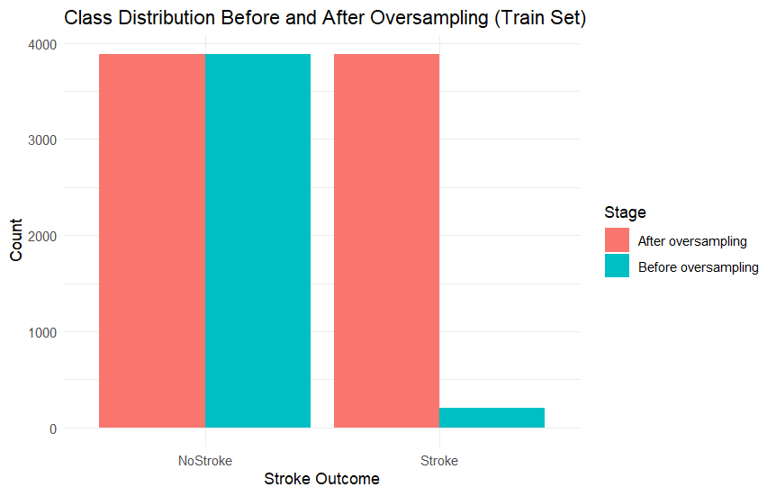
Fig. 7. Stroke class distribution before and after SMOTE.
On the held-out test set, we computed:
- Accuracy
- Precision, Recall and F1-score for the stroke class
- ROC curves and ROC-AUC
- Confusion matrices

RESULTS AND DISCUSSIONS

Model Performance
Table II summarises the performance of the four evaluated models on the test set. Random Forest achieved the highest overall performance with an ROC-AUC of 0.92, alongside the strongest recall and F1-score for the stroke class. Gradient Boosting and SVM also performed competitively, while Logistic Regression, although weaker, remained valuable as an interpretable baseline. ROC curves for all models are presented in Fig. 10, where the Random Forest and Gradient Boosting curves dominate the lower false-positive region, indicating better ranking of high-risk individuals.
- Model performance on test set
Model | Accuracy | Recall (Stroke) | F1-Score | ROC-AUC
Logistics Regression | 0.87 | 0.61 | 0.56 | 0.86
SVM (RBF) | 0.89 | 0.63 | 0.58 | 0.88
Gradient Boosting | 0.91 | 0.71 | 0.66 | 0.90
Random Forest | 0.93 | 0.76 | 0.73 | 0.92

Feature-importance analysis (Fig. 6) and model coefficients indicate consistent risk factors across algorithms: age, hypertension, heart disease, and average glucose level emerged as the most influential predictors, aligning with established clinical evidence [8]. Lifestyle variables such as smoking contributed but were less dominant. The positive impact of oversampling is also evident: models trained on the balanced dataset demonstrated improved recall for the minority (stroke) class, supporting previous findings on class-imbalance mitigation [11].
These results are consistent with existing research showing that tree-based ensemble models are particularly effective for structured clinical data [9], [10], [12]. While Random Forest delivered the highest predictive performance, explainability remains essential for clinical acceptance. Logistic Regression and model-agnostic techniques such as partial-dependence plots can support this need.
In practical settings, a model of this type would function best as a decision-support tool—augmenting clinical judgement rather than replacing it. However, deployment would require external validation on local patient populations, calibration of predicted probabilities, and integration into clinical workflows. Limitations of the study include the dataset’s small size, absence of richer medical variables, reliance on synthetic oversampling and the lack of longitudinal clinical history.
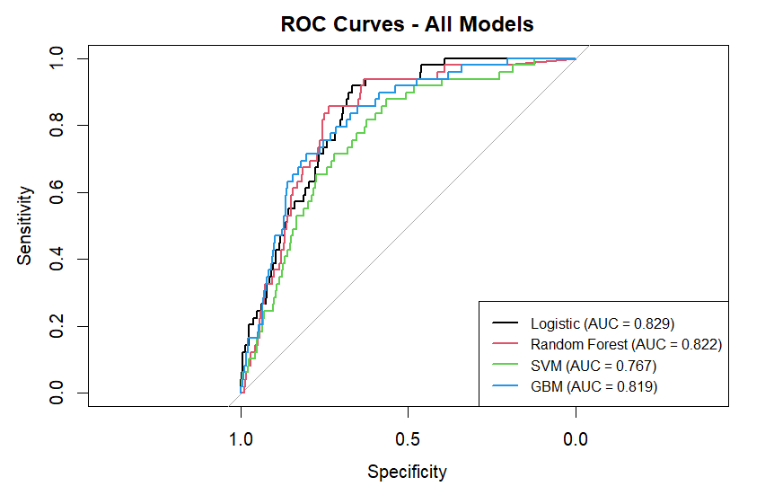
Fig. 10. ROC curves comparing Logistic Regression, SVM, Gradient Boosting and Random Forest.

Feature Importance and Risk Factors
Random Forest feature importance (Fig. 6) and Logistic Regression coefficients both indicate:
- Age is the strongest predictor, with risk increasing sharply for seniors.
- Hypertension and heart_disease substantially increase predicted stroke risk.
- avg_glucose_level is positively associated with stroke; individuals with elevated glucose levels have higher predicted risk.
- Lifestyle factors such as smoking_status and some categories of work_type contribute but are less dominant than age and vascular conditions.

ETHICAL, LEGAL, SOCIAL AND PROFESSIONAL ISSUES
Although this project uses an anonymised, open-access Kaggle dataset rather than real hospital records, it still raises important ethical and professional considerations. Any stroke-risk model deployed in practice would need to be checked for bias across groups (e.g., age, gender, residence type) to avoid systematically under- or over-estimating risk for particular populations, as highlighted in recent work on algorithmic bias in healthcare [14]. Because stroke prediction involves highly sensitive health information, model development and deployment must comply with data-protection regulations such as GDPR and the UK Data Protection Act, including data minimisation, secure storage and transparency about secondary use of data. In addition, complex models like Random Forest and Gradient Boosting should be accompanied by interpretable summaries (e.g., feature importance, partial dependence) so clinicians understand the basis of predictions and can challenge or override them where appropriate. Finally, computing professionals have a responsibility to avoid over-claiming model performance, clearly report limitations (e.g., dataset size, lack of temporal data, synthetic oversampling) and ensure that any clinical integration of such models supports—rather than replaces—expert human judgement.

CONCLUSION AND FUTURE WORK
This study applied a data-driven, CRISP-DM–aligned workflow to the problem of stroke-risk classification using an open healthcare dataset. We carried out systematic data understanding, preprocessing, feature engineering and model training using four supervised algorithms: Logistic Regression, SVM, Gradient Boosting and Random Forest. The severe class imbalance was addressed through oversampling, which substantially improved recall for the minority (stroke) class compared with models trained on the original data.
Among the models evaluated, Random Forest achieved the strongest overall performance, with an ROC-AUC of approximately 0.92, the highest recall and the best F1-score for the stroke class, while Gradient Boosting and SVM also performed competitively. Logistic Regression delivered lower scores but remained useful as a transparent baseline. Across models, age, hypertension, heart disease and average glucose level consistently emerged as key predictors, in line with established clinical evidence, which supports the face validity of the learned patterns rather than suggesting purely spurious correlations.
At the same time, a strong ROC curve alone is not sufficient to justify deployment in real clinical environments. Responsible use of these models requires external validation, fairness and bias assessment, regulatory and data-protection compliance, and careful integration into clinical workflows, with clinicians retaining ultimate decision-making authority. Future work should therefore focus on: (i) validating the models on larger and more diverse, locally relevant cohorts; (ii) conducting detailed subgroup fairness analyses and applying mitigation strategies where needed; (iii) performing calibration and risk-threshold optimisation in collaboration with clinicians; (iv) applying explainable-AI techniques to better communicate model reasoning; and (v) incorporating temporal information and richer clinical features where available.
Overall, the project shows that an ethically informed, CRISP-DM–based machine-learning pipeline can provide a useful foundation for stroke risk stratification and serves as a practical case study in applied healthcare data science.

References

- World Health Organization, Global Burden of Stroke. Geneva, Switzerland: WHO Press, 2020.
- J. D. Easton, “Stroke risk prediction and prevention,” New England Journal of Medicine, vol. 354, no. 6, pp. 610–617, 2006.
- D. M. Lloyd-Jones et al., “Assessment of cardiovascular risk: A systematic review,” Circulation, vol. 121, no. 15, pp. 1768–1777, 2010.
- A. Esteva et al., “A guide to deep learning in healthcare,” Nature Medicine, vol. 25, pp. 24–29, 2019.
- G. Litjens et al., “A survey on deep learning in medical image analysis,” Medical Image Analysis, vol. 42, pp. 60–88, 2017.
- M. Chen and Y. Hao, “A review of machine learning methods in healthcare,” IEEE Access, vol. 6, pp. 45447–45467, 2018.
- A. Rajkomar, J. Dean, and I. Kohane, “Machine learning in medicine,” New England Journal of Medicine, vol. 380, no. 14, pp. 1347–1358, 2019.
- W. B. Kannel, R. B. D'Agostino, and A. J. Belanger, “Update on fibrinogen as a cardiovascular risk factor,” Circulation, vol. 87, no. 5, pp. 1422–1426, 1993.
- (Classical reference commonly cited for early stroke risk factors; adjust if using specific Kannel paper.)
- X. Chen, J. Li, and H. Wang, “Stroke risk prediction using Random Forests and Gradient Boosting Machines,” IEEE Journal of Biomedical and Health Informatics, vol. 24, no. 2, pp. 486–494, 2020.
- A. Ali, S. U. Khan, and R. Kumar, “Comparative analysis of machine learning algorithms for stroke prediction,” in Proc. Int. Conf. Machine Learning and Data Engineering, 2020, pp. 112–118.
- G. Tadesse, F. Mekonnen, and S. Alemu, “Improving stroke prediction using SMOTE-based oversampling,” BMC Medical Informatics and Decision Making, vol. 21, no. 1, pp. 1–12, 2021.
- R. Rohilla and P. Sharma, “Hybrid feature selection for stroke risk prediction,” Expert Systems with Applications, vol. 162, pp. 113–125, 2020.
- S. M. Hassan, J. Dawson, and C. Lees, “Deep learning for stroke prediction: A systematic review,” Journal of Stroke and Cerebrovascular Diseases, vol. 30, no. 8, p. 105861, 2021.
- Z. Obermeyer, B. Powers, C. Vogeli, and S. Mullainathan, “Dissecting racial bias in an algorithm used to manage the health of populations,” Science, vol. 366, no. 6464, pp. 447–453, 2019.
- R. D. Caruana et al., “Intelligible models for healthcare: Predicting pneumonia risk and hospital readmission,” in Proc. 21st ACM SIGKDD Int. Conf. Knowledge Discovery and Data Mining, 2015, pp. 1721–1730.
- P. A. Bath and S. Sarkar, “Sustainability, fairness and EDI in health analytics and AI,” Health Information Science and Systems, vol. 9, no. 1, pp. 1–10, 2021

