**Tic-Tac-Toe**

v. 1.0

**done by Alexander Koss**

**(group B22 green, Vinnytsia IT-Academy)**

**Task obtained: 00.00.2023**

**Pre-defence: 00.00.2023, Teacher1 ___________**

**Defence: 00.00.2023, Teacher2 ___________**

**CONTENTS**

1. **System requirements**
2. **About game Tic-Tac-Toe (typical rules)**
3. **User guide**
4. **Programmer instruction**
5. **About the author**

1. **System requirements**

**Operating system:** Windows

**Processor:** 800 MHz

**RAM:** 512 MB

**Videocard:** 32 MB

1. **About game Tic-Tac-Toe (typical rules**)

Tic-Tac-Toe is a game of logic between two opponents on a 3 by 3 square or larger (up to an "infinite square"). One of the players plays with «crosses» and the other with «zeros».

The project uses a 5x7 square.

**Rules:**

Players take turns putting signs (one always crosses, the other always zeros) on free cells of the 5×7 field. The first player to line up 4 of his pieces vertically, horizontally or diagonally wins.

The first move is made by the player placing the crosses.

Usually at the end of the game the winning side crosses out its 4 pieces (zeros and crosses) making a continuous row.

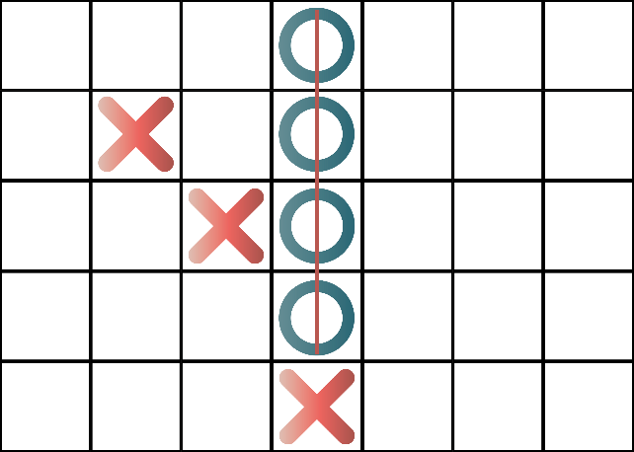 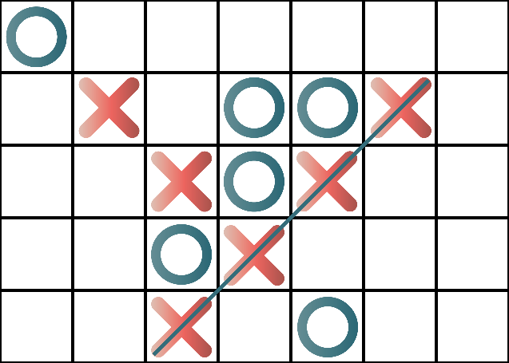

An example of winning for tic-tac-toe

**Analysis**

For each side, algorithms are generally known which guarantee a draw for any opponent's play and allow a win for an opponent's error. Thus, the game is in a state of «draw death».

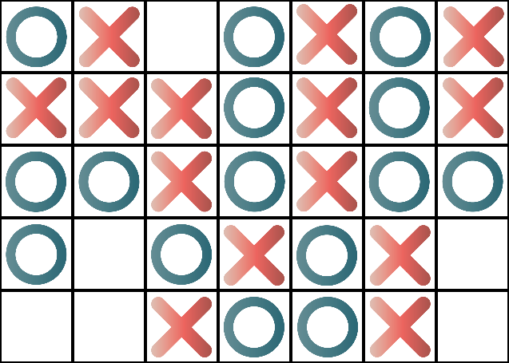

Example of a "draw death" condition.

**3. User guide**

a. Locate and run the TicTacToe.exe file in the TicTacToe folder.

b. Read the program name and author information and press any key.

c. Read the game description shown below and press any key.

d. Enter the coordinates where you want to put a cross

e. Wait for the bot to make its move

f. Repeat steps d-e until you have a line of 4 identical characters

g. If the field is full and no one has won, it will be a draw

h. The game will end automatically after a line of four or after filling the entire field

**4. Programmer instruction**

The project was written on C++.

Advantages of C++:

**Portability:** C++ is one of the most used and portable to different platforms, almost any type of computer and operating system.

**Brevity: c**ode written in C++ is very short in comparison with other languages.

**Modular programming:** applications written on C++ can be made up of several source code files which are compiled separately and then linked together. This characteristic allows to link C++ code with the one written in  other languages (for example, Assembler).

**Speed:** The resulting code from a C++ compilation is very efficient due to the reduced size of the language itself.

Project is a single cpp-unit which contains all necessary algorithms and functions.

Find and open the file Kalah.cpp in folder Kalah. For edition, debugging and compiling program code you may use C++ compilers such as MS Visual Studio, Visual C++, C++ Builder, Borland C++, Dev C++ and similar.

Main global variables:

Char cell[7][5]- variable where the field is stored

Bool playerWin- a variable where the condition whether the player has won is stored

Bool botWin - a variable where the condition whether the bot has won is stored

Bool draw - a variable where the condition is stored or a draw has occurred

Main functions:

Void checkrow – checks the line for four in a row

Void checkColluns - checks the line for four in a colluns

Void checkRightDiag – checks the diagonal from right to left

Void checkLeftDiag – сhecks diagonals from left to right

Void checkWin – checks all function

**5. About the author**

This project was done by Alexander Koss – Vinnitsya IT-Academy student (group_, January 2023).