English | Výslovnost | Česky
Elephant | [elefant] | slon | 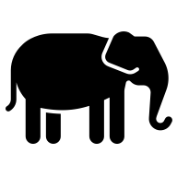
Lion | [lajon] | lev | 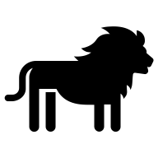
Horse | [hors] | kůň | 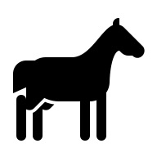
Monkey | [manki] | opice | 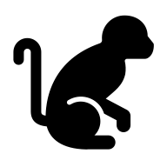
Giraffe | [džiraf] | žirafa | 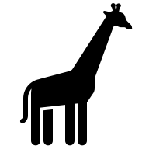 | 
Zebra | [zíbra] | zebra | 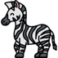
Snake | [snejk] | had | 
Tortoise | [tórtys] | želva | 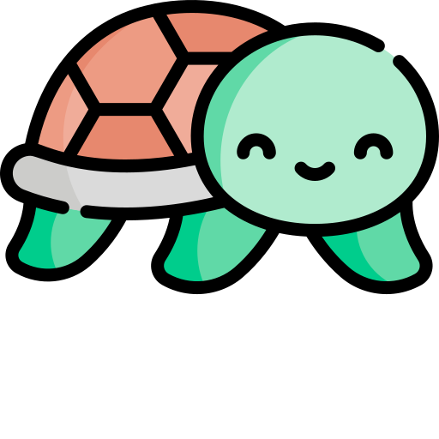
Bear | [braun ber] | medvěd | 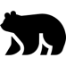
Rhinoceros  (Rhino) | [rajnoseres  rajno] | nosorožec | 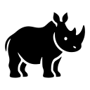
Camel | [keml] | velbloud | 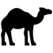
Eagle | [bold ígl] | orel | 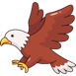
Fox | [red foks] | liška | 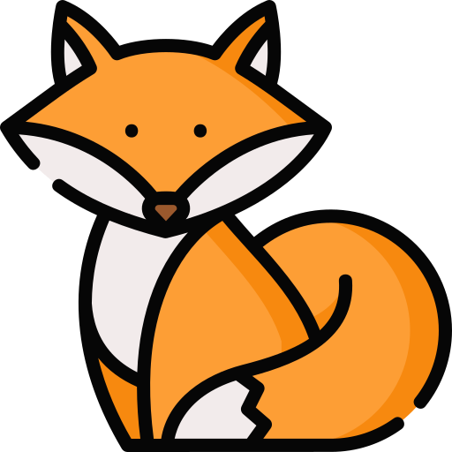
Wolf | [vulf] | vlk | 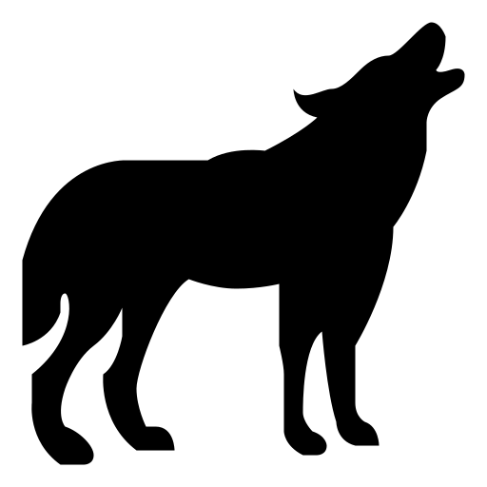
Pig | [pig] | prase | 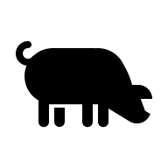
Goat | [gout] | koza | 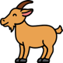
Cow | [kau] | kráva | 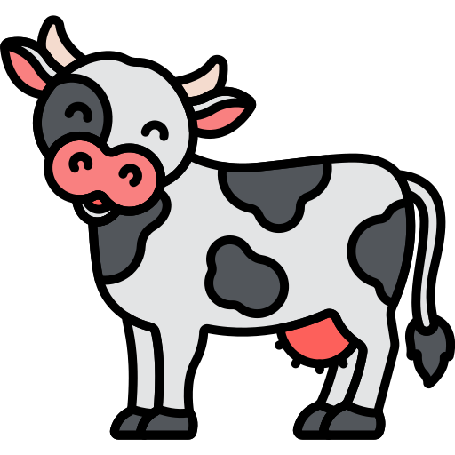
Goose | [gús] | husa | 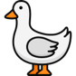
Duck | [dak] | kachna | 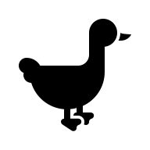
Turkey | [trki] | krocan | 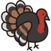
Deer | [dýr] | jelen | 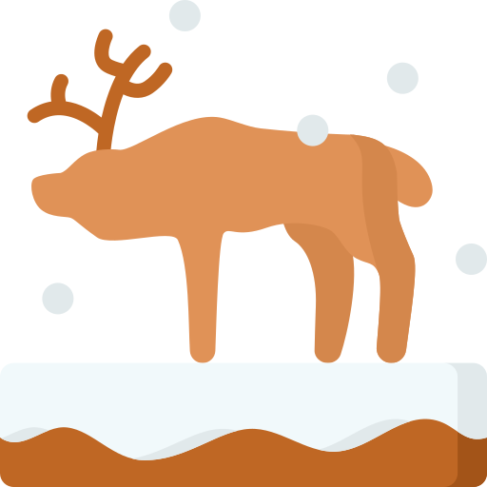
Sheep | [šíp] | ovce | 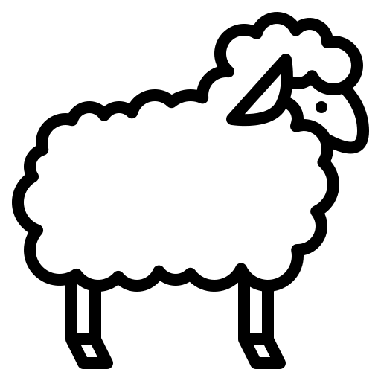
Parrot | [perot] | Papoušek | 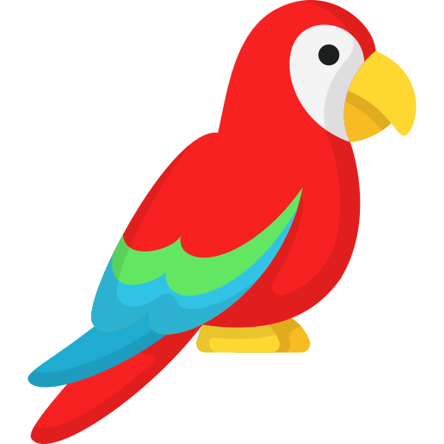 | 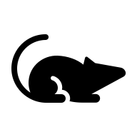
Rabbit | [rebit] | králík | 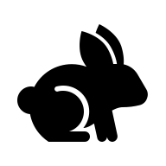
Mouse | [maus] | myš | 
Hippopotamus  (Hippo) | [hipopotemes  hipo] | hroch | 

