数据表结构

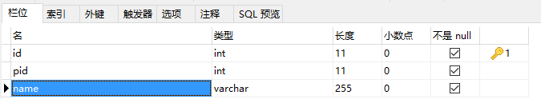

查询所有子树的方法

delimiter //

Drop FUNCTION IF EXISTS getChildList;

CREATE FUNCTION `getChildList` (rootId INT) RETURNS VARCHAR (1000)

BEGIN

DECLARE sTemp VARCHAR (1000) ;

DECLARE sTempChd VARCHAR (1000) ;

SET sTemp = '$' ;

SET sTempChd = cast(rootId AS CHAR) ;

WHILE sTempChd IS NOT NULL DO

SET sTemp = concat(sTemp, ',', sTempChd) ;

SELECT group_concat(id) INTO sTempChd

FROM

test2

WHERE

FIND_IN_SET(pid, sTempChd) > 0 ;

END WHILE ;

RETURN sTemp ;

END//

select * from test2 where FIND_IN_SET(id,getChildList(1));