# Pre and Post Email Migration Scripted Reports

1: The script is maintained and updated to GitHub, ensure that you are working with the most current copy.

1. <https://github.com/BellTechlogix/MailboxReports/blob/master/MailboxReports/MBSizeReport.ps1>

2: To run the Pre-Migration Script use the following Directions:

1. Log into a system that either has Exchange installed, or has the exchange management shell installed
2. Copy the script to a folder on the local machine
3. Run the Script by changing to the directory then typing .\MBSizeReport.ps1
4. Select your Report Type and hit OK
   1. 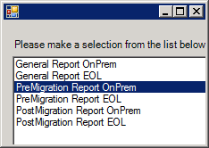
   2. If you are running any of the Exchange Online(EOL) Reports, you must run the script from an already connected EOL Management Shell
5. Select the Details you want to gather
   1. 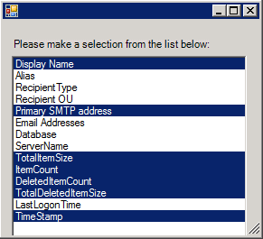
6. You will then be prompted whether you want to poll all mailboxes, if you have a subset you wish to select from a CSV then select No, otherwise select Yes and it will pull all Mailboxes.
7. If you Select No then you will be prompted to select your CSV
   1. 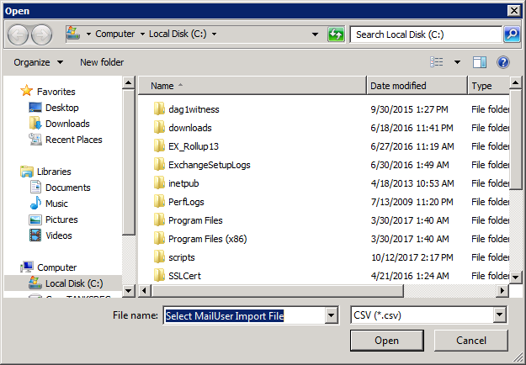
   2. Your CSV must have a column either labeled EmailAddress or PrimarySMTPAddress
   3. Hit OK
   4. The Script will place your report into the same location as your input csv
8. If you select Yes then you will be prompted to select the Folder to place the report in
   1. 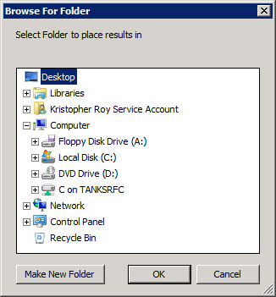
9. The script will run and return your CSV to the appropriate folder.