**I.**

1.

S → r X d | r Z d  
X → o a | e a  
Z → a i

LG:

raid

S: rXd

S: rZd

SYZ

S

X: oa

X: ea

Z: ai

* S: rZd

Z: ai => Succes

**II.**

1.

Không

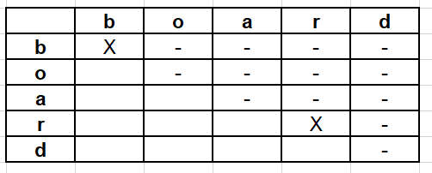

**III.**

1.

