**Android Framework**

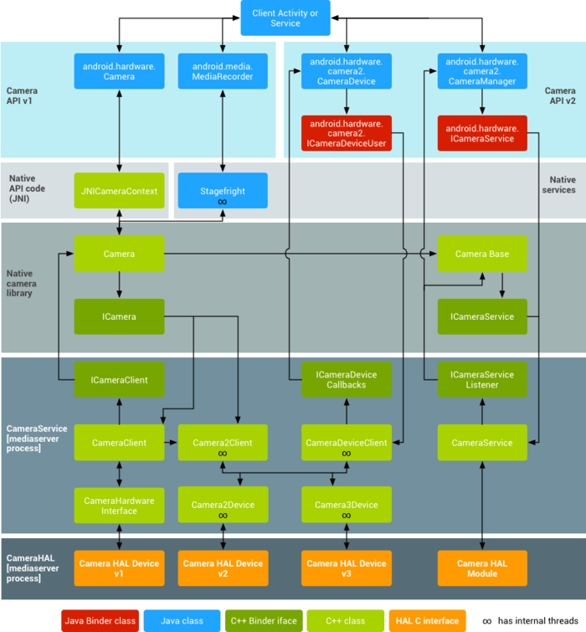

HAL：Hardware Abstract Level