SkillHer 🎯

Basic Details

Team Name: Semaphores

Team Members

Ann Santhosh

S. Blessy Catherine

Hosted Project Link

https://moodle.com/

Project Description

SkillHer is a democratized learning platform built on Moodle, designed to help women gain expertise in fields like automotive engineering, coding, and technical trades.

The Problem Statement

Many women struggle to master technical subjects due to a lack of personalized guidance, hands-on training, and structured learning, creating a gap between knowledge and real-world application.

The Solution

SkillHer is a Moodle-based learning platform that bridges the skill gap by offering:

✅ Personalized Learning Paths

✅ 1:1 Doubt-Clearing Sessions

✅ Hands-On Training Opportunities in technical fields

Technical Details

Technologies/Components Used

For Software:

Languages: Python, PHP, HTML, CSS, JSON

Frameworks: Moodle, Flask

Libraries: Flask, Sentence Transformers, Bits and Bytes, Pandas, MySQL

Tools: XAMPP, VS Code, Postman, Google Colab, Google Drive

📌 Workflow

1️⃣ User Interaction Layer (Frontend)

Users (students & educators) interact with the platform through a web-based Moodle LMS.

They can enroll in courses, book 1:1 sessions, chat with the AI assistant, and access study materials.

2️⃣ Application Layer (Backend & Business Logic)

Moodle (PHP & MySQL Backend):

Handles user authentication, course management, and session scheduling.

AI Chatbot (Flask API + LLM Integration):

Processes user queries and provides real-time assistance.

3️⃣ Data Processing & Storage Layer

MySQL Database:

Stores user data, course progress, session details, and

chat history.

Embedded AI Model (SentenceTransformers):

Generates responses for the chatbot based on trained knowledge.

4️⃣ Communication Layer (API & Real-Time Processing)

Flask API:

Facilitates interaction between Moodle and the AI chatbot.

WebSockets / AJAX:

Enables real-time updates for chat and session notifications.

5️⃣ Deployment & Monitoring

XAMPP (Local Development) → Cloud

Logging & Monitoring (via Moodle logs & API monitoring tools)

Implementation

Installation & Run Commands

1️⃣ Download & Install XAMPP from the official website.

2️⃣ Run XAMPP Control Panel

3️⃣ Start MySQL & Apache2 services

4️⃣ Access the website via:

🔗 https://moodle.com/

LLM datasets training: https://colab.research.google.com/drive/13LxvH-xJ9y9HptXuC6RoHKZEjraDQ-iZ?usp=sharing

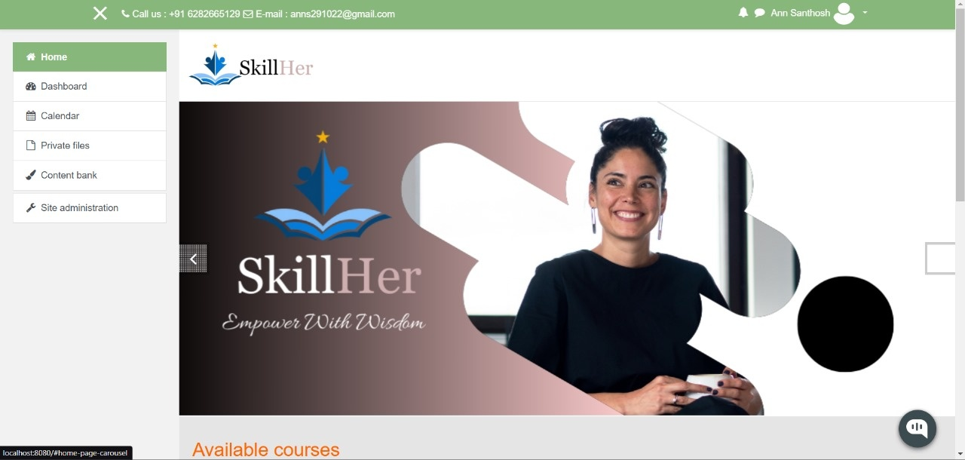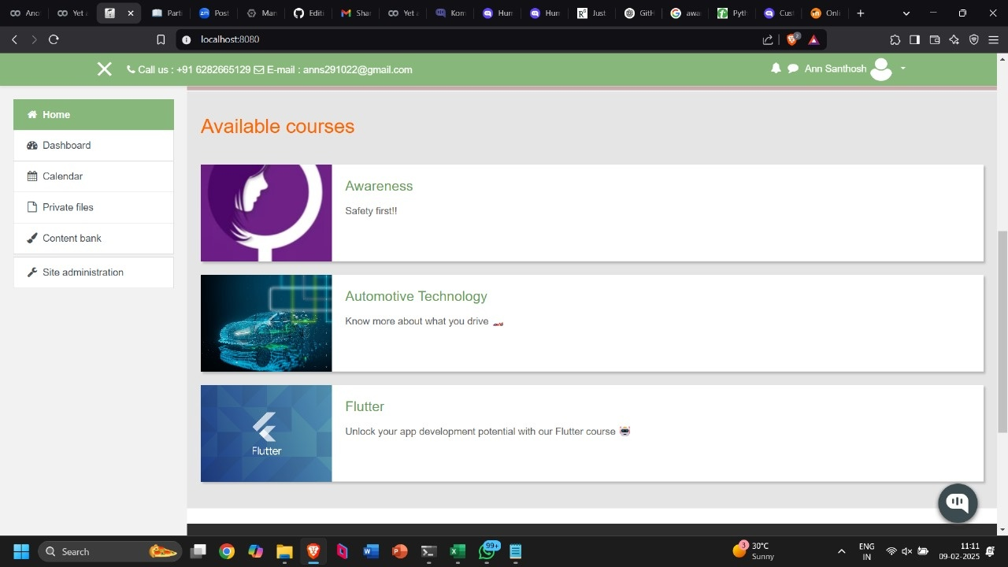📸 Screenshots

(Add at least 3 screenshots showcasing the platform)

Project Demo

📹 Video

https://drive.google.com/drive/folders/1TQOU-gu80KETcOwrm7r1uPCMUHNC49Fr

Additional Demos

GitHub Repository: https://github.com/Bellaann/chat-bot

Team Semaphores

Ann Santhosh

S. Blessy Catherine