Web Output
To run web application installed python 3.10 in your system and then install all packages given in requirements.txt file and then double click on ‘runWeb.bat’ file to start server and then will get below server
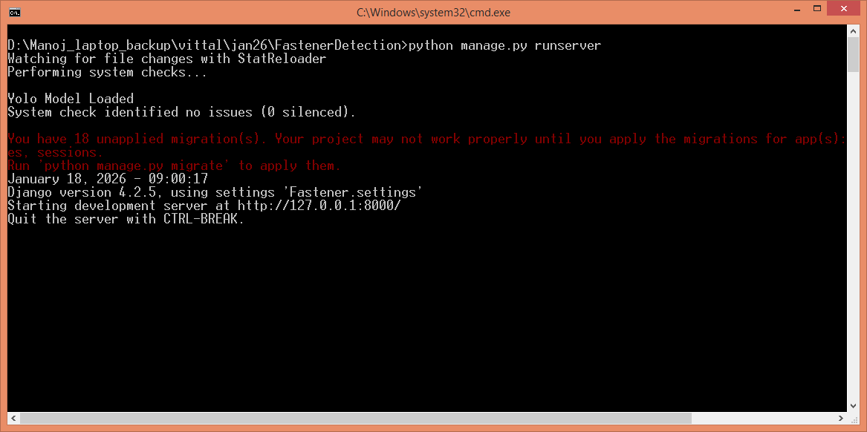
In above screen python server started and now open browser and enter URL as http://127.0.0,1:8000/index.html and then press enter key to get below page
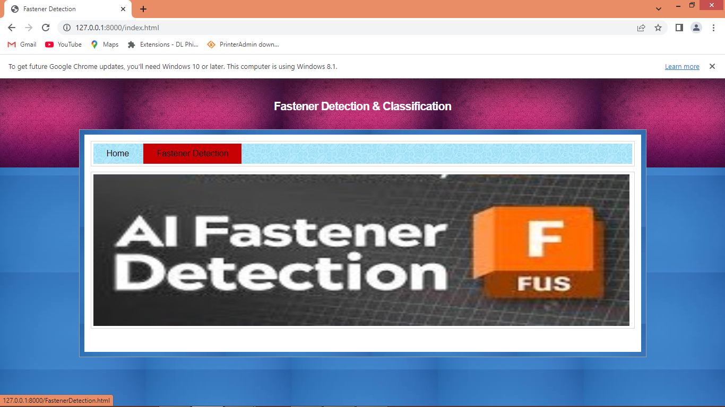
In above screen click on ‘Fastener Detection’ link to get below page
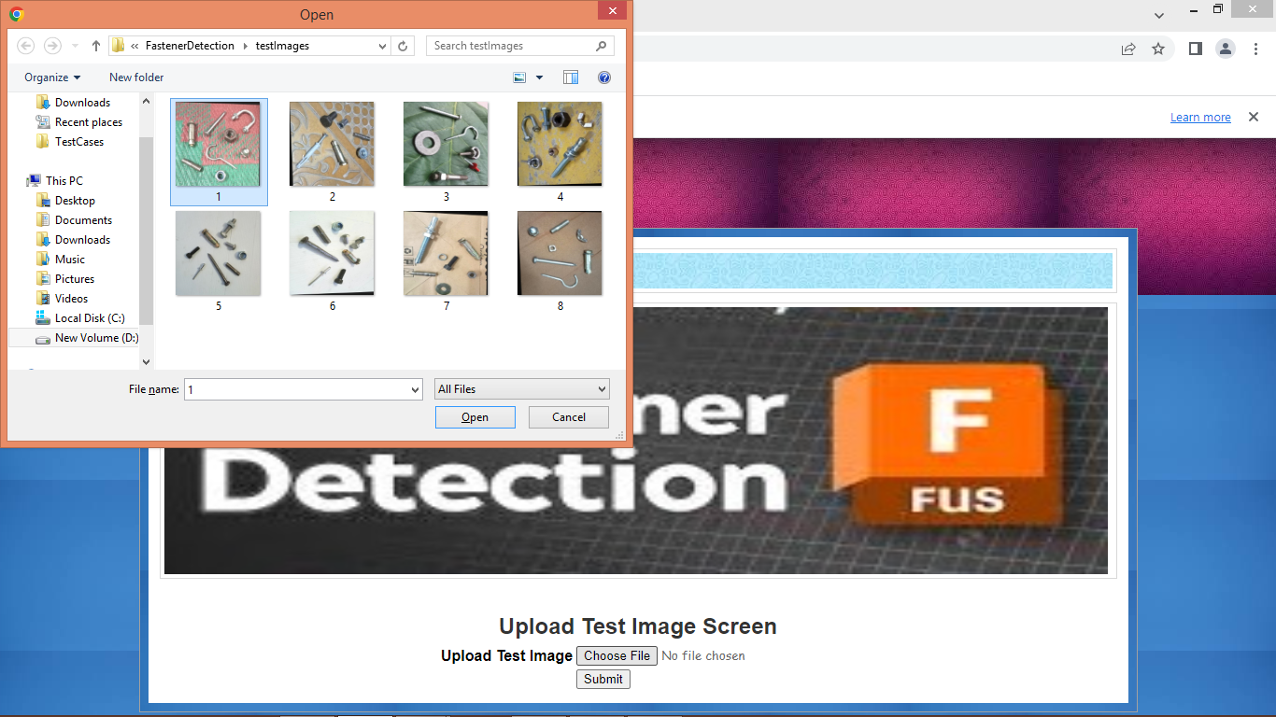
In above screen selecting and uploading test image and then press button to get below page
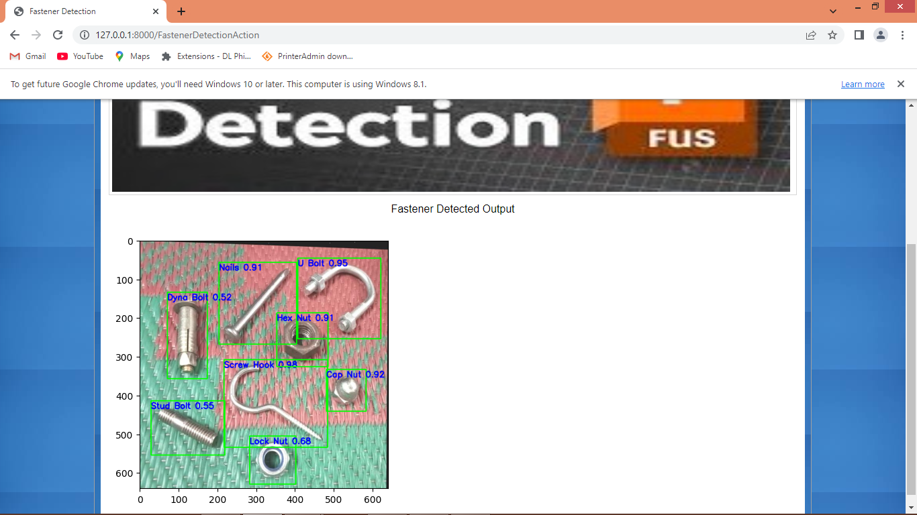
In above screen can see detection output with bounding boxes and class labels and similarly you can upload and test other images
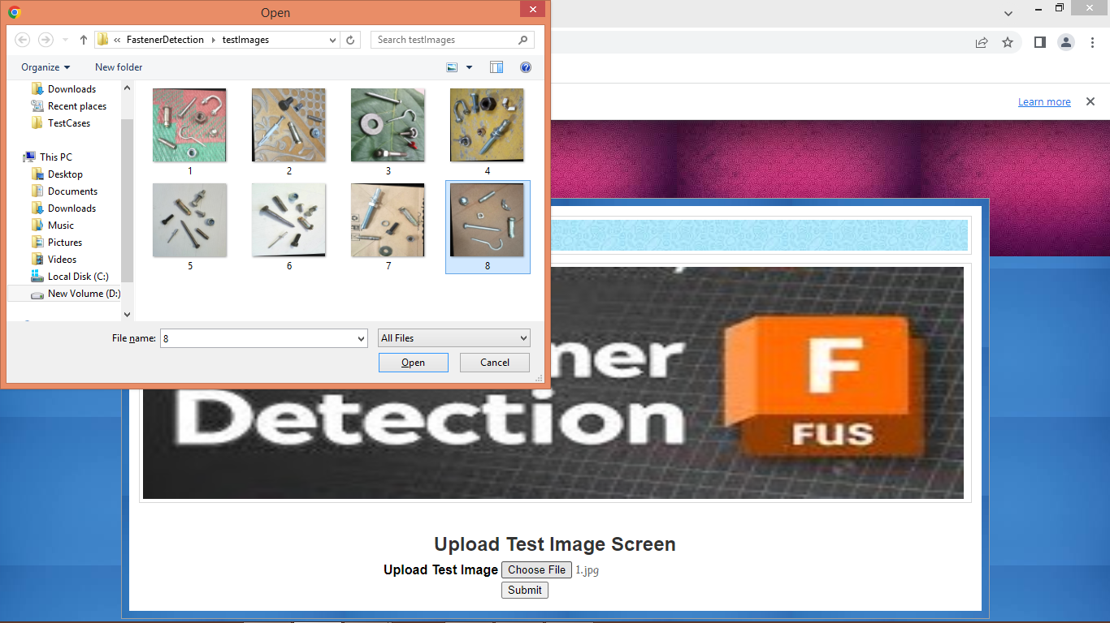
In above screen uploading another image and then press button to get below page
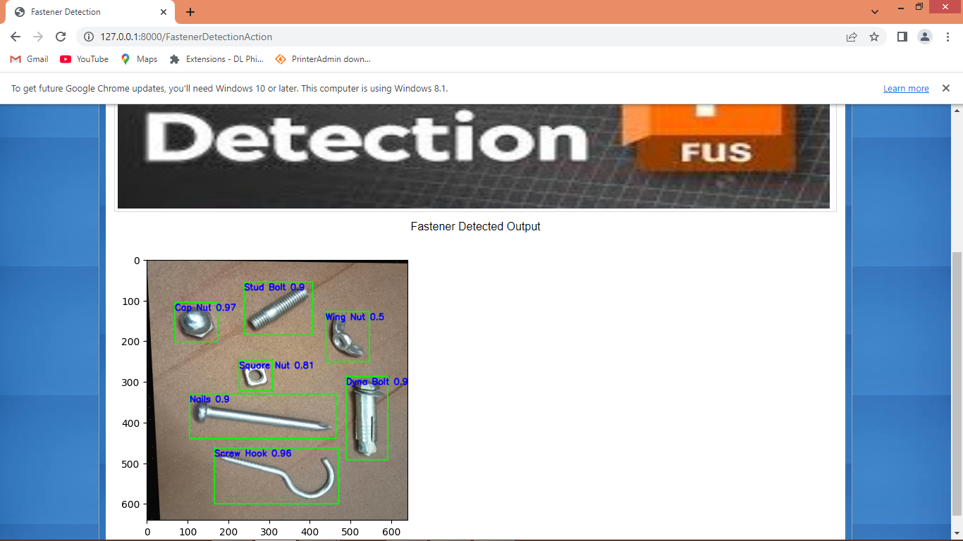
In above screen can see detected output
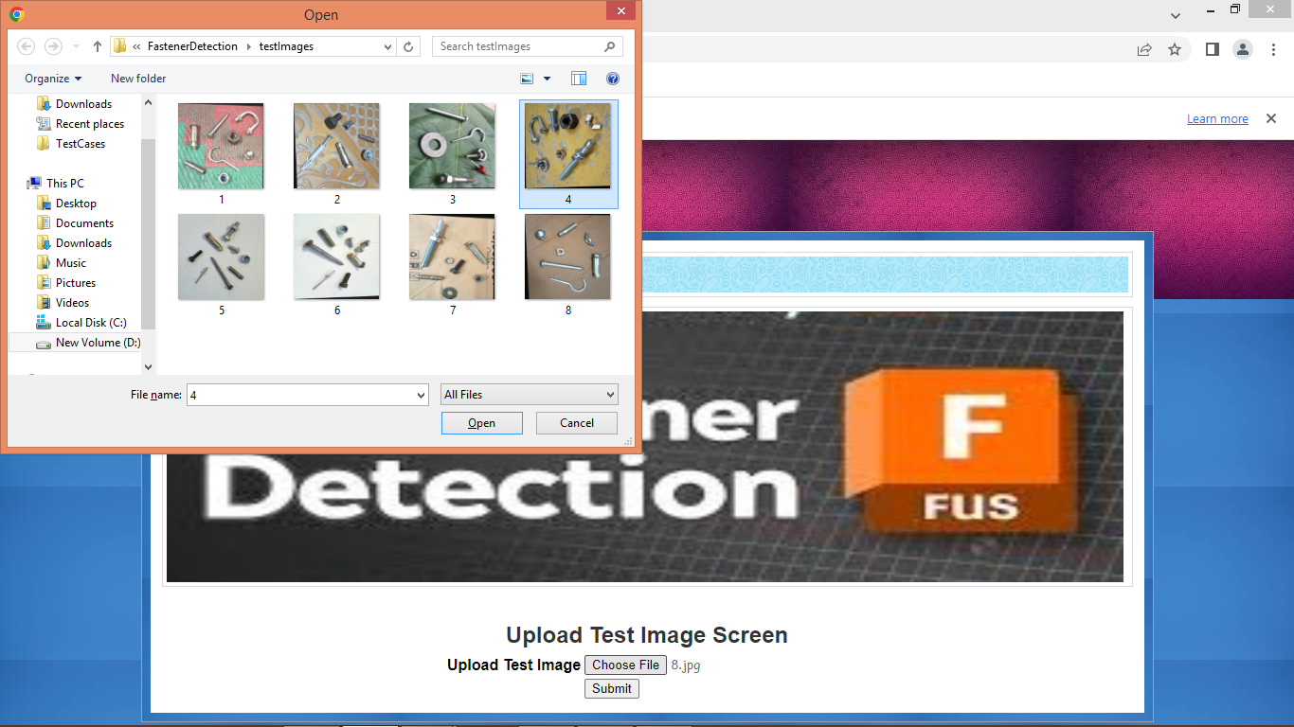
In above screen testing another image and below is the output
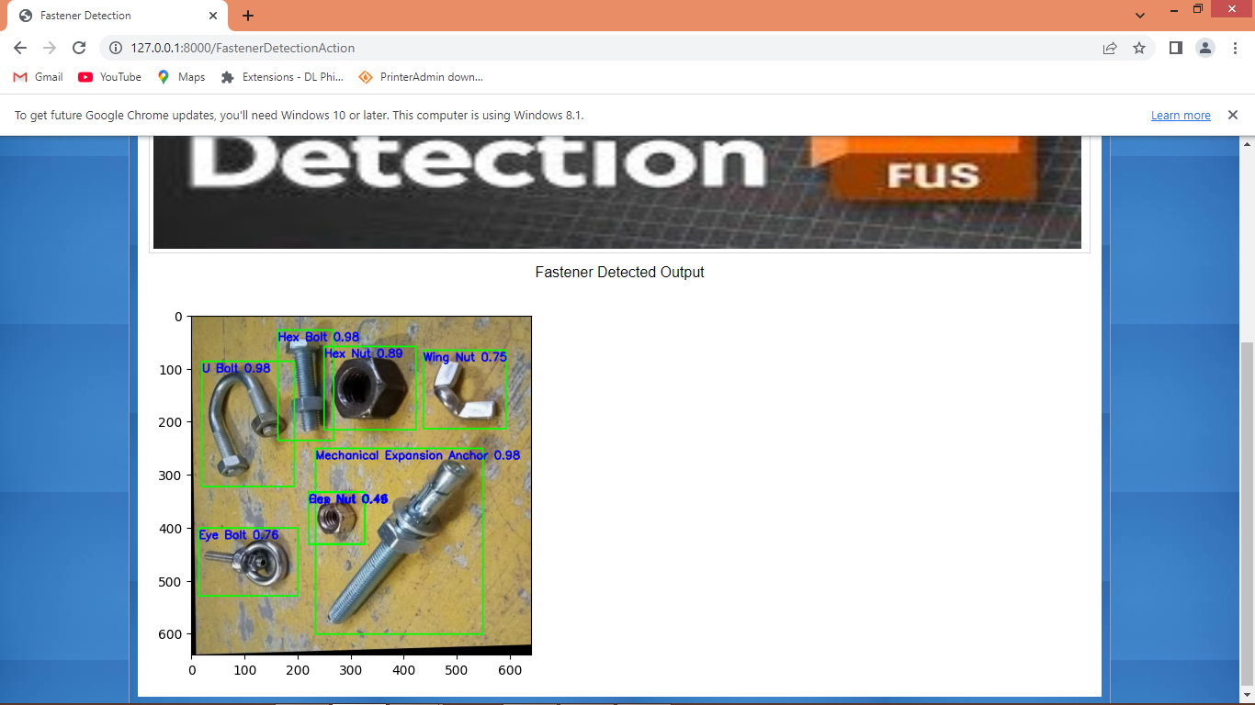
In above screen can see another image output and similarly you can test with other images

