An Invisible Crisis

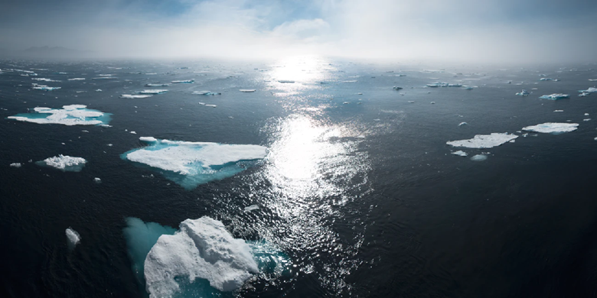

Image by William Bossen via [Unsplash](https://unsplash.com/photos/Q1js5z4tKLA)

**One greenhouse gas stands out**

You might wonder why greenhouse gases matter. It is a fair question. Greenhouse gases, as the name implies, are gases that trap heat from the sun. In high concentrations, these gases can negatively impact the climate by retaining more heat. This is commonly referred to as Climate Change.

Water vapor is a natural greenhouse gas but is not included in climate concerns due to its short life in the atmosphere due to precipitation. Other greenhouse gases that can remain for years or more are carbon dioxide, methane, nitrous oxide, and fluorinated gases. However, one greenhouse gas has seen significant increases in the atmosphere. That gas is carbon dioxide. How significant? For that answer, look at the graph below.

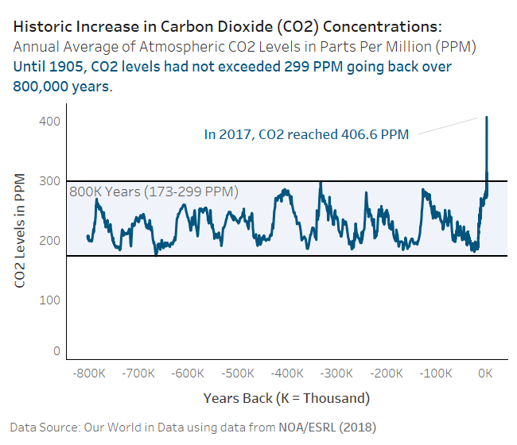

**So, what changed?**

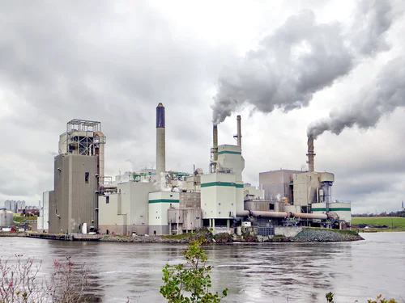

Image by ETA+ via [Unsplash](https://unsplash.com/photos/rzOq5UqWWkE)

We did. As advances in technology increased our dependence on fossil fuels, we released more carbon dioxide into the air. That trend increased over time. To give you an idea of how much, look at the next graph that shows per second carbon dioxide emissions for every 50 years from 1800 until 2000. The trend has only gotten worse since 2000.

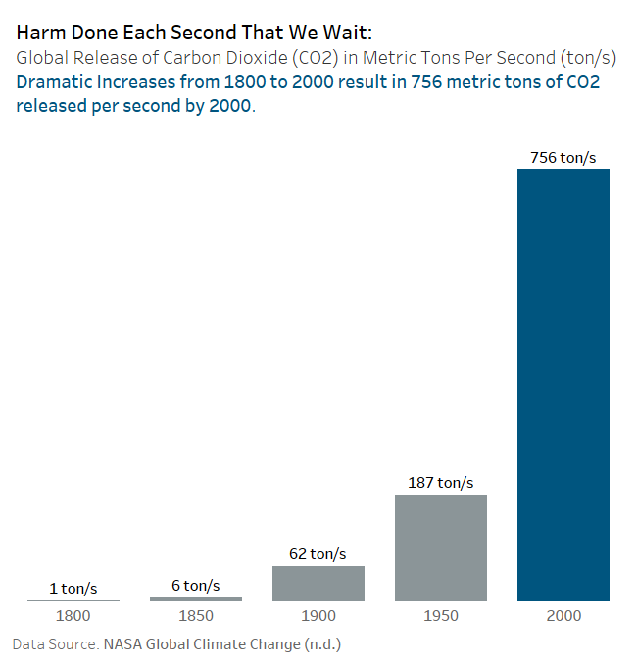

**Hold on, aren’t climate experts divided?**

That is a common myth propagated by corporations and others with a vested interest in maintaining the status quo. A lot of money is made from burning fossil fuels. In 2016, [John Cook](https://iopscience.iop.org/article/10.1088/1748-9326/11/4/048002) and others decided to look at data from several research studies on peer reviewed literature related to climate change. Depending on a few factors, their work showed a range of 90 to 97 percent consensus among climate experts on human caused Climate Change. I used data from the report to compose this graph.

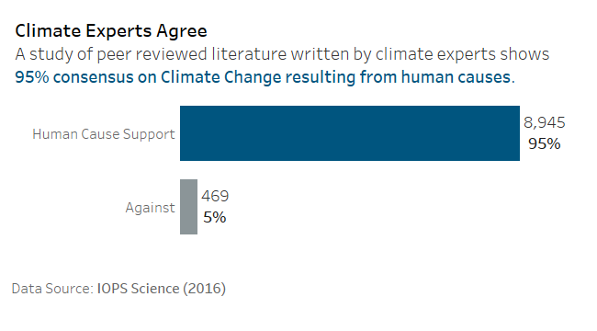

**Ocean temperatures are rising**

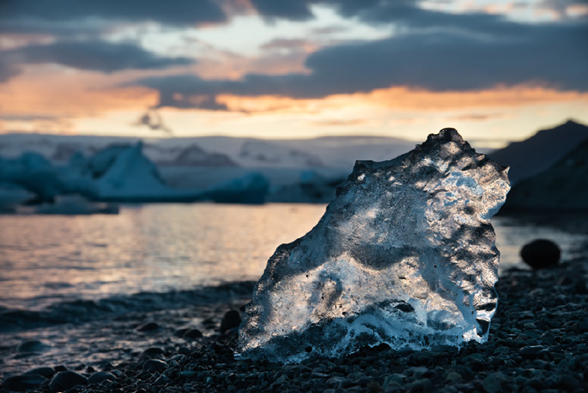

Image by Joseph Vary via [Unsplash](https://unsplash.com/photos/Wovj8TOSHRw)

Ocean water absorbs a lot of the heat caused by excess carbon dioxide. You might think that would be a good thing, but it is not. This results in melting polar ice and rising sea levels. We have already seen significant rises in ocean temperature and climate scientists are predicting far worse if we do not reduce carbon dioxide emissions drastically.

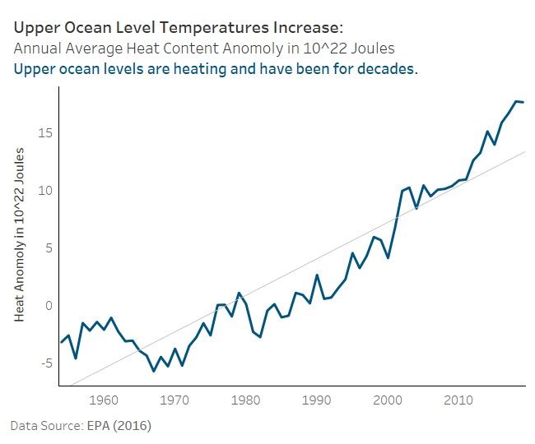

**With rising ocean temperatures come rising sea levels**

Coast lines across the world are impacted by rising water levels. Climate scientists predict worsening trends if we continue to emit carbon dioxide at current levels.

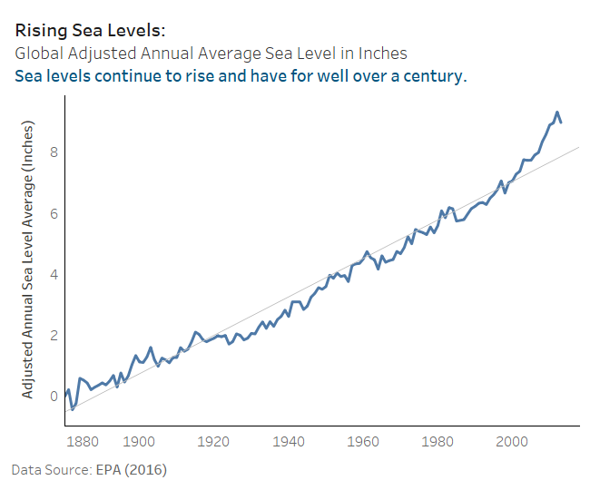

Yet many still deny the impact. This photo highlights the irony.

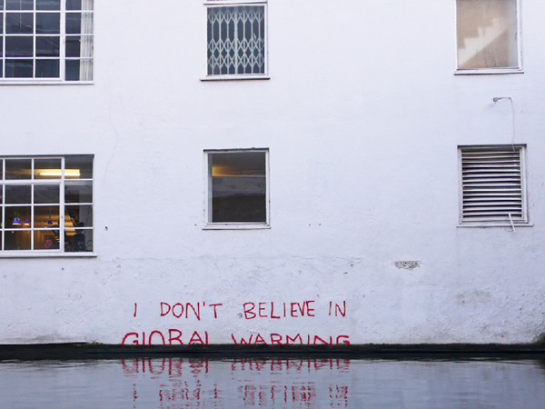

Image by Dullhunk via [Creative Commons](https://search.creativecommons.org/photos/150814a2-e640-4bf7-8fa5-4417343ed436)

**Lost coastal land in the United States**

There are other signs. Coastal property is already being affected. Rising sea levels result in lost coastal habitat and impacts valuable property where many of us vacation and live. The map below shows areas already affected in the United States. Louisiana has experienced many problems due to lost wetlands that are now submerged. The [EPA](https://19january2017snapshot.epa.gov/sites/production/files/2016-09/documents/climate-change-la.pdf) warns that this increases the likelihood of damage caused by hurricanes.

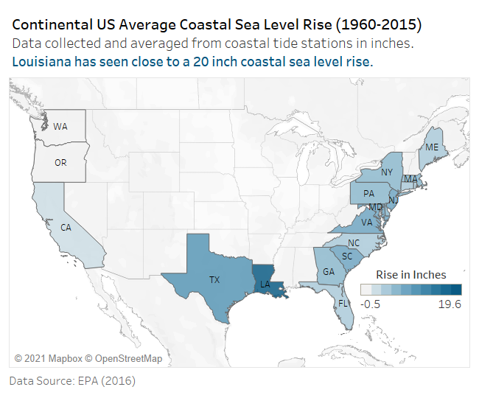

**Arctic summer melts leave less habitat**

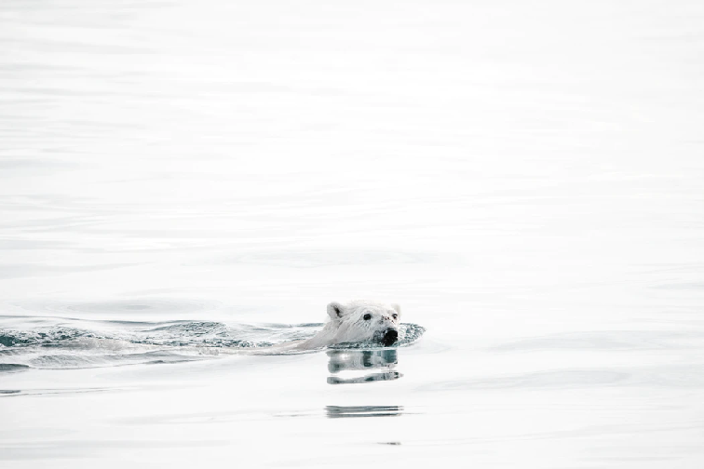

Image by Annie Spratt via [Unsplash](https://unsplash.com/photos/F2M5Uynt62U)

Some areas see the impact sooner than others. Arctic species have bore the brunt of this crisis so far. According to several recent reports, such as one from [Nature](https://www.nature.com/articles/s41558-020-0818-9.epdf) in 2020, the polar bear may become extinct in the wild by 2100. The cause often cited is lost summer habitat due to Climate Change. Many other species are also at risk. The trend downward of Arctic ice coverage shown below looks bleak.

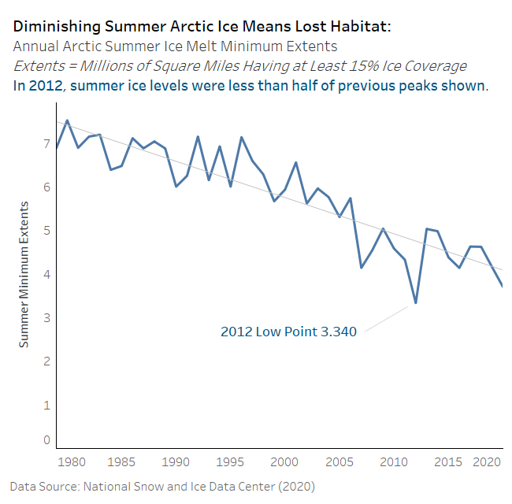

**Where can we start?**

China and the United States are the worst emittors. The following geographic heatmap shows the weight of almost three decades of that history. Both countries have to do better. Leaders across the globe must commit to eliminating emissions by focusing on green technology and reducing dependence on fossil fuel.

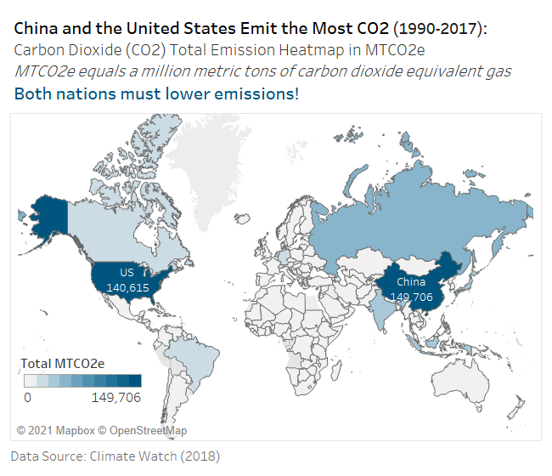

**Let’s help them out!**

It would be unforgivable to let another species go extinct due to our actions, ourselves included. Reduce your emissions by purchasing fuel efficient vehicles, learn about your carbon footprint and contact your government leaders. Demand action on Climate Change due to greenhouse gases and carbon dioxide in particular! I want my grandchildren to have more than photos of these magnificent creatures. Don’t you?

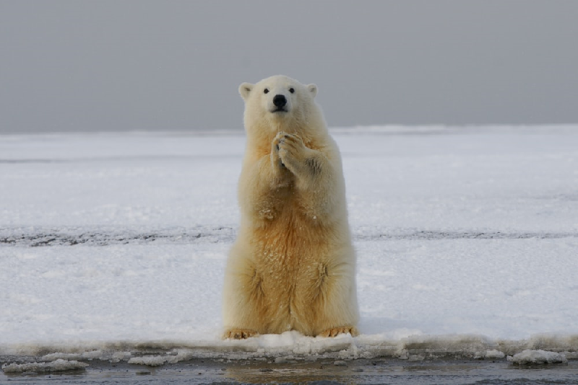

Image by Hans-Jurgen Mager via [Unsplash](https://unsplash.com/photos/AZ31hv9kdzE)

**Sam Loyd**

**February 2021**