Patrice Moracchini
CSD310-308A(2261-DD)
Nov 9, 2025

Normalized Tables
Module 3.2 Assignment
Pr. Sampson
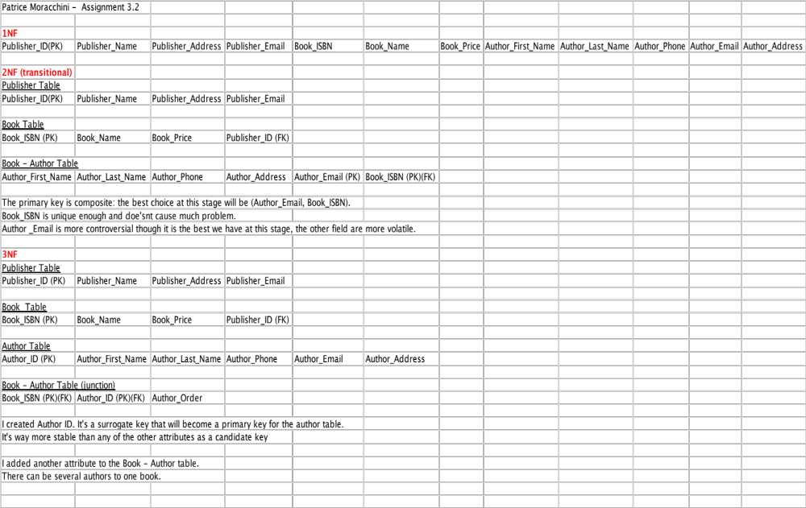
References:

[Decomplexify]. (2025, November 9). Learn Database Normalization - 1NF, 2NF, 3NF, 4NF, 5NF [Video]. YouTube.
https://www.youtube.com/watch?v=GFQaEYEc8_8&t=1247s
[Decomplexify]. (2025, November 9). Database Keys Made Easy - Primary, Foreign, Candidate, Surrogate, & Many More [Video]. YouTube.
https://www.youtube.com/watch?v=8wUUMOKAK-c
Google. (2025). How to Call the Author Position in a Database When a Book has Several Authors [AI overview in Google Search].
https://www.google.com/search?q=how+to+call+the+author+position+in+a+database+when+a+book+has+several+authors&oq=how+to+call+the+author+position+in+a+database+when+a+book+has+several+authors&gs_lcrp=EgZjaHJvbWUyBggAEEUYOdIBCDE0MTlqMGo3qAIAsAIA&sourceid=chrome&ie=UTF-8

