Patrice Moracchini
CSD310-308A(2261-DD)
Nov 2, 2025

Data Models
Module 2.3 assignment
Pr. Sampson

- Translate the following business rules into one Entity relationship diagram (ERD) using Visual Paradigm.
  - a USER has many ROLES.
  - a USER has one BIRTHDATE.
  - a USER can have many DEPENDENTS.

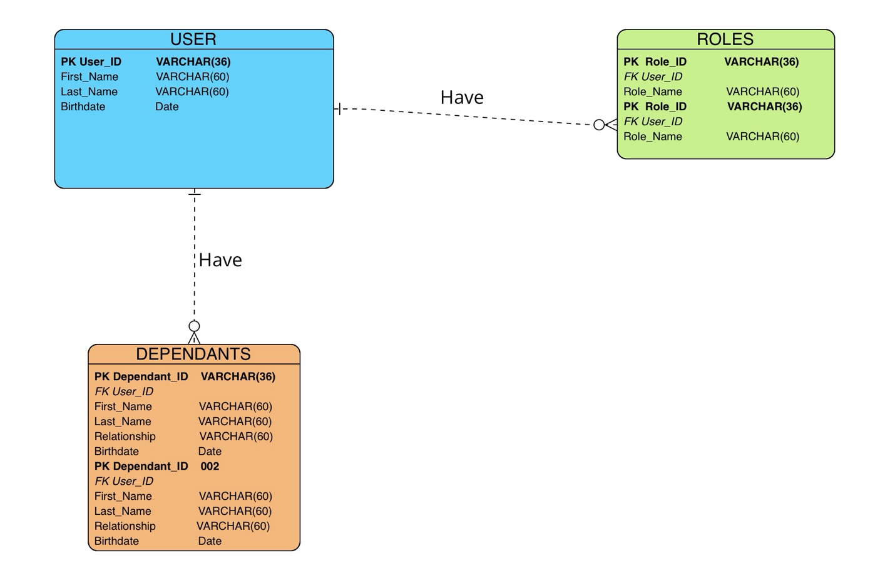

- Convert the translated diagram into one NoSQL data structure.

{
"user_id": "U001",
"first_name": "Juan",
"last_name": "Alvaro",
"birthdate": "1975-06-75",
"roles": [
{"role_id": "r_HR_Director", "role_name": "HR Director"},
{"role_id": "r_ETL", "role_name": "ETL"}
],
"dependents": [
{"dependent_id": "D001", "name": "Vera Alvaro", "relationship": "Daughter", "birthdate": "2002-05-17"},
{"dependent_id": "D002", "name": "Petra Alvaro", "relationship": "Spouse", "birthdate": "1980-05-10"}
]
}

