Patrice Moracchini
CSD310-308A(2261-DD)
Nov 16, 2025

Movies!
Module 5.3 Assignment
Pr. Sampson

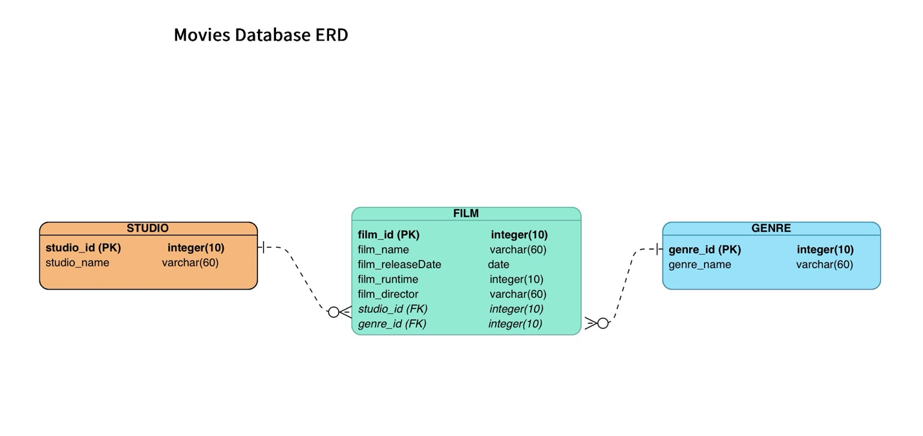

The business rules are:
one STUDIO can produce many FILM(s)
one FILM(s) can be described using one Genre

I created three entity tables: Studio , Film and Genre

studio_id is the primary key for the Studio table and the foreign key for the Film table which creates a one-to-many relationship from the Studio table to the Film table
film_id is the primary key of the Film table
genre_id is the primary key for the Genre table and creates a foreign key constraint with the Film table with a one-to-many relationship from the Genre table to the Film table.

