Patrice Moracchini
CSD325-308A(2261-DD)
Dec 16, 2025

GUI ToDo
Module 10.2 assignment
Pr. Yarborough

Original program execution:
After adding two tasks

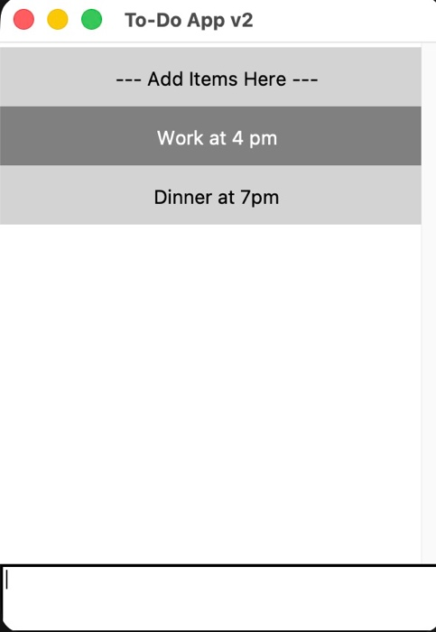

Modified Program Execution:

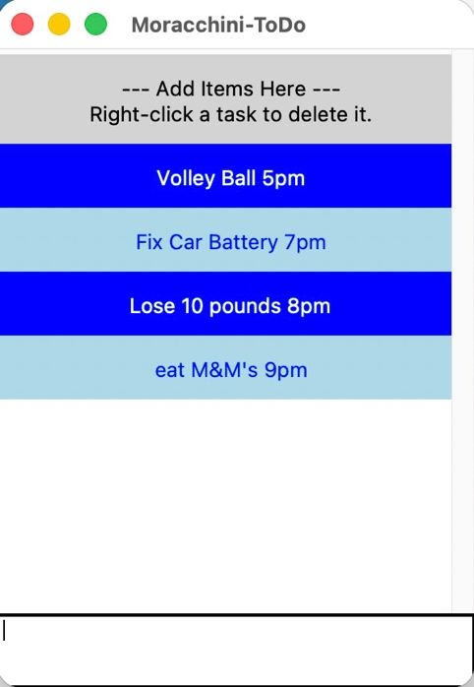

Exit Key:

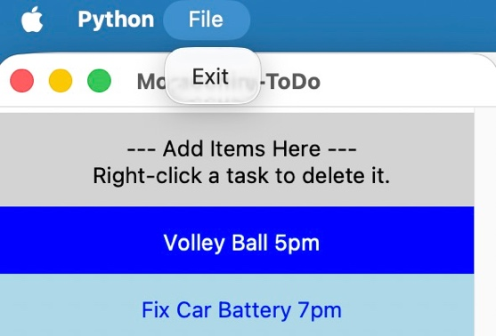

Deleting task:

