Patrice Moracchini
CSD325-308A(2261-DD)
Dec 21, 2025

APIs
Module 12.2 assignment
Pr. Sampson

I decided to redo module 9.2, as I misread the instructions, and it was one of my favorite modules.

API tutorial program result:

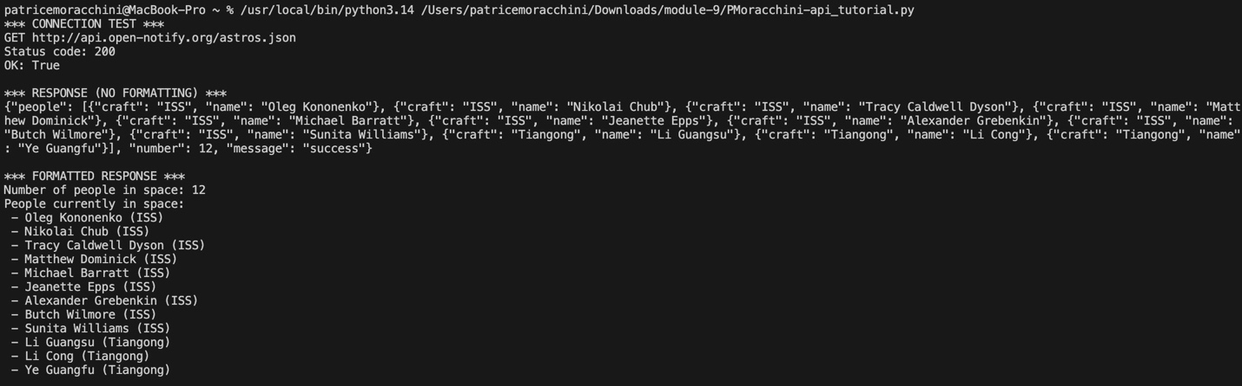

Star Wars API (planets) program result:

