Patrice Moracchini
CSD325-308A(2261-DD)
Dec 16, 2025

Django Basics
Module 11.2 assignment
Pr. Yarborough

Django Server Running

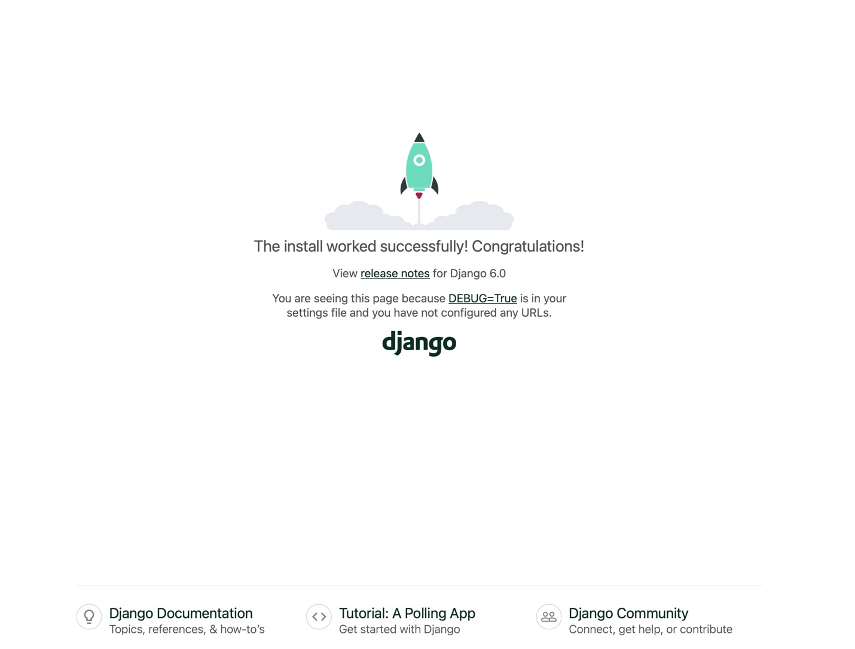

App Created and Running

