Patrice Moracchini
CSD325-308A(2261-DD)
Dec 9, 2025

Test Cases
Module 4.2 assignment
Pr. Yarborough

Screenshots Program city_functions.py

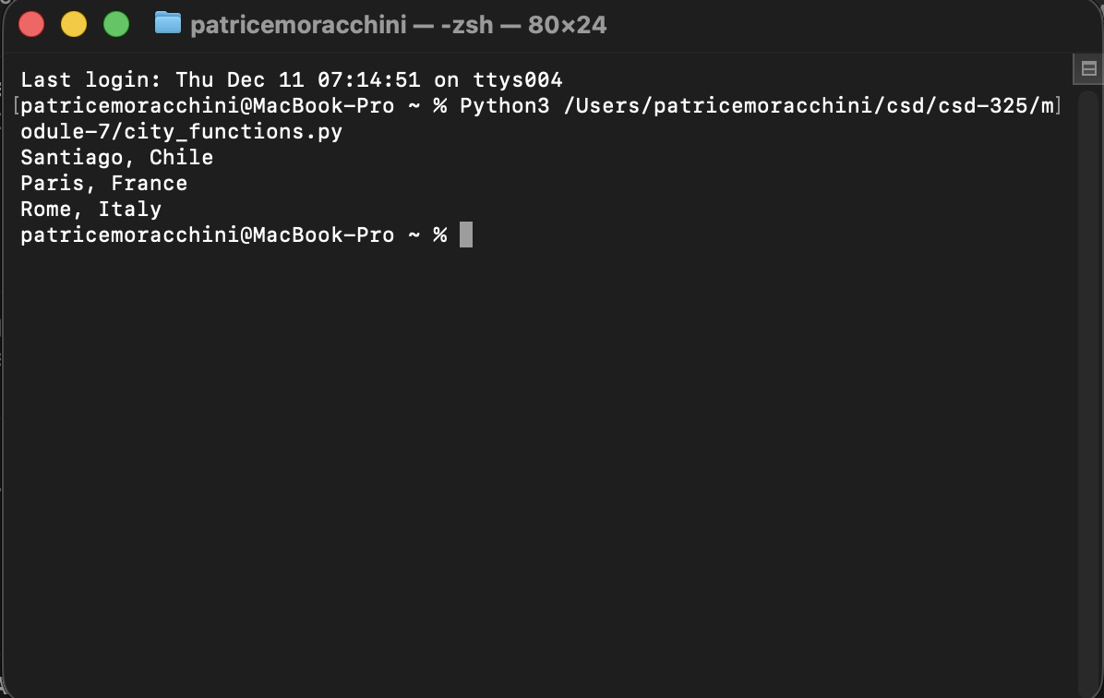

Screenshots Program test_cities.py

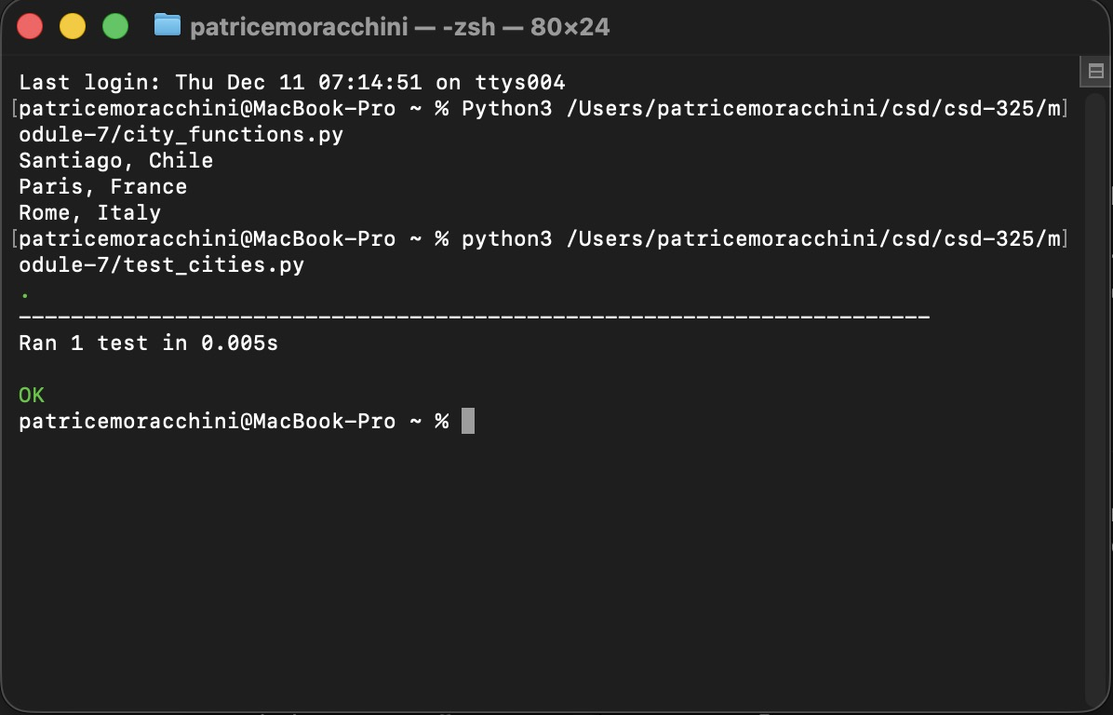

Screenshots Program city_functions.py version 2

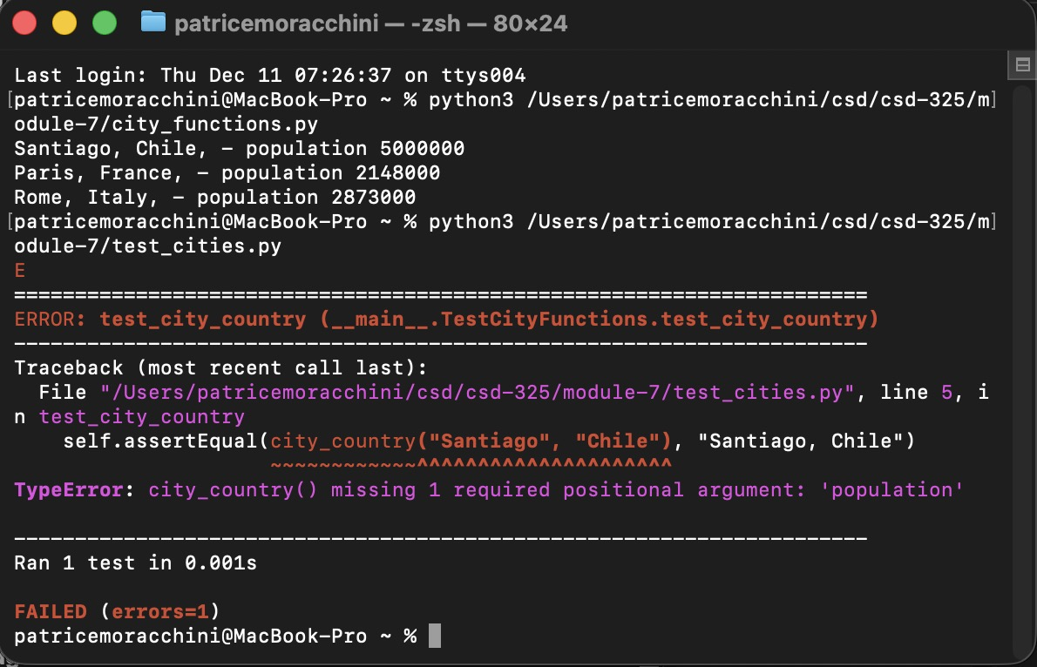

Screenshots Program city_functions.py version 3

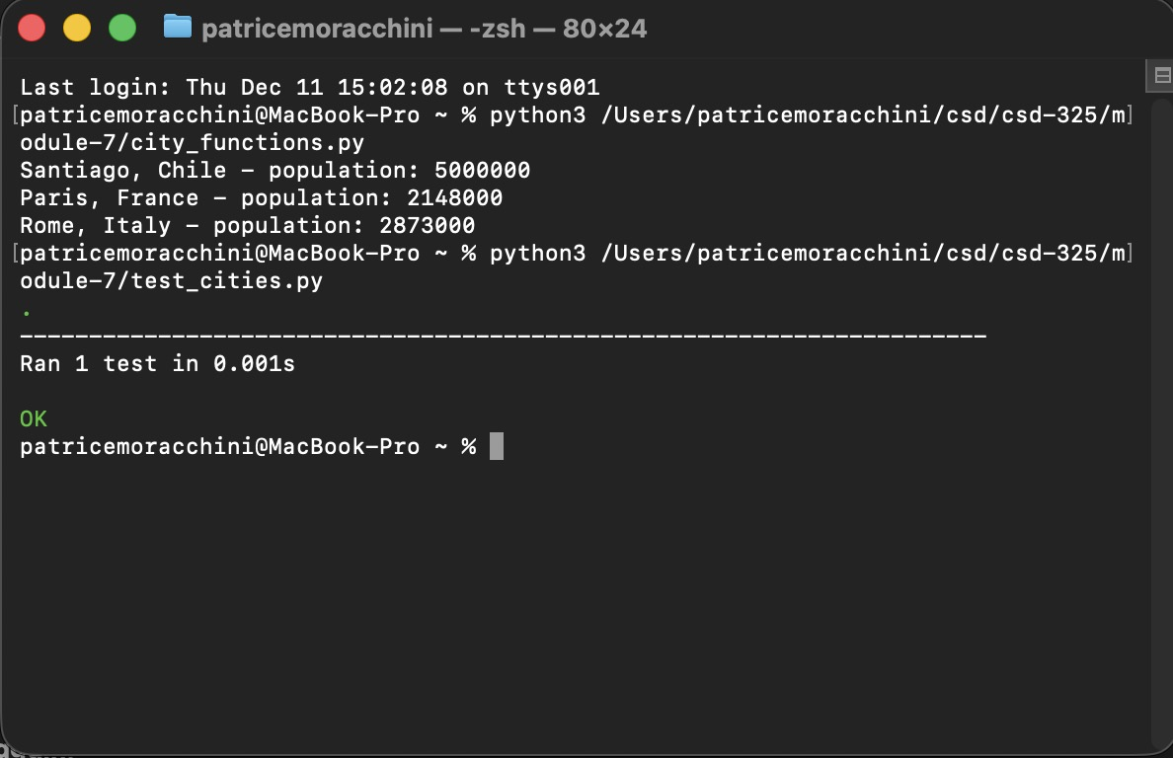
Screenshots Program city_functions.py version 4

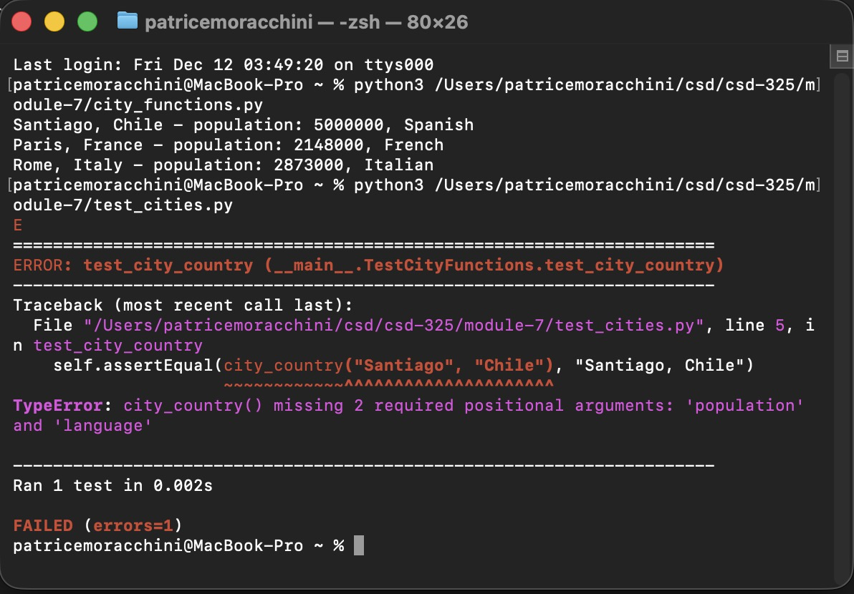

Screenshots Program city_functions.py version 5

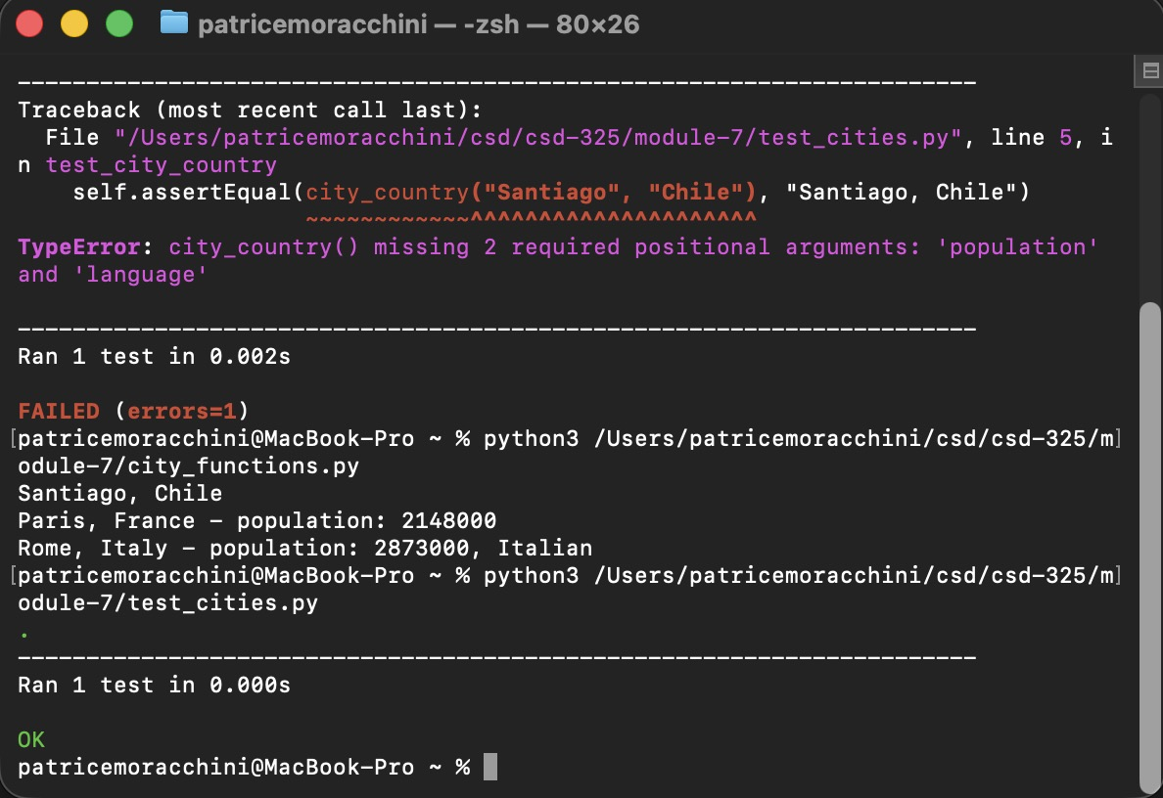
I already did the changes when I made the program with language optional: I called the function 3 times with different parameters:
City, Country
City, Country, Population
City, Country, Population, Language

