Patrice Moracchini
CSD325-308A(2261-DD)
Dec 14, 2025

JSON Practice
Module 8.2 assignment
Pr. Yarborough

Flowchart

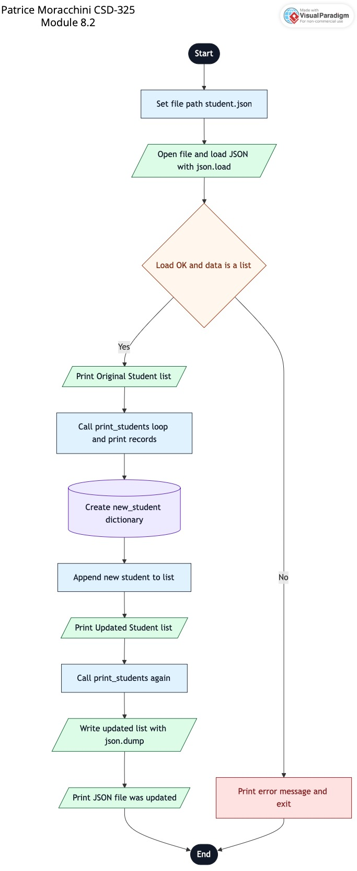

Result after program execution:

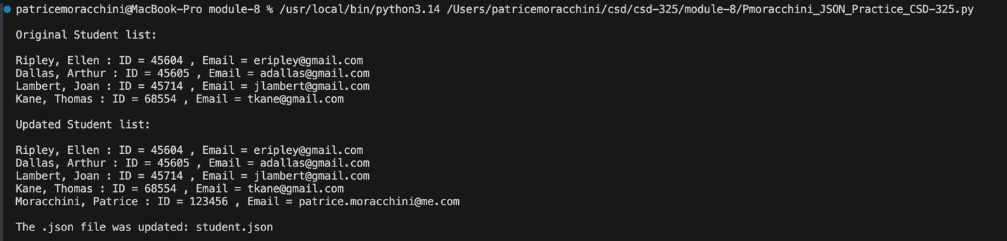

.json file content:

[
{
"F_Name": "Ellen",
"L_Name": "Ripley",
"Student_ID": 45604,
"Email": "eripley@gmail.com"
},
{
"F_Name": "Arthur",
"L_Name": "Dallas",
"Student_ID": 45605,
"Email": "adallas@gmail.com"
},
{
"F_Name": "Joan",
"L_Name": "Lambert",
"Student_ID": 45714,
"Email": "jlambert@gmail.com"
},
{
"F_Name": "Thomas",
"L_Name": "Kane",
"Student_ID": 68554,
"Email": "tkane@gmail.com"
},
{
"F_Name": "Patrice",
"L_Name": "Moracchini",
"Student_ID": 123456,
"Email": "patrice.moracchini@me.com"
}
]

