Patrice Moracchini
CSD325-308A(2261-DD)
Nov 2, 2025

Documented Debugging + Flowchart(s)
Module 2.2 assignment
Pr. Yarborough

Program:

# Patrice Moracchini
# 09/14/2025
# Description: This program demonstrates the use of a tuple in Python.
# It initializes a tuple named 'playlist' with singers' names,
# displays the contents in a single statement, then iterates
# through the collection displaying formatted sentences using f-strings.
# Finally, the program repeats the output in reverse order
# with a different context string.

def main():
# Step 1: Initialize a Tuple named 'playlist' with 20 singers
playlist = (
"Taylor Swift", "Beyoncé", "Ed Sheeran", "Adele", "Bruno Mars",
"Ariana Grande", "Lady Gaga", "Justin Bieber", "Billie Eilish", "Rihanna",
"Katy Perry", "Harry Styles", "Shawn Mendes", "Selena Gomez", "Sam Smith",
"Dua Lipa", "Sabrina Carpenter", "Madonna", "Drake", "The Weeknd"
)

# Step 2: Display the contents in a single statement
print("Playlist of popular singers:")
print(playlist)

print("\n--- Singers in Sentences ---")
# Step 3: Iterate through and display each value as a complete sentence
for singer in playlist:
print(f"{singer} is one of the most well-known singers in the world.")

print("\n--- Singers in Reverse Order (Different Context) ---")
# Step 4: Repeat in reverse order, different f-string context
for singer in reversed(playlist):
print(f"If I could go to a concert, I would love to see {singer} perform live.")

# Run the program
if __name__ == "__main__":
main()

Flowchart

Debugging screenshots:

I a

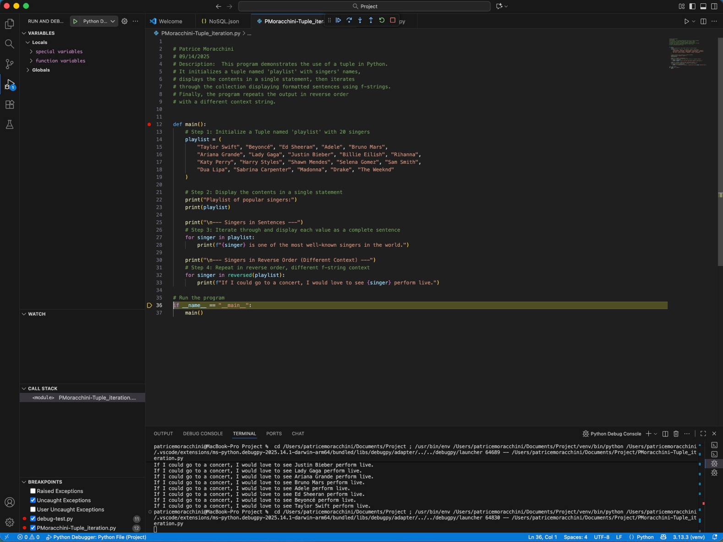
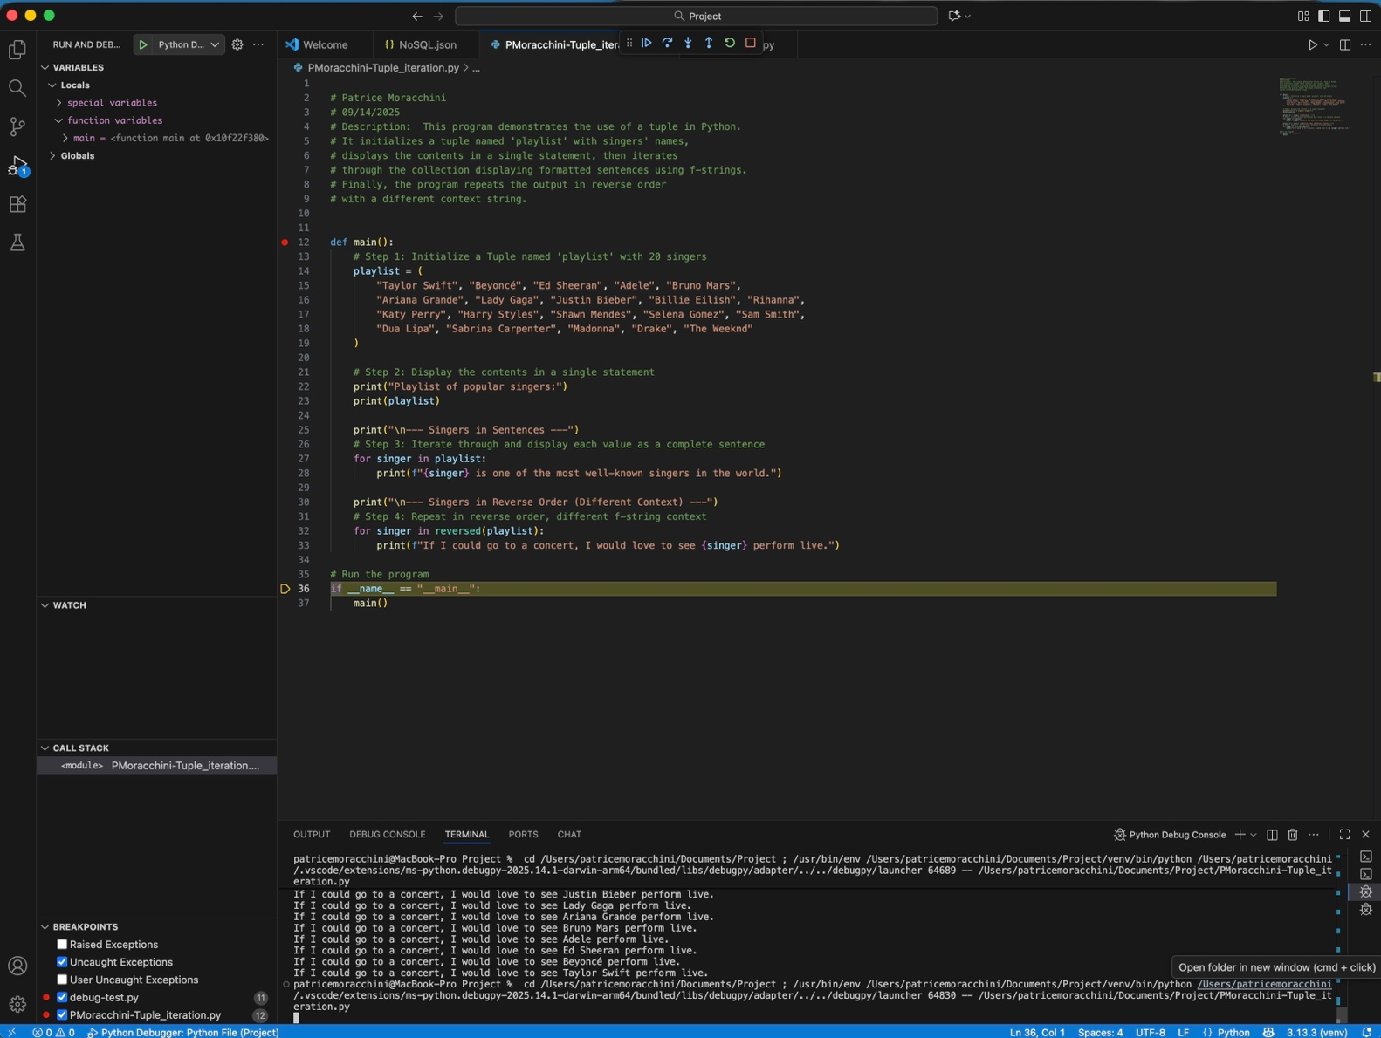

By creating two other breakpoints on lines 25 and 30, the debugger decomposes every action allowed by the function print, and we can see every sentence printing in the terminal one by one every time we press step over.

