Patrice Moracchini
CSD325-308A(2261-DD)
Dec 9, 2025

High/Low Temperatures
Module 4.2 assignment
Pr. Yarborough

Original Sitka Program Flowchart

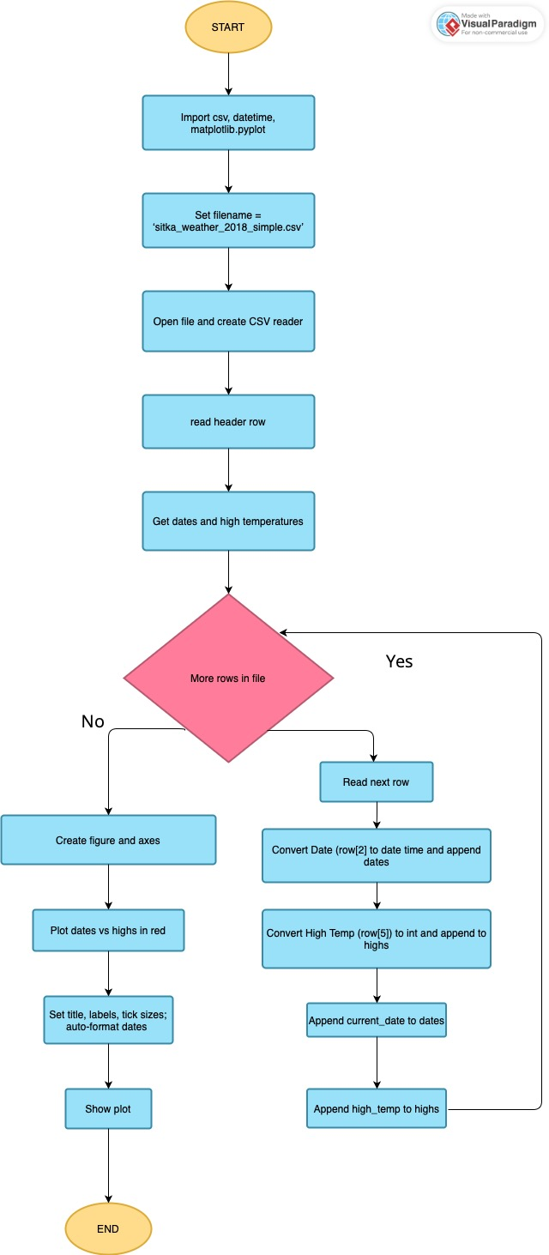
Flowchart After Demanded Modifications

