Patrice Moracchini
CSD340-308A(2265-DD)
Jan 25, 2025

Building a Web Page Exercise, Part 3
Module 3.3 Assignment
Pr. Sampson

Screenshot Website result

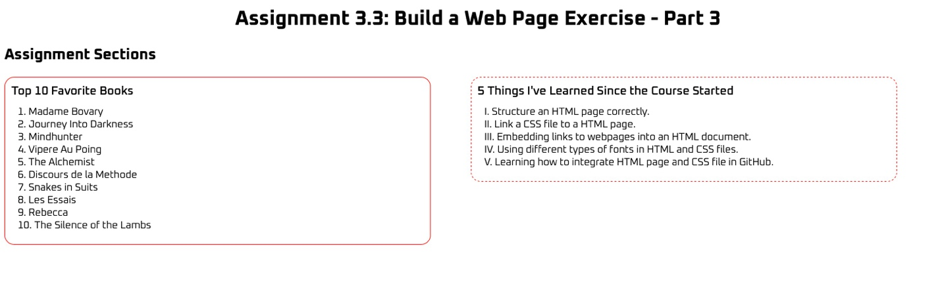

I added “Assignment Sections” with an h2 tag because the W3C HTML validator returned an error when I applied my HTML code, so I decided to add it.

W3C Markup Validation screenshot

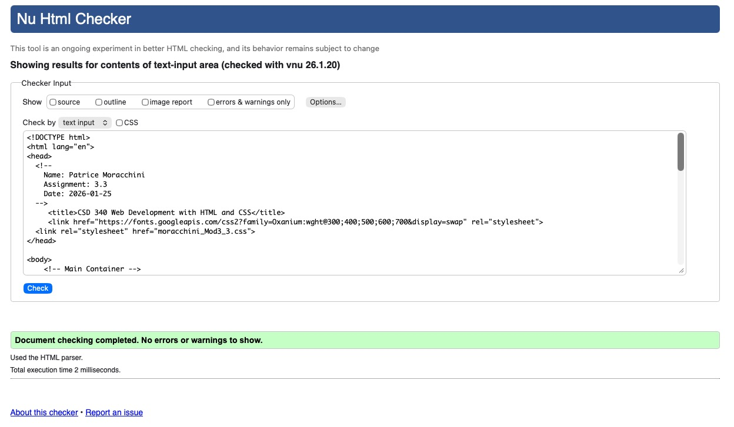

W3C CSS Validation screenshot

