Patrice Moracchini
CSD340-308A(2265-DD)
Jan 18, 2025

GitHub Repository Setup
Module 1.2 Assignment
Pr. Sampson

Local Directory Setup:

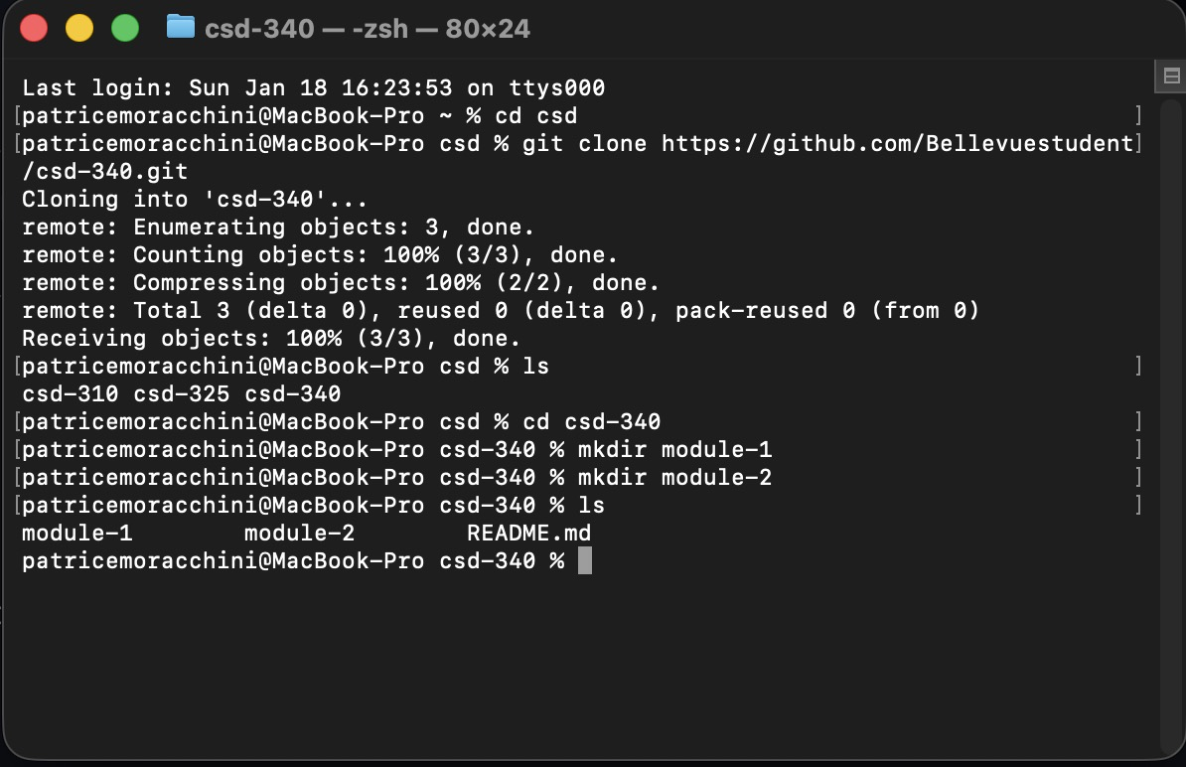

Link to GitHub Repository

https://github.com/Bellevuestudent/csd-340.git

README.md file modifications:

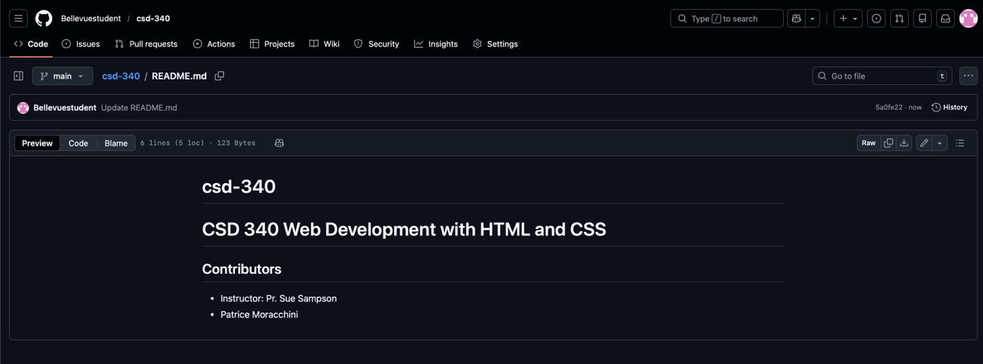

Local Directory Structure:

