Patrice Moracchini
CSD340-308A(2265-DD)
Jan 25, 2025

GitHub Pages
Module 3.2 Assignment
Pr. Sampson

W3C HTML validator results:

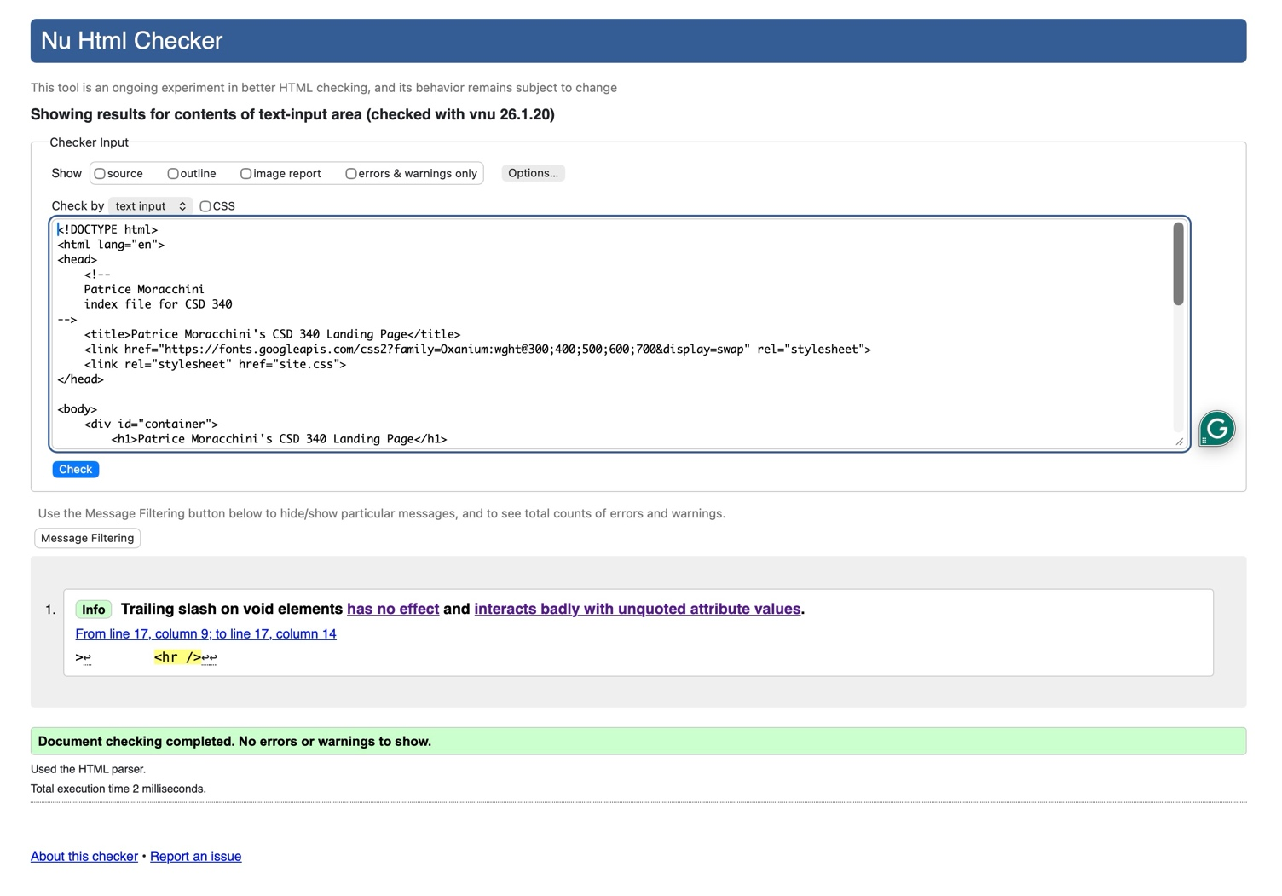

W3C CSS validator results

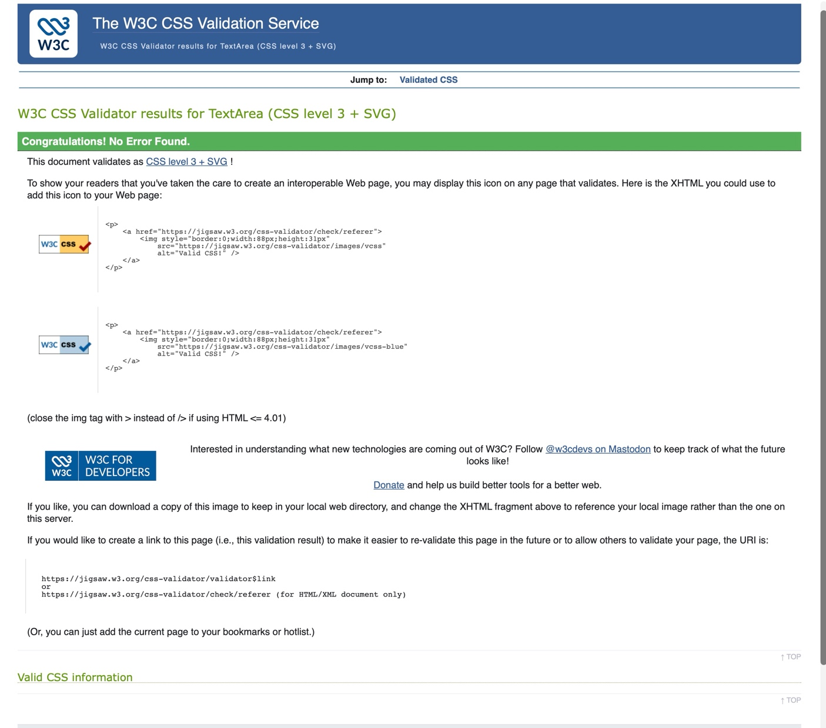

Browser results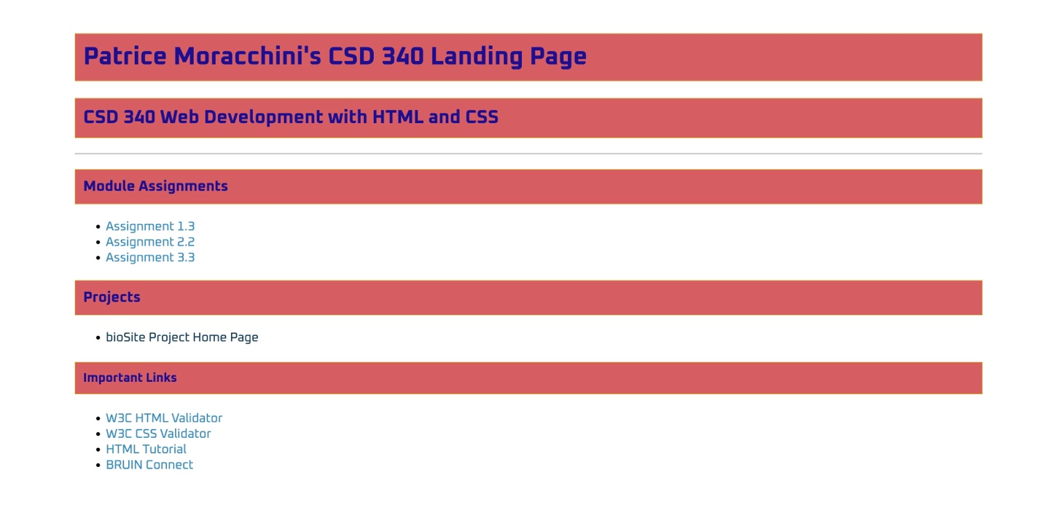

https://bellevuestudent.github.io/csd-340/

