Patrice Moracchini
CSD340-308A(2265-DD)
Jan 18, 2025

Building a Web Page Exercise, Part 1
Module 1.3 Assignment
Pr. Sampson

Starter code checked

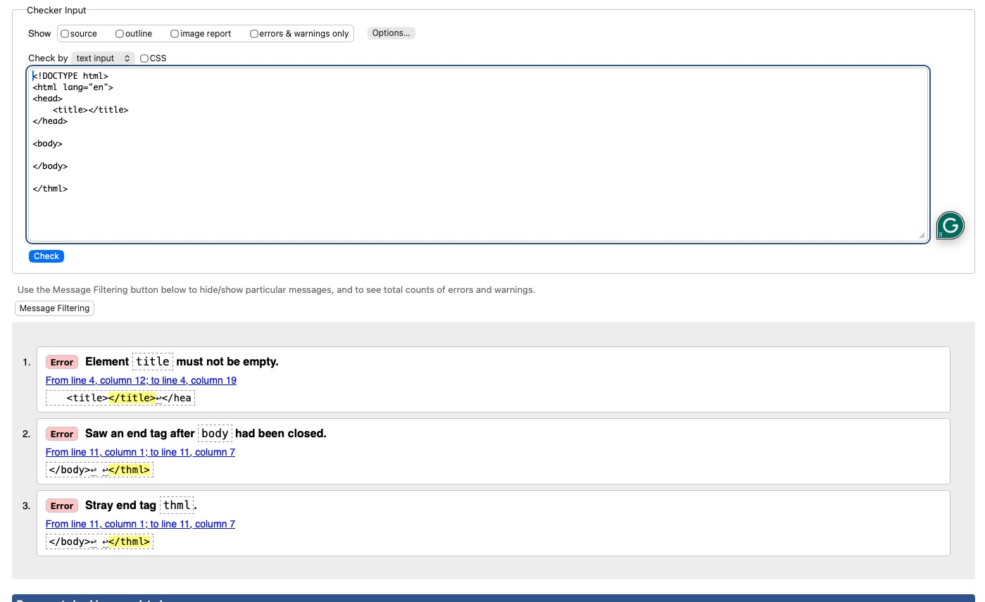

Error correction:

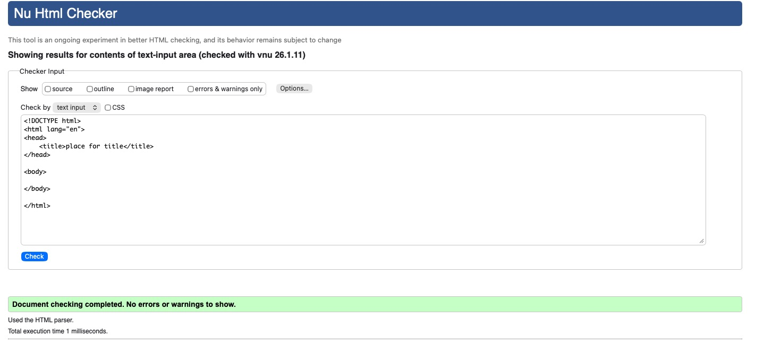

Adding title, header, and paragraph.

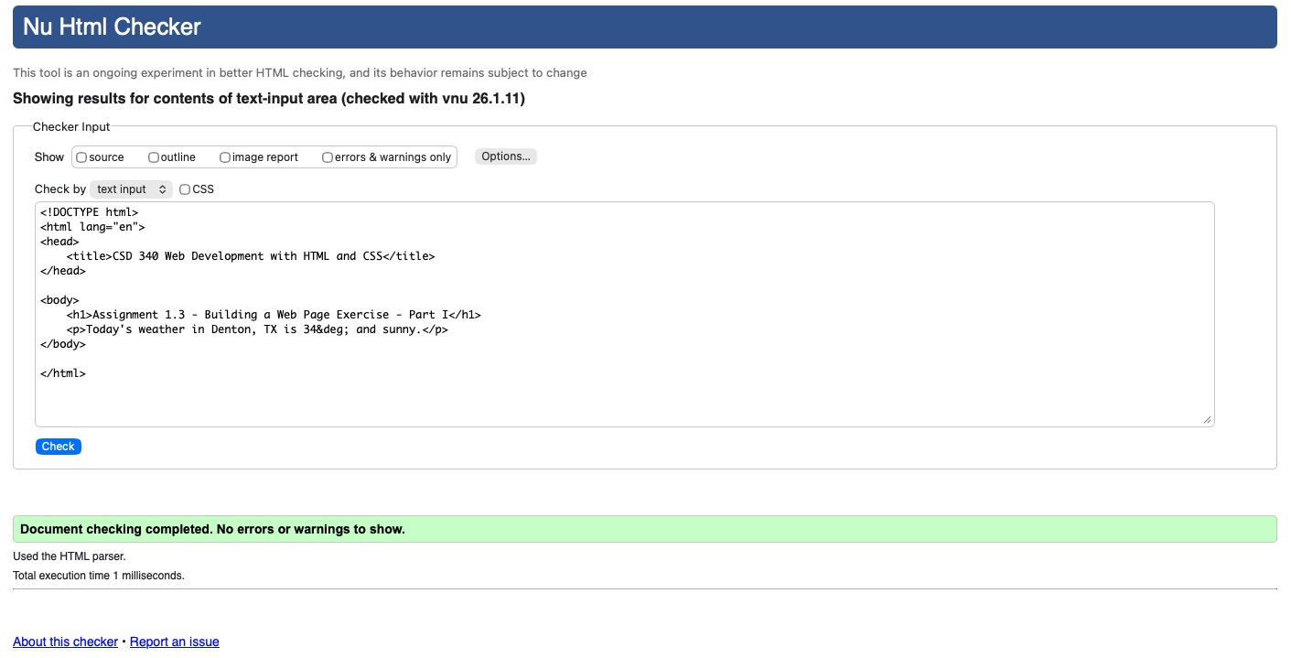

Webpage result:

