Tester: | Patrice Moracchini
Date: | 2026/06/28
Instructor | Pr. Sampson
Course | CSD-430
Project: | Todo
Course: | CSD 380: DevOps
Description: | Todo Business Requirements
Date: | 2026/06/25
Developer: | Isaac Ellingson

TABLE OF CONTENTS
New Task Items Appear in the Todo List 2
Clicking the Trash Button Removes the Corresponding Task 3
Clicking the Edit Button Brings Up a Functional Edit Form 4
Invalid URLs Show a Useful Custom Error Page 5
Empty Tasks Cannot Be Added 6
Landing Page Inputs 8
Edit existing Task 9
Delete Existing task 10
Create new ToDo Item 11
Make sure the screen size is responsive 12

Test 1 | New Task Items Appear in the Todo List
 | Test Objective: Verifies that when a new item is entered through the panel, it correctly appears on the task list | Developer: Isaac Ellingson  Date tested: 2026/06/25 | Peer tester: Patrice Moracchini  Date tested: 2026/06/28
Step | Action | Expected results: | Developer pass/fail | Tester pass/fail  + Screenshot
1 | Visit https://buwebdev.github.io/todo/ | Page loads without errors | yes | Yes
2 | Type "Visit Mom" into the "Task" text field up top. | The text input line changes as directed | yes | Yes
3 | Click the "Add Task" button below the field. | The new Task appears at the bottom of the list | yes | Yes
Comments | The webpage load perfectly when the link is clicked. The task form is clickable and opens a text box in which we can type.  When we click the button “Add Task”, the task item appears at the bottom of the list.
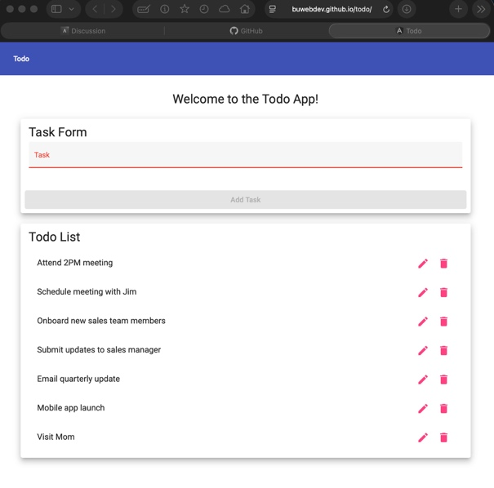
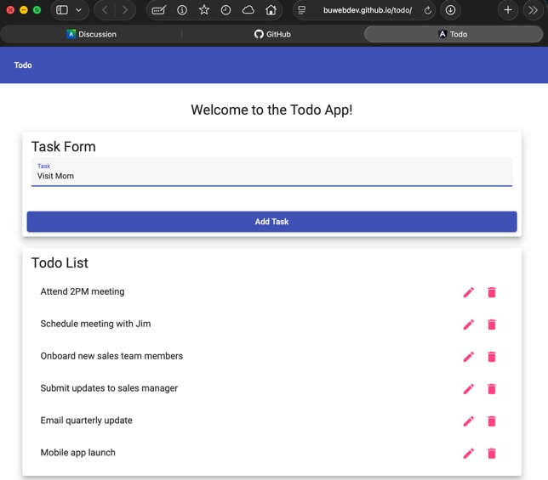
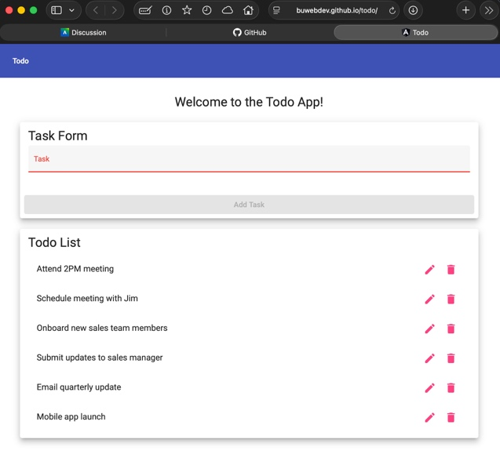

Test 2 | Clicking the Trash Button Removes the Corresponding Task
 | Test Objective: Verifies that Tasks can be deleted | Developer: Isaac Ellingson  Date tested: 2026/06/25 | Peer tester: Patrice Moracchini  Date tested: 2026/06/28
Step | Action | Expected results: | Developer pass/fail | Tester pass/fail
1 | Visit https://buwebdev.github.io/todo/ | Page loads without errors | yes | Yes
2 | Click on the trash can to the right of "Onboard new sales team members" | The "Onboard new sales team members" task disappears, and the tasks below it moves up. | yes | Yes
Comments | The webpage load perfectly when the link is clicked. The trash can icon is clickable and make the task disappear from the list when clicked.
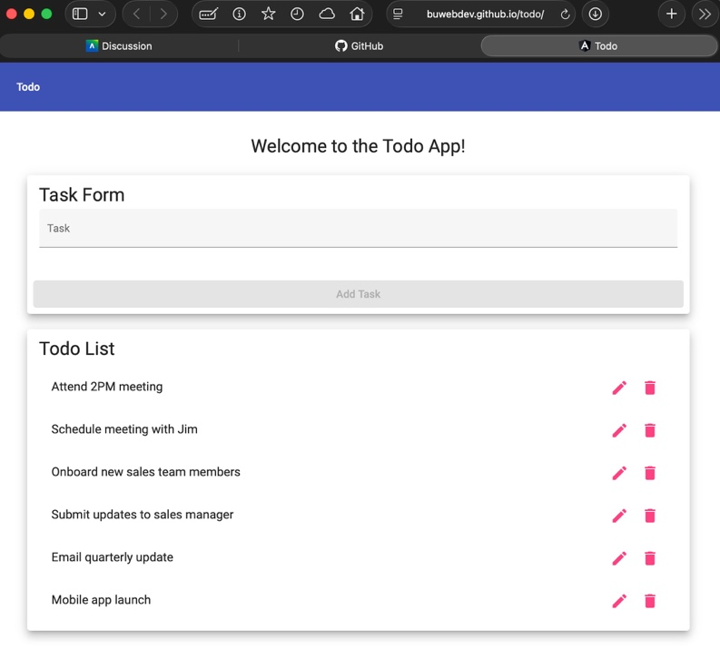
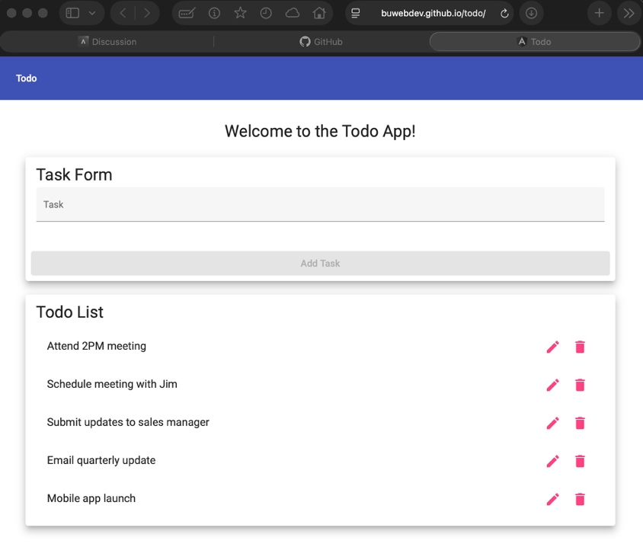

Test 3 | Clicking the Edit Button Brings Up a Functional Edit Form
 | Test Objective: Ensures that tasks can be edited. | Developer: Isaac Ellingson  Date tested: 2026/06/25 | Peer tester: Patrice Moracchini  Date tested: 2026/06/28
Step | Action | Expected results: | Developer pass/fail | Tester pass/fail
1 | Visit https://buwebdev.github.io/todo/ | Page loads without errors | yes | Yes
2 | Click the pencil button to the right of "Onboard new sales team members" | A Task Edit form appears. | yes | Yes
3 | Delete the word "sales" so that the edit line reads "Onboard new team members" | The text input line changes as directed | yes | Yes
4 | Click the "Save" button | The third item in the list now reads "Onboard new team members" | yes | Yes
Comments | The page loads flawlessly when the address link is clicked. The pencil icon is clickable and makes a “Edit Form” window appear, hovering and dimming the main page. The task item selected appear and is editable. Clicking the button save add the the new item to the list
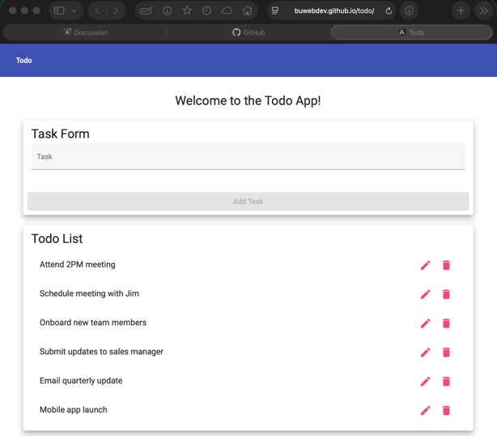
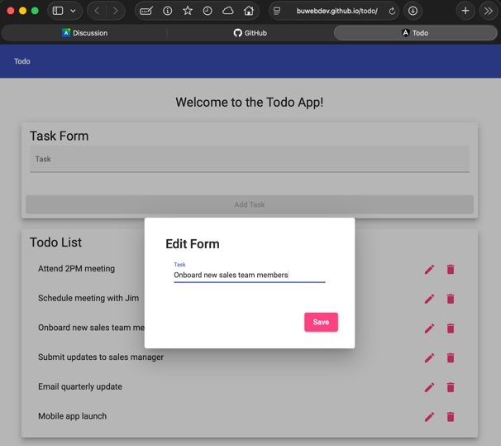
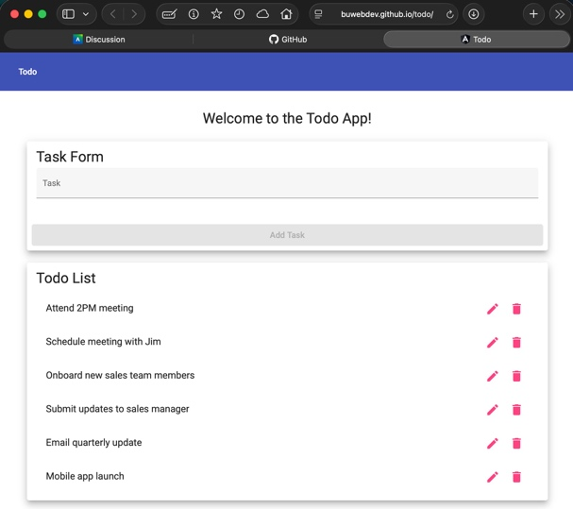
Test 4 | Invalid URLs Show a Useful Custom Error Page
 | Test Objective: Ensure that server data does not leak and users are not confused by a default error page. | Developer: Isaac Ellingson  Date tested: 2026/06/25 | Peer tester: Patrice Moracchini  Date tested: 2026/06/28
Step | Action | Expected results: | Developer pass/fail | Tester pass/fail
1 | Visit https://buwebdev.github.io/todo/stuart | A custom error page is displayed, helping users return to the functional app without confusion | no | No
Comments | The webpage doesn’t appear when the address is invalid. But the expected error page with instruction to help the user is not available. Instead, a white page with the small inscription “not-found works!” in the left up corner appears.
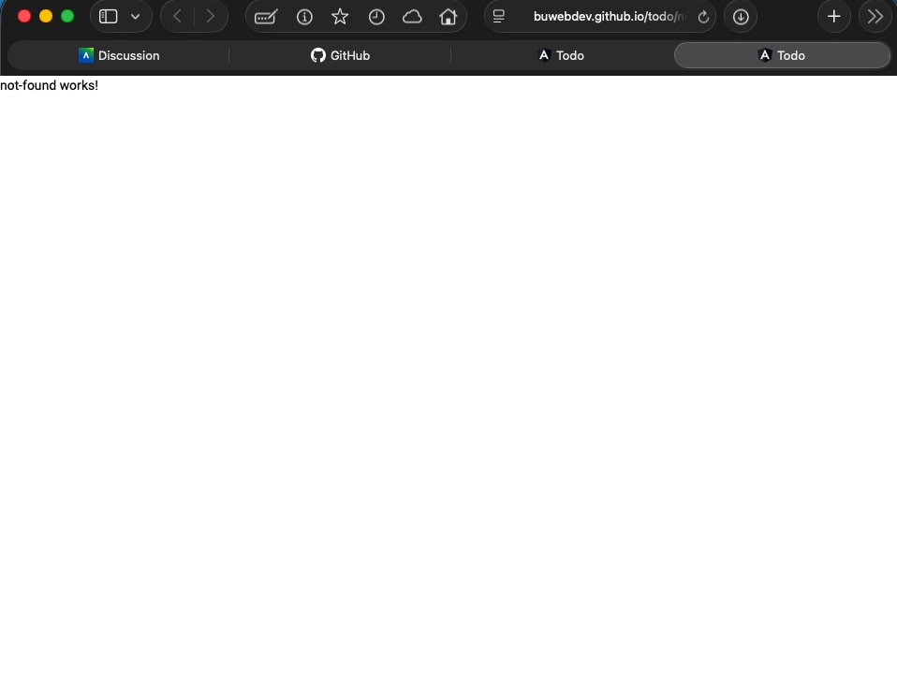

Test 5 | Empty Tasks Cannot Be Added
 | Test Objective: Ensure that the Todo list cannot be polluted with empty Tasks | Developer: Isaac Ellingson  Date tested: 2026/06/25 | Peer tester: Patrice Moracchini  Date tested: 2026/06/28
Step | Action | Expected results: | Developer pass/fail | Tester pass/fail
1 | Visit https://buwebdev.github.io/todo/ | Page loads without errors | yes | Yes
2 | Place the cursor within the text entry area |  | yes | Yes
3 | Click a blank area outside the text entry area to finish editing the task without adding any text | A red color indicator shows that the text entry was invalid | yes | Yes
4 | Click the "Add Task" button | Nothing happens; button is disabled. | yes | Yes
Comments | The page loads entirely. The task form entry is clickable and the cursor appears. But the word task and the line under the text entry stays red and the button “Add Task” is greyed out and not clickable. Impossible to add an empty task.
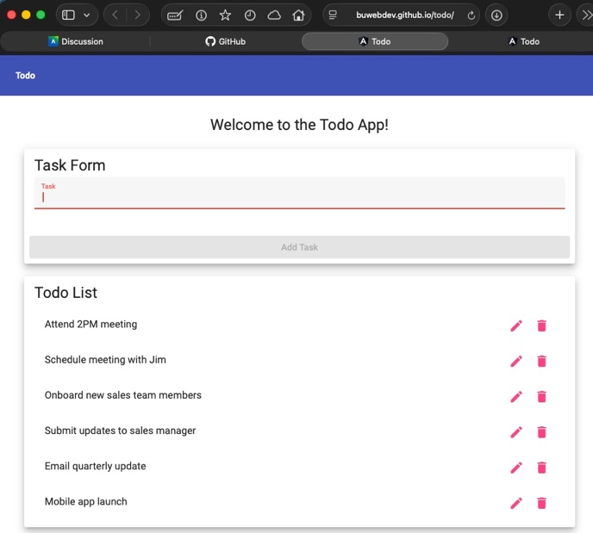

Project: Todo Project | Developer: Matthew Rozendaal
Course: CSD380 | Assignment: Mod 4.2
Description: Todo is a business application focused on the monitoring of task items. Users of this system are able to create, update, and delete items from their “Todo List.” Views have been created to support most major devices and web browsers. | Tester: Patrice Moracchini
Date: 2026/06/12 | Date: 2026/06/28
.

Test 1 | Landing Page Inputs
 | Test Objective: Verify Landing Page contains needed inputs | Developer: Matthew Rozendaal  Date tested: 2026/06/12 | Peer tester: Patrice Moracchini  Date tested: 2026/06/28
Step | Action | Expected results: | Developer pass/fail | Tester pass/fail  + Screenshot
1 | Visit https://buwebdev.github.io/todo/ | That the page loads | Yes | Yes
2 | Confirm there is a task input form | The input form should closely mimic the prototype | Yes | Yes
3 | Confirm there is a Todo list below task input | The Todo List should mimic the prototype | Yes | Yes
Comments | The page loads without error. All the elements expected, like the task input form and the list are present.

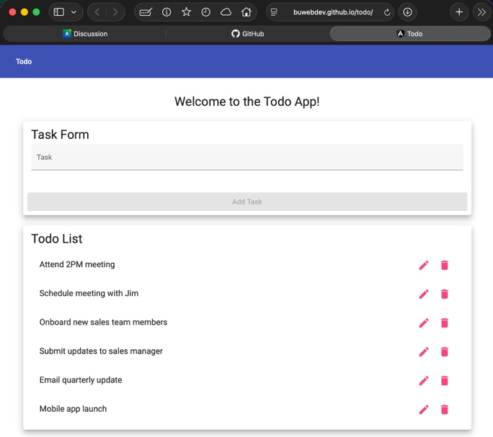

Test 2 | Edit existing Task
 | Test Objective:  Should edit an existing task and be able to save it | Developer: Matthew Rozendaal  Date tested: 2026/06/12 | Peer tester: Patrice Moracchini  Date tested: 2026/06/28
Step | Action | Expected results: | Developer pass/fail | Tester pass/fail  + Screenshot
1 | Visit https://buwebdev.github.io/todo/ | That the page loads | Yes | Yes
2 | In the Todo List, click the edit button for an existing item | An edit form should pop up | Yes | Yes
3 | Edit the value | The value in the pop up should allow you to edit it | Yes | Yes
4 | Click Save | The form should close and the edited value should show in the list | Yes | Yes
Comments | The page loads perfectly. The edit button is clickable and opens a window that dim and hover the main window and is named “Edit Form”. The task item can be edited and when save is clicked, the modification appears in the list.
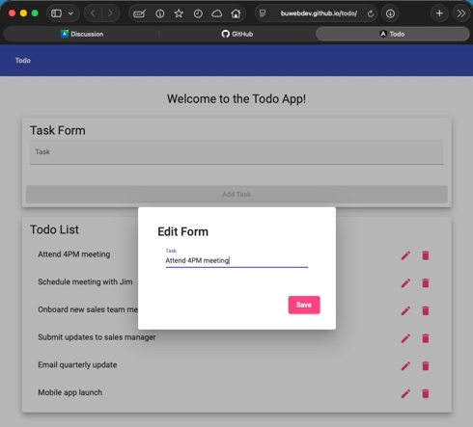
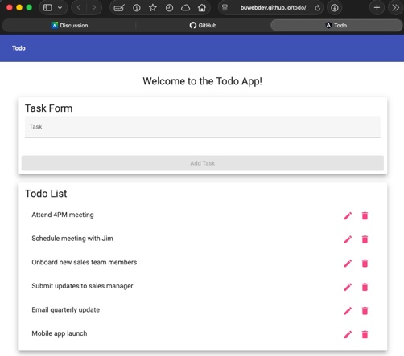
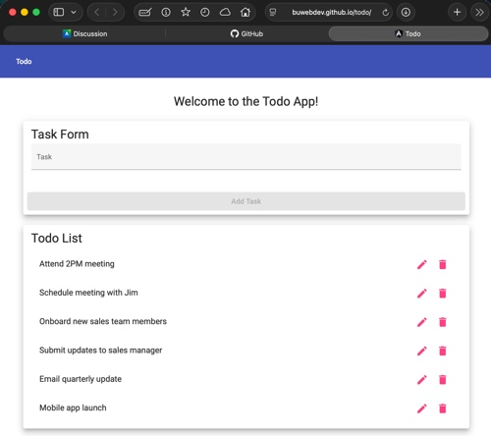

Test 3 | Delete Existing task
 | Test Objective:  Should be able to delete a task | Developer: Matthew Rozendaal  Date tested: 2026/06/12 | Peer tester: Patrice Moracchini  Date tested: 2026/06/28
Step | Action | Expected results: | Developer pass/fail | Tester pass/fail
1 | Visit https://buwebdev.github.io/todo/ | That the page loads | Yes | Yes
2 | In the Todo List, click the delete button (Trash can) for one of the items on the list | The item should disappear from the UI | Yes | Yes
Comments | While the ability to delete works perfectly, we may want to have a pop up to confirm the user’s action. Especially with the edit button so close. Other than that the page load perfectly and allow to do the delete task.

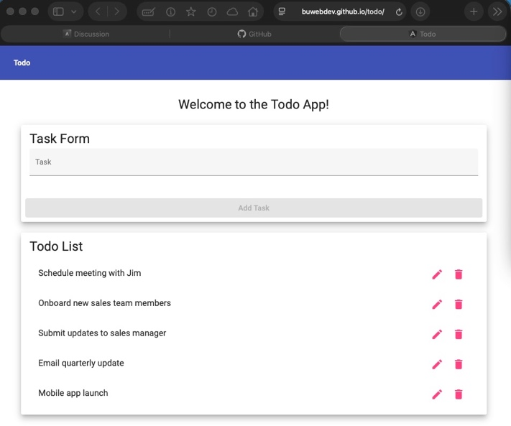
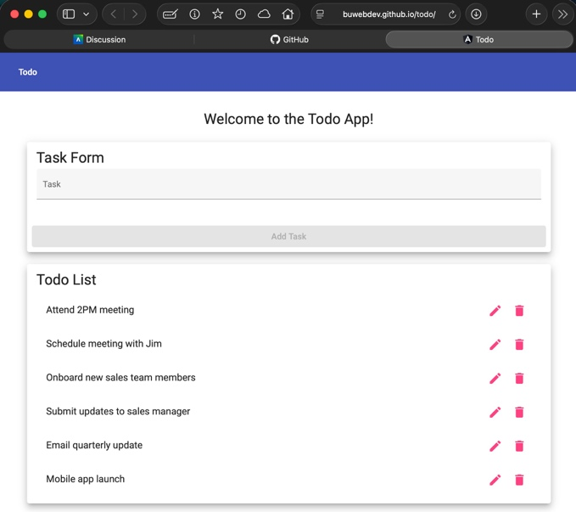

Test 4 | Create new ToDo Item
 | Test Objective:  Create a new ToDo item in the UI | Developer: Matthew Rozendaal  Date tested: 2026/06/12 | Peer tester: Patrice Moracchini  Date tested: 2026/06/28
Step | Action | Expected results: | Developer pass/fail | Tester pass/fail
1 | Visit https://buwebdev.github.io/todo/ | That the page loads | Yes | Yes
2 | Enter “New Task” into Task Form | The Add Task Button should become available | Yes | Yes
3 | Click “Add Task” | A new task in the Todo List with “New Task” as the name | Yes | Yes
Comments | While the button to add a task works well, users may want to add multiple without needing to click with mouse. If the Add Task is enabled, allowing the task to be added by clicking “enter” on the keyboard would be ideal
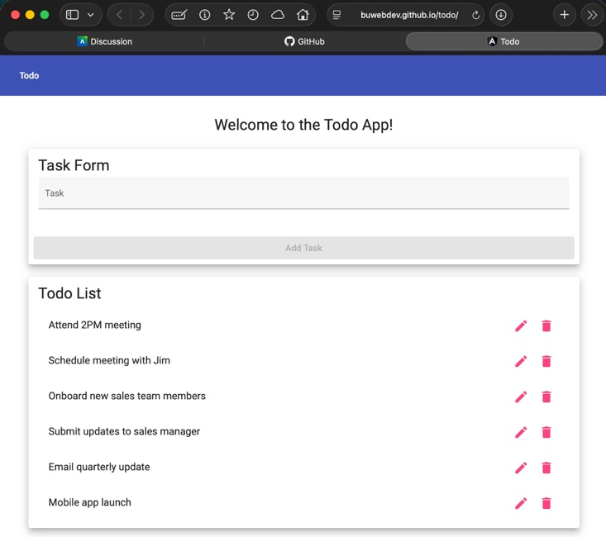
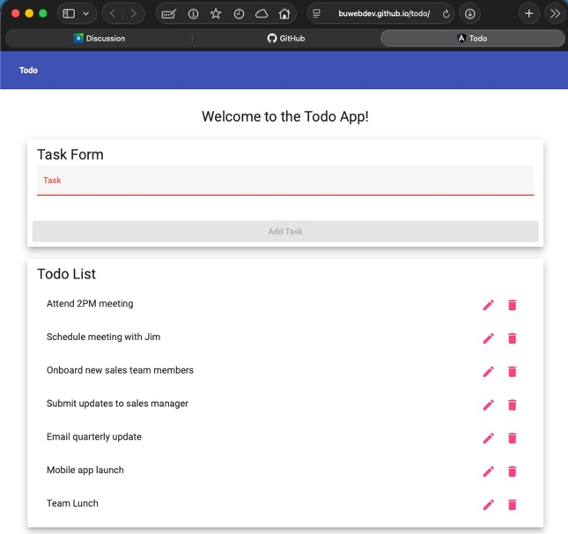
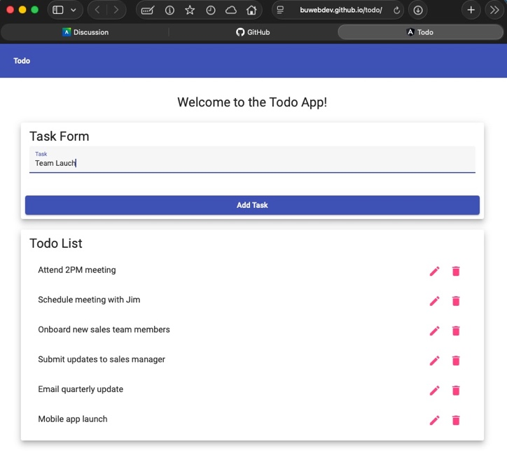

Test 5 | Make sure is screen size responsive
 | Test Objective:  Make sure elements on page react to different screen dimensions | Developer: Matthew Rozendaal  Date tested: 2026/06/12 | Peer tester: Patrice Moracchini  Date tested: 2026/06/28
Step | Action | Expected results: | Developer pass/fail | Tester pass/fail
1 | Visit https://buwebdev.github.io/todo/ | That the page loads | Yes | Yes
2 | Right click and choose inspect | A developer panel should show up | Yes | Yes
3 | Enable device emulation | The web page should change in size, and the developer console should give you the ability to change the dimensions of the website. | Yes | Yes with different commands
4 | Change the size of the view of the web site to bigger sizes | The web page items should contract when dimensions are smaller and expand when dimensions are bigger. | Yes | Yes
Comments | Tested on Safari, MacOS Tahoe 26.6. Changed the action to Develop Tab/Enter Responsive Design to change to different size.
