Patrice Moracchini
CSD420-308A(2265-DD)
Mar 24, 2026

GitHub Repository Setup
Module 1.2 Assignment
Pr. Payne

Link to GitHub Repository:
https://github.com/Bellevuestudent/csd-420.git
Screenshot 1: GitHub repository
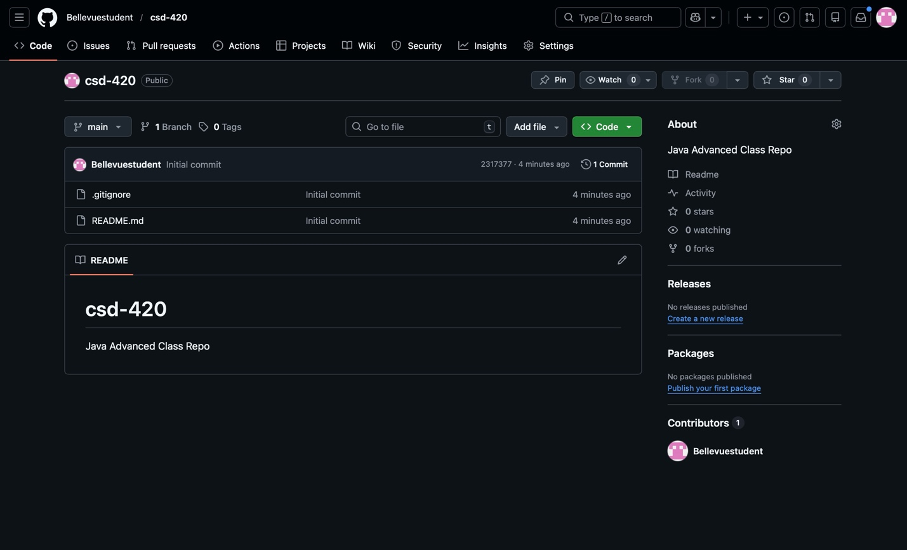

Screenshot 2: Local directory structure

